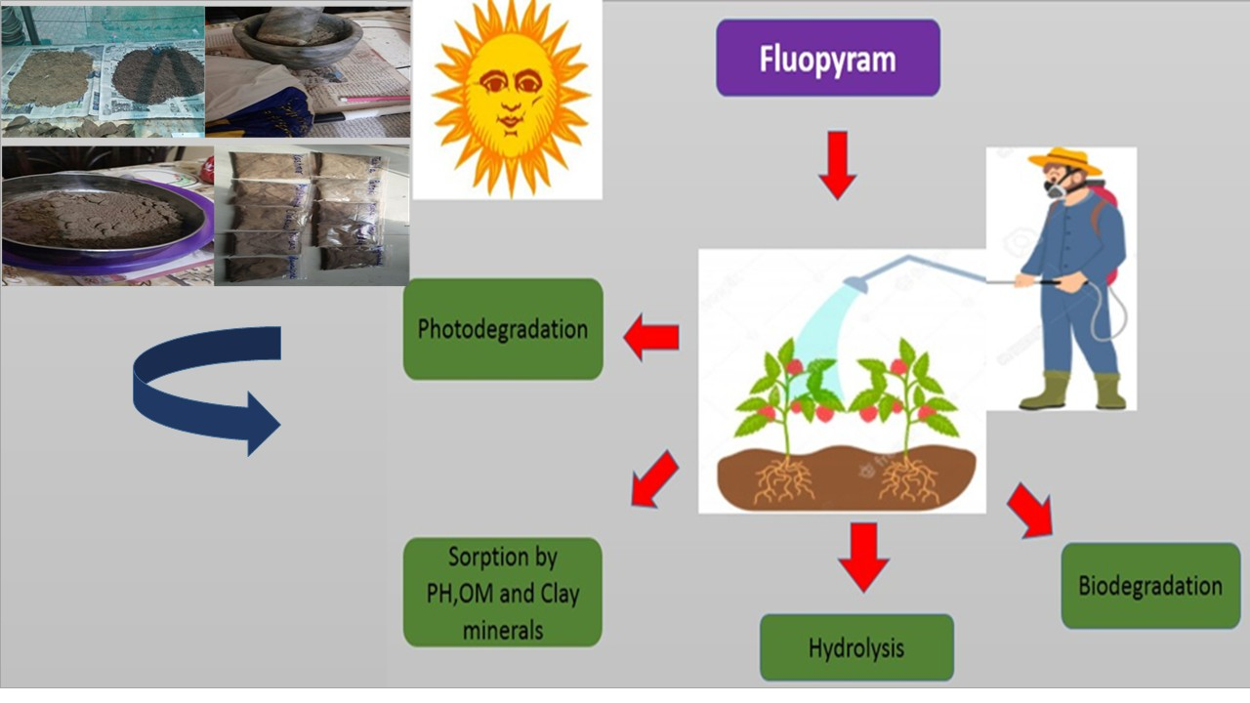
Fig. S1 Pedospherical fate elucidation of FLP

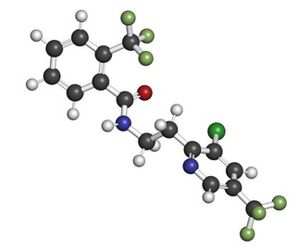
Fig. S2 Three-dimension (3D) structure of FLP fungicide

Table S1 Physiochemical properties of FLP.
Structural Formula | 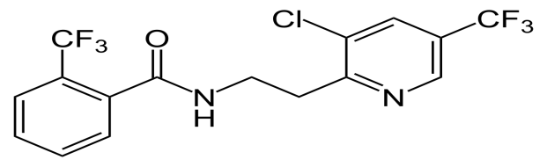
Molecular Formula | C₁₆H₁₁ClF₆N₂O
Molecular weight | 396.76 g/mol
Effect | Skin redness, weakness, headache, and dizziness
Chemical Group | Benzamides
Applications | Potatoes, apples, grapes, strawberries, sugarbeet, cotton

