Table 1: Investigation result
Test | Result | Normal range
CBC
TWBC | 2.7 x 10^3 | N.R 10-26
RBC | 4.74 x 10^6 | N.R 4.1- 6.7
HGB | 10.8 g/dL
HCT | 32.8 % | N.R 44-50 low
MCV | 69.3 fl | 102 – 115 low
MCH | 22.7 pg | 33 – 39 low
MCHC | 32.9 g/dl
PLT | 299 x 10^3 / | 150 - 450
LYM% | 39 | N.R %20 -40
MXD % | 14.6 | 1-15
NEUT% | 46.4 %
LYM | 1.1 x 10^3 / ml | 2.5-10.5
NEUT | 1.3 x 10^3 / ml
MXD | 0.3
RDW-CV | 18.6 | 11 – 16
CRP | 7 | Up to 10
Bleeding profile
INR | 0.8
PT | 13.9
PT Control | 15
Liver profile
Total portion | 6.5 g/dl | 6.6-8.7
Serum albumin | 3.9 g/dl | 3.4-4,8
Bilirubin (Total) | 0.2 mg/dl | Less than 1.1
Bilirubin (Direct) | 0.1 mg/dl | Less than 0.3
Bilirubin (indirect) | 0.1 mg/dl
ALT (GPT) | 27 U/L | Up to 45
AST (GOP) | 37 U/l | Up to 42
ALP | 232 U/L | Child 727
Urea and electrolytes
Blood urea | 55 mg/dl | 10-50
Serum creatinine | 0.5 mg/dl | F(o.6-1.1) M(0.7-1.4)
Na+ | 140 mmol/L | 135-145
K+ | 4.5 mmol/L | 3.5-5.0

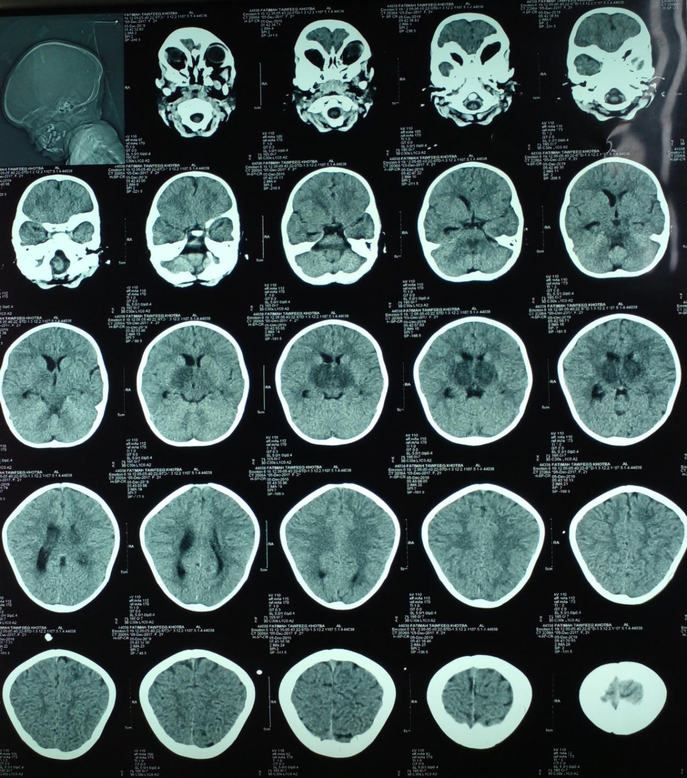
Figure 1: CT brain was done which revealed bilateral basal ganglia infarction.

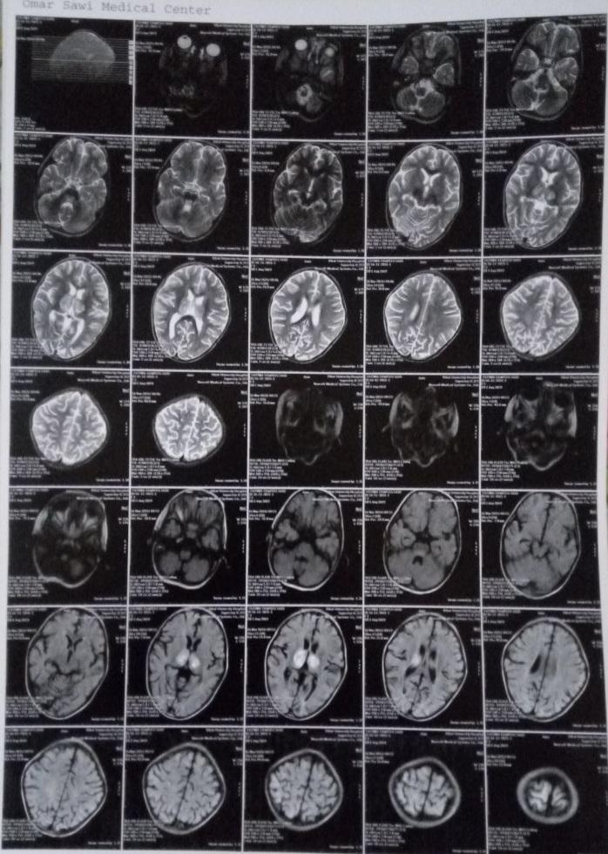
Figure 2: MRI reveals bilateral thalamic lesion due to viral encephalitis or vascular insult.
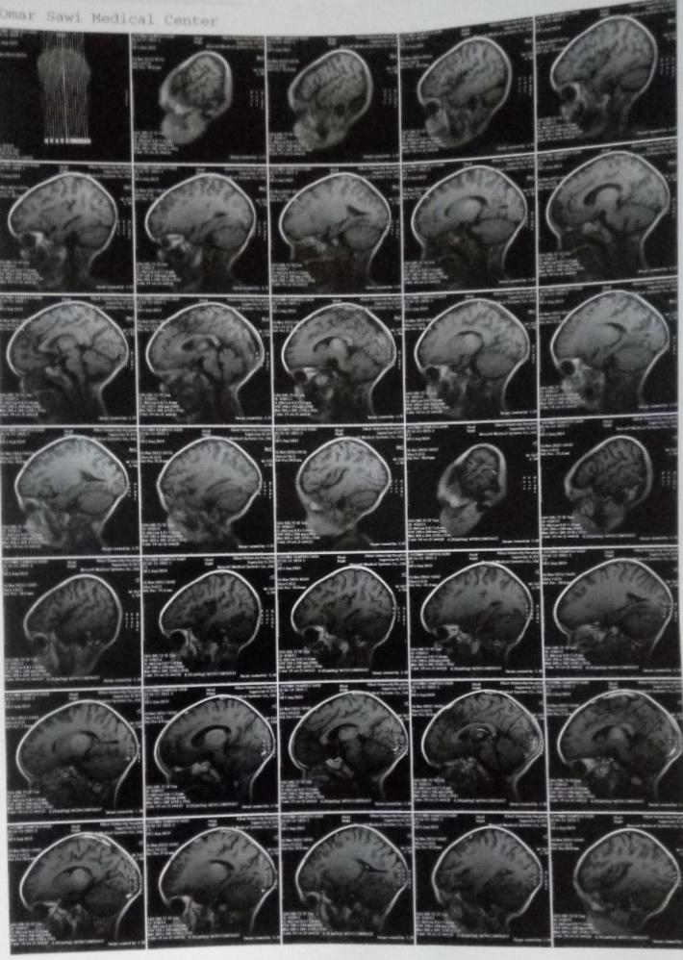
Figure 3: MRI reveals bilateral thalamic lesion due to viral encephalitis or vascular insult.

