Supporting information
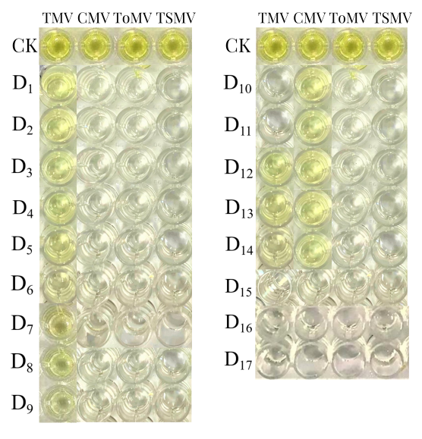
Figs.1 Virus detection results of diseased plants (D1~D17) of S.m.-SC by Das-ELISA test. CK: positive control, D1~D17: diseased plants. All plant samples were determined at least twice.
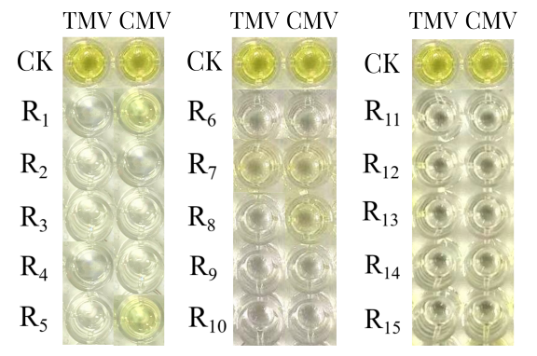
Figs.2 Virus detection results of regenerated plants of S.m.-SC by Das-ELISA test. CK: positive control, R1~R15: directly regenerated plants. R1, R5, R8: CMV positive; R7: CMV and TMV positive, other was negative. All plant samples were determined at least twice.

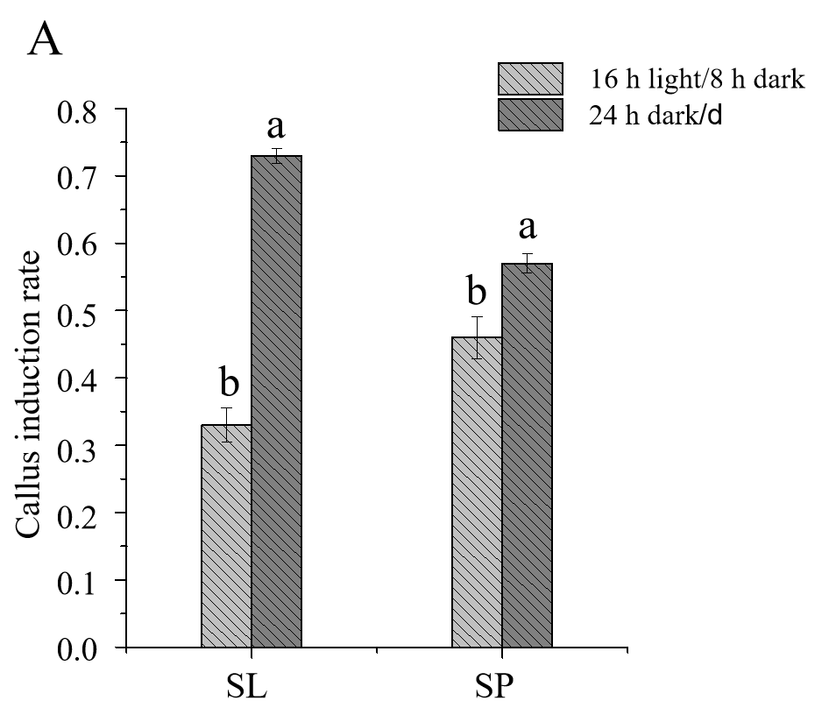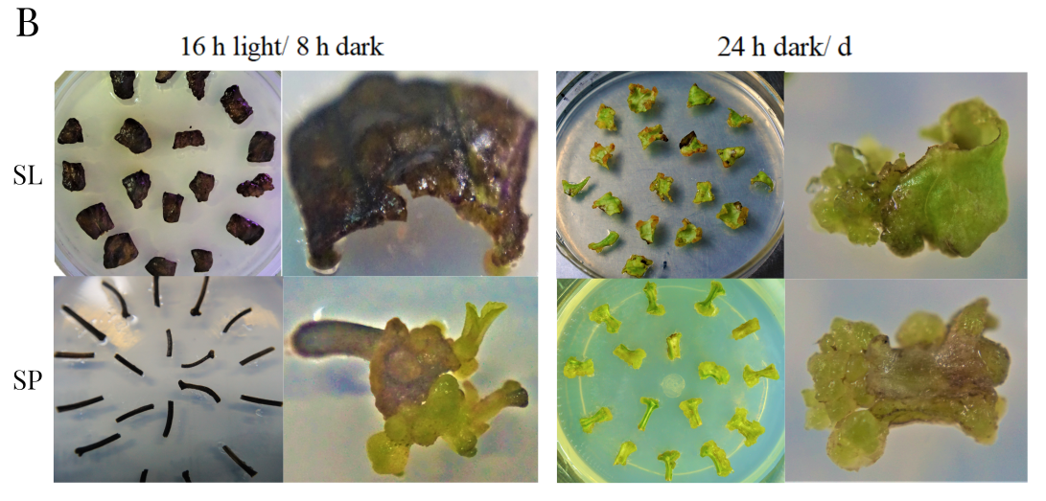
Figs.3 Callus induction rate and growth status of SP and SL under two kinds light condition of 16 h light/ 8 h dark and 24 h dark/d. A: callus induction rate of SL and SP under two kinds of light condition, namely, 16 h light/ 8 h dark and 24 h dark/d. B: Growth status of SP and SL on L2 media under two kinds of light condition, namely, 16 h light/ 8 h dark and 24 h dark/d. SL: secondary leaf, SP: secondary petiole. Different letters indicate significant differences among light condition for each group as determined by Duncan’s multiple range test followed by one-way ANOVA at the p<0.05 significant level. Number of secondary tissue inoculated per group was about eighteen; three replication of each group were laid. Data were collected after 3 weeks.

