Comparison of various orgainc acids for xylo-oligosaccharide productions in term of pKa values and combined severity
Rou Cao ^{a,b,c}, Xinlu Liu ^{a,b,c}, Jianming Guo ^{a,b,c}, Yong Xu ^{a,b,c,*}
ª Key Laboratory of Forestry Genetics & Biotechnology (Nanjing Forestry University), Ministry of Education, Nanjing 210037, People’s Republic of China
^{b} Jiangsu Co-Innovation Center of Efficient Processing and Utilization of Forest Resources, College of Chemical Engineering, Nanjing Forestry University, Nanjing 210037, People’s Republic of Chin
^{c} Jiangsu Province Key Laboratory of Green Biomass-based Fuels and Chemicals, Nanjing 210037, People’s Republic of China
* Corresponding author at: College of Chemical Engineering, Nanjing Forestry University. No. 159 Longpan Road, Nanjing 201137, People’s Republic of China.
E-mail address: xuyong@njfu.edu.cn (Y. X.)
Tel: +86 025 85427587
Fax: +86 025 85427587

Table S1. The pKa values of four organic acids.
Organic acid | pKa value
Formic acid | 3.75
Glycolic acid | 3.83
Lactic acid | 4.14
Acetic acid | 4.75

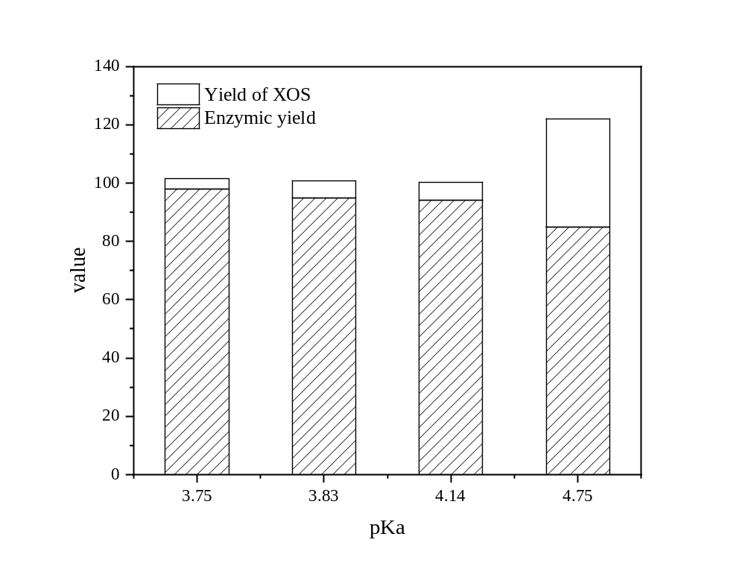
Fig. S1 The comprehensive effectiveness of XOS yield and enzymatic hydrolysis.
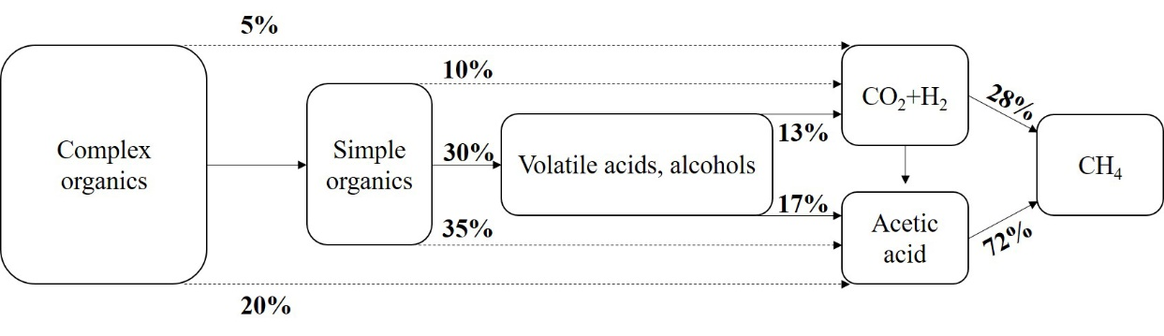
Fig. S2 Process of Anaerobic biological treatment

