Further engineering of R. toruloides for the production of terpenes from lignocellulosic biomass

James Kirby^{a,b}, Gina M. Geiselman^{a,b}, Junko Yaegashi^{c,d}, Joonhoon Kim^{a,d}, Xun Zhuang^{a,b}, Mary Bao Tran-Gymfi^{a,b}, Jan-Philip Prahl^{a,e}, Eric R. Sundstrom^{a,e}, Yuqian Gao^{a,i}, Nathalie Munoz Munoz^{a,h}, Kristin E. Burnum-Johnson^{a,h}, Veronica T. Benites^{a,f}, Edward E. K. Baidoo^{a,f}, Anna Fuhrmann^{c}, Katharina Seibel^{c}, Bobbie-Jo M. Webb-Robertson^{a,i}, Jeremy Zucker^{a,i}, Carrie D. Nicora^{a,i}, Deepti Tanjore^{a,e}, Jon K. Magnuson^{a,d}, Jeffrey M. Skerker^{g} and John M. Gladden^{a,b *}
Affiliations
ªDepartment of Energy, Agile BioFoundry, Emeryville, CA, 94608, USA
^{b}Department of Biomass Science and Conversion Technology, Sandia National Laboratories, Livermore, CA 94550, USA
^{c}Joint BioEnergy Institute, Lawrence Berkeley National Laboratory, Emeryville, CA 94608, USA
^{d}Chemical and Biological Processing Group, Pacific Northwest National Laboratory, Richland, WA 99354, USA.
^{e}Advanced Biofuels and Bioproducts Process Development Unit, Lawrence Berkeley National Laboratory, Emeryville, CA 94608, USA
^{f}Biological Systems and Engineering Division, Lawrence Berkeley National Laboratory, Berkeley, CA, USA.
^{g}Environmental Genomics and Systems Biology Division, Lawrence Berkeley National Laboratory, Berkeley, CA 94720, USA
^{g}QB3-Berkeley, University of California, Berkeley, CA 94704, USA
^{h}The Environmental Molecular Sciences Laboratory, ^{i}Biological Sciences Division, Pacific Northwest National Laboratory, Richland, WA 99354, USA
*Corresponding author. Tel. +1 (510) 495-2490
Email address: (John M. Gladden) jmgladden@lbl.gov

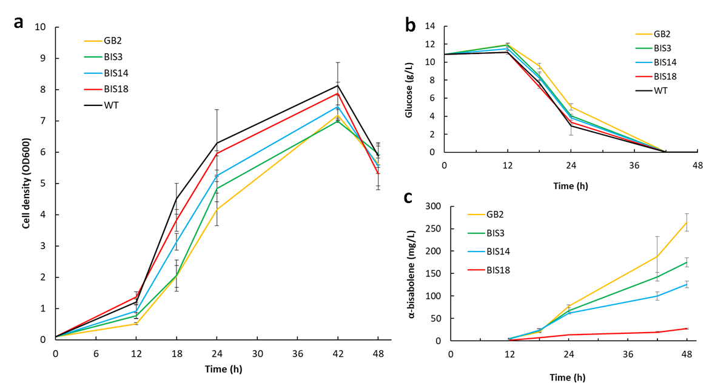
Fig. S1 Growth (a), glucose consumption (b), and α-bisabolene production (c) in SD medium containing 10 g/L glucose by five R. toruloides strains selected for omics analysis, including wild type (WT). Three strains (BIS18, BIS14, and BIS3) harbor the P_{GAPDH}-BIS cassette at various copy numbers (1, 7, and 10, respectively) and strain GB2 contains of 6 copies of P_{ANT}-BIS in addition to 10 copies of P_{GAPDH}-BIS.

Table S1. Selected transcriptomics (A) and proteomics (B) data for five R. toruloides strains (WT, BIS18, BIS14, BIS3, and GB2) sampled following 18 hours (exponential, exp) and 48 hours (stationary, stat) of growth in SD medium containing 10 g/L glucose. The average of log2(FPKM) values and spectral counts for three replicates are used for transcriptomics and proteomics, respectively.
A. | WT | BIS18 | BIS14 | BIS3 | GB2 | WT | BIS18 | BIS14 | BIS3 | GB2
 | exp | exp | exp | exp | exp | stat | stat | stat | stat | stat
ANT | 11.3 | 11.0 | 11.4 | 12.0 | 11.9 | 9.5 | 10.5 | 10.7 | 10.4 | 10.4
BIS |  | 8.5 | 11.7 | 12.8 | 13.3 |  | 8.3 | 11.3 | 11.8 | 12.6
TEF1 | 11.1 | 10.9 | 11.4 | 11.9 | 12.1 | 10.2 | 10.7 | 11.0 | 10.6 | 10.9
ERG10 | 6.9 | 7.0 | 7.8 | 8.3 | 8.9 | 5.6 | 5.8 | 6.3 | 5.9 | 6.5
ERG13 | 6.1 | 6.2 | 7.7 | 8.7 | 9.6 | 5.5 | 5.7 | 6.0 | 6.2 | 6.4
ERG20 | 6.1 | 6.2 | 7.2 | 8.0 | 8.3 | 4.9 | 5.4 | 5.5 | 6.1 | 5.8

B. | WT | BIS18 | BIS14 | BIS3 | GB2 | WT | BIS18 | BIS14 | BIS3 | GB2
 | exp | exp | exp | exp | exp | stat | stat | stat | stat | stat
ANT | 73.3 | 73.5 | 68.0 | 71.8 | 68.0 | 62.0 | 59.3 | 58.8 | 56.5 | 53.3
BIS |  | 101.8 | 228.8 | 265.3 | 337.3 |  | 92.5 | 194.0 | 258.3 | 296.0
TEF1 | 181.3 | 178.5 | 174.5 | 189.3 | 210.0 | 130.0 | 134.5 | 121.3 | 132.3 | 145.0
ERG10 | 26.8 | 23.5 | 25.0 | 32.8 | 42.5 | 21.5 | 25.3 | 26.3 | 28.8 | 32.0
ERG13 | 31.5 | 27.3 | 31.5 | 50.3 | 56.8 | 19.0 | 18.5 | 21.5 | 25.0 | 30.8
ERG20 | 14.0 | 13.0 | 15.0 | 19.8 | 19.8 | 8.8 | 9.5 | 12.0 | 14.8 | 12.5

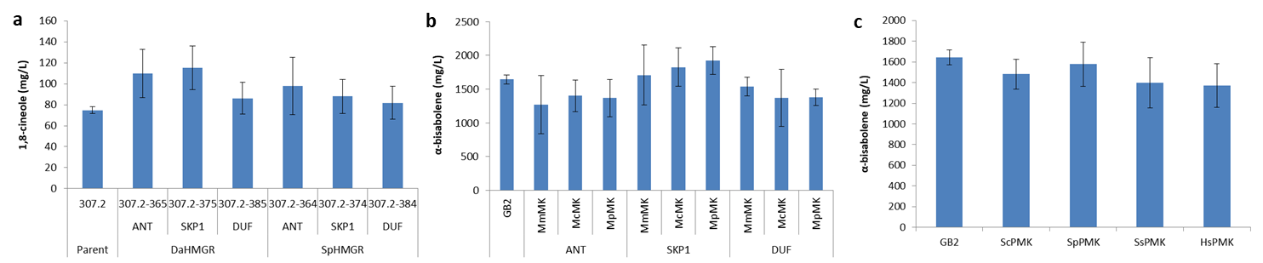
Fig. S2 Determining the impact of HMGR, MK, and PMK ortholog overexpression on α-bisabolene and 1,8-cineole production in R. toruloides strains, GB2 and 307.2, respectively. a Native promoters P_{ANT}, P_{SKP1} and P_{DUF} were used to drive expression of HMGRs from Delftia acidovorans (DaHMGR) and Silicibacter pomeroyi (SpHMGR) in the 1,8-cineole producing strain 307.2. b Archaeal MKs, from Methanosarcina mazei (MmMK), Methanosaeta concilii (McMK), and Methanocella paludicola (MpMK) were expressed under control of the P_{ANT}, P_{SKP1} and P_{DUF} promoters in the α-bisabolene producing strain, GB2. c PMKs selected from S. cerevisiae (ScPMK), Streptococcus pneumoniae (SpPMK), Sus scrofa (SsPMK), and Homo sapiens (HsPMK) were expressed under control of P_{DUF} in strain GB2. Strains were grown in culture tubes containing GXY medium and 1,8-cineole and α-bisabolene were measured at 8 and 7 days, respectively. Titers are shown for the two parent strains, 307.2 and GB2 and as an average of all transformants for each gene inserted into these parents.

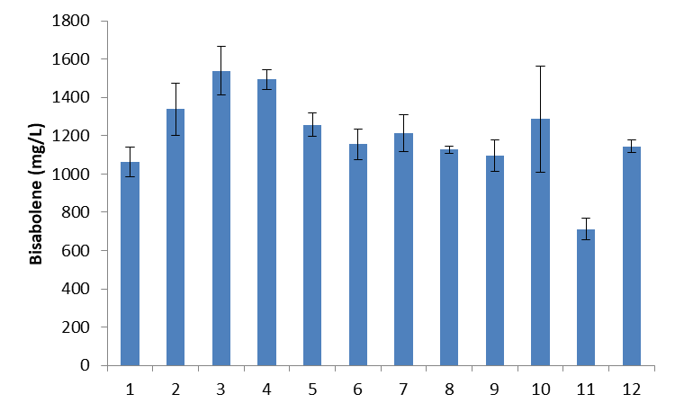
Fig. S3 Production of α-bisabolene by strain GB2 in media composed of DMR-EH, 5 g/L (NH₄)₂SO₄, 76 mM KH₂PO₄, 24 mM K₂HPO₄, pH 5.75, supplemented with: nothing (1), 200 µg/L thiamine (2), 400 µg/L thiamine (3), 800 µg/L thiamine (4), 400 µg/L pyridoxine hydrochloride (5), 2 µg/L folic acid (6), 100 µM FeSO₄ (7), 100 µM MgSO₄ (8), 1 mM MgSO₄ (9), 1 mM Na₂SO₄ (10), 7 mg/L ZnSO₄ (11), or 6.2 mg/L CuSO₄ (12).

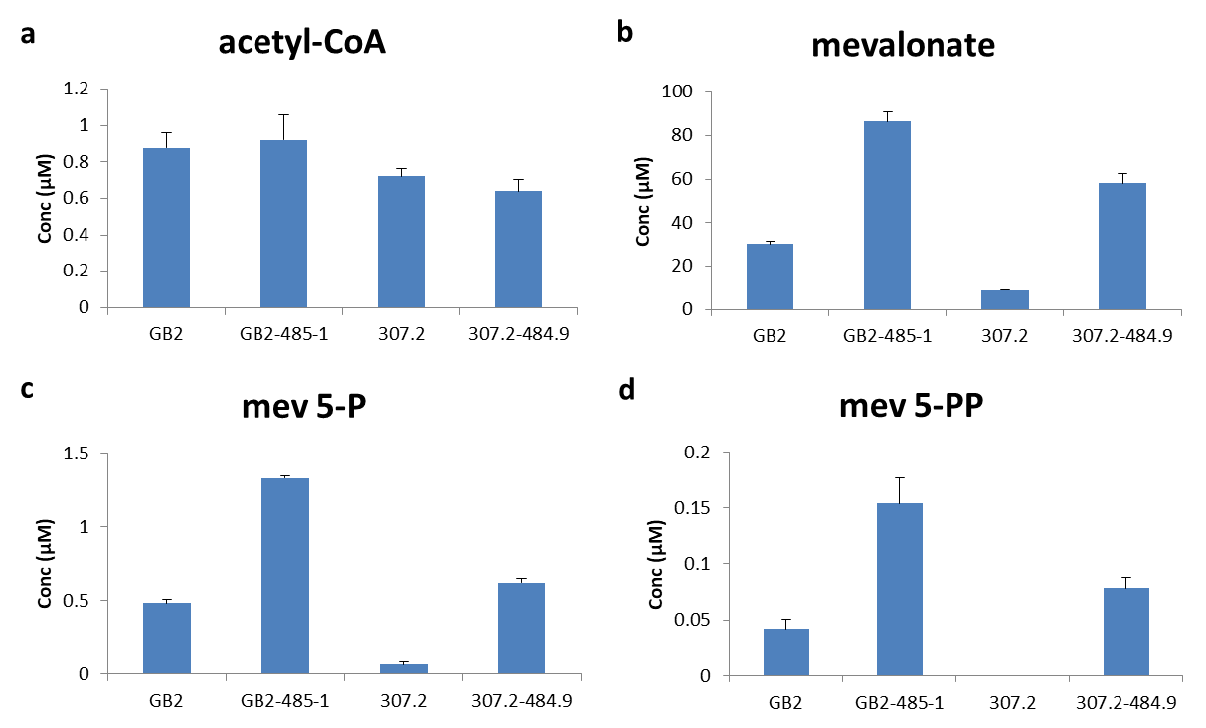
Fig. S4. Accumulation of mevalonate pathway intermediates in response to mevalonate pathway engineering. Intracellular mevalonate pathway intermediates were measured for R. toruloides strains GB2, GB2-485.1, 307.2, and 307.2-484.9 after 40 hours of growth in DMR-EH medium supplemented with 10 g/L yeast extract. Mev 5-P, mevalonate 5-phosphate; Mev 5-PP, mevalonate 5-diphosphate.

