Support information
A novel NIR-II theranostic agent: a win–win strategy of tracing and blocking tumor-associated vessels for oral squamous cell carcinoma
Zheng Wei^{bd}, Hongbo Zhang^{ad}, Huihui Zou^{e}, Chuanhui Song^{f}, Sufeng Zhaoª, Guorong Zhang^{g}, Jianchuan Ran^{ad}, Zichen Cao^{ad}, Xinyu Zhang^{ad}, Yu Cai*^{c}, Wei Han*^{ad}
ªDepartment of Oral and Maxillofacial Surgery, Nanjing Stomatological Hospital, Medical School of Nanjing University, 30 Zhongyang Road, 210008, Nanjing, China.
^{b}Pediatric Dentistry, Nanjing Stomatology hospital, Medical school of Nanjing University, No 30 Zhongyang road, Nanjing, 210008, China.
^{c}Clinical Research Institute, Zhejiang Provincial People’s Hospital, People’s Hospital of Hangzhou Medical College, No. 158 Shangtang Road, Hangzhou, 310014, Zhejiang Province, China.
^{d}Central Laboratory of Stomatology, Nanjing Stomatological Hospital, Medical School of Nanjing University, 30 Zhongyang Road, 210008, Nanjing, China.
^{e}Jiangbei Medical Center, Nanjing Stomatological Hospital, Medical School of Nanjing University, NO 359 Puzhu Middle Road, Jiangbei new district, Nanjing, 210008, Nanjing
^{f}Department of Rheumatology and Immunology, Institute of Translational Medicine, The Affiliated Drum Tower Hospital of Nanjing University Medical School, Nanjing, 210008, China.
^{g}Department of Orthodontics, Nanjing Stomatological Hospital, Medical School of Nanjing University, 30 Zhongyang Road, 210008, Nanjing, China.
E-mail: iamycai@163.com; doctorhanwei@hotmail.com.

Table1. Information of 40 OSCC patients.
Patient | Gender | Age | Location | WPOI | T | N | MVD
1 | F | 57 | Tongue | 1 | 1 | 0 | 113
2 | M | 76 | Buccal mucosa | 1 | 1 | 1 | 135
3 | M | 81 | Buccal mucosa | 2 | 3 | 2 | 211
4 | F | 63 | Floor of mouth | 2 | 2 | 0 | 317
5 | F | 49 | Buccal mucosa | 2 | 4 | 1 | 122
6 | M | 77 | Gingiva | 2 | 1 | 1 | 286
7 | M | 60 | Buccal mucosa | 2 | 1 | 0 | 129
8 | F | 81 | Buccal mucosa | 2 | 2 | 0 | 129
9 | F | 66 | Tongue | 3 | 3 | 0 | 236
10 | M | 49 | Tongue | 3 | 3 | 2 | 229
11 | M | 62 | Buccal mucosa | 3 | 2 | 0 | 203
12 | F | 73 | Upper lip | 3 | 1 | 0 | 294
13 | F | 70 | Tongue | 3 | 4 | 1 | 223
14 | F | 66 | Tongue | 3 | 2 | 1 | 279
15 | M | 66 | Tongue | 3 | 2 | 1 | 268
16 | M | 76 | Buccal mucosa | 3 | 3 | 0 | 252
17 | M | 62 | Tongue | 3 | 2 | 2 | 129
18 | M | 63 | Tongue | 3 | 2 | 0 | 269
19 | F | 66 | Tongue | 4 | 3 | 2 | 384
20 | M | 68 | Buccal mucosa | 4 | 4 | 0 | 371
21 | M | 53 | Buccal mucosa | 4 | 2 | 1 | 287
22 | M | 66 | Gingiva | 4 | 2 | 1 | 155
23 | M | 65 | Tongue | 4 | 4 | 1 | 326
24 | F | 68 | Buccal mucosa | 4 | 3 | 1 | 420
25 | F | 59 | Tongue | 4 | 2 | 2 | 250
26 | F | 62 | Tongue | 4 | 1 | 0 | 328
27 | M | 44 | Buccal mucosa | 4 | 2 | 1 | 270
28 | M | 58 | Tongue | 4 | 3 | 2 | 429
29 | M | 66 | Tongue | 4 | 2 | 1 | 303
30 | F | 81 | Buccal mucosa | 4 | 4 | 2 | 231
31 | M | 60 | Gingiva | 5 | 2 | 0 | 232
32 | M | 58 | Tongue | 5 | 2 | 0 | 176
33 | M | 68 | Tongue | 5 | 3 | 0 | 462
34 | F | 74 | Buccal mucosa | 5 | 3 | 2 | 193
35 | M | 80 | Tongue | 5 | 2 | 0 | 231
36 | F | 53 | Floor of mouth | 5 | 4 | 2 | 327
37 | M | 60 | Buccal mucosa | 5 | 2 | 2 | 509
38 | F | 65 | Tongue | 5 | 2 | 2 | 467
39 | F | 66 | Tongue | 5 | 3 | 0 | 410
40 | M | 51 | Gingiva | 5 | 3 | 0 | 203

Table2. Pearson’s relationship analysis between WPOI and MVD
 |  | WPOI | MVD
WPOI | Pearson’s co-relation | 1 | 0.575
WPOI | Significance |  | 0.000
MVD | Pearson’s co-relation | 0.575 | 1
MVD | Significance | 0.000
Number |  | 40 | 40
*: Two-tailed test

Table3. Nonparametric test of T stage and MVD.
 |  | T stage | MVD
T stage | Spearman correlation | 1 | 0.429
T stage | Significance |  | 0.006
MVD | Spearman correlation |  | 1
MVD | Significance | 0.006 | 0.429
Number |  | 40 | 40
*: Nonparametric test was chosen because the data did not conform to the normal distribution

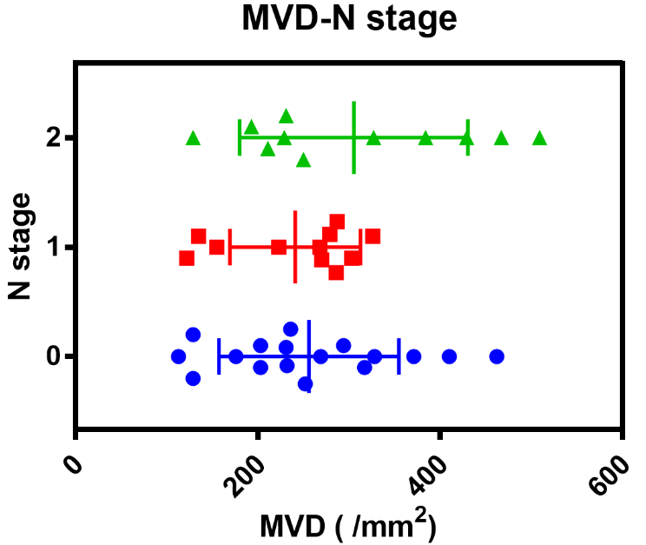
Figure S1. The relationship between vessel co-option MVD and N stage. These was no significant co-relationship based on the Spearman correlation test (p = 0.448). And details were shown in the Table 4.

Table 4. Spearman correlation analysis between N stage and MVD
 |  | T stage | MVD
WPOI | Spearman correlation | 1 | 0.125
WPOI | Significance |  | 0.448
T stage | Spearman correlation |  | 1
T stage | Significance | 0.448 | 0.125
Number |  | 40 | 40
*: There was no correlation between the N stage and MVD

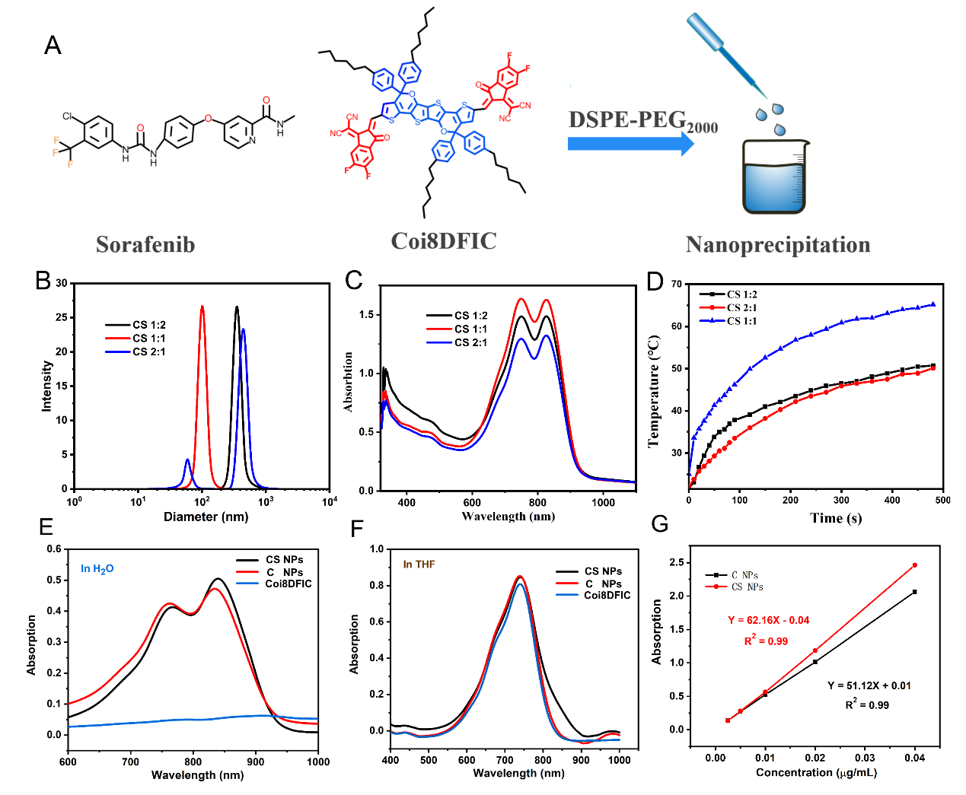
Figure S2. A The structural formulas of Coi8DFIC and Sorafenib. B-D. the Nano size, UV absorption and thermal effect of CS NPs with various ration of Coi8DFIC and Sorafenib (1:2, 1:1 and 2:1). E and F. The UV absorption of CS NPs, C NPs and Coi8DFIC in H2O and THF, respectively. G. The absorption co-efficient of C NPs and CS NPs at the maximum absorption peak. The absorption co-efficient of C NPs and CS NPs were 51.21 Lg-1cm-1 and 62.16 Lg⁻¹cm⁻¹.

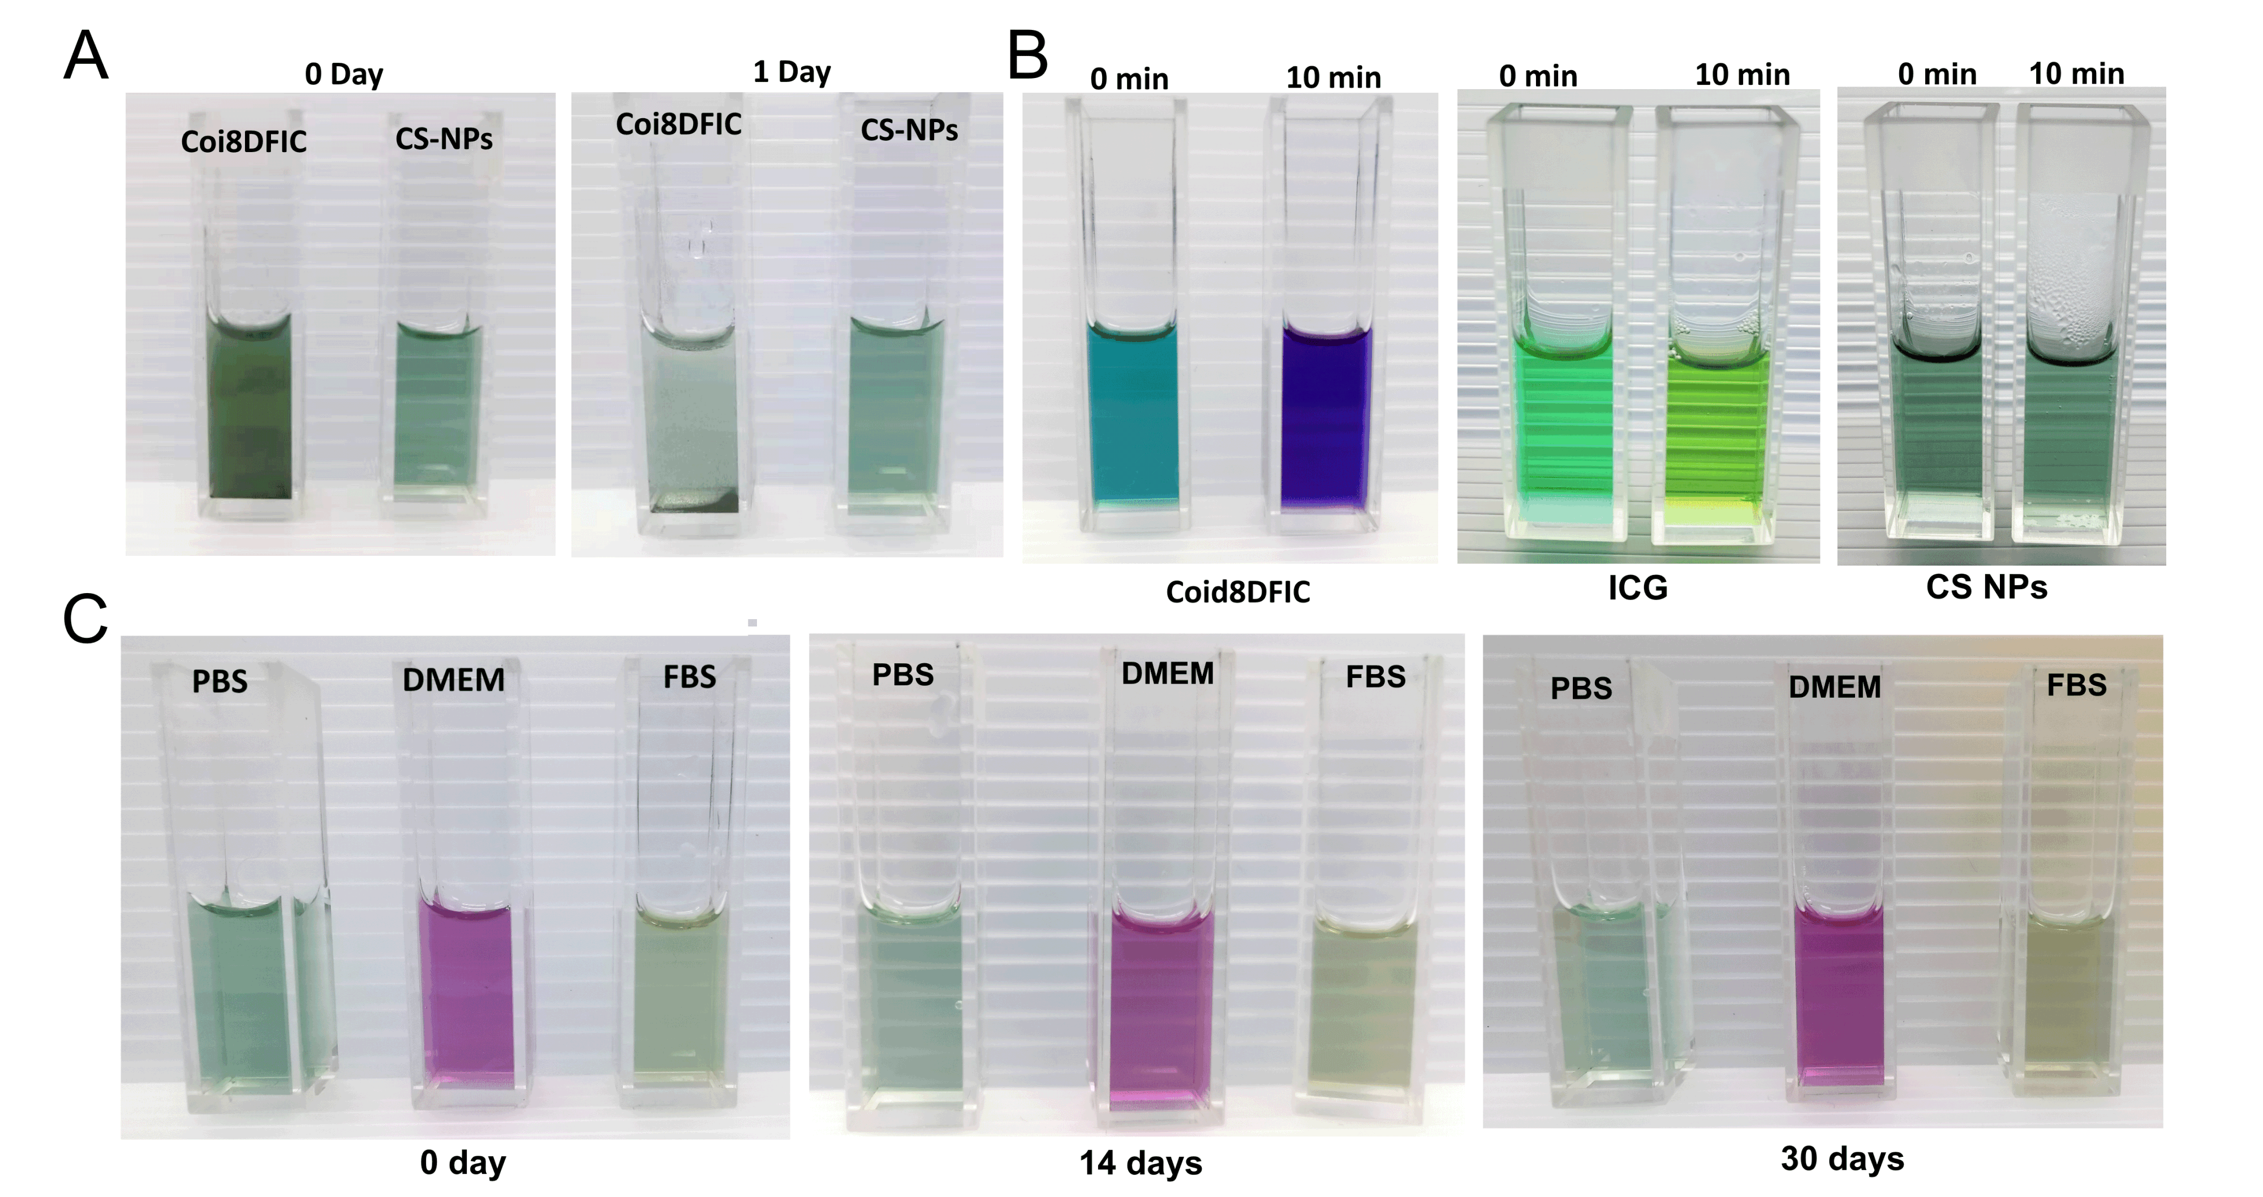Figure S3. A. Solution stability of COi8DFIC and CS NPs in water. COi8DFIC was hydrophobic and obvious precipitates could be seen in the solution after one day's storage. CS NPs showed better water solubility, which was homogeneous and transparent solution. B showed the photostability of Coi8DFIC, ICG and CS NPs, those who received 808 nm laser irradiation for 10 min (0.5W/cm²). C. The stability of CS NPs in PBS, DMEM and FBS, and those solutions were stored for 30 days.

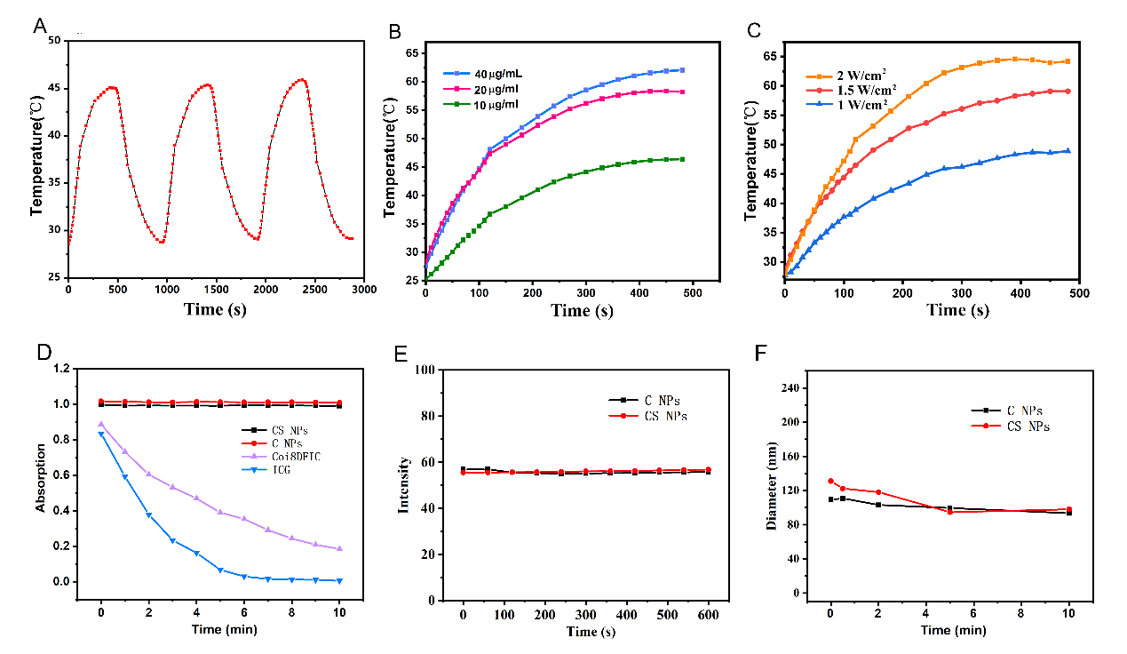
Figure S4. A. Three heat heating and cooling cycles of CS NPs. B and C. The photothermal effect of C NPs. D-F. The UV absorption, fluorescence and nano size of Coi8DFIC, ICG, C NPs and CS NPs under 10 min 808nm laser irradiation (0.5 W/cm²).

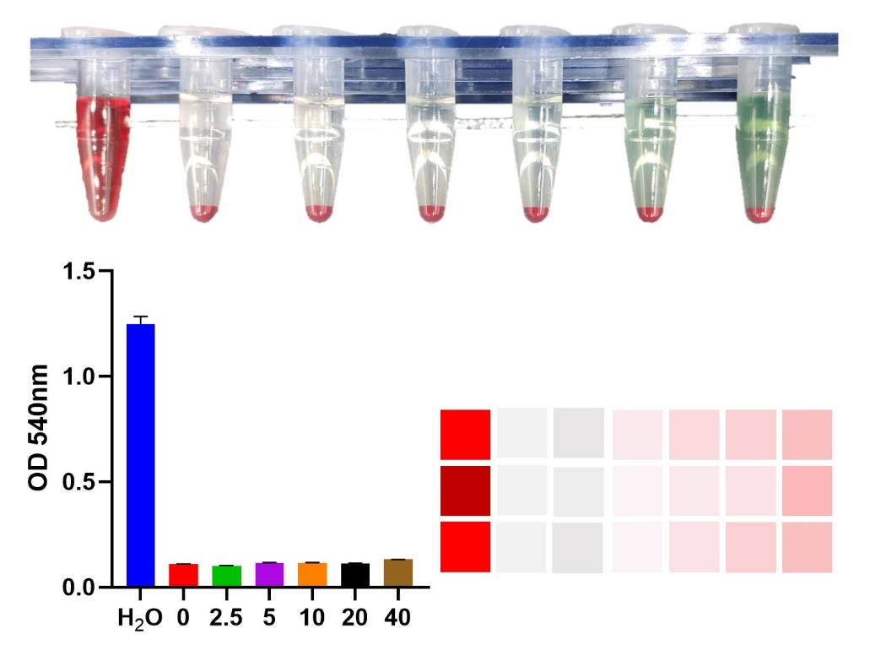
Figure S5. Hemolysis assay of CS NPs.

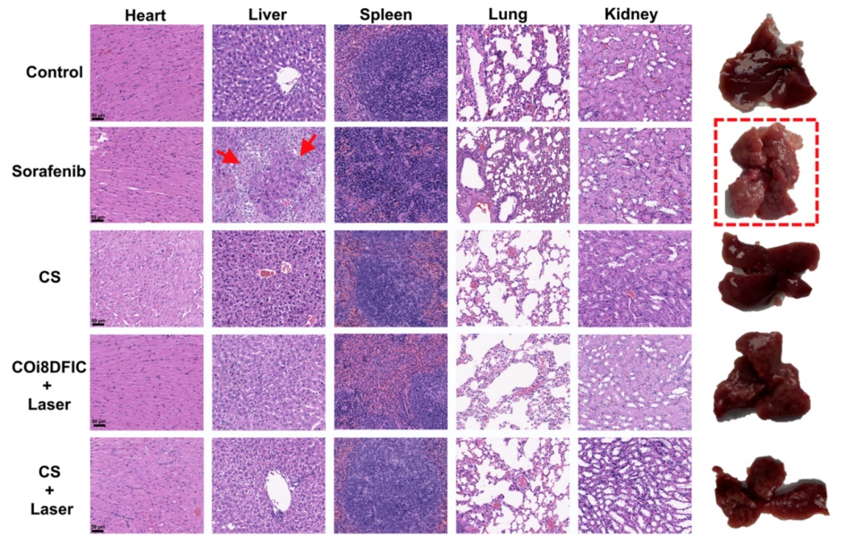
Figure S6. H&E stain results of mice organs. The liver damage caused by sorafenib could be seen in the second figure of line 2. At the same time, the liver also showed like a foam.

