Ultrasound Targeted Microbubble Destruction combined with Fe-MOF based Bio-/Enzyme-Mimics Nanoparticles for treating of Cancer
Xi Xiang^{1#}, Houqing Pang^{2#}, Tian Ma^{1,3}, Fangxue Du¹, Ling Li¹, Jianbo Huang¹, Lang Ma¹, Li Qiu^{1*}

Abstract
Background: Cancer urgently needs a new strategy for its recurrence and treatment resistance with the existing treatments. Fe-based metal-organic frameworks (MOFs) had the potential in ROS generation due to Fenton catalysis, which has been shown to be effective in antitumor therapy. However, Fenton catalysis requires sufficient H₂O₂ as the reactant to generate hydroxyl radical. Therefore, further improvement of Fe-MOF is needed. In the research, bio-/enzyme-mimics nanoparticles FeN200@GOx@M were synthesized and were used combined with ultrasound targeted microbubble destruction (UTMD) as a novel method for cancer therapy.
Methods: FeN200@GOx@M was synthesized by loading GOx and encapsulating tumor cell membrane. The nanostructures were characterized by SEM, TEM, XRD, EDS, XPS, and so on. The anti-tumor efficiency of FeN200@GOx@M was evaluated by cytotoxicity test, live/dead cell staining and apoptosis ratio in vitro. The combination of FeN200@GOx@M and UTMD was applied in vivo to verify the enhancement of anti-tumor effect of UTMD on FeN200@GOx@M.
Results: FeN200@GOx@M was successfully synthesized. FeN200@GOx@M was most easily intake by A2780 tumor cells, generated the most ROS in tumor cells, and induced the most apoptotic tumor cells in vitro. In addition, UTMD technology further improved the anti-tumor efficiency in vivo due to its sonoporation, which helped create reversible holes in cell membranes for easier been destroyed by FeN200@GOx@M.
Conclusion: Fe-MOF based bio-/enzyme-mimics nanoparticles FeN200@GOx@M had excellent anti-tumor efficiency. And UTMD can improve the therapeutic effectiveness. The combination of FeN200@GOx@M and UTMD provided a novel, safe, and efficient treatment strategy for cancer.
Keywords: Metal-organic frameworks, Ultrasound targeted microbubble destruction, cancer, Nanoparticles, Ultrasound, Treatment
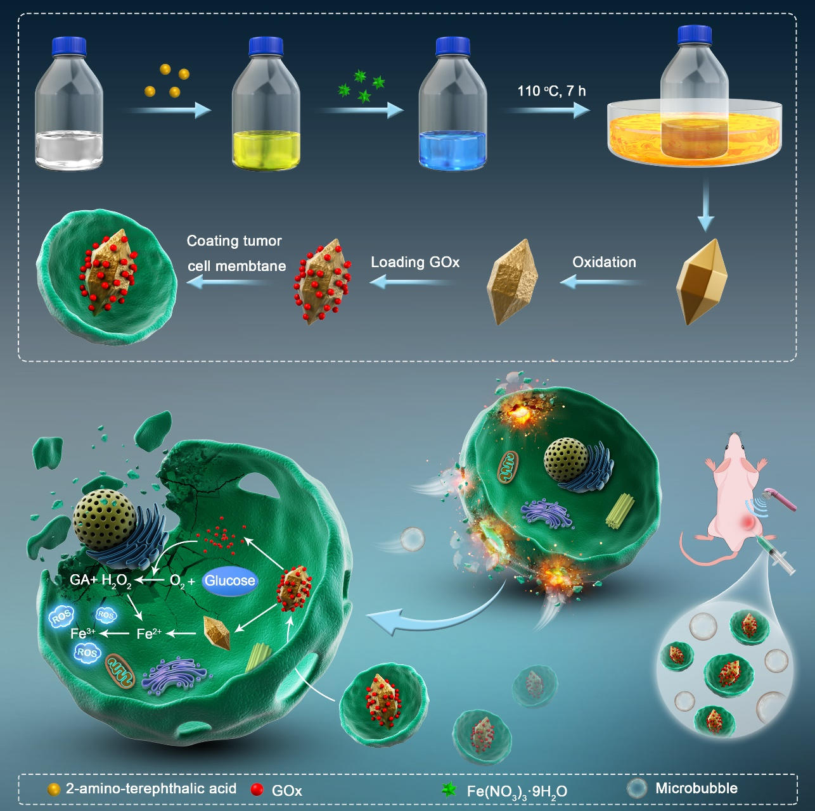
Scheme 1. The diagram of FeN200@GOx@M synthesis and anti-tumor principle in vivo

