Supplementary Information

Ultrasound Targeted Microbubble Destruction combined with Fe-MOF based Bio-/Enzyme-Mimics Nanoparticles for treating of Cancer
Xi Xiang^{1#}, Houqing Pang^{2#}, Tian Ma^{1,3}, Fangxue Du¹, Ling Li¹, Jianbo Huang¹, Lang Ma¹, Li Qiu^{1*}

¹ Department of Medical Ultrasound, Laboratory of Ultrasound Imaging Drug, West China Hospital of Sichuan University, Chengdu, 610041, China
² Department of Ultrasound, West China Second University Hospital, Sichuan University/ West China women’s and children’s Hospital, Chengdu, 610041, China
³ College of Polymer Science and Engineering, State Key Laboratory of Polymer Materials Engineering, Sichuan University, Chengdu, 610041, China
*Corresponding author. E-mail address: qiulihx@scu.edu.cn
#These authors contributed equally to this work.

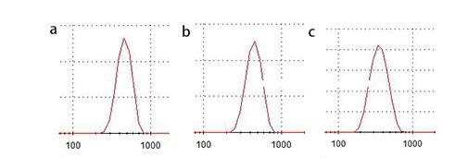
Figure S1: The particle sizes of a) FeN25, b) FeN200, and c) FeN300.

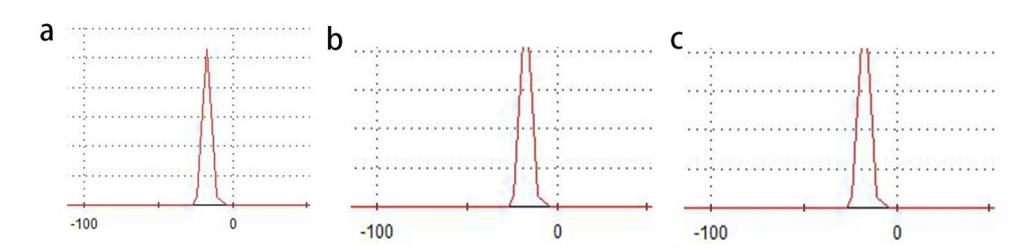
Figure S2: The zeta potential of a) FeN25, b) FeN200, and c)FeN300.

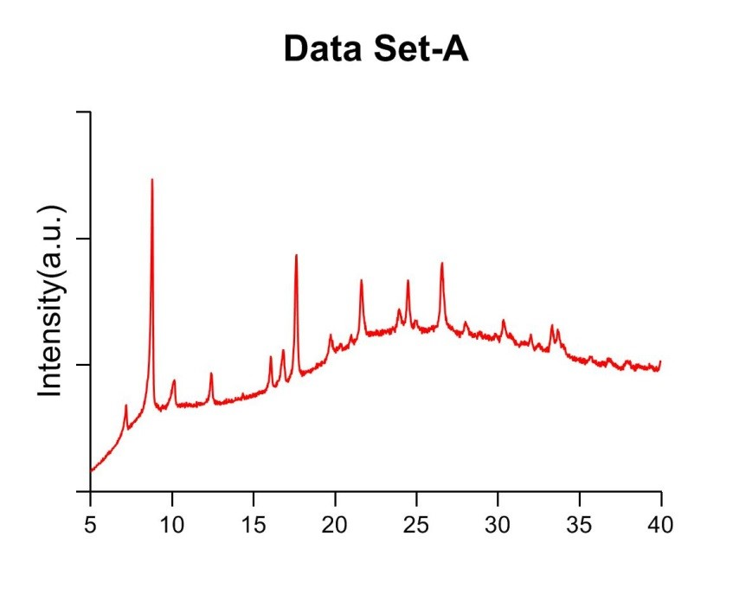
Figure S3: XRD pattern of FeN25.

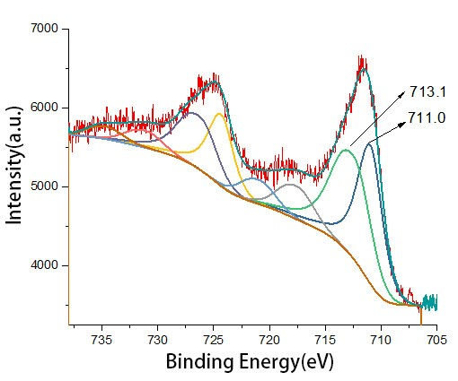
Figure S4: XPS analysis of FeN25, supporting that both Fe²⁺(52%) and Fe³⁺(48%) existed in iron oxide and confirming that Fe₃O₄ was formed in the nanoparticles.

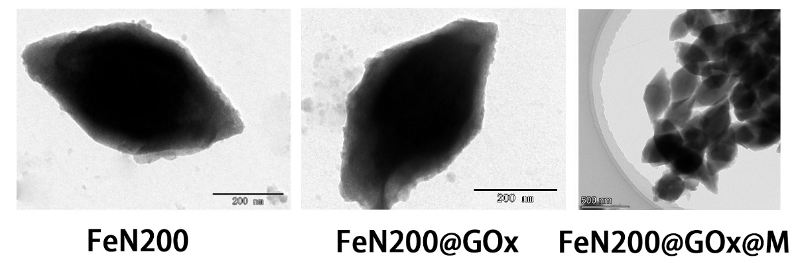
Figure S5: TEM images of FeN200, FeN200@GOx, and FeN200@GOx@M.

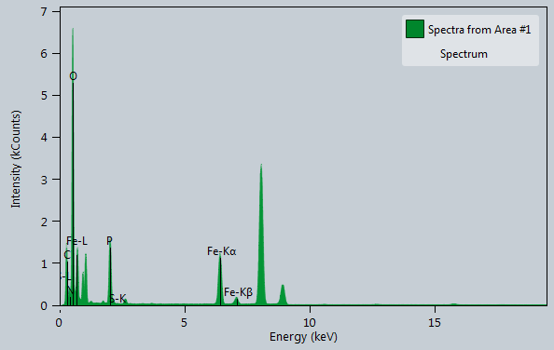

Figure S6: EDS analysis of FeN200@GOx@M. P atoms indicated the presence of cell membrane.

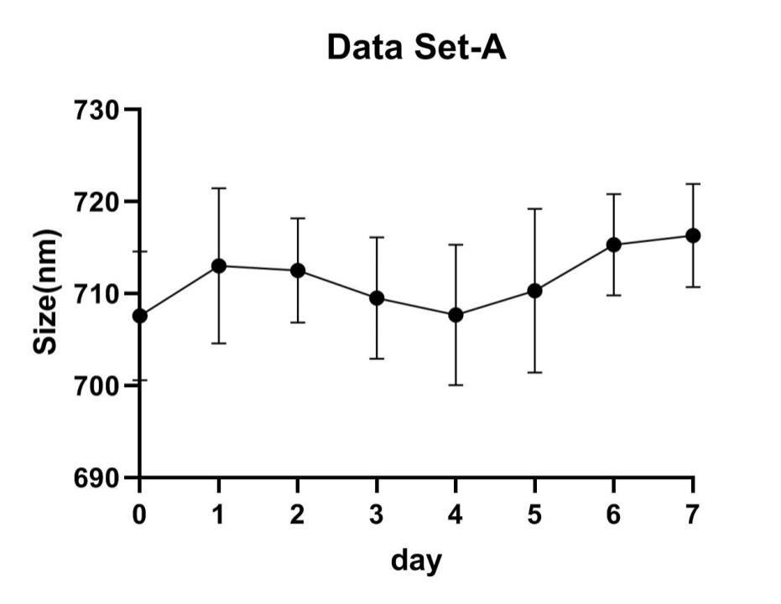
Figure S7: The size of FeN200@GOx@M in different time after synthesis, indicating the stability of nanoparticles.

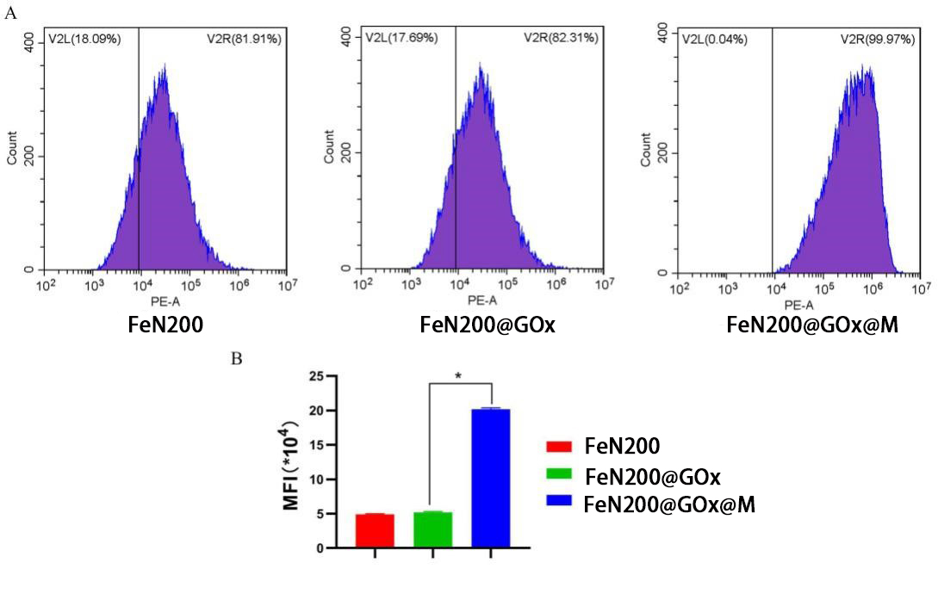
Figure S8: Flow cytometry and quantitative analysis of intake of nanoparticles in A2780 tumor cells.

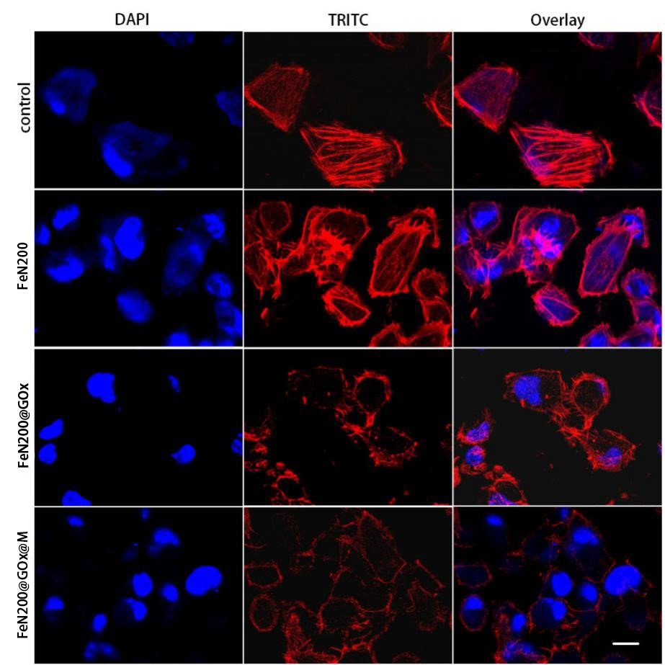

Figure S9: Cytoskeletal staining in different groups.

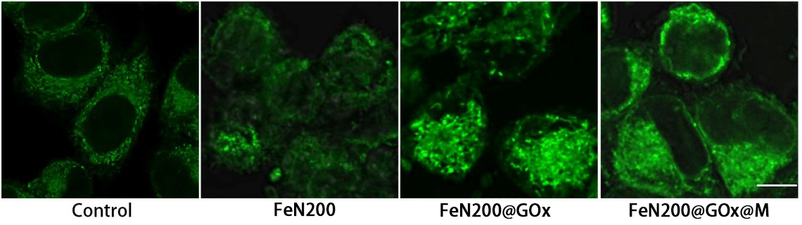
Figure S10: Intracellular mitochondrial morphology changes in different groups.
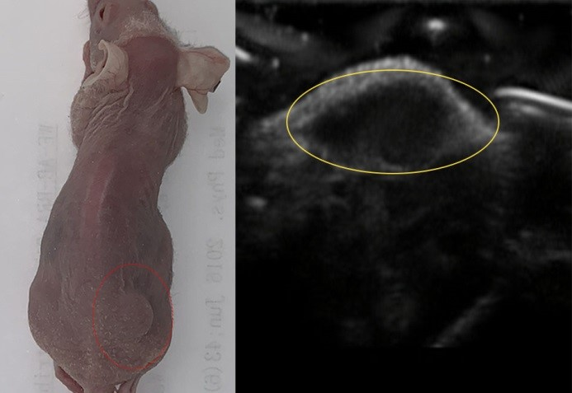
Figure S11: A general view of the mouse model and a portable sonogram of the tumor.

