SUPPLEMENTARY INFORMATION

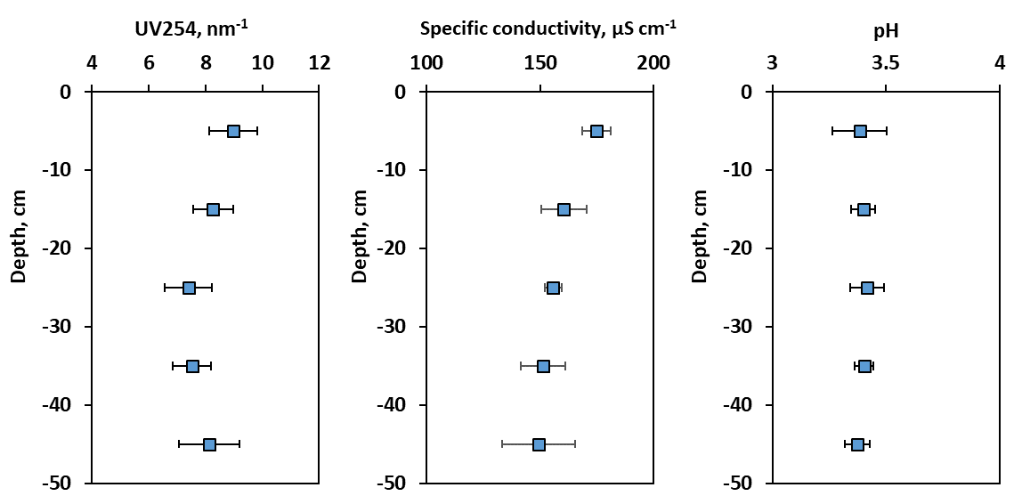

Fig. S1. Results of solute parameters (UV absorbance, Specific conductivity and pH) measurements in three independent but completely identical 50-cm long artificial peat cores subjected to freeze/thawing treatment. The symbols represent the mean values and the error bars represent standard deviation of three replicates. Note a local minimum of UV_{254 nm} in the middle of the core, at 25 cm depth which is reproducible among three replicates.

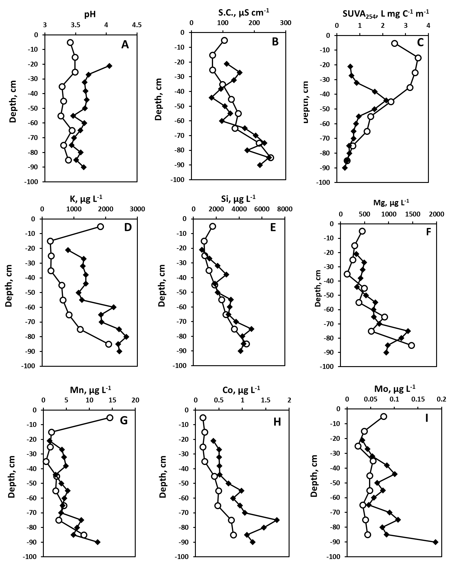
Fig. S2. pH (A), Specific Conductivity (B), SUVA_{254 nm} (C), K (D), Si (E), Mg (F), Mn (G), Co (H) and Mo (I) distribution in the peat core before (open circles) and after (solid diamonds) bi-directional freezing/thawing experiment on three sections (15-50, 50-70 and 70-95 cm) of a peat core.
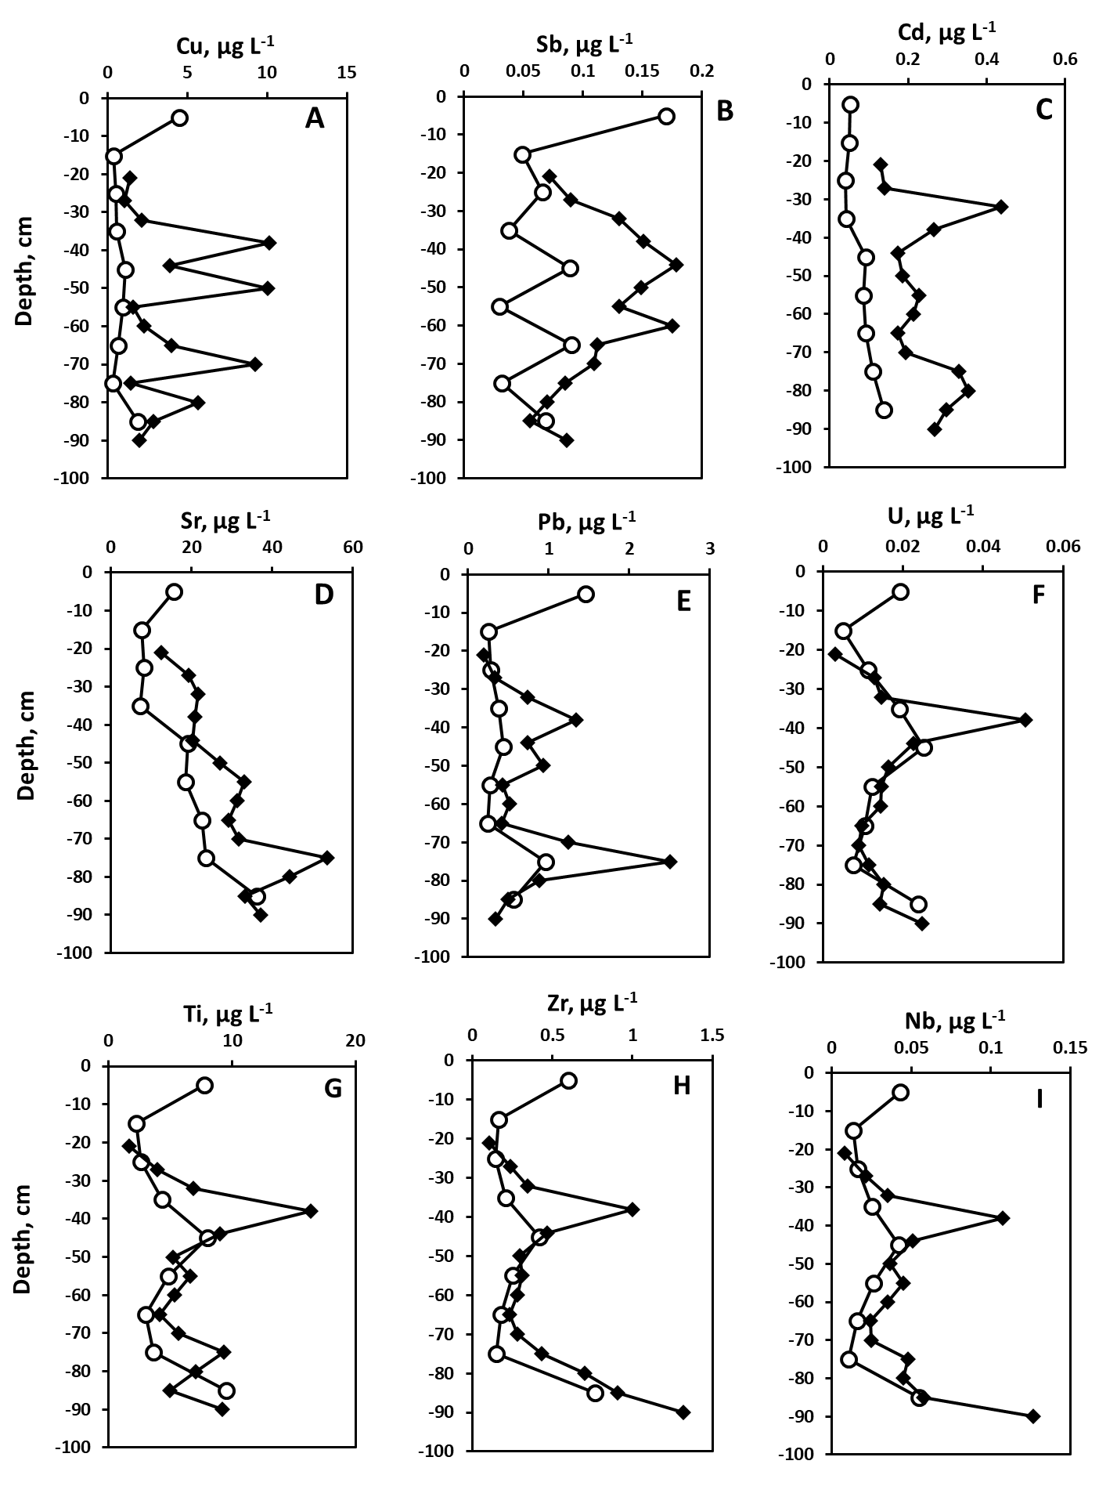
Fig. S3. Copper (A), Sb (B), Cd (C), Sr (D), Pb (E), U (F), Ti (G), Zr (H) and Nb (I) distribution in the peat core before (open circles) and after (solid diamonds) bi-directional freezing/thawing experiment on three sections (15-50, 50-70 and 70-95 cm) of a peat core.

A
B
Figure S4. PCA (A) and HCA (B) results of the peat core subjected to freeze-thaw cycle. Non-elements (depth, TBC, pH, Specific Conductivity (S.C.) and SUVA₂₅₄) and DOC are shown by red color).

