SUPPLEMENTARY INFORMATION
SUPPLEMENTARY DISCUSSION
Triggers of smaller (non-cable breaking) turbidity currents
There is a clear correlation between spring tides and the three cable-breaking flows on Jan 14-16th and March 9th 2020, and April 28-29th 2021 (Fig. 4). However, it is less clear whether the slower and shorter runout (non-cable-breaking) flows are also associated with spring-neap tidal cycles (Supplementary Figure 3). The timing of turbidity currents was first detected by a mooring located ~80 km from the river mouth (Fig. 1). Transit speeds between first and second moorings were used to infer flow speeds, and hence the time at which flows began at the river mouth (Methods). For fast moving flows (2-8 m/s), such as the three cable breaking flows, uncertainties in when flows initiated at the river mouth are just a few hours, so correlations to spring-neap cycles are clear. But for slower moving flows (especially those travelling at < ~0.5 m/s) there may be uncertainties of several days for when flows initiated, complicating correlations to spring-neap tidal cycles. However, for the five fastest (>2 m/s) non-cable breaking flows in the upper canyon, there is a correlation between event timings and greater tidal range (Fig. 4c).
Earlier (1883-1937) cable breaks and turbidity currents
Early telegraphic communications cables (1883 to 1937) that crossed the Congo Submarine Canyon followed three routes across the upper canyon, at water depths of <2 km (Supplementary Figure 2a)⁷⁴. Faults on these early cable routes were frequent, and also record turbidity currents in the upper canyon (Supplementary Fig. 2b). The faults occurred most commonly during months in which the Congo River discharge was high (Supplementary Fig. 3c)⁷⁴. Thus, there is a weak relationship between months with elevated river discharge and more frequent turbidity currents, which were powerful enough to break those older cables⁷⁸. This again suggests that elevated sediment supply to the estuary plays a role in triggering turbidity currents, although some events occurred long after the flood peak in December. However, this is a broad relationship, and some turbidity currents occur during periods of relatively low river discharge, as again seen in 2019-2020 (Fig. 3). Clusters of cable-breaking turbidity currents tended to again occur after one of more years with elevated Congo River discharge (Supplementary Fig. 2d). However, no statistically significant correlation was observed between the timing of these 1883-1937 cable breaks and spring tides at Soyo.
Waves unlikely to trigger large (cable-breaking) turbidity currents
Large waves are thought to be able to trigger turbidity currents in submarine canyons⁷⁵. Ocean buoys can provide an excellent record of these phenomena. However, their global coverage is spatially and temporally variable and their data are not always freely available. For the Congo Canyon, we therefore used global model reanalysis data. We used ERA5 hourly reanalysis data of significant wave height (m), mean wave period (seconds), and mean wave direction (degrees) provided by the European Centre for Medium-Range Weather Forecasts (ECMWF) at the head of the Congo Canyon. These data were gridded at 0.5° x 0.5°. The data revealed no clear relationship between significant wave and swell height, mean wave period, or mean wave direction and turbidity current occurrence. It is therefore unlikely that the observed turbidity currents were triggered as a consequence of surface waves or their influence on the seafloor. Indeed, a spit at the entrance to the estuary tends to protect the head of the canyon (Fig. 1d) from the prevailing wave direction thus reducing the influence of wave triggering at the head of the canyon inside the river mouth/estuary.
Triggering of large (cable-breaking) turbidity currents by river floods and spring tides
This section provides a more complete discussion of how unusually large turbidity currents could potentially be associated with major floods of the Congo River, but finally occur at spring tides. However, detailed field observations during 2020 and 2021 are lacking from the estuarine river mouth, so the exact processes that produced these cable-breaking flows is uncertain. Further field work may be necessary to distinguish between the competing models discussed below.
Older field observations from times without major floods provide some important insights into sediment transfer from the Congo River to the submarine canyon head (Supplementary Figure 4a). For example, transfer of sand and mud from the river is decoupled. Sand is supplied mainly as bedload, with the rate of bedload transport into the main canyon head dependent on river discharge, but also increasing markedly during stronger ebb tides⁵⁵. In contrast, finer muddy sediment is carried primarily within a surface plume of fresher water originating from the river, which extends much more widely across the estuarine river mouth⁵⁶ (Supplementary Fig. 4a). Most authors have assumed that muddy sediment dominates the annual sediment flux from the Congo River (often quoted as ~43 Mt/yr ^{6,56}). However, some studies suggest annual rates of bedload transport may be up to 150 Mt/yr near the river mouth⁵⁵.
Detailed field observations have also been made for an extensive (~ 30 km³) shallow-water (< 12 m) plateau, which is located just upstream from the port of Soyo (Y in Supplementary Fig. 4a) (Nunny pers. Comm., 2021). The muddy surface river plume normally flows above this plateau (Supplementary Fig. 4a). These observations indicate that mud settling occurs across this shallow plateau from the surface river plume. During periods of the stronger river flow, the freshwater plume can touch-down on the seabed across the plateau, causing remobilisation of the bed. When there is a combination of peak river discharge and low tides, this process has been observed to form seaward-flowing fluid-mud layers⁵⁷ across the plateau. These fluid-mud layers can be several meters thick, and they flow into an adjacent tributary canyon head (Z in Supplementary Fig. 4a).
Four different general models for generation of the large cable breaking turbidity currents are now presented and evaluated, in the light of available field evidence outlined above.
Model 1: Delayed failure of the canyon-lip: The first model is that major floods of the Congo River drive exceptionally large amounts of sand-dominated bedload across the lip of the submarine canyon (Supplementary Figure 4b)⁵⁵. Rapid and sustained deposition of sand at the canyon-lip would indeed cause it to rapidly build out. The rapidly deposited sediment could then fail as a submarine landslide, to generate a major turbidity current. It is possible that the volume of sediment that fails in such a post-flood landslide is unusually large, and thus produces a particularly fast-moving turbidity current in the canyon head. However, a significant time delay (2 weeks to 4 months) occurs between Congo River flood peaks and all three cable-breaking turbidity currents (Figs. 3 and 4). Thus, although rapidly deposited flood-sediment may prime the submarine canyon-head for failure, it must then remain close to failure for weeks to months, until a minor perturbation associated with spring tides triggers final failure^{30,45}. Those perturbations might be due to expansion of gas bubbles in sediment⁵⁴, although the maximum tidal range of the Congo Estuary (~1.2 m) is not extreme. Alternatively, somewhat increased bedload transport may occur across the canyon-lip at a spring ebb tide⁵⁵, potentially causing final failure. This type of model can generate turbidity currents at smaller fjord-deltas, where turbidity currents tend to occur at low tides when river discharges are high^{30,49-51}. In these studies of fjords, the timing of turbidity currents was delayed by only by a few hours after the river flood peak⁴⁹. However, studies elsewhere suggest that sediment in submarine canyon heads may remain close to failure for longer periods⁷¹.
Model 2: Mud settling from the surface plume, and remobilisation at later spring tide
A second model is that major river floods provide exceptionally large amounts of fine-grained mud, which is then stored within the river-mouth estuary for weeks to months, before being released at spring tides (Supplementary Figure 4c and 5). This mud is initially dispersed via surface plumes⁵⁶ (Fig. 1d), and settles onto the seabed across the entire estuary. Field observations from the shallow water plateau upstream of Soyo (Supplementary Fig. 4a) show that a mud layer accumulates throughout the year (Fig. 5). During periods of elevated river discharge, and especially when spring ebb tides also occur, the freshwater plume may touch-down on the shallow water plateau. This causes the previous deposited mud to be resuspended, forming highly-mobile fluid-mud layers, which are observed to be several meters thick across the shallow-water plateau near Soyo (Supplementary Figs 4 and 5). These fluid-mud layers then drain into tributary canyon-heads, where they may either directly generate smaller turbidity currents, or produce unstable deposits that episodically fail to produce even larger turbidity currents (Supplementary Figs. 4 and 5).
Model 3: Sediment trapping by near-bed circulation into an estuarine turbidity maximum
A third model, which may act in conjunction with the second model, is that near-bed estuarine circulation⁵⁷ traps large volumes of muddy sediment from the river flood, forming an estuarine turbidity maximum (Supplementary Figure 4d). Work in other estuaries shows how flood sediment may indeed be trapped efficiently by estuarine circulation for at least several weeks after floods^{58,72}. This trapped mud could then be released at a spring tide, weeks to months after the flood, to generate a major turbidity current (Supplementary Figure 4d).
Recent work on Canadian fjords has emphasised how settling of fine sediment from surface river plumes may be remobilised episodically on the delta fronts, thereby generating frequent turbidity currents^{30, 49-51}. Indeed, this is the main process that generates turbidity currents at some deltas⁴⁹. In these fjords, stronger surface plumes occur at low tides, and when river discharges are elevated. The exact process by which mud is episodically remobilised is still uncertain, and it may be trapped by estuarine circulation^{58,72} (model 3), or build up to create more mobile (fluid mud) layers (model 2) ⁵⁷.
Model 4: Direct plunging of sediment laden (hyperpycnal) river plumes:
Past work on how rivers impact the deep-sea has also focussed on a final model, in which river floodwater contains enough sediment to be denser than seawater, such that it plunges to travel along the seabed (Supplementary Figure 4e)²⁷. The Congo River typically has unusually low suspended sediment concentrations for large rivers (e.g. 26-38 mg/l)⁵³, which are lower than the sediment concentrations needed for the river water to exceed the density of seawater, even via convective fingering (~1,000 mg/l)^{27,73}. Thus, this model seems unlikely, although it is possible that suspended sediment concentrations in the river plume may increase somewhat during major flood events.
SUPPLEMENTARY REFERENCES
71. Bailey, L.P., Clare, M.A., Rosenberger, K., Cartigny, M.J.B., Talling, P.J., Paull, C.K., Gwiazda, R., Parsons, D.R., Simmons, S.M., Xu, J., Haigh, I.D., Maier, K.L., McGann, M., Lundsten, ER., & Monterey CCE Team. Preconditioning by sediment accumulation can produce powerful turbidity currents without major external triggers. Earth and Planetary Sci. Letters 562, art.116845 (2021).
72. Ralston, D. K., & Geyer, W. R. Sediment transport time scales and trapping efficiency in a tidal river. J. Geophys. Res. 122, 2042–2063 (2017).
73. Parsons, J.D., Bush, J.W.M., & Syvitski, J.P.M. Hyperpycnal plume formation from riverine outflows with small sediment concentrations. Sedimentology 48, 465–478 (2001).
74. Heezen, B.C., Menzies, R.J., Schneider, E.D., Ewing, M.W., & Granelip, C.L., 1964. Congo Submarine Canyon. A.A.P.G. Bulletin, 48, 1126-1149.

SUPPLEMENTARY TABLE 1: Time of faults (2002-2021) on seabed cables due to turbidity currents along Congo Canyon.
Cable | Cable Fault - Date and Time | Latitude | Longitude | Water Depth (m) | Distance from shore (km)
SAT-3 cable operational from 2001, WACS cable from 2012, and ACE cable from 2021
SAT-3 | 01.23 UTC on 9th Oct. 2002 | 5.946S | 9.416 E | 3573 | 552
January 14-16th 2020 flow
WACS (shallow) | No fault occurred | 5.644 S | 10.659 E | 2584 | 262
SAT-3 | 23:05 UTC on 15th Jan. 2020 | 5.946S | 9.416 E | 3573 | 552
WACS (deeper) | 07:54 UTC on 16th Jan. 2020 | 5.722 S | 8.303 E | 4098 | 773
March 9th 2020 flow
WACS (shallow) | No fault occurred | 5.644 S | 10.659 E | 2584 | 262
SAT-3 | 9th March (no exact time)  Broke same place as Jan 15th. | 5.946S | 9.416 E | 3573 | 552
WACS (deeper) | No fault occurred | 5.722 S | 8.303 E | 4098 | 773
April 28-29th 2021 flow
WACS (shallow) | No fault occurred | 5.644 S | 10.659 E | 2584 | 262
SAT-3 | 15.06 UTC on 28th April 2021 | 5.946S | 9.416 E | 3573 | 552
WACS (deeper) | No fault occurred | 5.722 S | 8.303 E | 4098 | 773
ACE | 15.02 UTC on 29th April 2021 | 6.09 S | 7.57 E | 4368 | 897

SUPPLEMENTARY TABLE 2.
Arrival times and distances between moorings and cables used to calculate flow transit speeds.
Mooring Name | Position - Latitude (DDM) | Position - Longitude (DDM) | date mooring starts recording (day after 11 sept) | date mooring stops recording and surfaced | Water depth (m) | Distance from shore (m)
M3 | 5 57.21 S | 11 33.19 E | 20 Sept (Day 9) | 10-Oct-19 | 1565 | 101,999
M4 | 5 55.45 S | 11 28.41 E | 20 Sept (Day 9) | 15-Jan-20 | 1629 | 113,361
M1 | 5 54.01 S | 11 19.91 E | 19 Sept (Day 8) | 10-Oct-19 | 1875 | 136,180
Aniitra2 | 5 54.01 S | 11 19.68 E | 19 Sept (Day 8) | 29-Dec-19 | 1875 | 136,417
Aniitra3 | 5 52.73 S | 11 10.5 E | 21 Sept (Day 10) | 10-Oct-19 | 2017 | 163,495
M2 | 5 50.23 S | 11 2.33 E | 25 Sept (Day 14) | 15-Jan-20 | 2172 | 190,597
M9 | 5 41.18 S | 10 42.58 E | 21 Sept (Day 10) | 15-Jan-20 | 2172 | 190,918
SAT3 submarine cable |  |  |  |  | 3573 | 552,415
WACS submarine cable |  |  |  |  | ~3800 | 772,685
M5 | 5 43.87 S | 8 7.32 E | 28 Sept (Day 17) | 15-Jan-20 | 4036 | 797,870
M8 | 5 45.41 S | 7 40.49 E | 2 Oct (Day 21) | 15-Jan-20 | 4299 | 877,199
M6 | 5 52.14 S | 6 55.52 E | 29 Sept (Day 18) | 15-Jan-20 | 4495 | 992,891
M7 | 6 27.86 S | 6 2.83 E | 11 Sept (Day 0) | 15-Jan-20 | 4736 | 1,128,339

Mooring Name | Oct 10 Event | Oct 10 Event -speed | 27-28 Oct Event | 27-28 Oct Event speed | 30 Oct Event | 30 Oct Event - speed
M3 | '10-Oct-2019 02:42:36' |  | no data |  | no data
 |  | M3>M1: 34181m in 8892s = 3.84 m/s
M4 | no data |  | no data |  | no data
M1 | '10-Oct-2019 05:10:48' |  | no data |  | no data
Aniitra2 | '10-Oct-2019 05:09:45' |  | '27-Oct-2019 14:45:45' |  | 30-Oct-2019 02:36:45'
 |  | A2>M2: 54180m in 29484s = 1.84 m/s
Aniitra3 | no data |  | no data |  | no data | A2>M2: 54180m in 47998s = 1.13 m/s
 |  |  |  | A2>M2: 54180m in 75327s = 0.719 m/s
M2 | '10-Oct-2019 13:21:09' |  | '28-Oct-2019 11:41:42' |  | '30-Oct-2019 15:56:33'
M9 | '10-Oct-2019 13:25:54' | M2>M9:321m in 285s = 1.13 m/s | 28-Oct-2019 11:50:58' | M2>M9: 321m in 556s = 0.58 m/s | no data
SAT3 submarine cable | no break | no break | no break | no break | no break | no break
WACS submarine cable | no break | no break | no break | no break | no break | no break
M5 | no flow recorded | no flow recorded | no flow recorded | no flow recorded | no flow recorded | no flow recorded
M8 | no flow recorded | no flow recorded | no flow recorded | no flow recorded | no flow recorded | no flow recorded
M6 | no flow recorded | no flow recorded | no flow recorded | no flow recorded | no flow recorded | no flow recorded
M7 | no flow recorded | no flow recorded | no flow recorded | no flow recorded | no flow recorded | no flow recorded

Mooring Name | 24-25 Nov Event | 24-25 Nov Event speed | 28-29 Nov Event | 28-29 Nov Event - speed | 15-16 Dec Event 10 - | 15-16 Dec Event - speed
M3 | no data |  | no data |  | no data
M4 | no data |  | no data |  | no data
M1 | no data |  | no data |  | no data
Aniitra2 | '24-Nov-2019 18:10:30' |  | '28-Nov-2019 10:17:14' |  | '15-Dec-2019 01:17:15'
Aniitra3 | no data | A2>M2: 54180m in 22554 s = 2.40 m/s | no data | A2>M9: 54501m in 209168s = 0.26 m/s | no data | A2>M9: 54501m in 94759s = 0.58 m/s
M2 | '25-Nov-2019 00:26:24' |  | no data |  | no data
M9 | '25-Nov-2019 00:28:55' | M2>M9: 321m in 151s = 2.13 m/s | '29-Nov-2019 15:23:22' |  | '16-Dec-2019 03:36:34'
SAT3 submarine cable | no break | no break | no break | no break | no break | no break
WACS submarine cable | no break | no break | no break | no break | no break | no break
M5 | no flow recorded | no flow recorded | no flow recorded | no flow recorded | no flow recorded | no flow recorded
M8 | no flow recorded | no flow recorded | no flow recorded | no flow recorded | no flow recorded | no flow recorded
M6 | no flow recorded | no flow recorded | no flow recorded | no flow recorded | no flow recorded | no flow recorded
M7 | no flow recorded | no flow recorded | no flow recorded | no flow recorded | no flow recorded | no flow recorded

Mooring Name | 27 Dec Event | 27 Dec Event - speed | 8-15 Jan Event | 8-15 Jan Event speed | Jan 14-16 Event (Big flow, Broke cables) | Jan 14-16 Event - speeds
M3 | no data |  | no data |  | no data
M4 | no data |  | no data |  | Jan 14th 2020 22:30:51
 |  |  |  |  |  | M4>M2: 77,236m in 14,657 = 5.27 m/s
M1 | no data |  | no data
Aniitra2 | '27-Dec-2019 18:20:15' |  | no data |  | no data
Aniitra3 | no data | A2>M9: 54180m in 16749s = 3.23 m/s | no data |  | no data
M2 | no data |  | no data |  | '15-Jan-2020 02:56:42'
M9 | '27-Dec-2019 23:00:11' |  | '08-Jan-2020 12:14:01' |  | '15-Jan-2020 02:56:43'
 |  |  |  |  |  | M9>SAT-3: 361,497m in 72,497s = 4.99 m/s
SAT3 submarine cable | no break | no break | no break |  | cable break @ 23:05 on 15th Jan
 |  |  |  | M9>M5: 606952m in 137843s = 4.40 m/s |  | SAT-3>WACS: 220,270m in 31,740 = 6.94 m/s
WACS submarine cable | no break | no break | no break |  | cable break @ 07:54 on 16th Jan
 |  |  |  |  |  | WACS>M5: 25185m in 3564s = 7.07m/s
M5 | no flow recorded | no flow recorded | '10-Jan-2020 02:31:24' |  | '16-Jan-2020 08:53:24'
 |  |  |  | M5>M8: 79329m in 176128s = 0.45 m/s |  | M5>M8R: 79329m in 9,796s = 8.10 m/s
M8 | no flow recorded | no flow recorded | '12-Jan-2020 03:26:52' |  | '16-Jan-2020 11:36:40'
 |  |  |  | M8>M6: 115692m in 314768s = 0.37 m/s |  | M8R>M6: 115692m in 17480s = 6.62 m/s
M6 | no flow recorded | no flow recorded | '15-Jan-2020 18:53:00' |  | '16-Jan-2020 16:28:00'
 |  |  |  |  |  | M6>M7: 135448m in 16407s = 8.26 m/s
M7 | no flow recorded | no flow recorded | no flow recorded | flow never reached last mooring | '16-Jan-2020 21:01:27'

SUPPLEMENTARY FIGURES
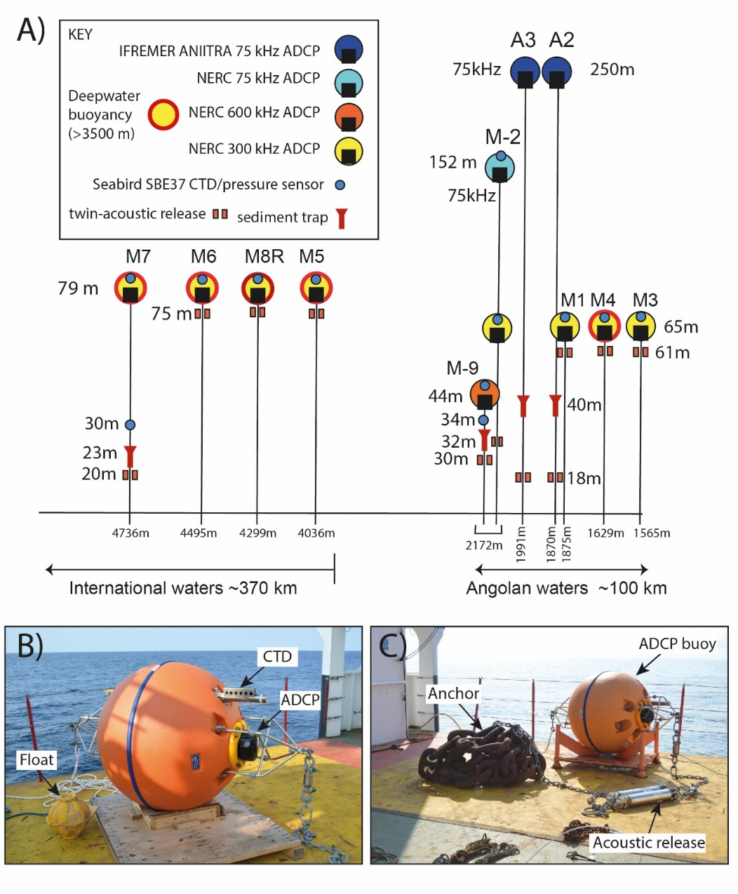
Supplementary Figure 1. (A) Summary diagram of the array of 11 moorings deployed along the Congo Canyon and Channel in 2019-2020 (locations in Fig. 1). Seven moorings were deployed in shallow, Angolan waters in the upper canyon (right side), and four moorings were deployed in deeper, international waters (left side). The diagram shows the type of ADCP and other sensors included in each mooring, and their heights above the seabed. Water depths of mooring anchors are shown, together with positions of sediment traps, and acoustic releases for recovery. However, all moorings surfaced after their wire was broken by turbidity currents, on the various dates shown in Figure 2. (B and C) Photographs of moorings on deck before deployments in 2019, showing the anchor, buoyant float that houses the ADCP and CTD sensors, and the two acoustic releases, which are all linked via chain or wire.
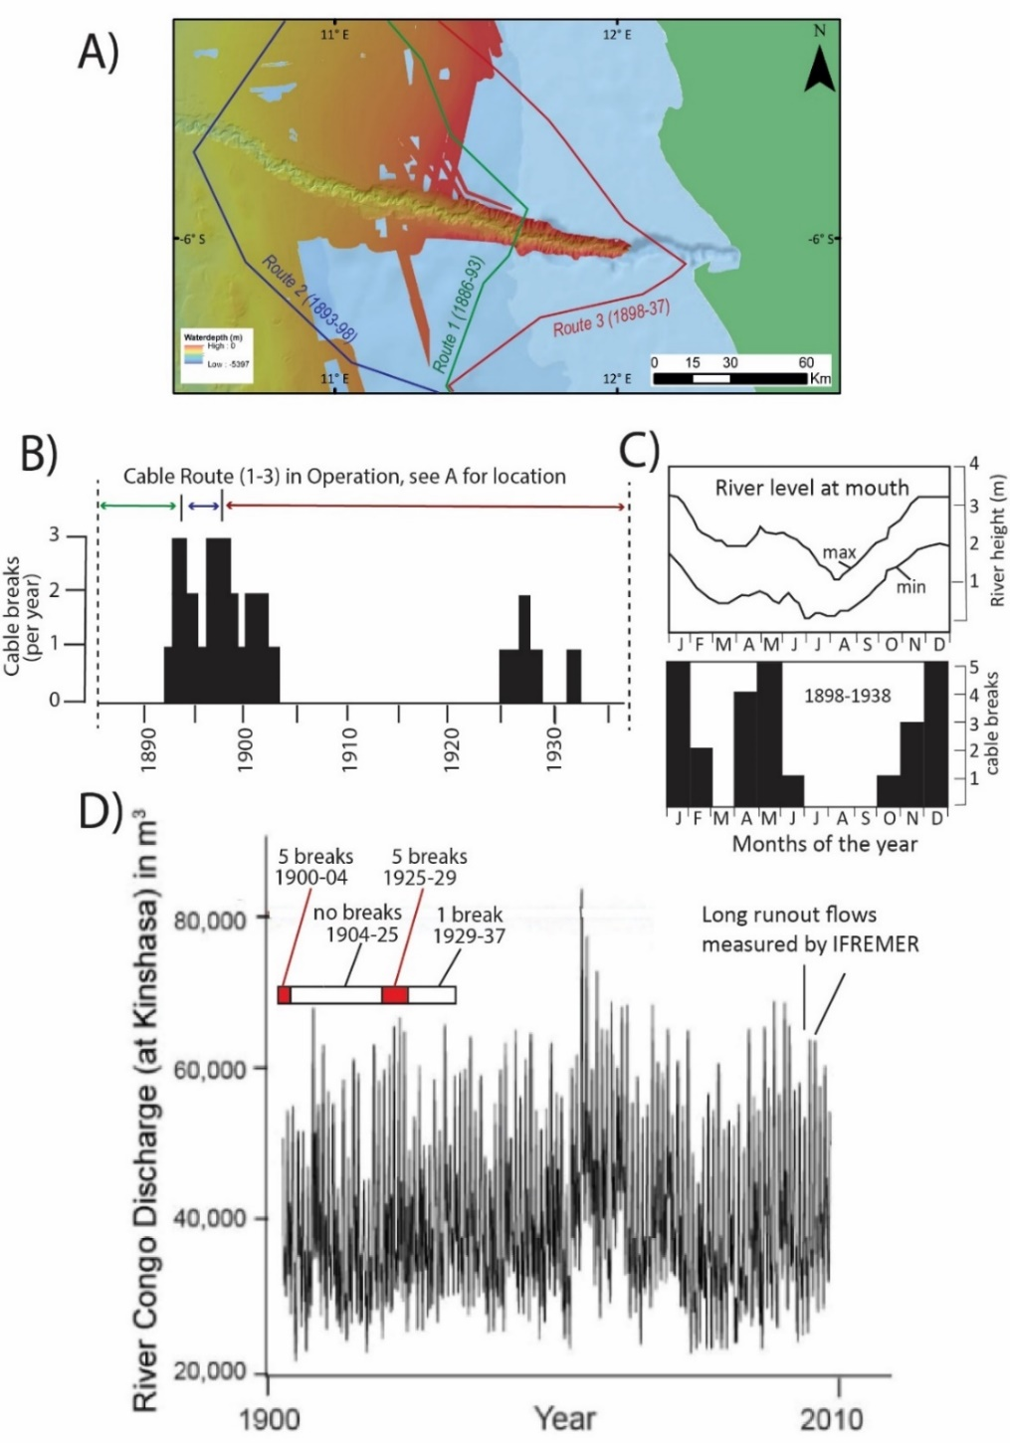
Supplementary Figure 2. Insights into timing, frequency and triggers of turbidity currents in upper Congo Canyon from the location of older (1886 to 1937) seabed cable breaks⁷⁸. These cable routes were located in the upper canyon, closer to shore than the currently active telecommunication cables (Fig. 1). (A) Map of upper canyon and river mouth showing three cable routes used from 1886-1893, 1893-1898, and 1898-1937⁷⁸. (B) Number of cable breaks each year between 1886 to 1937. (C) Monthly changes in Congo River level at a gauging station near its mouth, and total number of cable breaks in each month, from 1989 to 1938. (D) Changes in annual maximum discharge of the Congo River at Kinshasa from 1900-2008, compared to periods in which there were five cable breaks red box (1900-1904), no cable breaks (1904-1923), 5 cable breaks (1925-1929), and one cable break (1928-1937). Parts A-C after⁷⁸.
Supplementary Figure 3. Relationship between the timing of smaller flows recorded by ADCPs in the upper canyon and tidal cycles in 2009-10, 2013 and 2019-20. For each period, velocity profile data from a moored ADCP in the upper canyon are compared to tidal data from Soyo in the Congo River mouth, with vertical bars indicating flow arrival times in tidal time series. (a and b) Timing of turbidity currents and tidal cycles in 2009-10. (c and d) Timing of turbidity currents and tidal cycles in 2013, with ADCP data shown from two different mooring deployments. (e and f) Timing of turbidity currents and tidal cycles in 2019-20. ADCP-moorings were damaged and returning no data after a large flow on January 14th. Also shown is timing of a turbidity current on March 9th 2020 based on cable breaks. There is a delay between flow initiation at river mouth, and arrival at these offshore mooring that are ~80 km from the river mouth. This time delay is strongly dependent on flow front speed. For example, the delay is ~0.35 days for front speeds of 5 m/s, 0.86 days at 2 m/s, 1.73 days at 1 m/s, 3.46 days at 0.5 m/s, and 8.65 days at 0.2 m/s. Thus, time delays start to the approach the duration of spring-neap tidal cycles for slower flows, and this makes it difficult to compare the time at which slower flows started with spring-neap tidal cycles. Thus, only the timing of faster (>2-4 m/s) turbidity currents can be compared reliably to tidal cycles.
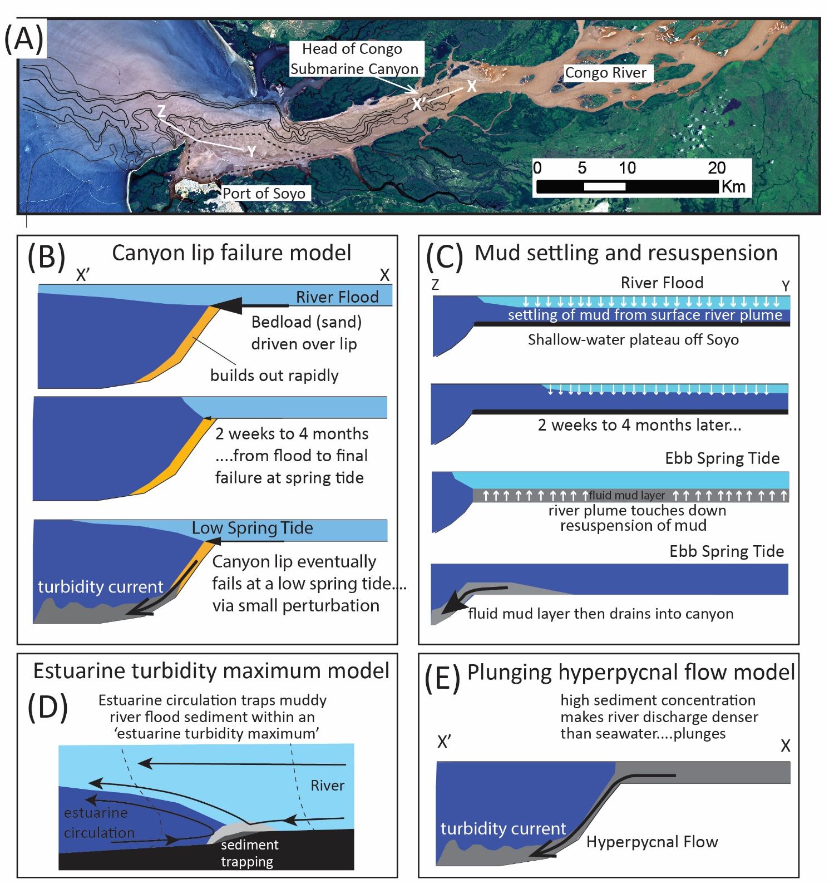
Supplementary Figure 4. Different models for initiation turbidity currents due to an initial river flood, but finally triggered at a spring tide. (a) Satellite image of the Congo River and the estuary at its mouth, with bathymetric contours (Fig. 1d). Image also shows main head of the submarine canyon (X-X), and a shallow water plateau offshore Soya (Y) that lies next to tributary canyon heads (Z). (b) Model 1: flood drives sediment over the lip of the submarine canyon, which fails weeks to months later at a low spring tide, to generate a major turbidity current. (c) Model 2: mud settles from the surface plume (part a) onto the seabed, and is then resuspended at a spring tide to form a highly mobile fluid mud layer, which then drains into the tributary canyon heads to generate a turbidity current. (d) Model 3: muddy sediment is trapped within the estuary due to near-bed estuarine circulation - in an estuarine turbidity maximum. (e) Model 4: hyperpycnal flow model in which the river discharge has sufficient suspended sediment to be denser that seawater, such that the river discharge plunges to flow directly along the seabed.

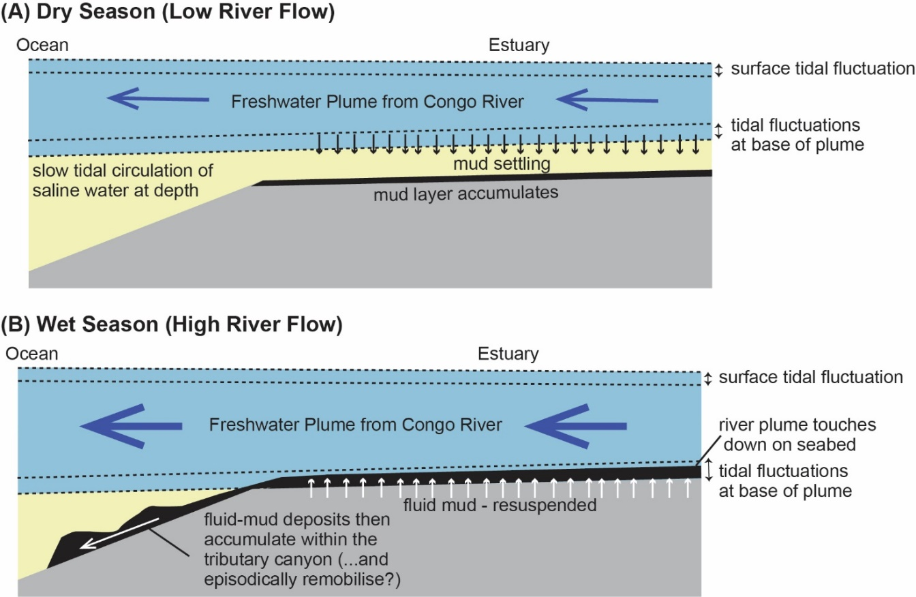
Supplementary Figure 5. Schematic summary of field observations for a transect across the extensive shallow-water plateau upstream from Soyo to the tributary canyon heads (Y-Z in Supplementary Fig. 4a), in a year without an exceptional river flood (R. Nunny, pers. comm., 2021). (A) During months of low river flow in a normal (non-flood) year, mud settles from the freshwater surface river plume, forming a mud layer across the plateau. (B) During months with high river flow in a normal year, the surface river plume touches down on the seabed across the plateau, especially during spring tides. This acts to remobilise the seabed mud, thereby forming highly-mobile fluid-mud layers that can be several meters thick. These fluid mud layers then move into the tributary canyon head, where deposit mud within the tributary canyon. However, the mud deposit in the tributary canyon may then episodically remobilise to form unusually large turbidity currents that runout for even longer distances.

