Reactivity-Tunable Palladium Precatalysts with Favorable Catalytic Properties in Suzuki–Miyaura Cross-Coupling Reactions

Siou-Wei Liang,¹ Yingjie Guo,² Wan-Ching Lee,³ Pin-Rui Zeng,³ Tzu-Hao Lin,¹ I-Chung Lu,^{3,*} and Yu-Chang Chang^{1,*}

¹Department of Applied Chemistry, Providence University, Taichung 43301, Taiwan, ²Department of Cosmetic Science, Providence University, Taichung 43301, Taiwan, ³Department of Chemistry, National Chung Hsing University, Taichung 40227, Taiwan

E-mail: 1. vickhang@pu.edu.tw, 3. iclu@nchu.edu.tw

Supporting Information
Table of Contents
- The general experimental methods………………………………….S3
- The general experimental methods for mass spectrometer………….S5
- The synthesis of precatalyst 1a...........................................................S6
- The synthesis of precatalyst 1b……………………………….……..S7
- Crystallographic data table for 1a and 1b….………….…………….S8
- Figure S1-S8 …………………………………………………….….S9
- Table S1-S9 and Scheme S1...………………………………….…. S17
- Spectroscopic data for complexes and catalytic products…….……S26
- NMR spectra for complexes and catalytic products…….…………S39
- Computational Methods…...…………………………..…….……S68
- The wB97XD-optimized Cartesian coordinates…………….……S69
- References……..………...………………………………………S100

- The general experimental methods:
All reactions were carried out under a nitrogen atmosphere using standard Schlenk techniques or in a nitrogen-flushed glovebox. Unless otherwise noted, all manipulations were performed in air. Solvents were were purified by a Vigor solvent purification system to remove water and oxygen from solvents. All reagents were directly used as received unless otherwise stated. [(NHC_{IPr})PdCl₂]₂ and [(NHC_{IMes})PdCl₂]₂ were synthesized based on the reported methods. The Suzuki cross-coupling reactions were monitored by a GC-FID or GC-BID (barrier discharge ionization detector (BID-2030)) on a Shimadzu Nexis GC-2030 instrument.
Routine ¹H NMR spectra were recorded on a Brucker-AV-400 (400 MHz) spectrometer. The chemical shifts were reported in ppm relative to the internal standards TMS (δ 0.00 ppm) and CHCl₃ (δ 7.26 ppm). ³¹P and ¹³C{H} NMR spectra were recorded at 162.0 and 100.6 MHz, respectively. The chemical shifts for the former and the latter are reported in ppm relative to external standards H₃PO₄ (δ 0.0 ppm) and CHCl₃ (δ 77.0 ppm), respectively. Elemental analyses were carried out on an Elementar Vario EL cube analyzer.
The crystals were immersed with FOMBLIN®Y under N₂ and mounted on a diffractometer employing graphite‐monochromated Mo‐Kα radiation (λ = 0.71073 Å). Intensity data were collected with ω scans. Data collection and reduction were performed with the CrysAlisPro software, and the absorptions were corrected by using the SCALE3 ABSPACK multiscan method. The space group determination was based on a check of the Laue symmetry and systematic absences, and was confirmed by structure solution, performed by direct methods with the SHELXTL package. All non‐hydrogen atoms were located from successive Fourier maps and hydrogen atoms were refined by using a riding model. Anisotropic thermal parameters were used for all non‐hydrogen atoms, and fixed isotropic parameters were used for hydrogen atoms.

2. The general experimental methods for mass spectrometer:
2.1 A Thermo Scientific LTQ XL linear ion trap mass spectrometer performed the analysis in this study. The synthesized precatalyst 1a and 1b (0.2 mg, 2.5 x 10-4 mmols) were dissolved in acetone (~ 1 mL), and the samples were pumped using a Thermo Scientific Surveyor MS pump delivering 8 µL /min to electrospray ionization (ESI) source. Each spectrum was acquired 60 scans in negative mode. The potential of ESI was applied by -4.1kV, combining with the tube lens in -40 V. The temperature of the ion transfer tube was varied from 400 °C to 275 °C, depending on the analytes and experimental purpose. To avoid samples reacting with oxygen or water vapor in the ionization region, the ESI source housing was purged with nitrogen by a home-built line system.
2.2 Explanation of calculated isotopic patterns The observed species provide the information of m/z but not chemical compositions in mass spectrometry. The analysis of isotopic distribution completes the leak of information because all the species at a given range overlay represent their distinct pattern. The simulated isotopic patterns were all calculated by a home-written process using Python in this work. The similarity between theoretical and observed isotope patterns were examined to confirm the species in the mass spectra.

3. The synthesis of precatalyst 1a
The [(NHC_{IPr})PdCl₂]₂ (0.567 g, 0.5 mmol) and SPO_{tolyl} (2.0 eq, 0.230 g, 1.0 mmol) and and 30 mL of acetone was added into a 100-mL round-bottom flask with a stir bar. The reaction was performed at room temperature for 3.0 hours. Subsequently, the product was purified by column chromatography on silica gel (hexanes/dichloromethane=7/3). The isolated yield was 85% (0.676 g). (pale yellow solid)

31P NMR (162 MHz, CDCl3): δ 85.32 (s, 1P; trans), 86.51 (s, 1P; cis). 1H NMR (400 MHz, CDCl3): δ 1.10 (d, J = 6.9 Hz, 12H; H_{Ipr, CH3}), 1.31 (d, J = 6.5 Hz, 12H; H_{Ipr, CH3}), 2.31 (s, 6H; H_{tolyl,CH3}), 3.09 (hept, J = 6.8 Hz, 4H; H_{CH-(CH3)2}), 6.73 (s, 1H; P_{OH}), 7.03 (d, J = 7.7 Hz, 4H; H_{Ipr,meta}), 7.13 (d, J = 1.55 Hz, 2H; H_{IPr-CH=CH}), 7.33-7.38 (m, 8H; H_{tolyl}), 7.54 (t, J = 7.9 Hz, 2H; H_{Ipr,para}).
13C NMR (100 MHz, CDCl3): δ 21.6 (s, 2C; C_{tolyl,CH3}), 23.0 (s, 4C; C_{IPr,CH3}), 26.3 (s, 4C; C_{IPr,CH3}), 28.7 (s, 4C; C_{NHC,CH-(CH3)2}), 123.9 (s, 4C; C_{IPr,meta}), 124.4 (d, J = 5.9 Hz, 2C; C_{NHC,CH=CH}), 128.5 (d, J = 12.0 Hz, 4C; C_{tolyl,meta}), 129.8 (s, 2C; C_{IPr,para}), 131.0 (d, J = 56.8 Hz, 2C; C_{tolyl,ipso}), 132.8 (d, J = 13.0 Hz, 4C; C_{tolyl,ortho}), 135.3 (s, 4C; C_{IPr,ortho}), 141.0 (s, 2C; C_{tolyl,para}), 146.6 (s, 2C; C_{IPr,ipso}), 174.5 (d, J = 210.6 Hz, 1C; C_{NHC}).
Analysis (calcd., found for C41H51Cl2N2OPPd): C (61.85, 61.41), H (6.46,6.63), N (3.52, 3.32).
ESIMS (m/z): [M-H]⁻ calcd. for C35H39Cl2N2OPPd, 793; Found, 793.17. The highest abundance found at m/z 795.08.

4. The synthesis of precatalyst 1b
The [(NHC_{IMes})PdCl₂]₂ (0.483 g, 0.5 mmol) and SPO_{tolyl} (2.0 eq, 0.230. g, 1.0 mmol) and 30 mL of acetone was added into a 100-mL round-bottom flask with a stir bar. The reaction was performed at room temperature for 3 hours. Subsequently, the product was purified by column chromatography on silica gel (hexanes/dichloromethane=7/3). The isolated yield was 80% (0.569g). (pale yellow solid).

31P NMR (162 MHz, CDCl3): δ 84.31 (s,1P; trans), 85.38 (s,1P; cis)
1H NMR (400 MHz, CDCl3): δ 2.28 (s, 12H; H_{IMes,CH3}), 2.33 (s, 6H; H_{IMes,CH3}), 2.42 (s, 6H; H_{tolyl,CH3}), 6.66 (s, 1H; P_{OH}), 7.04-7.06 (m, 10H; ArH), 7.37-7.42 (m, 4H, ArH).
13C NMR (100 MHz, CDCl3): δ 18.72 (s, 4C; C_{IMes,CH3}), 21.22 (s, 2C; C_{tolyl,CH3}), 21.50 (s, 2C; C_{IMes,CH3}), 123.38 (d, J = 5.8 Hz, 2C; C_{NHC,CH=CH}), 128.45 (d, J = 11.47 Hz, 4C;C_{tolyl,meta}), 129.04 (s, 4C; C_{IMes,meta}), 131.12 (d, J = 56.5 Hz, 2C; C_{tolyl,ipso}), 132.72 (d, J = 13.0 Hz, 4C; C_{tolyl,ortho}), 135.35 (s, 2C; C_{IMes,para}), 136.16 (s, 4C; C_{IMes,ortho}), 138.71 (s, 2C; C_{tolyl,para}), 140.88 (s, 2C; C_{IMes,ipso}), 171.71 (d, J = 212.6 Hz, 1C; C_{NHC}).
Analysis (calcd., found for C35H39Cl2N2OPPd: C (59.04, 59.20), H (5.52, 5.72), N (3.93, 3.91).
ESIMS (m/z): [M-H]⁻ calcd. for C35H39Cl2N2OPPd, 709; Found, 709.17. The highest abundance found at m/z 711.08.

5. Crystallographic data table for 1a and 1b
 | 1a | 1b
Formula | C₄₁H₅₁Cl₂N₂OPPd | C₃₅H₄₁Cl₂N₂O₂PPd (+solvent)
Fw | 796.10 | 729.97
T, K | 150(2) | 150(2)
Crystal system | Monoclinic | Monoclinic
Space group | C2/c | P 21/n
a, Å | 39.545(4) | 11.7683(8)
b, Å | 10.2290(9) | 18.7900(12)
c, Å | 20.5541(15) | 15.5226(10)
a ° | 90° | 90°
β ° | 103.684(6)° | 90.086(3)°
γ ° | 90° | 90°
V, Å³ | 8078.2(12) | 3432.5(4)
Z | 8 | 4
ρ_{calc}, Mg/m³ | 1.309 | 1.413
μ(MoKα), mm⁻¹ | 0.664 | 0.776
Reflections collected | 81490 | 70879
No. of parameters | 437 | 390
Indep. reflns (R_{int}) | 10500 (0.0791) | 8187(0.0796)
Final R indices R₁ª,wR₂ª | 0.0525, 0.1387 | 0.0618, 0.1509
GoF ^{b} | 1.089 | 0.992
ª R₁= [|F₀| -|F_{c}|]/ |F₀|], wR₂= [w(F₀²- F_{c}²)²/ w(F₀²)²]^{1/2}, w= 0.10.
^{b} GoF = [Σw(F₀²-F_{c}²)²/(N_{rflns} – N_{params})]^{1/2}.

6. Figure S1-S8

Figure S1. The relative stability of trans and cis isomers for (a) 1a and (b) 1b. (Level of theory: the ωB97XD functional was employed in conjunction with the 6-31+G(d) basis set for non-metal atoms and MWB28 for Palladium)

Figure S2. The variable-temperature ³¹P NMR spectra for 1a. (a) from 0 ºC to 80 ºC, and (b) from 20 ºC to -80 ºC.

Figure S3. The variable-temperature ³¹P NMR spectra for 1b. (a) from 0 ºC to 80 ºC, and (b) from 20 ºC to -80 ºC.

Figure S4. DFT-calculated gas-phase (in EtOH) bond dissociation free energy (BDFE in kcal/mol) for dissociation of NHC_{IMes}, PA_{tolyl}, and deprotonated PA_{tolyl}− in (a) 1b and (b) deprotonated 1b−. (G09-wB97xD functional was used in conjunction with 6-31+G(d) basis set for non-metals and MWB28 for Pd. The solvation effects of EtOH were considered using the integral equation formalism variant polarizable continuum model.)

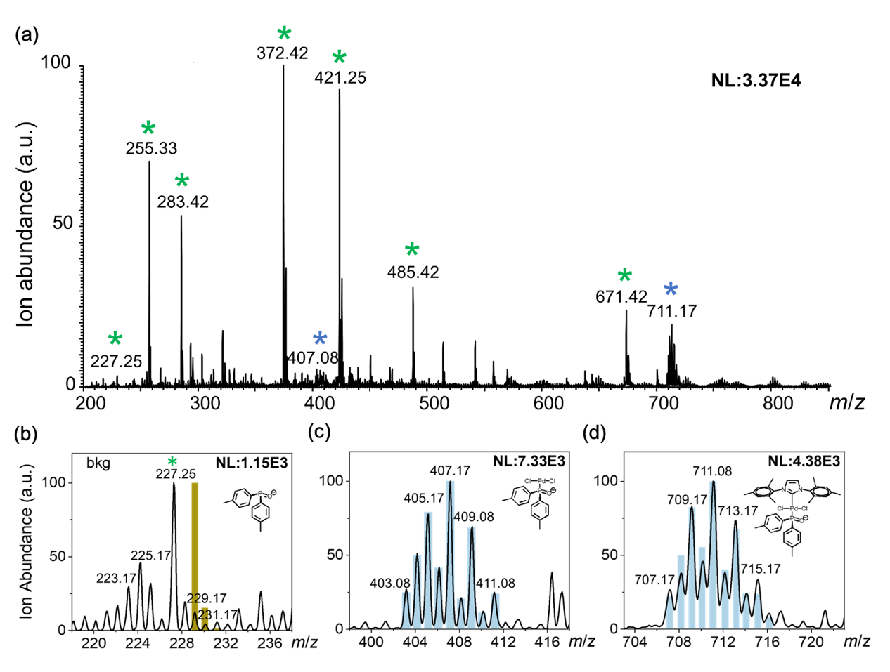
Figure S5. (a) Full electrospray ionization mass spectrometry of 1b precatalyst in negative mode at 275 °C inlet temperature. All 1b-related ions are indicated with a blue star, and background ions from the solvent are indicated with a green star. Three expanded m/z regions of the possible precatalyst and ligand ions: (b) PA_{tolyl}⁻ (m/z 229.23) (c) (O⁻)(tolyl)₂P→Pd(II)Cl₂ (m/z 407.17), and (d) the deprotonated 1b ion (m/z 711.08). Spectra are fitted with calculated isotope distributions (blue bar) to verify that the elementary compositions match the detected ions. The anticipated m/z region of the PA_{tolyl}⁻ (yellow) in spectrum (b) demonstrated an ion signal nearing background level.

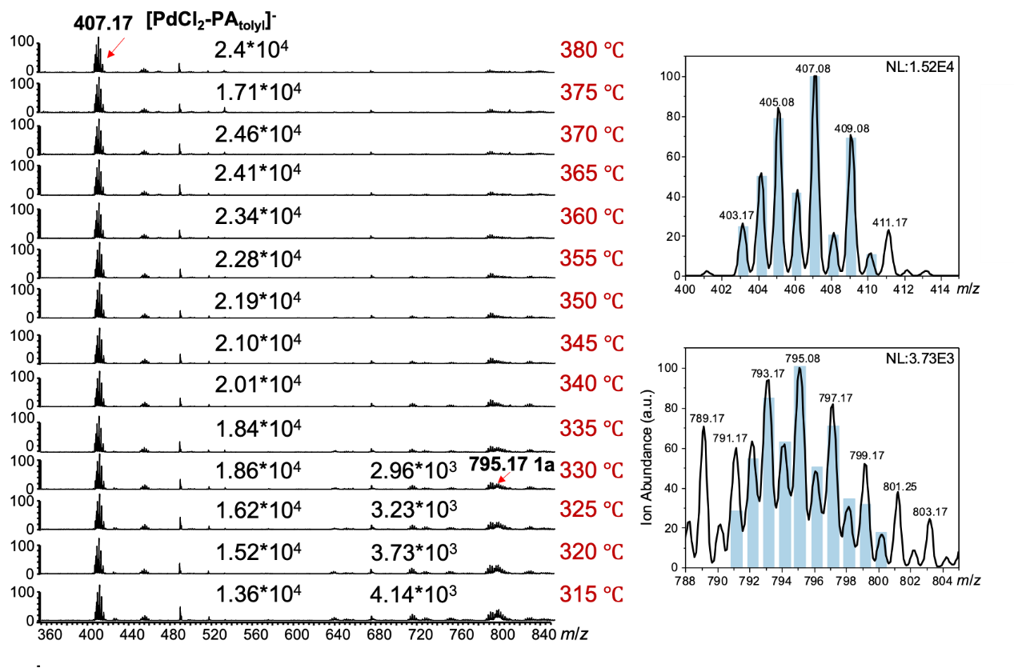
Figure S6. Mass spectra observed for 1a precatalyst in negative ion mode acquired from inlet temperatures 380 ºC to 315 ºC. The calculated isotope distributions (blue bar) confirmed the elementary composition of parent and fragment ions in the mass spectra.

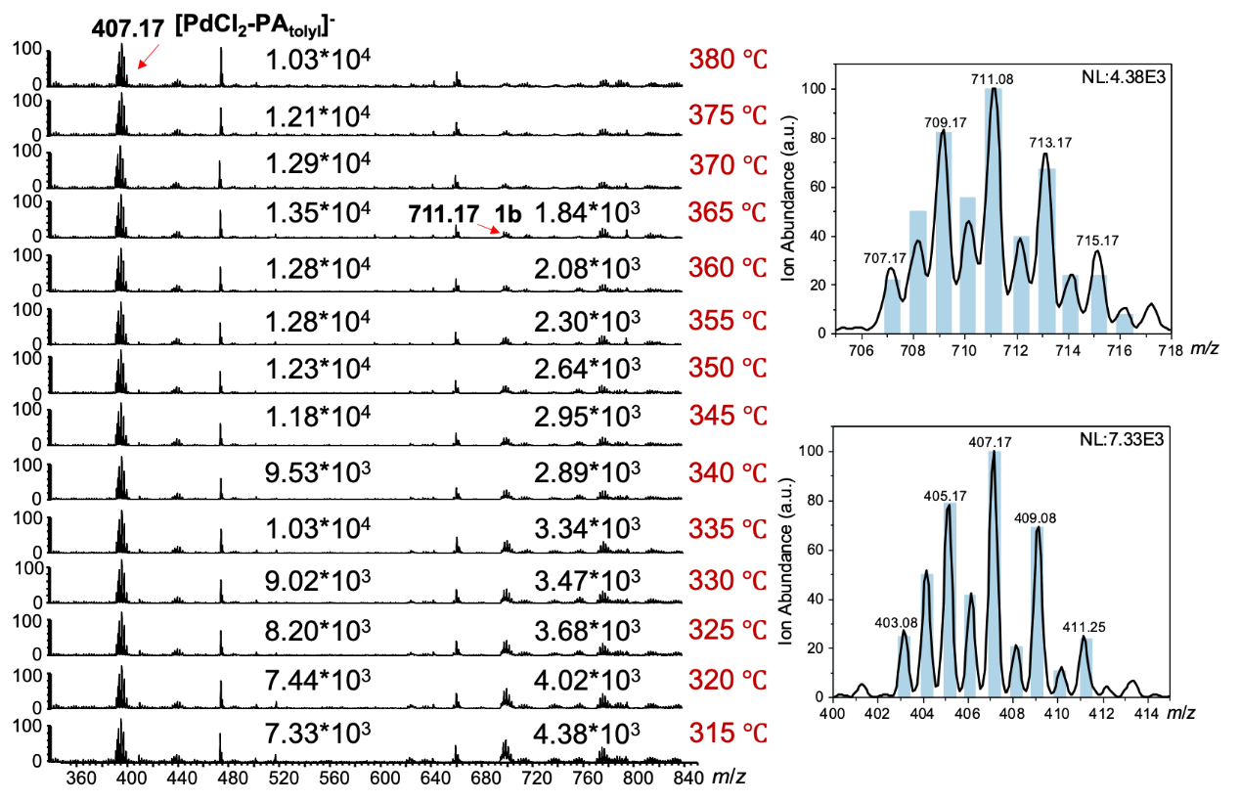
Figure S7. Mass spectra observed for 1b precatalyst in negative ion mode acquired from inlet temperatures 380 ºC to 315 ºC. The calculated isotope distributions (blue bar) confirmed the elementary composition of parent and fragment ions in the mass spectra.

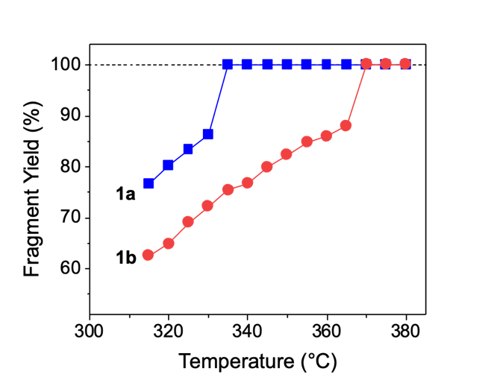
Figure S8. Fragmentation yield of precatalyst 1a (blue square) and 1b (red circle) as a function of inlet capillary temperature.

The fragment yield (FY) can be estimated using the equation as follow:
$$FY (\%)=\frac{I(f^{-}) }{[I\left(f^{-}\right)+I\left(p^{-}\right)]}$$where I(p⁻) is the intensity of parent ion signal of the deprotonated 1 ((O⁻)(tolyl)₂P→Pd(II)Cl₂←NHC), and I(f ⁻) is the intensity of total fragment ion signals of the anionic (O⁻)(tolyl)₂P→Pd(II)Cl₂.

7. Table S1-S8 and Scheme S1
Table S1. Search of the optimal reaction conditions
Entry | Base | Solvent | Conv. | Entry | Base | Solvent | Conv.
1 | KO^{t}Bu | Toluene | 8% | 17 | KO^{t}Bu | Acetonitrile | Non
2 | NaOH | Toluene | 12% | 18 | NaOH | Acetonitrile | 7%
3 | K₃PO₄ | Toluene | 66% | 19 | K₃PO₄ | Acetonitrile | 9%
4 | K₂CO₃ | Toluene | 25% | 20 | K₂CO₃ | Acetonitrile | 12%
5 | Cs₂CO₃ | Toluene | 46% | 21 | Cs₂CO₃ | Acetonitrile | 6%
6 | KF |  | 45% | 22 | KF |  | 11%
7 | CsF |  | 25% | 23 | CsF |  | 14%
8 | NEt₃ |  | 3% | 24 | NEt₃ |  | 2%
9 | KO^{t}Bu | THF | 11% | 25 | KO^{t}Bu | EtOH | 99%
10 | NaOH | THF | 11% | 26 | NaOH | EtOH | 92%
11 | K₃PO₄ | THF | 26% | 27 | K₃PO₄ | EtOH | 95%
12 | K₂CO₃ | THF | 23% | 28 | K₂CO₃ | EtOH | 60%
13 | Cs₂CO₃ | THF | 28% | 29 | Cs₂CO₃ | EtOH | 93%
14 | KF | THF | 68% | 30 | KF | EtOH | 69%
15 | CsF |  | 19% | 31 | CsF |  | 81%
16 | NEt₃ |  | 2% | 30 | NEt₃ |  | 12%

Precatalyst 1a (0.004 g, 0.005 mmol, 1 mol%), base (1.5 eq, 0.75 mmol), and 1.06 eq. of phenylboronic acid (0.065 g, 0.53 mmol) were loaded into a 4-mL glass vail with a septum screw cap. After the vial was sealed, phenyl chloride (0.05 mL, 0.5 mmol) and solvent (1 mL) were injected into the vial. The reaction was carried out at 35 ºC for 4 hours. Finally, the conversion of biphenyl product was determined by GC-BID.
Table S2. The search for the optimized reaction time for the SMR
Entry | Base (eq.) | Phenylboronic acid (eq.) | Time (mins) | Isolated Yield (%)
1 | KO^{t}Bu (1.5) | 1.06 | 1 | 26
2 | KO^{t}Bu (1.5) | 1.06 | 2 | 36
3 | KO^{t}Bu (1.5) | 1.06 | 3 | 99
4 | KO^{t}Bu (1.5) | 1.06 | 5 | 99
5 | K₃PO₄ (2) | 1.30 | 5 | 78
6 | K₃PO₄ (2) | 1.30 | 8 | 99

Precatalyst 1a (0.008 g, 0.01 mmol, 1 mol%), base (KO^{t}Bu: 1.5 eq, 0.168 g, 1.5 mmol or K₃PO₄: 2.0 eq, 0.425 g, 2.0 mmol), and phenylboronic acid (1.06 eq., 1.06 mmol or 1.3 eq., 1.03 mmol) were put into a 15-mL Schlenk tube with a stir bar. The Schlenk tube was capped, vacuumed and back-filled with N₂ for three times. Subsequently, phenyl chloride (0.1 mL, 1 mmol) and EtOH (2 mL) were injected into the Schlenk tube. The reaction was carried out at 35 ºC for the designated reaction time. Finally, biphenyl product was isolated by column chromatography (Hexanes). Note that the microliter syringe, glass vial, and EtOH were pre-heated at 35 ºC in such fast SMR.
Table S3. SMRs that catalyzed by Pd(t-Bu₃P)₂ or (dppf)PdCl₂
Catalyst | Time | Conversion (%) | Catalyst | Time | Conversion (%)
dppfPdCl₂ | 5 mins | 0.8% | Pd(t-Bu₃P)₂ | 5 mins | 2%
dppfPdCl₂ | 1 hrs | 1.2% | Pd(t-Bu₃P)₂ | 1 hrs | 8%
dppfPdCl₂ | 2 hrs | 1.8% | Pd(t-Bu₃P)₂ | 2 hrs | 26%
dppfPdCl₂ | 3 hrs | 2.2% | Pd(t-Bu₃P)₂ | 3 hrs | 33%

Precatalyst of (dppf)PdCl₂ (0.740 g, 0.01 mmol, 1 mol%) or Pd(t-Bu₃P)₂ (0.511 g, 0.01 mmol, 1 mol%), 1.5 eq. of KO^{t}Bu (0.168 g, 1.5 mmol), and 1.06 eq. of o-tolylboronic acid (0.144 g, 1.06 mmol) were loaded into put into a 15-mL Schlenk tube with a stir bar. The Schlenk tube was capped, vacuumed and back-filled with N₂ for three times. Subsequently, phenyl chloride (0.10 mL, 1 mmol) and EtOH (2 mL) were injected into the Schlenk tube. The reaction was carried out at 35 ºC for the designated reaction time. Finally, the product was determined by GC-FID.

Table S4. The role played by cation of base in the catalytic cycle
Base | Time | Yield^{[a]} (%) | Base | Time | Conversion (%)
LiO^{t}Bu |  | 7 | LiOH |  | 2
NaO^{t}Bu | 3 mins | 77 | NaOH | 5 mins | 32
KO^{t}Bu |  | 99 | KOH |  | 82
Base | Time | Conversion (%) | Base | Time | Conversion (%)
Li₂CO₃ |  | 4 | LiF |  | 0
Na₂CO₃ |  | 25 | NaF |  | 0
K₂CO₃ | 60 mins | 68 | KF | 60 mins | 66
Rb₂CO₃ |  | 90 | RbF |  | 67
Cs₂CO₃ |  | 88 | CsF |  | 78
[a] Phenyl chloride (1.0 mmol), phenylboronic acid (1.06 mmol), base (1.5 mmol), and 1a (1 mmol%) were reacted in 2 mL of EtOH at 35 ºC for 3 minutes.

Precatalyst 1a (0.004g, 0.005 mmol, 1 mol%), 1.5 eq. of base (0.75 mmol), and 1.06 eq. of phenylboronic acid (0.066 g, 0.53 mmol) were put into a 4-mL glass vail. Then, the vial was capped, vacuumed and back-filled with N₂ for three times. Next, phenyl chloride (0.05 mL, 0.5 mmol) and EtOH (1 mL) were injected into the vial. The reaction was carried out at 35 ºC. Biphenyl product was isolated by column chromatography (Hexane). Or, the conversion of product was determined by GC-FID.

Table S5. The role played by anionic base dissociated from salt additive
Entry | Base | Conversion %
1 | NaO^{t}Bu | 99
2 | NaOH | 60
3 | Na₂CO₃ | 10
4 | NaOAc | 1
5 | NaF | 0

Precatalyst 1a (0.004 g, 0.005 mmol, 1 mol%), 1.5 eq. of sodium salt (0.75 mmol), and 1.06 eq. of phenylboronic acid (0.066 g, 0.53 mmol) were put into a 4-mL glass vail. Then, the vial was capped, vacuumed and back-filled with N₂ for three times. Subsequently, phenyl chloride (0.05 mL, 0.5 mmol) and EtOH (1 mL) were injected into the vial. The reaction was allowed to react 35 ºC for 10 minutes. The conversion of product was determined by GC-FID.

Table S6. The role played by cation of base in the catalytic cycle. (H₂O:EtOH = 1:1)
Base | Time | Conversion (%) | Base | Time | Conversion (%)
Li₂CO₃ |  | 78 | LiF |  | 4
Na₂CO₃ |  | 80 | NaF |  | 44
K₂CO₃ | 15 mins | 90 | KF | 60 mins | 59
Rb₂CO₃ |  | 90 | RbF |  | 64
Cs₂CO₃ |  | 91 | CsF |  | 69

Precatalyst 1a (0.004 g, 0.005 mmol, 1 mol%), 1.5 eq. of salt (M₂CO₃ or MF, 0.75 mmol), and 1.06 eq. of o-tolylboronic acid (0.072 g, 0.53 mmol) were put into a 4-mL glass vail. Then, the vial was capped, vacuumed and back-filled with N₂ for three times. Subsequently, phenyl chloride (0.05 mL, 0.5 mmol) and the solvent (EtOH:H₂O = 1:1) (1 mL) were injected into the vial. The reaction was allowed to react 35 ºC for 15 (M₂CO₃) and 60 (MF) minutes. The conversion of product was determined by GC-FID.

Table S7. The role played by anionic base dissociated from salt additive in H₂O
Base | Solvent | Time | Conversion (%)
LiF | H₂O | 60 mins | 8
Li₂CO₃ | H₂O | 60 mins | 58

Precatalyst 1a (0.004 g, 0.005 mmol, 1 mol%), 1.5 eq. of lithium salt (0.75 mmol), and 1.06 eq. of o-tolylboronic acid (0.077g, 0.53 mmol) were put into a 4-mL glass vail. Then, the vial was capped, vacuumed and back-filled with N₂ for three times. Subsequently, phenyl chloride (0.05 mL, 0.5 mmol) and H₂O (1 mL) were injected into the vial. The reaction was allowed to react 35 ºC for 60 minutes. The conversion of product was determined by GC-FID.

Table S8. The reduction of Pd(II) to Pd(0) in precatalyst 1
Entry | [Pd] | Reducing agent | Base | Solvent | Yield
1 | 1a | Diphenylmethanol | KO^{t}Bu | Toluene | 66%
2 | 1b | Diphenylmethanol | KO^{t}Bu | Toluene | 38%

Precatalyst 1a or 1b (0.080 or 0.071 g, 0.1 mmol), 1.0 eq. of diphenylmethanol (0.0184 g, 0.1 mmole), and 2.0 eq. of KO^{t}Bu (0.0224 g, 0.2 mmol) were put into a 4-mL glass vail. After the via was sealed with a septum screw cap, the vial was capped, vacuumed and back-filled with N₂ for three times. Subsequently, toluene (0.5 mL) was injected into the tube. The reaction was carried out at 35 ºC for 30 minutes. Product was isolated by column chromatography (hexanes/EA = 9/1).
The EtOH is likely to participate in the base promoted reduction of Pd(II) precatalyst to Pd(0) active species., The potential reduction pathway of Pd(II) in the proposed anionic (⁻O)R₂P→Pd(II)Cl₂ species is illustrated in Scheme 3. The presence of O^{t}Bu⁻ in EtOH could generate ethoxide ligand (⁻OEt) for subsequent formation of Pd(0) catalyst and aldehyde. To confirm the reduction pathway, diphenylmethanol (0.1 mmol) was used to react with 1 (0.1 mmol) and KO^{t}Bu (0.2 mmol) in 0.5 mL of toluene (Table S5). The reaction was allowed to react at 35 ºC for 30 minutes. Yields of benzophenone were isolated to be 66% in the reaction of 1a and 38% in 1b. The formation of benzophenone suggests the existence of reduced (⁻O)R₂P→Pd(0) species.

Scheme S1. The potential reduction route of Pd(II) in 1a.

8. Spectroscopic data for complexes and catalytic products
[(NHC_{IPr})PdCl₂]₂
1H NMR (400 MHz, CDCl3): δ 1.00 (d, J = 28.23 Hz, 24H), 1.31 (d, J = 44.9 Hz, 24H), 2.60 (br, 4H), 2.86 (br, 4H), 6.98 (s, 4H), 7.32 (br, 8H), 7.55 (t, J = 7.8 Hz, 4H).; 13C NMR (100 MHz, CDCl3): δ 23.2, 26.2 ,28.6, 124.2, 125.2, 130.3, 134.2, 147.9.

[(NHC_{IMes})PdCl₂]₂
1H NMR (400 MHz, CDCl3): 2.16 (br, 24H), 2.44 (s, 12H), 6.94 (br, 4H), 7.04 (br, 8H); 13C NMR (100 MHz, CDCl3): 18.8, 21.3, 124.5, 129.4, 134.4, 135.8, 139.2, 145.0.

Pd-PEPPSI-IPr
1H NMR (400 MHz, CDCl3): δ 1.12 (d, J = 6.8 Hz, 12H), 1.48 (d, J = 6.7 Hz, 12H), 3.16 (hept, J = 6.9 Hz, 4H), 7.05-7.08 (m, 1H), 7.14 (s, 2H), 7.35 (d, J = 6.7 Hz, 4H), 7.5 (t, J = 7.9 Hz, 2H), 7.53-7.56 (m, 1H), 8.51-8.60 (m, 2H); 13C NMR (100 MHz, CDCl3): δ 23.1, 26.2, 28.6, 123.9, 124.3, 125.0, 130.2, 131.8, 134.9, 137.3, 146.5, 149.2, 150.2, 153.3.

(dppf)PdCl₂: The synthetic method and characterization of (dppf)PdCl₂ were according to the literature.
¹P{¹H} NMR (CDCl₃, 162 MHz, δ/ppm):
33.96 (s, 1P)

Biphenyl (Figure 3a: a)
Reagents: phenylboronic acid (0.129 g, 1.06 equiv.) and chlorobenzene (0.10 mL, 1.0 mmol).
Isolation: The crude product was purified by column chromatography on silica gel (hexanes) The isolated yield was 99% (1a: 0.153 g) and 77% (1b: 0.119 g). (white solid).
1H NMR (400 MHz, CDCl3): δ 7.45 (t, J = 7.8 Hz, 2H), 7.55 (t, J = 4.3 Hz, 4H), 7.71 (d, J = 8.5 Hz, 4H); 13C NMR (100 MHz, CDCl3): δ 127.0, 127.1, 128.7, 141.1.

4-methyl-biphenyl (Figure 3a: b)
Reagents: 4-tolylboronic acid (0.144 g, 1.06 equiv.) and chlorobenzene (0.1 mL, 1.0 mmol).
Isolation: The crude product was purified by column chromatography on silica gel (hexanes) The isolated yield was 99% (1a: 0.164 g) and 96% (1b: 0.161 g). (white solid)
1H NMR (400 MHz, CDCl3): δ 2.51 (s, 3H), 7.34 (d, J = 9.2 Hz, 2H), 7.42 (t, J = 6.3 Hz, 1H), 7.52 (t, J = 7.5 Hz, 2H) 7.60 (d, J = 8.1 Hz, 2H), 7.68 (t, J = 8.2 Hz, 2H); 13C NMR (100 MHz, CDCl3): δ 21.0, 126.8, 126.9, 128.6, 129.4, 136.8, 138.3, 141.1.

4-(trifluoromethyl)-1,1'-biphenyl (Figure 3a: c)
Reagents: 4-(trifluoromethyl)phenylboronic acid (0.201 g, 1.06 equiv.) and chlorobenzene (0.1 mL, 1.0 mmol).
Isolation: The crude
product was purified by column chromatography on silica gel (hexanes) The isolated yield was 97% (1a: 0.216 g) and 62% (1b: 0.138 g). (white solid)
1H NMR (400 MHz, CDCl3): δ 7.43 (t, J = 6.8 Hz, 1H), 7.50 (t, J = 6.8 Hz, 2H), 7.62 (t, J = 7.4 Hz, 2H), 7.72 (s, 4H); 13C NMR (100 MHz, CDCl3): δ 124.3 (q, J = 270.5 Hz ), 125.7 (q, J = 3.8 Hz ), 127.3, 127.4, 128.2, 129.0, 129.3 (q, J = 32.0 Hz ), 139.8, 144.7.

2-methyl-1,1'-biphenyl (Figure 3a: d, e)
Reagents: 2-tolyllboronic acid (0.144 g, 1.06 equiv.) and chlorobenzene (0.10 mL, 1.0 mmol).
Isolation: The crude product was purified by column chromatography on silica gel (hexanes) The isolated yields of product d were 95% (1a: 0.160 g) and 96% (1b: 0.161 g), respectively. The isolated yields of product e were 92% (1a: 0.155 g) and 95% (1b: 0.160 g). (colorless liquid)
1H NMR (400 MHz, CDCl3): δ 2.53 (s, 3H), 7.48-7.51 (m, 4H), 7.57-7.58 (m, 3H), 7.62-7.64 (m, 2H); 13C NMR (100 MHz, CDCl3): δ 20.4, 125.7, 126.7, 127.2, 128.0, 129.1, 129.7, 130.2, 135.2, 141.8, 141.9

2,2'-dimethyl-1,1'-biphenyl (Figure 3a: f)
Reagents: 2-tolyllboronic acid (0.144 g, 1.06 equiv.) and 2-Chlorotoluene (0.117 mL, 0.1 mmol).
Isolation: The crude product was purified by column chromatography on silica gel (hexanes) The isolated yield was 99% (1a: 0.181 g) and 95% (1b: 0. 73 g). (colorless liquid)
1H NMR (400 MHz, CDCl3): δ 2.18 (s, 6H), 7.22 (d, J = 7.0 Hz, 2H), 7.32-7.38 (m, 6H); 13C NMR (100 MHz, CDCl3): δ 19.8, 125.5, 127.1, 129.2, 129.8, 135.7, 141.6.

2,6-dimethyl-1,1'-biphenyl (Figure 3a: g, h)
Reagents: phenylboronic acid (1.29 g, 1.06 equiv.) and 2-Chloro-m-xylene (0.133 mL, 1.0 mmol).
Isolation: The crude product was purified by column chromatography on silica gel (hexanes) The isolated yields of product g were 85% (1a: 0.173 g) and 91% (1b: 0.165 g). The isolated yields of product h were 78% (1a: 0.142 g) and 60% (1b: 0.109 g). (colorless liquid)
1H NMR (400 MHz, CDCl3): δ 2.19 (s, 6H), 7.24-7.30 (m, 5H), 7.47 (t, J = 6.4 Hz, 1H), 7.56 (t, J = 7.6 Hz, 2H); 13C NMR (100 MHz, CDCl3): δ 20.8, 126.5, 127.0, 127.3, 128.4, 128.9, 135.9, 141.1, 141.8.

2,4',6-trimethyl-1,1'-biphenyl(Figure 3a: i)
Reagents: 4-tolylboronic acid (0.144 g, 1.06 equiv.) and 2-Chloro-m-xylene (0.133 mL, 1.0 mmol).
Isolation: The crude product was purified by column chromatography on silica gel (hexanes) The isolated yield was 85% (1a: 0.167g) and 84% (1b: 0.165 g). (colorless liquid)
1H NMR (400 MHz, CDCl3): δ 2.35 (s, 6H), 2.68 (s, 3H), 7.32 (d, J = 8.4Hz, 2H), 7.37-7.45 (m, 3H), 7.50 (d, J = 7.6 Hz, 2H); 13C NMR (100 MHz, CDCl3): δ 20.8, 21.2 . 126.9, 127.2, 128.8, 129.1, 135.9, 136.1, 138.0, 141.8.

2,2',6-trimethyl-1,1'-biphenyl (Figure 3a: j, k)
Reagents: 2-tolylboronic acid (0.144 g, 1.06 equiv.) and 2-Chloro-m-xylene (0.133 mL, 1.0 mmol).
Isolation: The crude product was purified by column chromatography on silica gel (hexanes). The isolated yields of product j were 88% (1a: 0.172 g) and 30% (1b: 0.059 g). The isolated yields of product k were 47% (1a: 0.092 g) and 12% (1b: 0.024 g). (colorless liquid)
1H NMR (400 MHz, CDCl3): δ 2.12 (s, 6H), 2.14 (s, 3H), 7.17-7.19 (m, 1H; ArH), 7.26-7.33 (m, 3H), 7.39-7.45 (m, 3H); 13C NMR (100 MHz, CDCl3): δ 19.4, 20.3, 126.0, 126.9, 127.0, 127.2, 128.8, 129.4, 135.6, 135.8, 140.5, 141.1.

2-(p-tolyl)pyridine (Figure 3a: l)
Reagents: 4-tolylboronic acid (0.144 g, 1.06 equiv.) and 2-chloropyridine (0.095 mL, 1.0 mmol).
Isolation: The crude product was purified by column chromatography on silica gel (hexanes/EtOAc= 9/1) The isolated yield was 99% (1a: 0.168 g) and 83% (1b: 0.140 g) (colorless liquid).
1H NMR (400 MHz, CDCl3): δ 2.42 (s, 3H), 7.16-7.19 (m, 1H), 7.30 (d, J = 8.2 Hz, 2H), 7.69 (m, 2H), 7.94 (d, J = 8.2 Hz, 2H), 8.71 (m, 1H); 13C NMR (100 MHz, CDCl3): δ 20.9, 119.9, 121.5, 126.5, 129.2, 136.2, 136.4, 138.6, 149.2, 157.0.

1-(4'-methyl-[1,1'-biphenyl]-4-yl)ethan-1-one (Figure 3a: m)
Reagents: 4-tolylboronic acid (0.144 g, 1.06 equiv.) and 4-Chloroacetophenone (0.130 mL, 1.0 mmol).
Isolation: The crude product was purified by column chromatography on silica gel (hexanes/EtOAc= 9/1) The isolated yield was 99% (1a: 0.211 g), and 99% (1b: 0.211 g). (white solid)
1H NMR (400 MHz, CDCl3): δ 2.41 (s, 3H), 2.61 (s, 3H), 7.27 (d, J = 8.5 Hz, 2H), 7.52 (d, J = 8.1 Hz, 2H), 7.64 (d, J = 8.52 Hz, 2H), 8.00 (d, J = 8.7 Hz, 2H); 13C NMR (100 MHz, CDCl3): δ 21.0 26.4, 126.7, 126.9, 128.8, 129.5, 135.4, 136.7, 138.1, 145.5, 197.5.

4'-methyl-[1,1'-biphenyl]-4-carbonitrile (Figure 3a: n)
Reagents: 4-tolylboronic acid (0.144 g, 1.08 equiv.) and chlorobenzonitrile (0.138 g, 1.0 mmol).
Isolation: The crude product was purified by column chromatography on silica gel (hexanes/EtOAc= 9/1). The isolated yield was 99% (1a: 0.192g) and 83% (1b: 0.160 g). (white solid)
1H NMR (400 MHz, CDCl3): δ 2.42 (s, 3H), 7.29 (d, J = 9.0 Hz, 2H), 7.49 (d, J = 8.3 Hz, 2H), 7.67 (q, J = 4.0 Hz, 4H); 13C NMR (100 MHz, CDCl3): δ 20.9, 110.2, 118.7, 126.7, 127.1, 129.6, 132.2, 135.8, 138.4, 145.1.

4-methoxy-4'-methyl-1,1'-biphenyl (Figure 3a: o)
Reagents: 4-tolylboronic acid (0.144 g, 1.06 equiv.) and 4-methoxyl chloride (0.123 mL, 1.0 mmol).
Isolation: The crude product was purified by column chromatography on silica gel (hexanes/EtOAc= 9/1). The isolated yield was 99 % (1a: 0.197g) and 93% (1b: 0.184 g). (white solid)
¹H NMR (400 MHz, CDCl₃): δ 2.48 (s, 3H), 3.91 (s, 3H), 7.06 (d, J = 8.9 Hz, 2H), 7.32 (d, J = 8.1 Hz, 2H), 7.56 (d, J = 8.5 Hz, 2H), 7.61 (d, J = 8.1 Hz, 2H); ¹³C NMR (100 MHz, CDCl₃): δ 20.9, 55.0, 114.0, 126.4,127.8, 129.3, 133.5, 136.1, 137.8, 158.8.

Diphenylmethane (Figure 3b: aa)
Reagents: phenylboronic acid (0.129 g, 1.06 equiv.) and benzylchloride (0.115 mL, 1.0 mmol).
Isolation: The crude product was purified by column chromatography on silica gel (hexanes) . The isolated yield was 99% (1a: 0.169 g) and 99% (1b: 0.169 g). (colorless liquid)
1H NMR (400 MHz, CDCl3): δ 4.27 (s, 2H), 7.48-7.51 (m, 6H;), 7.56-7.59 (m , 4H); 13C NMR (100 MHz, CDCl3): δ 41.9, 126.0, 128.4, 128.9, 141.0.

- benzyl-4-methylbenzene (Figure 3b: ab, ah)
Reagents: 4-tolylboronic acid (0.144 g, 1.06 equiv) and benzylchloride (0.115 mL, 1.0 mmol).
Isolation: The crude product was purified by column chromatography on silica gel (hexanes). The isolated yields of product ab were 96% (1a: 0.175 g) and 99% (1b: 0.181 g). The isolated yields of product ah 97% (1a: 0.177 g) and 99% (1b: 0.181 g). (colorless liquid)
1H NMR (400 MHz, CDCl3): δ 2.59 (s, 3H), 4.21 (s, 2H), 7.36 (s, 4H), 7.43-7.47 (m, 3H), 7.52-7.56 (m, 2H); 13C NMR (100 MHz, CDCl3): δ 20.9, 41.4, 125.9, 128.3, 128.7, 128.8, 129.1, 135.3, 138.0, 141.3.

di-p-tolylmethane (Figure 3b: ac)
Reagents: 4-tolylboronic acid (0.144 g, 1.06 equiv.) and 4-methylbenzyl Chloride (0.132 mL, 1.0 mmol).
Isolation: The crude product was purified by column chromatography on silica gel (hexanes) . The isolated yield was 99% (1a: 0.197 g) and 99% (1b: 0.175 g). (colorless liquid)
1H NMR (400 MHz, CDCl3): δ 2.59 (s, 6H), 4.18 (s, 2H), 7.36 (br, 8H); 13C NMR (100 MHz, CDCl3): δ 20.9, 41.0, 128.7, 129.1, 135.3, 138.3.

1,3-dimethyl-2-(4-methylbenzyl)benzene (Figure 3b: ad)

Reagents: 4-tolylboronic acid (0.144 g, 1.06 equiv.) and 2-(chloromethyl)-1,3-dimethylbenzene (0.154 mL, 1.0 mmol).

Isolation: The crude product was purified by column chromatography on silica gel (hexanes). The isolated yield was 94% (1a: 0.198 g) and 91% (1b: 0.191 g), respectively. (colorless liquid)
1H NMR (400 MHz, CDCl3): δ 2.42 (s, 6H), 2.47 (s, 3H), 4.19 (s, 2H), 7.08 (d, J= 8.6Hz, 2H), 7.20-7.25 (m, 5H); 13C NMR (100 MHz, CDCl3): δ 20.1, 20.9, 34.5, 126.2, 127.6, 128.1, 129.0, 135.0, 136.5, 136.9.

4-benzylbenzonitrile (Figure 3b: ae)

Reagents: phenylboronic acid (0.129 g, 1.06 equiv.) and 4-cyanobenzyl chloride (0.152 g, 1.0 mmol).
Isolation: The crude product was purified by column chromatography on silica gel (hexanes/EtOAc= 9/1). The isolated yield was 81% (1a: 0.157g) and 75% (1b: 145 g). (colorless liquid)
1H NMR (400 MHz, CDCl3): δ 4.07 (s, 2H), 7.21 (d, J = 6.8 Hz, 2H), 7.28-7.38 (m, 5H), 7.57-7.60 (m, 2H); 13C NMR (100 MHz, CDCl3): δ 41.3, 109.3, 118.4, 126.1, 128.2, 128.4, 129.1, 131.6, 138.9, 146.2.

4-(4-methylbenzyl)benzonitrile (Figure 3b: af)

Reagents: 4-tolylboronic acid (0.144 g, 1.06 equiv.) and 4-cyanobenzyl chloride (0.152 g, 1.0 mmol).
Isolation: The crude product was purified by column chromatography on silica gel (hexanes/EtOAc= 9/1). The isolated yield was 95% (1a: 0.197g) and 85% (1b: 0.176 g). (colorless liquid)
1H NMR (400 MHz, CDCl3): δ 2.35 (s, 3H), 4.01 (s, 2H), 7.07 (d , J = 7.7 Hz, 2H), 7.15 (d , J = 7.9 Hz, 2H), 7.29 (d, J = 8.4 Hz, 2H), 7.57 (d, J = 8.4 Hz, 2H); 13C NMR (100 MHz, CDCl3): δ 20.6, 41.1, 109.5, 118.6, 128.5, 129.1, 129.2, 131.8, 135.7, 136.0, 146.7.

1-benzyl-4-(trifluoromethyl)benzene (Figure 3b: ag)

Reagents: 4-(trifluoromethyl)phenylboronic acid (0.201 g, 1.06 equiv.) and benzyl chloride (0.115 mL, 1.0 mmol).
Isolation: The crude product was purified by column chromatography on silica gel (hexanes/EtOAc= 9/1). The isolated yield was 80% (1a: 0.189 g) and 90% (1b: 0.213 g). (colorless liquid)
1H NMR (400 MHz, CDCl3): δ 4.20 (s, 2H), 7.37-7.53 (m, 7H), 7.73 (d , J = 8.6 Hz, 2H); 13C NMR (100 MHz, CDCl3): δ 41.7, 124.4 (q, J = 271.2 Hz ), 125.4 (q, J = 3.7 Hz ), 126.5, 127.8 (q, J = 36.2 Hz ), 128.7, 128.9, 129.2, 140.0, 145.3.

Benzophenone (Figure 3c: ba)
Reagents: phenylboronic acid (0.159 g, 1.3 equiv.) and benzoylchloride (0.116 mL, 1.0 mmol).
Isolation: The crude product was purified by column chromatography on silica gel (hexanes/EtOAc= 9/1). The isolated yield was 99% (1a: 0.183 g) and 94% (1b: 0.173 g). (colorless liquid).
1H NMR (400 MHz, CDCl3): δ 7.46 (t, J = 8.1 Hz, 4H), 7.56 (t, J = 7.3 Hz, 2H), 7.80 (d, J = 7.0 Hz, 4H); 13C NMR (100 MHz, CDCl3): δ 127.6, 129.2, 131.6, 136.8, 195.4.

phenyl(p-tolyl)methanone (Figure 3c: bb)
Reagents: 4-tolylboronic acid (0.177 g, 1.3 equiv.) and benzoylchloride (0.116 mL, 1.0 mmol)
Isolation: The crude product was purified by column chromatography on silica gel (hexanes/EtOAc= 9/1). The isolated yield was 99% (1a: 0.196g) and 99% (1b: 0.196 g). (colorless liquid)
1H NMR (400 MHz, CDCl3): δ 2.40 (s, 3H)7.25 (d, J = 6.8 Hz, 2H), 7.44 (t, J = 7.8 Hz, 2H), 7.54 (t, J =7.8 Hz, 1H), 7.72 (d, J = 8.5 Hz, 2H), 7.78 (d, J = 8.2 Hz, 2H); 13C NMR (100 MHz, CDCl3): δ 21.1, 127.8, 128.6, 129.4, 129.8, 131.7, 134.4, 137.5, 142.7, 195.8.

phenyl(4-(trifluoromethyl)phenyl)methanone (Figure 3c: bc)
Reagents: 4-(trifluoromethyl)phenylboronic acid (0.247 g, 1.3 equiv.) and benzoylchloride (0.116 mL, 1.0 mmol)
Isolation: The crude product was purified by column chromatography on silica gel (hexanes/EtOAc = 9/1). The isolated yield was 98% (1a: 0.246g) and 75% (1b: 0.188 g). (white solid)
1H NMR (400 MHz, CDCl3): δ 7.49 (t, J = 8.0 Hz, 2H), 7.62 (t, J = 7.2 Hz, 1H), 7.74 (d , J = 8.4 Hz, 2H),7.80 (d, J = 6.7 Hz, 2H),7.88 (d, J = 7.8 Hz, 2H); 13C NMR (100 MHz, CDCl3): δ 123.6 (q, J = 271 Hz ), 125.4 (q, J = 4 Hz), 128.3, 128.4, 129.9, 130.0, 133.0, 133.5 (q, J = 32 Hz ), 136.6, 140.6, 195.4.

phenyl(o-tolyl)methanone (Figure 3c: bd)
Reagents: 2-tolyllboronic acid (0.177 g, 1.3 equiv.) and benzoylchloride (0.116 mL, 1.0 mmol)
Isolation: The crude product was purified by column chromatography on silica gel (hexanes/EtOAc = 8/2). The isolated yield was 99% (1a: 0.195g) and 99% (1b: 0.195 g). (colorless liquid)
1H NMR (400 MHz, CDCl3): δ 2.36 (s, 3H), 7.24-7.46 (m, 6H), 7.56 (t, J = 7.2 Hz, 1H), 7.82-7.84 (m, 2H); 13C NMR (100 MHz, CDCl3): δ 19.7, 125.0, 128.2, 128.3, 129.9, 130.0, 130.7, 132.9, 136.5, 137.5, 138.4, 198.2.
9. NMR spectra for complexes and catalytic products

1a _¹H NMR
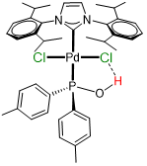
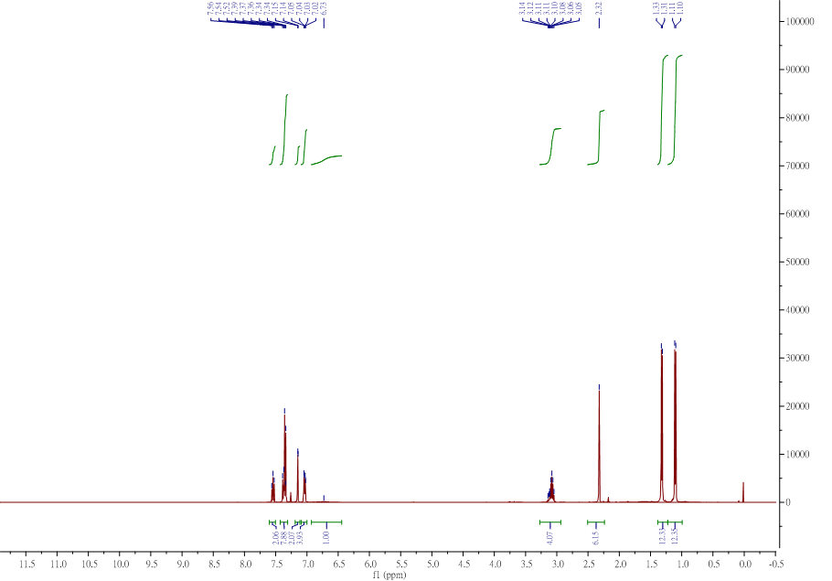
1a _¹³C NMR
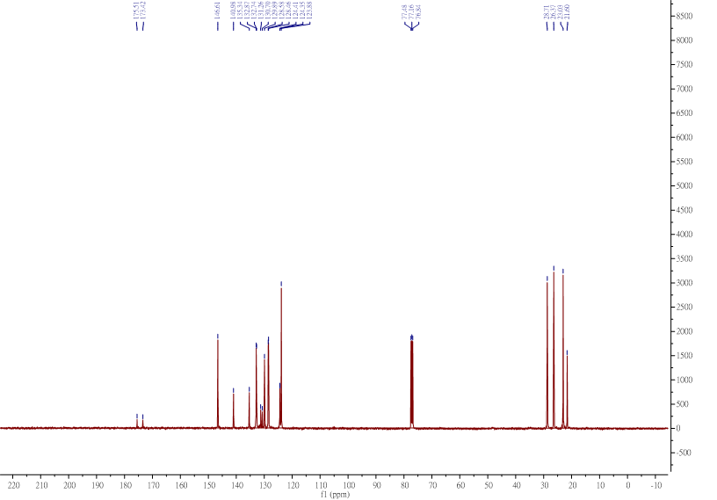
1a _³¹P NMR
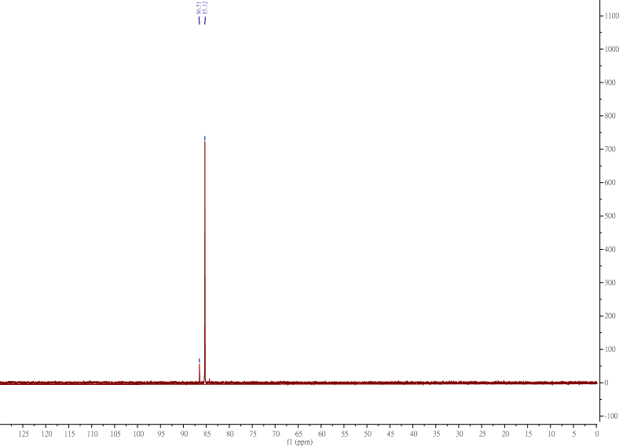
1b _¹H NMR
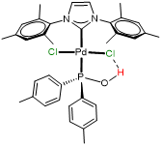
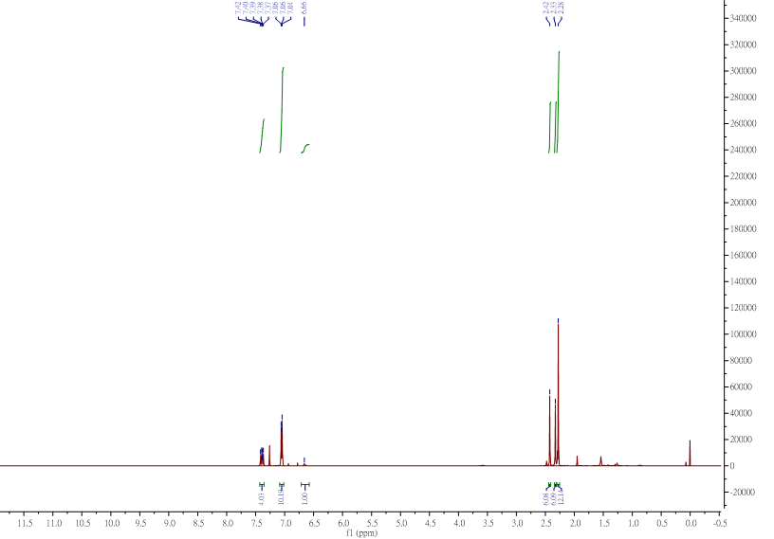

1b _¹³C NMR
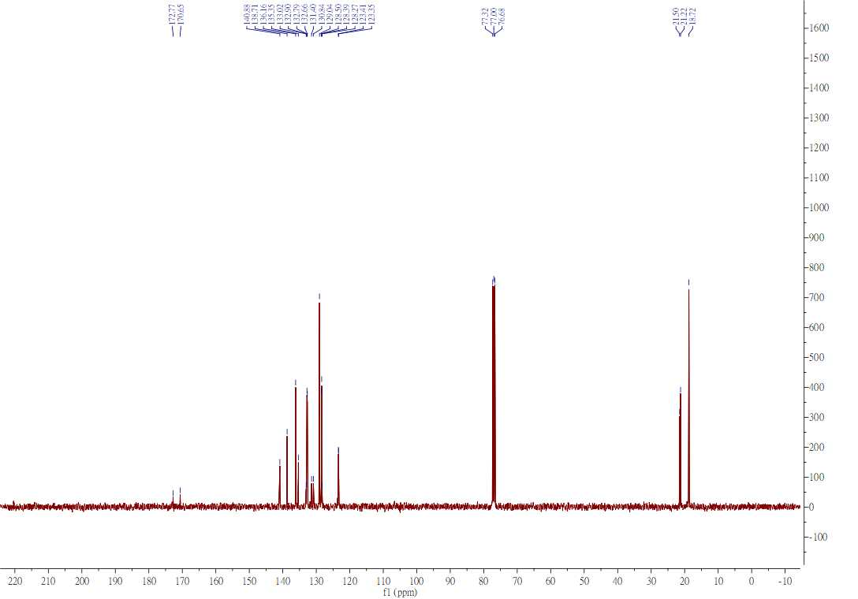
1b _³¹P NMR
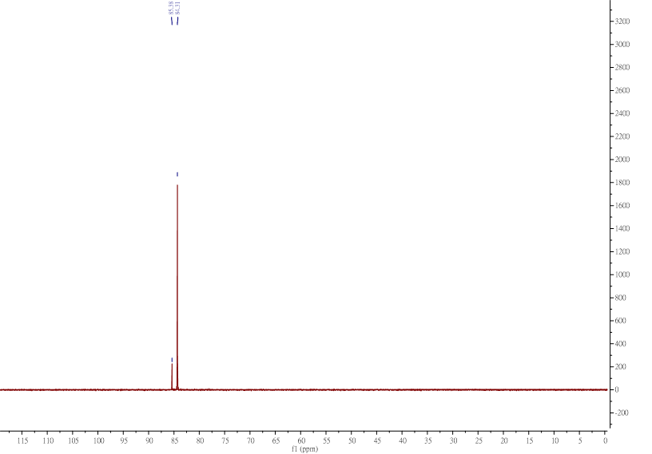

[(NHC_{IPr})PdCl₂]₂_¹H NMR
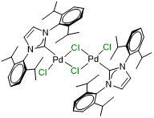
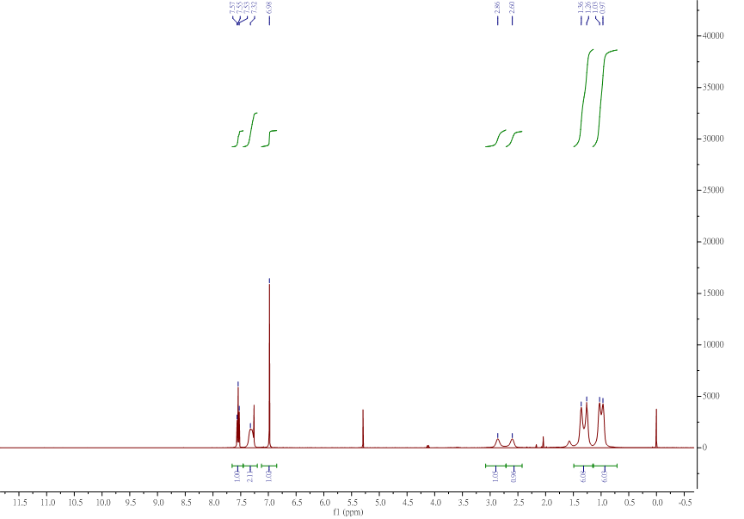[(NHC_{IPr})PdCl₂]₂_¹³C NMR

[(NHC_{IMes})PdCl₂]₂_¹H NMR
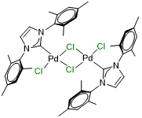
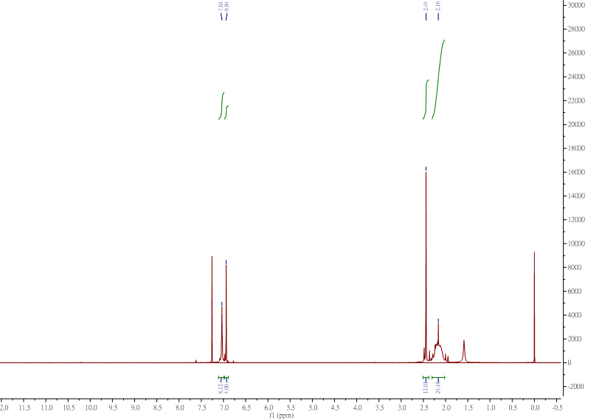
[(NHC_{IMes})PdCl₂]₂_¹³C NMR

PEPPSI_¹H NMR
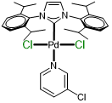
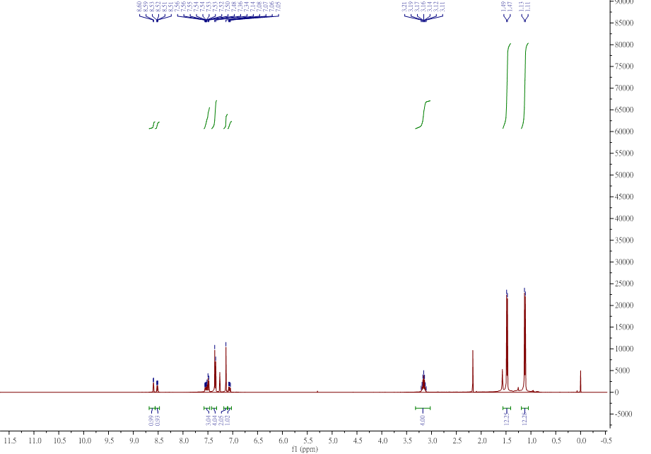
PEPPSI_¹³C NMR

Biphenyl (Figure 3a: a) _¹H NMR
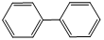
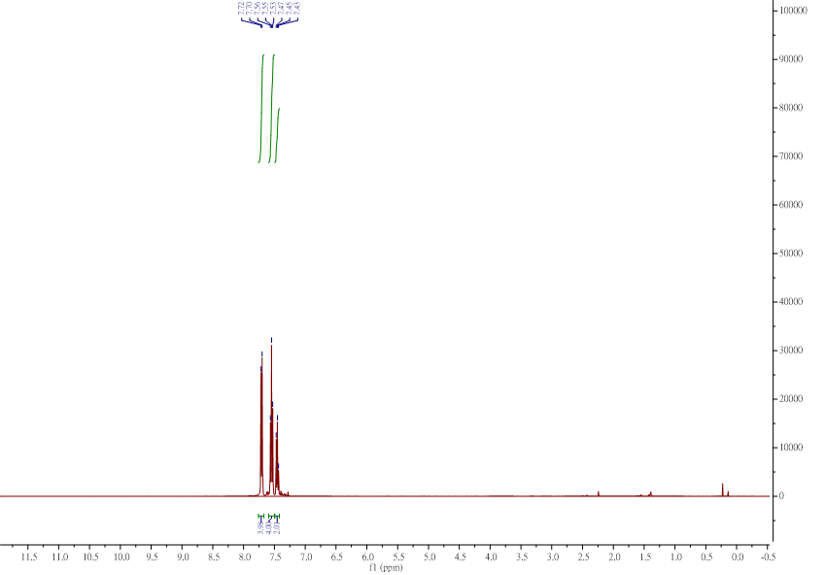
Biphenyl (Figure 3a: a) _¹³C NMR
4-methyl-biphenyl (Figure 3a: b) _¹H NMR
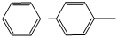
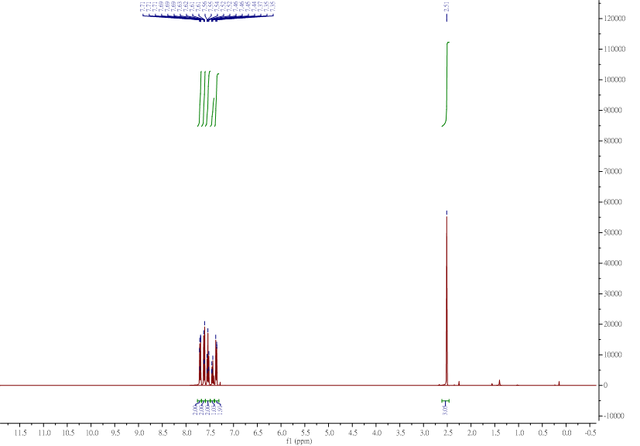
4-methyl-biphenyl (Figure 3a: b) _¹³C NMR

4-(trifluoromethyl)-1,1'-biphenyl (Figure 3a: c) _¹H NMR
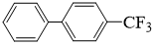
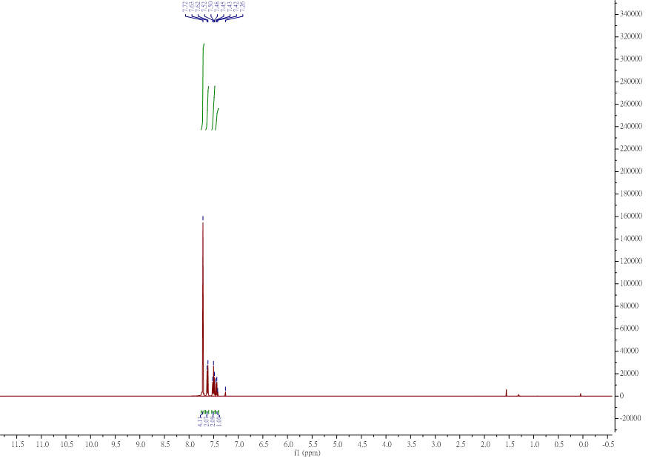
4-(trifluoromethyl)-1,1'-biphenyl (Figure 3a: c) _¹³C NMR
2-methyl-1,1'-biphenyl (Figure 3a: d, e) _¹H NMR
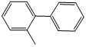
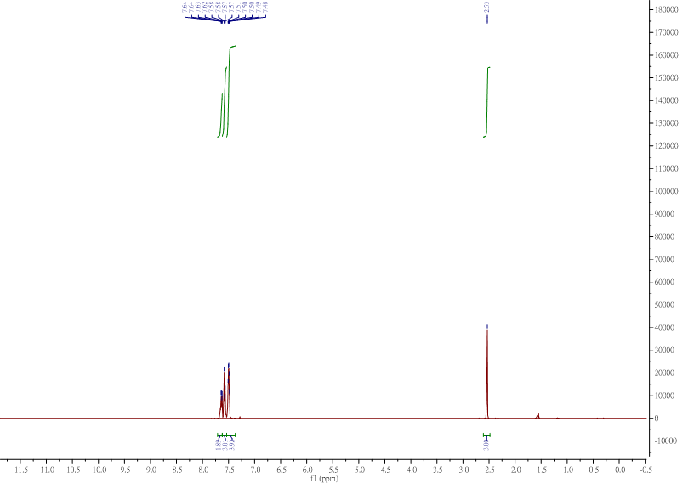
2-methyl-1,1'-biphenyl (Figure 3a: d, e) _¹³C NMR

2,2'-dimethyl-1,1'-biphenyl (Figure 3a: f) _¹H NMR
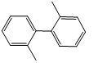
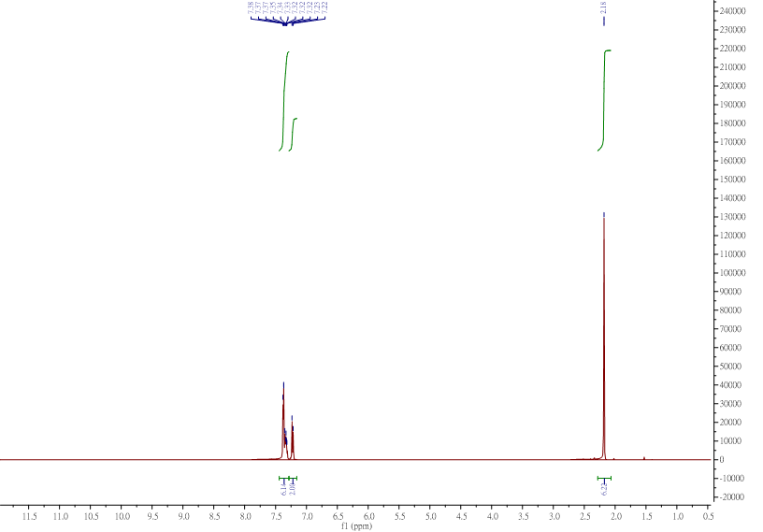
2,2'-dimethyl-1,1'-biphenyl (Figure 3a: f) _¹³C NMR
2,6-dimethyl-1,1'-biphenyl (Figure 3a: g, h) _¹H NMR
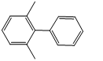
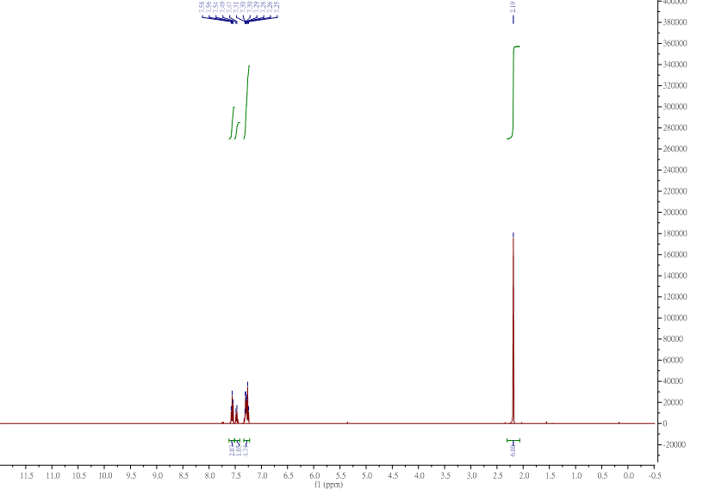
2,6-dimethyl-1,1'-biphenyl (Figure 3a: g, h) _¹³C NMR

2,4',6-trimethyl-1,1'-biphenyl(Figure 3a: i) _¹H NMR
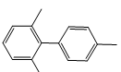
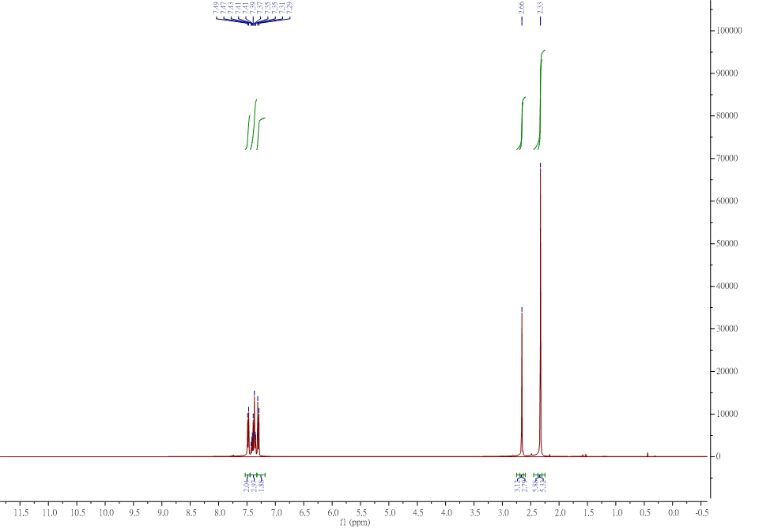
2,4',6-trimethyl-1,1'-biphenyl(Figure 3a: i) _¹³C NMR

2,2',6-trimethyl-1,1'-biphenyl (Figure 3a: j, k) _¹H NMR
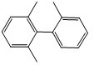
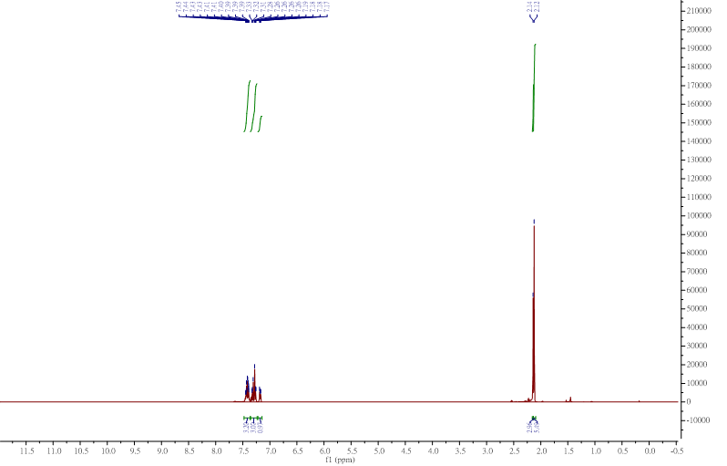
2,2',6-trimethyl-1,1'-biphenyl (Figure 3a: j, k) _¹³C NMR

2-(p-tolyl)pyridine (Figure 3a: l) _¹H NMR
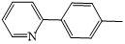
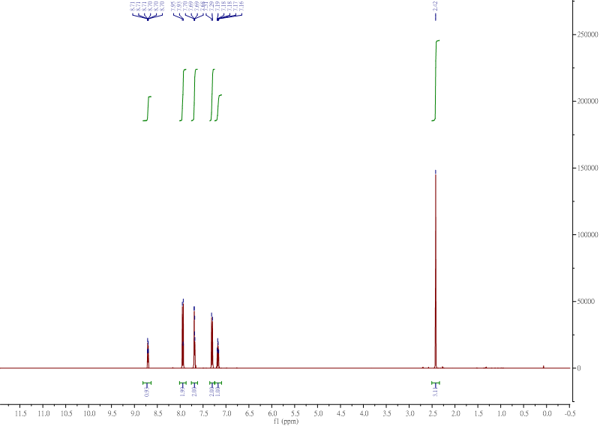
2-(p-tolyl)pyridine (Figure 3a: l) _¹³C NMR

1-(4'-methyl-[1,1'-biphenyl]-4-yl)ethan-1-one (Figure 3a: m)_¹H NMR
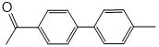
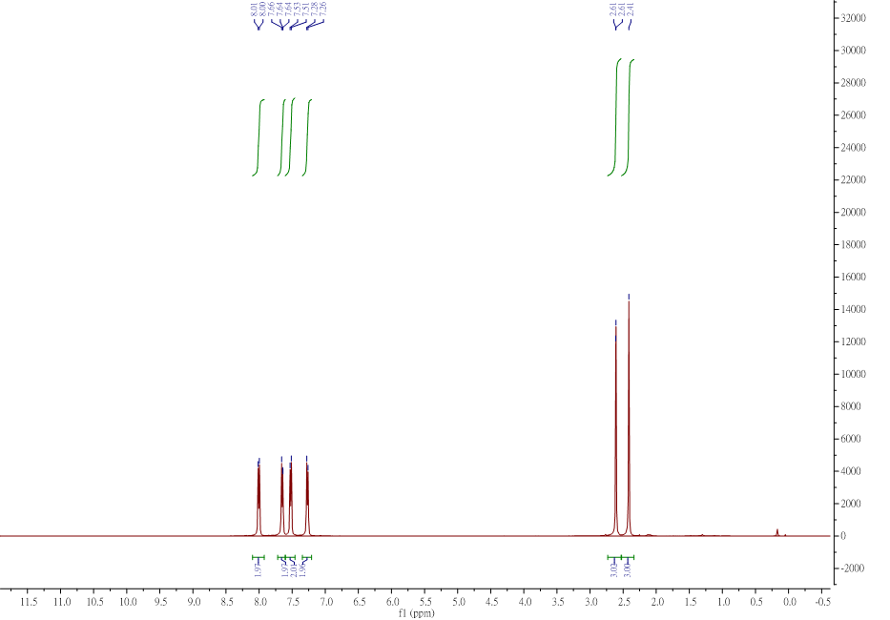
1-(4'-methyl-[1,1'-biphenyl]-4-yl)ethan-1-one (Figure 3a: m) _¹³C NMR
4'-methyl-[1,1'-biphenyl]-4-carbonitrile (Figure 3a: n) _¹H NMR
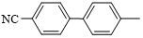
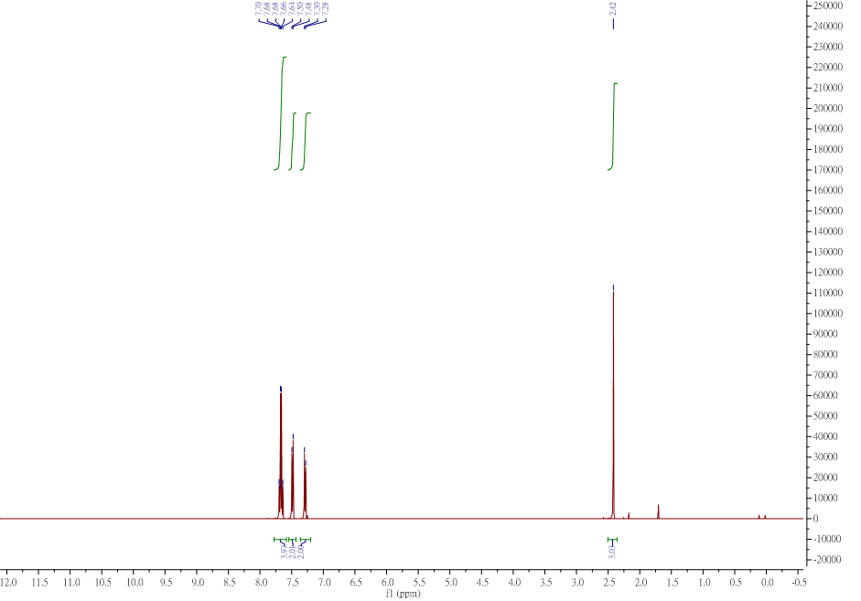
4'-methyl-[1,1'-biphenyl]-4-carbonitrile (Figure 3a: n) _¹³C NMR

4-methoxy-4'-methyl-1,1'-biphenyl (Figure 3a: o) _¹H NMR
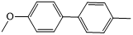
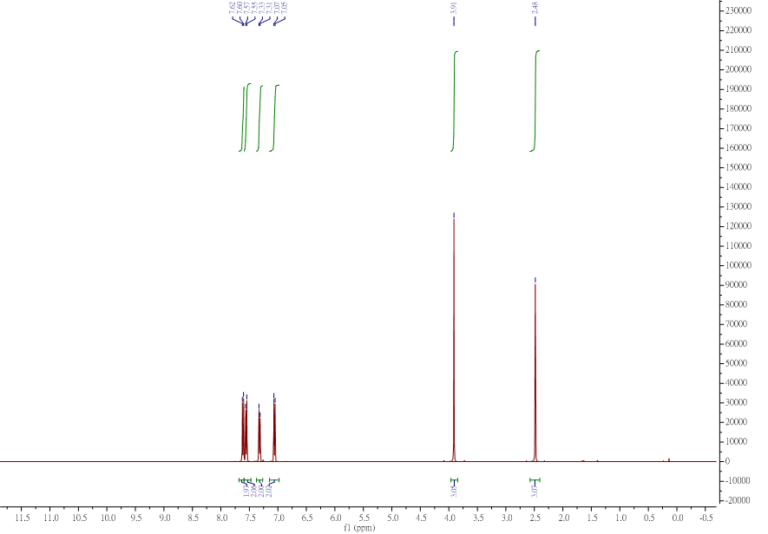
4-methoxy-4'-methyl-1,1'-biphenyl (Figure 3a: o) _¹³C NMR
Diphenylmethane (Figure 3b: aa) _¹H NMR
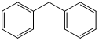
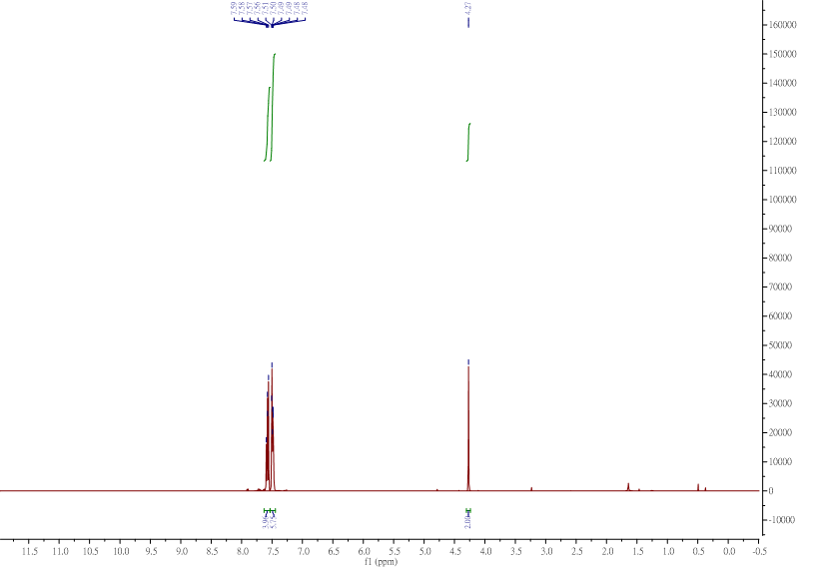
Diphenylmethane (Figure 3b: aa) _¹³C NMR
1- benzyl-4-methylbenzene (Figure 3b: ab, ah) _¹H NMR
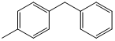
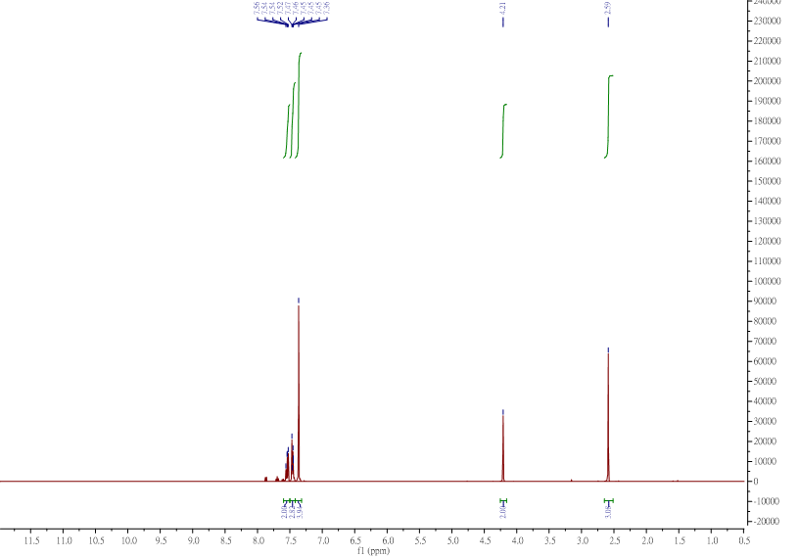
1-benzyl-4-methylbenzene (Figure 3b: ab, ah) _¹³C NMR

di-p-tolylmethane (Figure 3b: ac) _¹H NMR
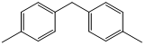
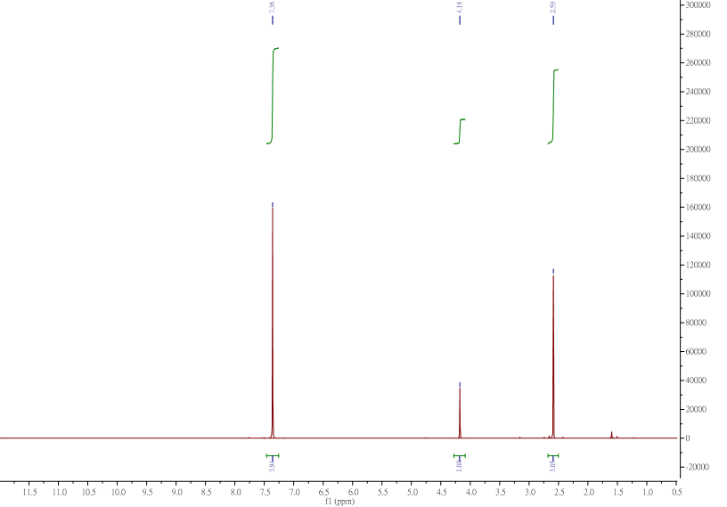

di-p-tolylmethane (Figure 3b: ac) _¹³C NMR

1-methyl-2-(4-methylbenzyl)benzene (Figure 3b: ad) _¹H NMR
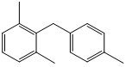
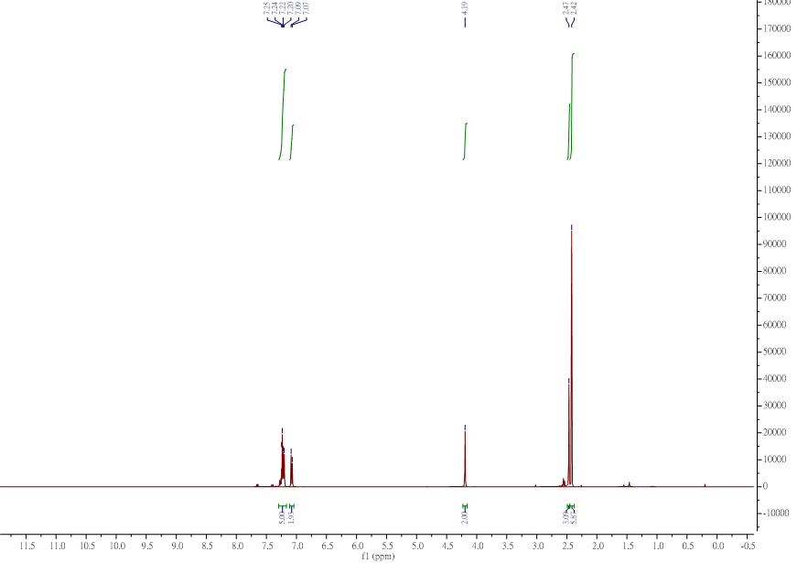
1-methyl-2-(4-methylbenzyl)benzene (Figure 3b: ad) _¹³C NMR
4-benzylbenzonitrile (Figure 3b: ae) _¹H NMR

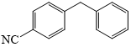
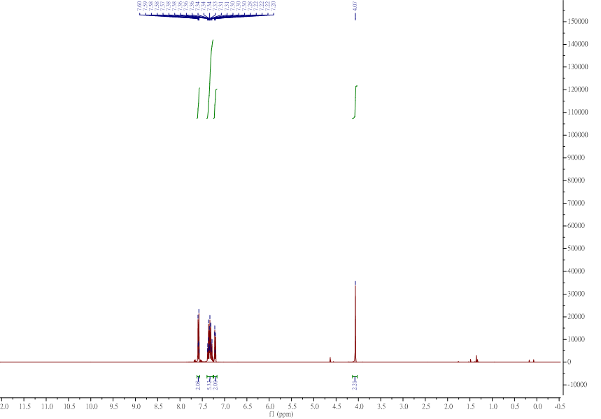
4-benzylbenzonitrile (Figure 3b: ae) _¹³C NMR

4-(4-methylbenzyl)benzonitrile (Figure 3b: af) _¹H NMR
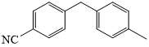
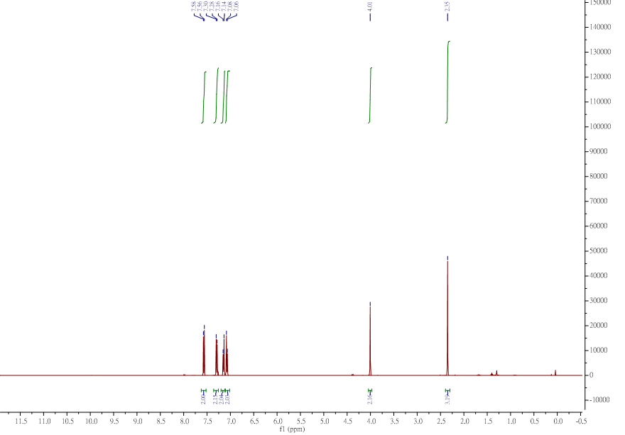
4-(4-methylbenzyl)benzonitrile (Figure 3b: af) _¹³C NMR

1-benzyl-4-(trifluoromethyl)benzene (Figure 3b: ag) _¹H NMR
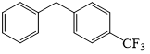
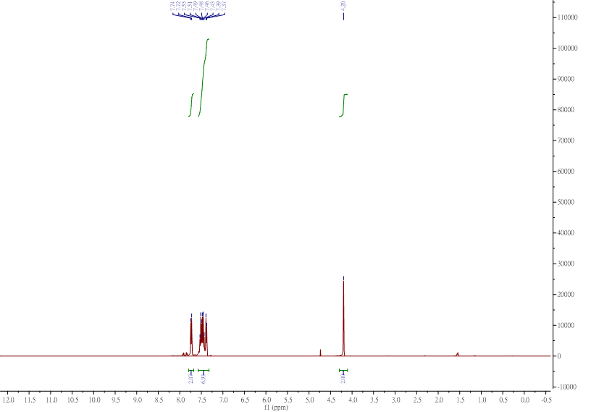
1-benzyl-4-(trifluoromethyl)benzene (Figure 3b: ag) _¹³C NMR

benzophenone (Figure 3c: ba) _¹H NMR
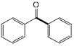
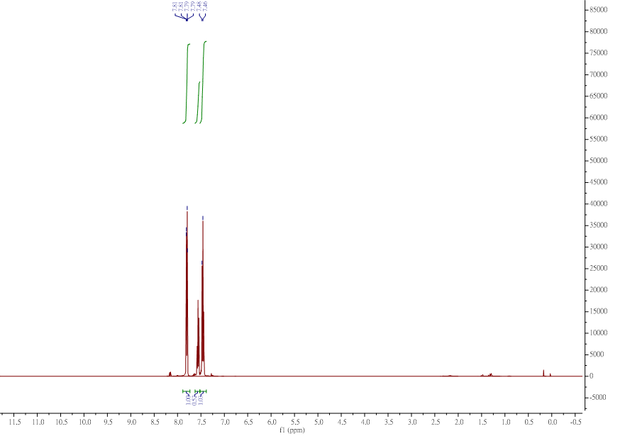
benzophenone (Figure 3c: ba) _¹³C NMR

phenyl(p-tolyl)methanone (Figure 3c: bb) _¹H NMR
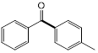
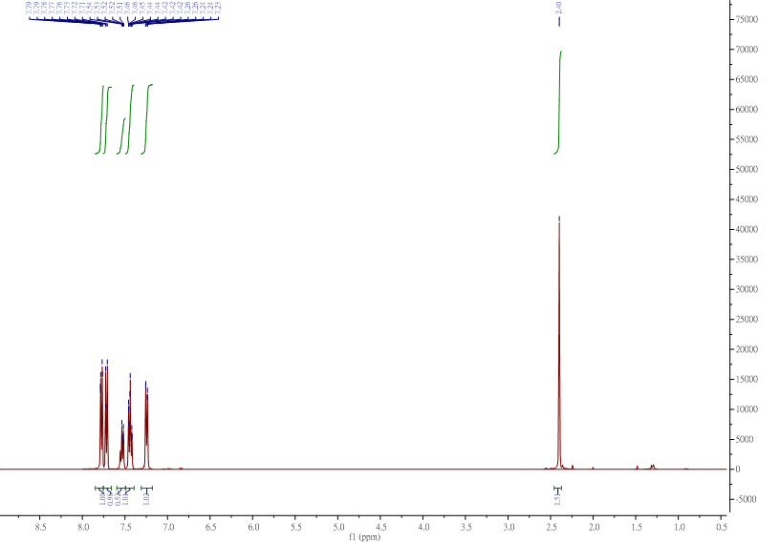
phenyl(p-tolyl)methanone (Figure 3c: bb) _¹³C NMR
phenyl(4-(trifluoromethyl)phenyl)methanone (Figure 3c: bc) _¹H NMR
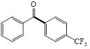
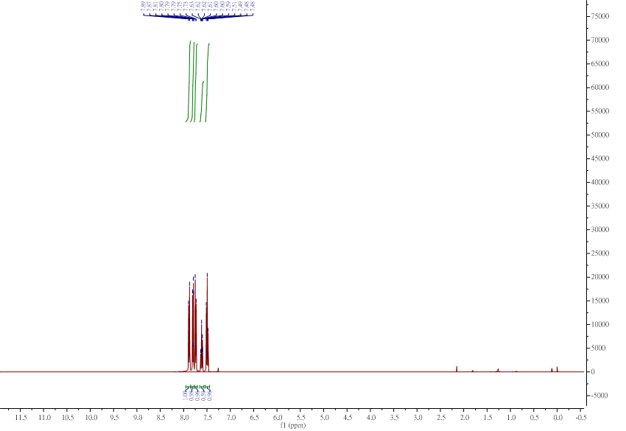
phenyl(4-(trifluoromethyl)phenyl)methanone (Figure 3c: bc) _¹³C NMR
phenyl(o-tolyl)methanone (Figure 3c: bd)_ ¹H NMR
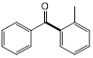
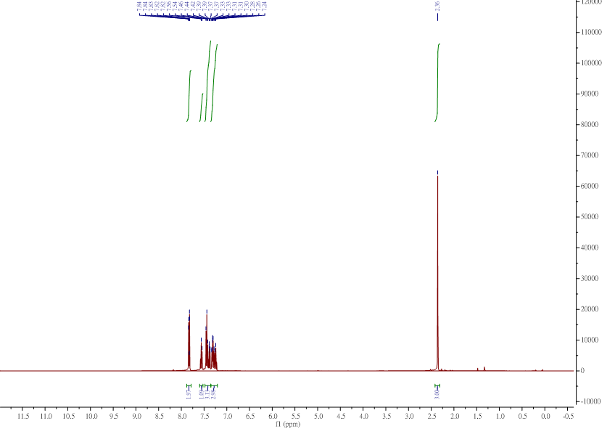
- phenyl(o-tolyl)methanone (Figure 3c: bd)_ ¹³C NMR
10. Computational Methods
All geometry optimizations and vibrational frequency calculations were performed with the Gaussian 09 package. The ωB97XD functional was used in conjunction with MWB28 ECP and valence basis set for Pd and 6-31+G(d) basis set for the other atoms. The optimized structures were confirmed to be local minima by frequency calculations (no imaginary frequency). With the gas-phase optimized structures, polarizable continuum model (PCM) using the integral equation formalism variant (IEFPCM) was employed to account for the solvation effect of EtOH. When calculating the bond dissociation free energies in EtOH, an energy correction of 1.89 kcal/mol was added to the solvation free energies of solutes to deal with the change of standard state of a solute from gas phase to solution (1 atm to 1 M). With the optimized wavefuctions of the gas-phase optimized structures or the single-point calculations with the IEFPCM model, Multiwfn and VMD were used to analyze and plot minimum value (V_{min}) of the molecular electrostatic potential (MESP) and MESP isosurface (10 kcal/mol higher than V_{min}). The CYLview20 was also used to visualize the optimized structures.

- The wB97XD-optimized Cartesian coordinates:

1a (trans): HF= -3167.1160575 a.u./N_{imag} =0
 | Coordinates
Atom | X | Y | Z
Pd | -0.039294 | 0.161297 | -0.408234
Cl | -1.053889 | -0.010722 | 1.691662
Cl | 0.913408 | 0.428319 | -2.541210
P | -2.089467 | 0.863849 | -1.243509
O | -2.045525 | 1.248889 | -2.828858
N | 1.913360 | -1.763918 | 0.907438
N | 2.820954 | 0.172000 | 0.694966
C | -3.394116 | -0.384185 | -1.085766
C | -3.058799 | -1.691998 | -0.724544
H | -2.029434 | -1.949603 | -0.488268
C | -4.044176 | -2.671144 | -0.646025
H | -3.763862 | -3.682279 | -0.359845
C | -5.380390 | -2.371588 | -0.921249
C | -5.707030 | -1.059593 | -1.286265
H | -6.741796 | -0.807618 | -1.507630
C | -4.729655 | -0.075318 | -1.367800
H | -5.005498 | 0.938107 | -1.648678
C | -6.452898 | -3.424237 | -0.798199
H | -7.219859 | -3.305171 | -1.570677
H | -6.033971 | -4.431550 | -0.885718
H | -6.952366 | -3.354401 | 0.175803
C | -2.730925 | 2.380008 | -0.487602
C | -3.421729 | 2.343367 | 0.726948
H | -3.668275 | 1.390860 | 1.185654
C | -3.773550 | 3.528394 | 1.364742
H | -4.303146 | 3.483770 | 2.313508
C | -3.447364 | 4.770992 | 0.814158
C | -2.759079 | 4.795968 | -0.402969
H | -2.494940 | 5.751356 | -0.850997
C | -2.399909 | 3.617544 | -1.048402
H | -1.860616 | 3.657532 | -1.990175
C | -3.845468 | 6.053414 | 1.500295
H | -4.763418 | 6.462121 | 1.060267
H | -4.030998 | 5.894018 | 2.567031
H | -3.066147 | 6.816299 | 1.400684
C | 1.694343 | -0.519873 | 0.418704
C | 3.167487 | -1.845858 | 1.491339
H | 3.535390 | -2.759623 | 1.928331
C | 3.733125 | -0.624413 | 1.369312
H | 4.687781 | -0.243282 | 1.693629
C | 0.985188 | -2.857625 | 0.769307
C | 0.829935 | -3.429685 | -0.506395
C | -0.113253 | -4.450489 | -0.638766
H | -0.274640 | -4.909320 | -1.608658
C | -0.850060 | -4.891158 | 0.454855
H | -1.581048 | -5.685822 | 0.329710
C | -0.650480 | -4.326351 | 1.707373
H | -1.230483 | -4.685625 | 2.551736
C | 0.270509 | -3.292655 | 1.895838
C | 1.700484 | -3.016423 | -1.684547
H | 1.943847 | -1.957309 | -1.580118
C | 1.004280 | -3.158563 | -3.040004
H | 1.615895 | -2.682994 | -3.813326
H | 0.864204 | -4.208361 | -3.325740
H | 0.030256 | -2.659466 | -3.038200
C | 3.020282 | -3.804731 | -1.660935
H | 3.672045 | -3.477537 | -2.479547
H | 3.560777 | -3.656891 | -0.719241
H | 2.834638 | -4.879356 | -1.779825
C | 0.496496 | -2.716434 | 3.284773
H | 0.948187 | -1.726159 | 3.168298
C | -0.803808 | -2.530248 | 4.077386
H | -0.599752 | -1.948084 | 4.982936
H | -1.552233 | -1.994995 | 3.488648
H | -1.225281 | -3.490579 | 4.398622
C | 1.461494 | -3.609500 | 4.083642
H | 1.659141 | -3.169382 | 5.067842
H | 1.023906 | -4.603475 | 4.237514
H | 2.421068 | -3.748701 | 3.575542
C | 3.099967 | 1.509168 | 0.236833
C | 3.941548 | 1.652884 | -0.879760
C | 4.228996 | 2.951427 | -1.299727
H | 4.876015 | 3.105746 | -2.157961
C | 3.683701 | 4.052442 | -0.649182
H | 3.913116 | 5.055474 | -0.998426
C | 2.838209 | 3.874286 | 0.437397
H | 2.411948 | 4.742791 | 0.930979
C | 2.525831 | 2.596440 | 0.909099
C | 4.545875 | 0.460459 | -1.608328
H | 3.965856 | -0.430021 | -1.342377
C | 4.473287 | 0.597194 | -3.134792
H | 3.457124 | 0.831850 | -3.460219
H | 5.151947 | 1.374432 | -3.505796
H | 4.775555 | -0.347116 | -3.602185
C | 6.002814 | 0.234699 | -1.172477
H | 6.416685 | -0.651358 | -1.667671
H | 6.622541 | 1.097234 | -1.446549
H | 6.095337 | 0.091672 | -0.091242
C | 1.626167 | 2.435979 | 2.123236
H | 1.344248 | 1.384594 | 2.215649
C | 0.320066 | 3.229058 | 1.984524
H | -0.357561 | 2.973283 | 2.805137
H | 0.494817 | 4.311690 | 2.011890
H | -0.195153 | 2.985569 | 1.050137
C | 2.382583 | 2.826178 | 3.401804
H | 1.749682 | 2.661547 | 4.281310
H | 3.296376 | 2.232332 | 3.521208
H | 2.670159 | 3.884796 | 3.383386
H | -1.146245 | 1.047778 | -3.165617

1a (cis): HF= -3167.1011046 a.u./N_{imag} =0
 | Coordinates
Atom | X | Y | Z
Pd | 0.129409 | -0.097935 | -1.254061
Cl | 1.092174 | -1.587663 | -2.817949
Cl | -0.566345 | 1.382193 | -2.959896
P | -0.900228 | 1.413425 | 0.037703
O | -0.890488 | 0.990558 | 1.636103
H | -1.229557 | 1.696728 | 2.204505
N | 2.051779 | -1.567913 | 0.520794
N | 0.078568 | -2.415300 | 0.712030
C | -0.137596 | 3.059316 | 0.050515
C | 1.133091 | 3.239766 | -0.499690
H | 1.615141 | 2.425360 | -1.032880
C | 1.784989 | 4.460833 | -0.362740
H | 2.774473 | 4.583768 | -0.796161
C | 1.190354 | 5.525979 | 0.318708
C | -0.085629 | 5.338079 | 0.863315
H | -0.570076 | 6.156383 | 1.391265
C | -0.745180 | 4.121863 | 0.729000
H | -1.743815 | 4.008083 | 1.147822
C | 1.887347 | 6.856988 | 0.440613
H | 1.714628 | 7.310430 | 1.422204
H | 2.967113 | 6.755649 | 0.295608
H | 1.515425 | 7.558058 | -0.316341
C | -2.673669 | 1.631687 | -0.272718
C | -3.175676 | 2.626474 | -1.118000
H | -2.499099 | 3.333434 | -1.587729
C | -4.538721 | 2.691635 | -1.377529
H | -4.917378 | 3.467571 | -2.038945
C | -5.429208 | 1.764366 | -0.822411
C | -4.914466 | 0.768628 | 0.010565
H | -5.581549 | 0.027814 | 0.445385
C | -3.551545 | 0.697247 | 0.283033
H | -3.174394 | -0.097251 | 0.921210
C | -6.900474 | 1.834166 | -1.143963
H | -7.479011 | 1.135091 | -0.532413
H | -7.296177 | 2.841565 | -0.973650
H | -7.078784 | 1.587446 | -2.197172
C | 0.755494 | -1.370292 | 0.168214
C | 2.193821 | -2.764023 | 1.205114
H | 3.154793 | -3.112637 | 1.546670
C | 0.961028 | -3.299879 | 1.315551
H | 0.619017 | -4.221562 | 1.756267
C | 3.110772 | -0.600293 | 0.353040
C | 3.129569 | 0.504344 | 1.230231
C | 4.121728 | 1.463758 | 1.032221
H | 4.154642 | 2.342172 | 1.668490
C | 5.076462 | 1.311295 | 0.031694
H | 5.838544 | 2.073085 | -0.109560
C | 5.072425 | 0.179041 | -0.769244
H | 5.840135 | 0.058715 | -1.527277
C | 4.093428 | -0.809542 | -0.624687
C | 2.167716 | 0.609905 | 2.405553
H | 1.192813 | 0.243635 | 2.080522
C | 1.948535 | 2.038074 | 2.913396
H | 1.137003 | 2.035771 | 3.650396
H | 2.838017 | 2.434436 | 3.418160
H | 1.673632 | 2.726143 | 2.109017
C | 2.641822 | -0.274318 | 3.572500
H | 1.918345 | -0.229039 | 4.396059
H | 2.746821 | -1.323152 | 3.281240
H | 3.611114 | 0.073040 | 3.950740
C | 4.175444 | -2.082733 | -1.448707
H | 3.195407 | -2.565301 | -1.425863
C | 4.509223 | -1.821753 | -2.922209
H | 4.384827 | -2.748639 | -3.492216
H | 3.835685 | -1.075560 | -3.349990
H | 5.546858 | -1.490515 | -3.054373
C | 5.214160 | -3.034878 | -0.831162
H | 5.234668 | -3.982051 | -1.382125
H | 6.218057 | -2.594541 | -0.874404
H | 4.999668 | -3.257704 | 0.220200
C | -1.350862 | -2.521806 | 0.896953
C | -1.862746 | -2.225113 | 2.178385
C | -3.232791 | -2.395655 | 2.380883
H | -3.658672 | -2.182020 | 3.356922
C | -4.065763 | -2.821584 | 1.351501
H | -5.130904 | -2.942680 | 1.529613
C | -3.534812 | -3.093802 | 0.100177
H | -4.189965 | -3.426716 | -0.699373
C | -2.164726 | -2.966590 | -0.153520
C | -0.993441 | -1.753397 | 3.337199
H | -0.065965 | -1.349227 | 2.922454
C | -1.659775 | -0.634463 | 4.153761
H | -2.159586 | 0.090482 | 3.507949
H | -2.405702 | -1.033188 | 4.851733
H | -0.905023 | -0.110893 | 4.751945
C | -0.635760 | -2.910093 | 4.284928
H | 0.000522 | -2.546223 | 5.100267
H | -1.543892 | -3.337475 | 4.726815
H | -0.100922 | -3.716973 | 3.778273
C | -1.621161 | -3.356688 | -1.513273
H | -0.561614 | -3.101178 | -1.557234
C | -2.310110 | -2.583607 | -2.644535
H | -1.804052 | -2.790890 | -3.592203
H | -3.365825 | -2.865568 | -2.747439
H | -2.254220 | -1.502662 | -2.479384
C | -1.734686 | -4.874188 | -1.720051
H | -1.279384 | -5.151857 | -2.676839
H | -1.218837 | -5.424687 | -0.924140
H | -2.781658 | -5.202521 | -1.733654

1b (trans): HF= -2931.2982153 a.u./N_{imag} =0
 | Coordinates
Atom | X | Y | Z
Pd | 0.376196 | -0.126581 | -0.417717
Cl | 0.891460 | 0.870458 | 1.638625
Cl | -0.037566 | -0.966846 | -2.588465
P | -0.901645 | 1.731774 | -0.983271
O | -1.241550 | 1.852515 | -2.574400
N | 2.370195 | -2.330063 | 0.506810
N | 0.326590 | -2.984438 | 0.522521
C | -0.415098 | 3.413492 | -0.531709
C | 0.938226 | 3.714917 | -0.348855
H | 1.682596 | 2.926464 | -0.411250
C | 1.328041 | 5.016129 | -0.056997
H | 2.382607 | 5.236691 | 0.092154
C | 0.384657 | 6.042708 | 0.063431
C | -0.965105 | 5.731061 | -0.119487
H | -1.715101 | 6.513279 | -0.029775
C | -1.365228 | 4.430507 | -0.412817
H | -2.421101 | 4.209846 | -0.546087
C | 0.825863 | 7.446532 | 0.392930
H | -0.018084 | 8.142938 | 0.397449
H | 1.300634 | 7.485664 | 1.380145
H | 1.559022 | 7.808273 | -0.336855
C | -2.525993 | 1.459811 | -0.208804
C | -2.669879 | 1.564414 | 1.180985
H | -1.825666 | 1.870936 | 1.793343
C | -3.885254 | 1.261866 | 1.779246
H | -3.983839 | 1.346931 | 2.859559
C | -4.984317 | 0.844900 | 1.016899
C | -4.828811 | 0.743786 | -0.365135
H | -5.667397 | 0.420822 | -0.977688
C | -3.612049 | 1.041667 | -0.976592
H | -3.507319 | 0.949190 | -2.053211
C | -6.292760 | 0.508131 | 1.686184
H | -7.037908 | 0.168460 | 0.960068
H | -6.162181 | -0.285587 | 2.432138
H | -6.705295 | 1.378893 | 2.208686
C | 1.112955 | -1.921399 | 0.228229
C | 2.374077 | -3.638494 | 0.966833
H | 3.290375 | -4.139223 | 1.237837
C | 1.085549 | -4.050230 | 0.977076
H | 0.633635 | -4.988053 | 1.259856
C | 3.545814 | -1.514768 | 0.377264
C | 4.101817 | -1.330749 | -0.893272
C | 5.228572 | -0.514552 | -0.989711
H | 5.677329 | -0.353674 | -1.968122
C | 5.793860 | 0.095593 | 0.131326
C | 5.221530 | -0.141316 | 1.381043
H | 5.656989 | 0.320250 | 2.264738
C | 4.093719 | -0.948512 | 1.531925
C | 3.511231 | -1.986435 | -2.113550
H | 4.209436 | -1.930666 | -2.953816
H | 3.282093 | -3.042321 | -1.930518
H | 2.575923 | -1.501969 | -2.413453
C | 6.987296 | 1.006724 | -0.013845
H | 7.709445 | 0.607280 | -0.733934
H | 6.676825 | 1.994876 | -0.374488
H | 7.501056 | 1.148344 | 0.941975
C | 3.497964 | -1.204644 | 2.891441
H | 2.414923 | -1.052085 | 2.879428
H | 3.696065 | -2.230447 | 3.226425
H | 3.924843 | -0.522163 | 3.631503
C | -1.100748 | -2.997649 | 0.344373
C | -1.620664 | -3.591526 | -0.812758
C | -2.995462 | -3.511255 | -1.016375
H | -3.418971 | -3.946454 | -1.919534
C | -3.837876 | -2.870190 | -0.104351
C | -3.282307 | -2.336391 | 1.055011
H | -3.927478 | -1.847521 | 1.781166
C | -1.910457 | -2.393530 | 1.309704
C | -0.727147 | -4.302568 | -1.794900
H | -1.265599 | -4.512892 | -2.722876
H | 0.147861 | -3.696762 | -2.046394
H | -0.372873 | -5.257231 | -1.385963
C | -5.318368 | -2.773332 | -0.372483
H | -5.508080 | -2.254388 | -1.318935
H | -5.774413 | -3.767572 | -0.445960
H | -5.830750 | -2.222163 | 0.422039
C | -1.345343 | -1.819136 | 2.580775
H | -0.545667 | -2.447550 | 2.987595
H | -0.916267 | -0.826208 | 2.412075
H | -2.129607 | -1.728528 | 3.338324
H | -0.919499 | 1.037032 | -3.014625

1b (cis): HF= -2931.2831432 a.u./N_{imag} =0
 | Coordinates
Atom | X | Y | Z
Pd | -0.234810 | -0.434320 | -1.076466
Cl | -1.065060 | -1.959001 | -2.672818
Cl | 0.017037 | 1.271412 | -2.695901
P | 0.519457 | 1.202564 | 0.272940
O | 0.820513 | 0.673665 | 1.813875
H | 1.294476 | 1.326708 | 2.347965
N | -1.651072 | -2.317642 | 0.788423
N | 0.468093 | -2.671634 | 0.881313
C | -0.668373 | 2.558074 | 0.512745
C | -1.938395 | 2.480327 | -0.060848
H | -2.188716 | 1.652731 | -0.717895
C | -2.885762 | 3.466071 | 0.197861
H | -3.867136 | 3.388856 | -0.264091
C | -2.593010 | 4.549599 | 1.028899
C | -1.314295 | 4.625407 | 1.594991
H | -1.058352 | 5.467526 | 2.234133
C | -0.363160 | 3.644211 | 1.341462
H | 0.628156 | 3.742061 | 1.780593
C | -3.627606 | 5.606353 | 1.322764
H | -3.173547 | 6.600655 | 1.385654
H | -4.401012 | 5.632659 | 0.549423
H | -4.121878 | 5.410023 | 2.282163
C | 2.113446 | 1.958762 | -0.149472
C | 2.223112 | 3.188198 | -0.805078
H | 1.329716 | 3.743394 | -1.073581
C | 3.477393 | 3.688033 | -1.134398
H | 3.551557 | 4.645682 | -1.644377
C | 4.644571 | 2.974483 | -0.837686
C | 4.521447 | 1.740473 | -0.194334
H | 5.411695 | 1.160359 | 0.038958
C | 3.271130 | 1.232934 | 0.143916
H | 3.199011 | 0.263234 | 0.627632
C | 5.993784 | 3.512379 | -1.241641
H | 6.804129 | 3.007358 | -0.706501
H | 6.160522 | 3.364483 | -2.315339
H | 6.071493 | 4.586537 | -1.043041
C | -0.464595 | -1.860807 | 0.317775
C | -1.468911 | -3.417284 | 1.609300
H | -2.303668 | -3.927375 | 2.063444
C | -0.138959 | -3.644243 | 1.664284
H | 0.438307 | -4.395379 | 2.179546
C | -2.925732 | -1.708755 | 0.517465
C | -3.264988 | -0.540090 | 1.208596
C | -4.464459 | 0.088080 | 0.872013
H | -4.729744 | 1.012126 | 1.382110
C | -5.320574 | -0.435303 | -0.095344
C | -4.977935 | -1.644382 | -0.702324
H | -5.649262 | -2.079449 | -1.439928
C | -3.787915 | -2.308732 | -0.408252
C | -2.427308 | -0.000620 | 2.338826
H | -2.611866 | 1.068288 | 2.481828
H | -2.686991 | -0.514857 | 3.273562
H | -1.356905 | -0.133567 | 2.179934
C | -6.582868 | 0.289318 | -0.490002
H | -6.864098 | 1.040115 | 0.255068
H | -6.447186 | 0.802197 | -1.449764
H | -7.420900 | -0.406078 | -0.606397
C | -3.490363 | -3.649531 | -1.025754
H | -2.423161 | -3.786981 | -1.206623
H | -3.844999 | -4.455261 | -0.368809
H | -3.999963 | -3.750031 | -1.987478
C | 1.893681 | -2.481684 | 0.843113
C | 2.526323 | -2.067776 | 2.026941
C | 3.907320 | -1.877684 | 1.998795
H | 4.408901 | -1.545519 | 2.905851
C | 4.655453 | -2.083806 | 0.838224
C | 3.991101 | -2.514256 | -0.306845
H | 4.557116 | -2.690548 | -1.219375
C | 2.611499 | -2.740032 | -0.330417
C | 1.767599 | -1.845831 | 3.311706
H | 2.331953 | -1.181113 | 3.972830
H | 0.788143 | -1.397467 | 3.133626
H | 1.616363 | -2.789859 | 3.849266
C | 6.148933 | -1.872738 | 0.831371
H | 6.455779 | -1.161088 | 1.604755
H | 6.675699 | -2.815661 | 1.021638
H | 6.492307 | -1.494490 | -0.137097
C | 1.969669 | -3.254908 | -1.589035
H | 1.027605 | -3.772445 | -1.396612
H | 1.730984 | -2.436895 | -2.276285
H | 2.650513 | -3.941493 | -2.102086

1a-trans-PA⁻: HF= -3166.5682624 a.u./N_{imag} =0
 | Coordinates
Atom | X | Y | Z
Pd | -0.077289 | 0.197471 | -0.513395
Cl | -1.196134 | 0.123488 | 1.593070
Cl | 1.163419 | 0.473586 | -2.490317
P | -1.992368 | 1.031829 | -1.557911
O | -2.060882 | 1.262387 | -3.055652
N | 1.573087 | -1.957392 | 0.938233
N | 2.689004 | -0.129101 | 0.936141
C | -3.405832 | -0.053320 | -1.059555
C | -3.202366 | -1.384685 | -0.692135
H | -2.190988 | -1.775218 | -0.605993
C | -4.280386 | -2.222743 | -0.412487
H | -4.088752 | -3.254810 | -0.122710
C | -5.593395 | -1.755436 | -0.489347
C | -5.797845 | -0.424626 | -0.870554
H | -6.813575 | -0.037722 | -0.946466
C | -4.721918 | 0.410140 | -1.157743
H | -4.905295 | 1.438937 | -1.459589
C | -6.765864 | -2.647681 | -0.157979
H | -7.526731 | -2.617468 | -0.947231
H | -6.450397 | -3.689534 | -0.034182
H | -7.250614 | -2.334152 | 0.775430
C | -2.347207 | 2.638316 | -0.717910
C | -2.971226 | 2.778037 | 0.524341
H | -3.341423 | 1.899080 | 1.042438
C | -3.095343 | 4.032511 | 1.118510
H | -3.578315 | 4.117063 | 2.091034
C | -2.594198 | 5.179370 | 0.497936
C | -1.974557 | 5.036186 | -0.747460
H | -1.572566 | 5.914951 | -1.250426
C | -1.856636 | 3.786465 | -1.349634
H | -1.375915 | 3.683148 | -2.319423
C | -2.739435 | 6.539772 | 1.137143
H | -3.584285 | 7.092633 | 0.705766
H | -2.914632 | 6.455495 | 2.215445
H | -1.839324 | 7.147351 | 0.987529
C | 1.539062 | -0.678809 | 0.475346
C | 2.716363 | -2.191518 | 1.687899
H | 2.923404 | -3.151238 | 2.132453
C | 3.414910 | -1.035361 | 1.695771
H | 4.350555 | -0.768768 | 2.160759
C | 0.599996 | -2.958283 | 0.589068
C | 0.594700 | -3.435705 | -0.735986
C | -0.373017 | -4.383794 | -1.070539
H | -0.427477 | -4.755733 | -2.088208
C | -1.282360 | -4.848230 | -0.126774
H | -2.035073 | -5.577898 | -0.414496
C | -1.238616 | -4.373352 | 1.176339
H | -1.961504 | -4.735092 | 1.901399
C | -0.301104 | -3.412064 | 1.563704
C | 1.620878 | -2.972788 | -1.760674
H | 1.812400 | -1.910830 | -1.596253
C | 1.131895 | -3.068569 | -3.206729
H | 1.846252 | -2.555167 | -3.858426
H | 1.044190 | -4.107630 | -3.552870
H | 0.168710 | -2.563679 | -3.327831
C | 2.944781 | -3.731722 | -1.577674
H | 3.688260 | -3.365881 | -2.296793
H | 3.356772 | -3.593622 | -0.571479
H | 2.805782 | -4.808036 | -1.745470
C | -0.265763 | -2.918795 | 3.001108
H | 0.251996 | -1.955165 | 3.007314
C | -1.665005 | -2.676815 | 3.581150
H | -1.577281 | -2.155246 | 4.541370
H | -2.261282 | -2.053455 | 2.910408
H | -2.196947 | -3.619154 | 3.767143
C | 0.503440 | -3.907134 | 3.893978
H | 0.579902 | -3.516496 | 4.916149
H | -0.016331 | -4.873003 | 3.936459
H | 1.517796 | -4.096099 | 3.527414
C | 3.205077 | 1.149872 | 0.528505
C | 4.186443 | 1.162097 | -0.477755
C | 4.727241 | 2.397663 | -0.832265
H | 5.486429 | 2.447606 | -1.607567
C | 4.285072 | 3.571458 | -0.231704
H | 4.708767 | 4.526297 | -0.532744
C | 3.286723 | 3.528644 | 0.731959
H | 2.929620 | 4.453354 | 1.176556
C | 2.721078 | 2.315515 | 1.134343
C | 4.657190 | -0.109256 | -1.170743
H | 3.918341 | -0.892160 | -0.975431
C | 4.735290 | 0.045061 | -2.694388
H | 3.788875 | 0.423687 | -3.088751
H | 5.546947 | 0.719699 | -2.995470
H | 4.934223 | -0.931871 | -3.152231
C | 6.010997 | -0.576642 | -0.613309
H | 6.314956 | -1.516237 | -1.090815
H | 6.787938 | 0.173208 | -0.810521
H | 5.973533 | -0.742295 | 0.468454
C | 1.640429 | 2.293365 | 2.200513
H | 1.187008 | 1.300296 | 2.218116
C | 0.504052 | 3.275922 | 1.894001
H | -0.315092 | 3.123179 | 2.603731
H | 0.830676 | 4.321689 | 1.968410
H | 0.096300 | 3.109051 | 0.892504
C | 2.249772 | 2.551787 | 3.586230
H | 1.471169 | 2.495215 | 4.356166
H | 3.022169 | 1.810344 | 3.825541
H | 2.710281 | 3.547257 | 3.639021

1b-(trans)-PA⁻: HF= -2930.7497522 a.u./N_{imag} =0
 | Coordinates
Atom | X | Y | Z
Pd | 0.302709 | -0.131004 | -0.500544
Cl | 1.108372 | 0.820555 | 1.533014
Cl | -0.424176 | -1.083128 | -2.533716
P | -0.457997 | 1.932676 | -1.294893
O | -0.654376 | 2.230774 | -2.768827
N | 1.800725 | -2.687451 | 0.578375
N | -0.322939 | -2.921897 | 0.672053
C | 0.405013 | 3.380601 | -0.540217
C | 1.798126 | 3.378581 | -0.419073
H | 2.350913 | 2.471340 | -0.648104
C | 2.477484 | 4.508991 | 0.019640
H | 3.562035 | 4.478985 | 0.116914
C | 1.787941 | 5.678802 | 0.357585
C | 0.398139 | 5.681219 | 0.233316
H | -0.162366 | 6.580205 | 0.486720
C | -0.283721 | 4.549052 | -0.214649
H | -1.366571 | 4.581080 | -0.310702
C | 2.535728 | 6.895648 | 0.848244
H | 1.856579 | 7.739429 | 1.013798
H | 3.050509 | 6.690501 | 1.795335
H | 3.296495 | 7.214092 | 0.124923
C | -2.105988 | 1.944545 | -0.453294
C | -2.264479 | 2.017754 | 0.936381
H | -1.387298 | 2.129512 | 1.569593
C | -3.528363 | 1.930520 | 1.508390
H | -3.632162 | 1.988557 | 2.591762
C | -4.670017 | 1.754708 | 0.716020
C | -4.504979 | 1.678498 | -0.667031
H | -5.377946 | 1.541708 | -1.304506
C | -3.239209 | 1.772542 | -1.247688
H | -3.110713 | 1.706000 | -2.325219
C | -6.033280 | 1.637495 | 1.353689
H | -6.812213 | 1.468655 | 0.601911
H | -6.070321 | 0.801151 | 2.064122
H | -6.294762 | 2.546594 | 1.909952
C | 0.640847 | -2.043769 | 0.287663
C | 1.566900 | -3.939817 | 1.127908
H | 2.374175 | -4.595100 | 1.416570
C | 0.224372 | -4.085921 | 1.189133
H | -0.394271 | -4.895601 | 1.544255
C | 3.108043 | -2.139429 | 0.363969
C | 3.629039 | -2.122030 | -0.934867
C | 4.892278 | -1.558144 | -1.115252
H | 5.310972 | -1.520944 | -2.119644
C | 5.623184 | -1.032053 | -0.049145
C | 5.076645 | -1.096509 | 1.231732
H | 5.632724 | -0.687798 | 2.073319
C | 3.815522 | -1.646695 | 1.464158
C | 2.853847 | -2.677030 | -2.098785
H | 3.505316 | -2.800768 | -2.969787
H | 2.409423 | -3.649493 | -1.857617
H | 2.025795 | -2.013844 | -2.377438
C | 6.966322 | -0.386667 | -0.289124
H | 7.592720 | -1.000720 | -0.946447
H | 6.845195 | 0.591704 | -0.769784
H | 7.507612 | -0.231600 | 0.650050
C | 3.229030 | -1.688620 | 2.850336
H | 2.248414 | -1.201344 | 2.856783
H | 3.105828 | -2.718076 | 3.208887
H | 3.876410 | -1.158763 | 3.555655
C | -1.732948 | -2.690774 | 0.524342
C | -2.396917 | -3.293714 | -0.548862
C | -3.752630 | -3.013618 | -0.712312
H | -4.278913 | -3.448640 | -1.559907
C | -4.434996 | -2.162195 | 0.156623
C | -3.743932 | -1.618108 | 1.237333
H | -4.264980 | -0.957974 | 1.926852
C | -2.388004 | -1.868778 | 1.446607
C | -1.666407 | -4.193747 | -1.509641
H | -2.331932 | -4.510106 | -2.318610
H | -0.822093 | -3.657003 | -1.955049
H | -1.282830 | -5.093602 | -1.012715
C | -5.878522 | -1.801652 | -0.085870
H | -5.940604 | -0.863543 | -0.650619
H | -6.397493 | -2.576809 | -0.660356
H | -6.416816 | -1.652178 | 0.856698
C | -1.666662 | -1.261565 | 2.618202
H | -1.030854 | -1.997181 | 3.125006
H | -1.011707 | -0.443437 | 2.299091
H | -2.384156 | -0.864709 | 3.343495

PA-tolyl-H: HF= -958.914511 a.u./N_{imag} =0
 | Coordinates
Atom | X | Y | Z
P | 0.006368 | 1.867495 | 0.543217
O | -0.120338 | 2.692382 | -0.913712
H | 0.101077 | 3.622197 | -0.786158
C | 1.401418 | 0.724372 | 0.200407
C | 2.415242 | 0.591642 | 1.148760
H | 2.380501 | 1.179086 | 2.064109
C | 3.476236 | -0.291715 | 0.937683
H | 4.253078 | -0.386102 | 1.693065
C | 3.554016 | -1.048511 | -0.230151
C | 2.540168 | -0.899541 | -1.188185
H | 2.585906 | -1.478998 | -2.108153
C | 1.477247 | -0.034334 | -0.975827
H | 0.694574 | 0.055527 | -1.724953
C | 4.684770 | -2.018399 | -0.464358
H | 5.160007 | -1.844971 | -1.436171
H | 5.454030 | -1.931896 | 0.308976
H | 4.318614 | -3.051850 | -0.459031
C | -1.385631 | 0.698271 | 0.289361
C | -1.479584 | -0.432016 | 1.111879
H | -0.710880 | -0.630751 | 1.856406
C | -2.537800 | -1.320481 | 0.977166
H | -2.587363 | -2.195539 | 1.622090
C | -3.538805 | -1.111350 | 0.020095
C | -3.443898 | 0.019409 | -0.790099
H | -4.207648 | 0.205419 | -1.542233
C | -2.383912 | 0.918220 | -0.659112
H | -2.325989 | 1.786385 | -1.308527
C | -4.671345 | -2.096352 | -0.129864
H | -4.305756 | -3.059578 | -0.505257
H | -5.163068 | -2.284696 | 0.831021
H | -5.428640 | -1.731023 | -0.830271

PA-tolyl⁻: HF= -958.3559652./N_{imag} =0
 | Coordinates
Atom | X | Y | Z
P | -0.000962 | 1.944675 | 0.710491
O | -0.001189 | 2.895793 | -0.512666
C | 1.370704 | 0.696903 | 0.351583
C | 1.803216 | -0.257690 | 1.274930
H | 1.317569 | -0.321228 | 2.248837
C | 2.847436 | -1.134482 | 0.977041
H | 3.157309 | -1.874829 | 1.714960
C | 3.508701 | -1.072734 | -0.251912
C | 3.088679 | -0.104678 | -1.171237
H | 3.591410 | -0.033994 | -2.136731
C | 2.043624 | 0.765955 | -0.872981
H | 1.719241 | 1.525137 | -1.583256
C | 4.656672 | -2.000172 | -0.575948
H | 5.611273 | -1.459428 | -0.620416
H | 4.757801 | -2.786706 | 0.180944
H | 4.514815 | -2.488546 | -1.548210
C | -1.368613 | 0.694154 | 0.347235
C | -1.779176 | -0.285047 | 1.259246
H | -1.273676 | -0.367211 | 2.221553
C | -2.823307 | -1.157705 | 0.963927
H | -3.116781 | -1.915427 | 1.691358
C | -3.510963 | -1.071883 | -0.252538
C | -3.113958 | -0.084339 | -1.156606
H | -3.635232 | 0.006499 | -2.110120
C | -2.064033 | 0.786104 | -0.859717
H | -1.757056 | 1.561081 | -1.560603
C | -4.656138 | -2.009240 | -0.557278
H | -4.350733 | -3.059634 | -0.467869
H | -5.495398 | -1.855956 | 0.133908
H | -5.033655 | -1.857096 | -1.574871

NHC_{IPr}: HF= -1159.7274141 a.u./N_{imag} =0
 | Coordinates
Atom | X | Y | Z
N | 1.057715 | 0.029422 | 0.574844
N | -1.057734 | -0.029382 | 0.574846
C | -0.000019 | 0.000148 | -0.288357
C | 0.675310 | 0.021890 | 1.910956
H | 1.393480 | 0.044262 | 2.716628
C | -0.675329 | -0.022213 | 1.910958
H | -1.393498 | -0.044780 | 2.716627
C | 2.427043 | 0.073625 | 0.155985
C | 2.987567 | 1.311748 | -0.182907
C | 4.328422 | 1.327981 | -0.576252
H | 4.795262 | 2.268789 | -0.854403
C | 5.073130 | 0.156670 | -0.622641
H | 6.115316 | 0.189455 | -0.928532
C | 4.488997 | -1.060202 | -0.284660
H | 5.083292 | -1.967359 | -0.335202
C | 3.152226 | -1.128021 | 0.109213
C | 2.164174 | 2.589545 | -0.190955
H | 1.222545 | 2.391581 | 0.330862
C | 1.813423 | 2.970972 | -1.636587
H | 1.178970 | 3.864785 | -1.655472
H | 2.721555 | 3.185257 | -2.213468
H | 1.276333 | 2.154375 | -2.129491
C | 2.858313 | 3.745448 | 0.539201
H | 2.190662 | 4.613563 | 0.582025
H | 3.124100 | 3.467769 | 1.565098
H | 3.773740 | 4.062686 | 0.026649
C | 2.476285 | -2.459515 | 0.402008
H | 1.668058 | -2.276057 | 1.118610
C | 1.833792 | -3.010103 | -0.881193
H | 1.301595 | -3.945871 | -0.671058
H | 1.122302 | -2.293105 | -1.302661
H | 2.602154 | -3.216140 | -1.636393
C | 3.412652 | -3.495632 | 1.031947
H | 2.835474 | -4.371030 | 1.349600
H | 4.168543 | -3.849735 | 0.321426
H | 3.930706 | -3.091642 | 1.908639
C | -2.427036 | -0.073592 | 0.155954
C | -3.152192 | 1.128042 | 0.109171
C | -4.488893 | 1.060288 | -0.284957
H | -5.083159 | 1.967469 | -0.335558
C | -5.072973 | -0.156542 | -0.623134
H | -6.115090 | -0.189288 | -0.929261
C | -4.328307 | -1.327890 | -0.576624
H | -4.795134 | -2.268656 | -0.854930
C | -2.987536 | -1.311714 | -0.183016
C | -2.476346 | 2.459504 | 0.402242
H | -1.668132 | 2.275988 | 1.118836
C | -1.833848 | 3.010287 | -0.880862
H | -1.122093 | 2.293455 | -1.302167
H | -2.602158 | 3.216067 | -1.636184
H | -1.301955 | 3.946216 | -0.670681
C | -3.412787 | 3.495447 | 1.032368
H | -2.835629 | 4.370734 | 1.350365
H | -4.168588 | 3.849782 | 0.321866
H | -3.930955 | 3.091183 | 1.908869
C | -2.164155 | -2.589528 | -0.190827
H | -1.222483 | -2.391432 | 0.330858
C | -1.813549 | -2.971400 | -1.636364
H | -1.179096 | -3.865220 | -1.655017
H | -2.721731 | -3.185868 | -2.213099
H | -1.276490 | -2.154974 | -2.129589
C | -2.858267 | -3.745171 | 0.539760
H | -2.190741 | -4.613385 | 0.582592
H | -3.123712 | -3.467222 | 1.565676
H | -3.773894 | -4.062367 | 0.027548

NHC_{IMes}: HF= -923.9068109 a.u./N_{imag} =0
 | Coordinates
Atom | X | Y | Z
N | 1.057990 | -0.046067 | 0.564618
N | -1.058643 | -0.045862 | 0.563807
C | 0.000032 | -0.009950 | -0.298247
C | 0.674867 | -0.100641 | 1.900437
H | 1.392599 | -0.132524 | 2.706454
C | -0.676589 | -0.100464 | 1.899910
H | -1.394939 | -0.132203 | 2.705375
C | 2.426111 | -0.016324 | 0.144927
C | 3.094819 | -1.223268 | -0.073388
C | 4.436713 | -1.169105 | -0.454051
H | 4.972348 | -2.100818 | -0.626155
C | 5.102164 | 0.044951 | -0.623004
C | 4.395826 | 1.228957 | -0.402827
H | 4.900994 | 2.184107 | -0.534999
C | 3.054663 | 1.221799 | -0.021390
C | 2.375558 | -2.538620 | 0.076679
H | 3.056160 | -3.376605 | -0.099365
H | 1.943389 | -2.652264 | 1.077038
H | 1.548856 | -2.606087 | -0.639082
C | 6.545426 | 0.083425 | -1.061480
H | 7.054943 | -0.859986 | -0.842033
H | 6.620126 | 0.256723 | -2.141807
H | 7.091925 | 0.889647 | -0.561030
C | 2.290894 | 2.503931 | 0.184909
H | 1.479390 | 2.586471 | -0.546506
H | 1.831535 | 2.545466 | 1.178631
H | 2.947942 | 3.371381 | 0.074298
C | -2.426405 | -0.016079 | 0.142971
C | -3.096464 | -1.222687 | -0.070903
C | -4.436481 | -1.168186 | -0.459396
H | -4.971521 | -2.099894 | -0.632944
C | -5.099015 | 0.045812 | -0.636966
C | -4.389486 | 1.230042 | -0.426094
H | -4.890164 | 2.185319 | -0.573898
C | -3.050953 | 1.222596 | -0.036877
C | -2.379369 | -2.538573 | 0.084949
H | -3.061079 | -3.376177 | -0.088601
H | -1.551864 | -2.610167 | -0.629517
H | -1.948638 | -2.649127 | 1.086252
C | -6.554607 | 0.087106 | -1.032174
H | -6.888741 | -0.875781 | -1.430702
H | -7.186959 | 0.328323 | -0.169179
H | -6.736752 | 0.850890 | -1.795671
C | -2.283123 | 2.504199 | 0.157113
H | -1.821002 | 2.551932 | 1.149269
H | -1.473349 | 2.578773 | -0.577061
H | -2.938116 | 3.372572 | 0.041660

1a-PA: HF= -2208.1288269 a.u. / _{Nimag}=0
 | Coordinates
Atom | X | Y | Z
Pd | -0.000012 | 0.000070 | -1.751066
Cl | 0.380621 | -2.248216 | -1.969717
Cl | -0.380734 | 2.248370 | -1.969470
N | 1.078283 | 0.058436 | 0.980631
N | -1.078274 | -0.058218 | 0.980659
C | -0.000005 | 0.000081 | 0.171446
C | 0.674109 | 0.039790 | 2.305671
H | 1.390019 | 0.086163 | 3.109960
C | -0.674074 | -0.039565 | 2.305687
H | -1.389969 | -0.085942 | 3.109988
C | 2.458596 | 0.133147 | 0.567014
C | 3.006218 | 1.400374 | 0.317163
C | 4.351128 | 1.447236 | -0.054688
H | 4.815711 | 2.405830 | -0.262434
C | 5.104878 | 0.284628 | -0.161597
H | 6.149174 | 0.344042 | -0.455389
C | 4.532904 | -0.952678 | 0.108671
H | 5.138002 | -1.849627 | 0.023772
C | 3.192399 | -1.060224 | 0.483614
C | 2.206186 | 2.679117 | 0.505578
H | 1.145213 | 2.441002 | 0.390478
C | 2.523807 | 3.747000 | -0.546105
H | 1.795452 | 4.560895 | -0.469519
H | 3.521068 | 4.180955 | -0.404312
H | 2.454387 | 3.335617 | -1.556812
C | 2.420244 | 3.231475 | 1.924257
H | 1.833701 | 4.145882 | 2.069068
H | 2.116301 | 2.509702 | 2.690588
H | 3.476909 | 3.473541 | 2.091041
C | 2.592915 | -2.410330 | 0.845123
H | 1.507501 | -2.342290 | 0.723118
C | 3.073580 | -3.543874 | -0.067661
H | 2.488089 | -4.447813 | 0.132023
H | 2.943830 | -3.285774 | -1.121476
H | 4.126867 | -3.791019 | 0.111643
C | 2.895343 | -2.750924 | 2.314098
H | 2.429442 | -3.705291 | 2.584907
H | 3.976455 | -2.842441 | 2.473982
H | 2.520151 | -1.985687 | 3.001581
C | -2.458574 | -0.133152 | 0.567037
C | -3.192556 | 1.060110 | 0.483643
C | -4.533049 | 0.952362 | 0.108713
H | -5.138285 | 1.849219 | 0.023824
C | -5.104838 | -0.285028 | -0.161556
H | -6.149127 | -0.344600 | -0.455339
C | -4.350910 | -1.447523 | -0.054667
H | -4.815350 | -2.406183 | -0.262423
C | -3.006004 | -1.400463 | 0.317178
C | -2.593272 | 2.410319 | 0.845101
H | -1.507844 | 2.342414 | 0.723139
C | -3.074090 | 3.543723 | -0.067779
H | -2.944442 | 3.285483 | -1.121570
H | -4.127379 | 3.790816 | 0.111604
H | -2.488638 | 4.447728 | 0.131722
C | -2.895813 | 2.750991 | 2.314034
H | -2.430073 | 3.705457 | 2.584774
H | -3.976945 | 2.842360 | 2.473869
H | -2.520536 | 1.985884 | 3.001612
C | -2.205783 | -2.679091 | 0.505573
H | -1.144848 | -2.440832 | 0.390423
C | -2.523279 | -3.747028 | -0.546097
H | -1.794703 | -4.560738 | -0.469629
H | -3.520410 | -4.181244 | -0.404183
H | -2.454088 | -3.335618 | -1.556804
C | -2.419723 | -3.231483 | 1.924257
H | -1.833123 | -4.145862 | 2.069024
H | -2.115798 | -2.509705 | 2.690590
H | -3.476366 | -3.473618 | 2.091082

1b-PA: HF= -1972.3120565 a.u./N_{imag} =0
 | Coordinates
Atom | X | Y | Z
Pd | 0.000371 | -0.005777 | -1.429838
Cl | -0.821299 | -2.135125 | -1.652461
Cl | 0.822698 | 2.122307 | -1.663426
N | -1.078025 | 0.061416 | 1.305853
N | 1.077243 | -0.062015 | 1.306527
C | -0.000220 | -0.001717 | 0.496474
C | -0.675290 | 0.041751 | 2.631813
H | -1.394916 | 0.085261 | 3.433931
C | 0.673974 | -0.037657 | 2.632237
H | 1.393262 | -0.078223 | 3.434814
C | -2.452927 | 0.115158 | 0.883644
C | -2.986825 | 1.346109 | 0.491008
C | -4.318372 | 1.361146 | 0.074603
H | -4.757107 | 2.304875 | -0.242300
C | -5.096826 | 0.203299 | 0.055672
C | -4.527609 | -0.994118 | 0.492431
H | -5.128039 | -1.901324 | 0.495895
C | -3.202081 | -1.065610 | 0.916846
C | -2.167218 | 2.609294 | 0.522252
H | -2.809979 | 3.485444 | 0.399649
H | -1.628676 | 2.714685 | 1.471085
H | -1.418877 | 2.622380 | -0.277435
C | -6.519619 | 0.239708 | -0.442482
H | -6.971891 | 1.224880 | -0.291011
H | -6.556020 | 0.020240 | -1.516348
H | -7.140668 | -0.503448 | 0.067613
C | -2.612731 | -2.359922 | 1.413588
H | -1.652286 | -2.567794 | 0.933319
H | -2.454449 | -2.333014 | 2.498938
H | -3.283725 | -3.194463 | 1.193928
C | 2.452410 | -0.113409 | 0.884891
C | 3.197771 | 1.070973 | 0.913937
C | 4.522203 | 1.002872 | 0.488991
H | 5.119844 | 1.912097 | 0.488453
C | 5.095849 | -0.194554 | 0.055012
C | 4.322003 | -1.354240 | 0.077110
H | 4.762850 | -2.297259 | -0.238555
C | 2.989902 | -1.342713 | 0.495324
C | 2.603146 | 2.364582 | 1.406238
H | 3.271728 | 3.200776 | 1.185499
H | 1.642890 | 2.568056 | 0.923625
H | 2.442891 | 2.340124 | 2.491347
C | 6.521390 | -0.220068 | -0.436057
H | 6.588866 | 0.207305 | -1.443550
H | 7.175760 | 0.370079 | 0.214263
H | 6.913811 | -1.240543 | -0.479753
C | 2.175128 | -2.608954 | 0.529195
H | 1.633181 | -2.712148 | 1.476285
H | 1.429931 | -2.628679 | -0.273311
H | 2.821917 | -3.483060 | 0.413236

(totyl)₂P-O^{-…}Li⁺: HF= -965.8868179 a.u./N_{imag} =0
 | Coordinates
Atom | X | Y | Z
P | 0.001366 | 1.789946 | -0.613488
O | 0.014014 | 2.778707 | 0.642380
C | -1.398947 | 0.630881 | -0.295962
C | -1.898966 | -0.185587 | -1.310907
C | -2.938058 | -1.080113 | -1.058481
C | -3.514908 | -1.170848 | 0.209769
C | -3.022835 | -0.334326 | 1.218323
C | -1.980947 | 0.553926 | 0.972603
C | -4.632423 | -2.143223 | 0.497277
H | -1.476192 | -0.127103 | -2.312637
H | -3.308457 | -1.713018 | -1.862500
H | -3.463058 | -0.384452 | 2.212901
H | -1.605698 | 1.199511 | 1.763010
H | -5.497397 | -1.636284 | 0.939999
H | -4.968712 | -2.647329 | -0.414195
H | -4.308435 | -2.914495 | 1.206097
C | 1.395025 | 0.619803 | -0.305443
C | 1.813771 | -0.278415 | -1.290121
C | 2.855598 | -1.168011 | -1.044023
C | 3.517029 | -1.178757 | 0.187988
C | 3.106734 | -0.264288 | 1.161800
C | 2.060641 | 0.624102 | 0.921462
C | 4.622713 | -2.167721 | 0.464107
H | 1.323861 | -0.287364 | -2.262400
H | 3.164040 | -1.862868 | -1.822847
H | 3.612554 | -0.247734 | 2.125599
H | 1.747495 | 1.331595 | 1.685455
H | 4.217999 | -3.097725 | 0.882437
H | 5.164889 | -2.427226 | -0.451240
H | 5.345072 | -1.770429 | 1.184899
Li | 0.004295 | 4.253844 | -0.260550

(totyl)₂P-O^{-…}Na⁺: HF= -1120.6269719 a.u./N_{imag} =0
 | Coordinates
Atom | X | Y | Z
P | -0.000368 | 1.544595 | 0.520951
O | -0.001661 | 2.469593 | -0.767850
C | 1.391538 | 0.351415 | 0.261538
C | 1.846779 | -0.470790 | 1.293793
C | 2.879810 | -1.380853 | 1.078418
C | 3.500095 | -1.480948 | -0.169521
C | 3.052436 | -0.642131 | -1.195452
C | 2.015839 | 0.263111 | -0.985162
C | 4.634672 | -2.448488 | -0.403669
H | 1.387009 | -0.408659 | 2.279081
H | 3.210476 | -2.021803 | 1.893723
H | 3.520494 | -0.705035 | -2.176694
H | 1.669484 | 0.909273 | -1.788644
H | 5.603497 | -1.934065 | -0.384552
H | 4.659032 | -3.228219 | 0.364353
H | 4.543294 | -2.938334 | -1.379286
C | -1.390876 | 0.349569 | 0.261649
C | -1.840678 | -0.478130 | 1.292780
C | -2.878266 | -1.382529 | 1.080388
C | -3.507106 | -1.475353 | -0.164689
C | -3.069172 | -0.627905 | -1.186712
C | -2.026655 | 0.272431 | -0.979207
C | -4.605947 | -2.481087 | -0.407066
H | -1.377008 | -0.419245 | 2.276410
H | -3.208586 | -2.023429 | 1.895966
H | -3.550218 | -0.676942 | -2.162327
H | -1.689823 | 0.927622 | -1.779396
H | -4.197690 | -3.414680 | -0.814007
H | -5.133638 | -2.728581 | 0.519990
H | -5.341900 | -2.104735 | -1.125722
Na | -0.008222 | 4.330117 | 0.186100

(totyl)₂P-O^{-…}K⁺: HF= -1558.2585403 a.u./N_{imag} =0
 | Coordinates
Atom | X | Y | Z
P | -0.180573 | 1.308393 | 1.302575
O | 0.155011 | 2.410346 | 0.222146
C | 1.072193 | -0.028777 | 0.806344
C | 2.351123 | 0.069024 | 1.373223
C | 3.426067 | -0.683340 | 0.897002
C | 3.260679 | -1.583406 | -0.161482
C | 1.982749 | -1.702939 | -0.720525
C | 0.911817 | -0.942861 | -0.245976
C | 4.405726 | -2.438550 | -0.645936
H | 2.508560 | 0.761872 | 2.199287
H | 4.404456 | -0.580002 | 1.363706
H | 1.820089 | -2.410535 | -1.532466
H | -0.066923 | -1.060975 | -0.707271
H | 4.308324 | -2.672615 | -1.711306
H | 5.370693 | -1.944552 | -0.491573
H | 4.434734 | -3.391126 | -0.103312
C | -1.685910 | 0.447778 | 0.630332
C | -2.227976 | -0.680977 | 1.258226
C | -3.375821 | -1.291126 | 0.765766
C | -4.036233 | -0.784373 | -0.361781
C | -3.503934 | 0.348763 | -0.977053
C | -2.346089 | 0.957209 | -0.486982
C | -5.295970 | -1.442381 | -0.869850
H | -1.741780 | -1.091622 | 2.142531
H | -3.774906 | -2.172203 | 1.266077
H | -4.004154 | 0.768491 | -1.848563
H | -1.942734 | 1.848263 | -0.963886
H | -5.135784 | -2.508601 | -1.068507
H | -6.104756 | -1.366790 | -0.133142
H | -5.644853 | -0.975838 | -1.796645
K | 1.968790 | 1.917017 | -1.342029

(Li⁺…O⁻)(totyl)2P→Pd(0): HF= -1093.8437307 a.u./N_{imag} =0
 | Coordinates
Atom | X | Y | Z
Pd | -0.017252 | 2.648084 | -0.536012
P | -0.004681 | 0.758063 | 0.675587
O | 0.069429 | 0.996148 | 2.225098
C | -1.420973 | -0.355064 | 0.332784
C | -2.445278 | 0.013993 | -0.536849
C | -3.517803 | -0.845779 | -0.778968
C | -3.594623 | -2.089392 | -0.151909
C | -2.566883 | -2.451369 | 0.730218
C | -1.495190 | -1.601369 | 0.968464
C | -4.738005 | -3.035516 | -0.421942
H | -2.403671 | 0.984874 | -1.027217
H | -4.305519 | -0.539542 | -1.464038
H | -2.610520 | -3.415248 | 1.233502
H | -0.707313 | -1.904169 | 1.654015
H | -5.134925 | -3.455201 | 0.509011
H | -5.558943 | -2.533256 | -0.943483
H | -4.410248 | -3.875673 | -1.046191
C | 1.406935 | -0.330915 | 0.250006
C | 1.559498 | -0.847114 | -1.039241
C | 2.646019 | -1.658204 | -1.351177
C | 3.609343 | -1.973679 | -0.386751
C | 3.450372 | -1.451445 | 0.899954
C | 2.363710 | -0.639370 | 1.218159
C | 4.780314 | -2.867085 | -0.715113
H | 0.822857 | -0.615294 | -1.806222
H | 2.749010 | -2.053348 | -2.359646
H | 4.188151 | -1.684185 | 1.665630
H | 2.244288 | -0.242291 | 2.222724
H | 4.646648 | -3.863856 | -0.277154
H | 4.898910 | -2.992250 | -1.796018
H | 5.715446 | -2.457808 | -0.317165
Li | -0.016807 | 2.763035 | 2.122796

(Na⁺…O⁻)(totyl)2P→Pd(0): HF= -1248.5828846 a.u./N_{imag} =0
 | Coordinates
Atom | X | Y | Z
Pd | -0.080813 | -2.437975 | -0.928856
P | -0.018128 | -0.732684 | 0.535078
O | -0.082713 | -1.074118 | 2.054815
C | 1.432012 | 0.370592 | 0.283038
C | 2.159445 | 0.384226 | -0.905360
C | 3.212610 | 1.282160 | -1.083404
C | 3.571095 | 2.176438 | -0.073642
C | 2.849702 | 2.142208 | 1.127085
C | 1.793588 | 1.256449 | 1.304226
C | 4.692859 | 3.167378 | -0.264930
H | 1.906237 | -0.320033 | -1.696214
H | 3.766251 | 1.279556 | -2.020228
H | 3.120031 | 2.824985 | 1.930675
H | 1.242380 | 1.239194 | 2.241275
H | 5.376986 | 3.166642 | 0.591054
H | 5.276023 | 2.942184 | -1.163685
H | 4.299414 | 4.185832 | -0.369663
C | -1.375842 | 0.466031 | 0.212490
C | -1.569769 | 1.026169 | -1.054215
C | -2.584536 | 1.950144 | -1.270415
C | -3.438795 | 2.339458 | -0.230214
C | -3.245935 | 1.768492 | 1.028502
C | -2.225508 | 0.842492 | 1.251044
C | -4.519653 | 3.365015 | -0.469514
H | -0.919268 | 0.737209 | -1.877890
H | -2.718824 | 2.380217 | -2.261264
H | -3.899911 | 2.053183 | 1.850672
H | -2.074313 | 0.409711 | 2.236629
H | -4.092243 | 4.372626 | -0.543547
H | -5.054710 | 3.168688 | -1.405295
H | -5.252061 | 3.372843 | 0.343983
Na | -0.075693 | -3.209663 | 1.934367
(K⁺…O⁻)(totyl)2P→Pd(0):: HF= -1686.2049511 a.u./N_{imag} =0
 | Coordinates
Atom | X | Y | Z
Pd | 0.254507 | -2.091354 | -1.300808
P | 0.056422 | -0.602348 | 0.374801
O | 0.135875 | -1.082560 | 1.851328
C | 1.317615 | 0.731579 | 0.198448
C | 1.563553 | 1.352742 | -1.030267
C | 2.509068 | 2.365272 | -1.135390
C | 3.246228 | 2.782174 | -0.018790
C | 3.000486 | 2.154619 | 1.202811
C | 2.046029 | 1.141634 | 1.313438
C | 4.279769 | 3.874107 | -0.150591
H | 1.012991 | 1.035149 | -1.914189
H | 2.684750 | 2.839671 | -2.099362
H | 3.560211 | 2.461361 | 2.084640
H | 1.855495 | 0.661107 | 2.269784
H | 4.765348 | 4.081487 | 0.808430
H | 5.059978 | 3.595085 | -0.868638
H | 3.826816 | 4.806882 | -0.506826
C | -1.482239 | 0.402807 | 0.225322
C | -2.117895 | 0.610082 | -0.998119
C | -3.254801 | 1.413577 | -1.081858
C | -3.792217 | 2.017843 | 0.056450
C | -3.158569 | 1.793289 | 1.284732
C | -2.019253 | 0.999976 | 1.370176
C | -5.019081 | 2.893274 | -0.023500
H | -1.727649 | 0.128098 | -1.893186
H | -3.736179 | 1.562835 | -2.046418
H | -3.566279 | 2.248040 | 2.186091
H | -1.536556 | 0.828597 | 2.329179
H | -4.765279 | 3.944919 | 0.157100
H | -5.492018 | 2.829378 | -1.008808
H | -5.763346 | 2.603437 | 0.726848
K | 0.393104 | -3.522416 | 1.679089
- References:

() (a) Izquierdo, F., Manzini, S., Nolan, S. P. The use of the sterically demanding IPr* and related ligands in catalysis. Chem. Commun. 50, 14926-14937 (2014); (b) Chen, M.-T., Wang, W.-R., Li, Y.-J. N-heterocyclic carbene–palladium complexes for Suzuki–Miyaura coupling reaction with benzyl chloride and aromatic boronic acid leading to diarylmethanes. Appl Organometal Chem. 33, e4912 (2019).
() CrysAlisPro, version 1.171, Agilent Technologies, Santa Clara, CA, 2009.
() CrysAlisPro SCALE3 ABSPACK, a scaling algorithm for empirical absorption correction using spherical harmonics, Oxford Diffraction, Agilent Technologies, Santa Clara, CA, 2005.
() Sheldrick, G. M. A short history of SHELX, Acta Crystallogr., Sect. A: Found. Crystallogr. 64, 112-122 (2008).
() The hydrogen atoms were allowed to ride on the carbon or oxygen atoms in their idealized positions and held fixed.
() Melvin, P. R., Balcells, D., Hazari, N., Nova, A. Understanding Precatalyst Activation in Cross-Coupling Reactions: Alcohol Facilitated Reduction from Pd(II) to Pd(0) in Precatalysts of the Type (η3-allyl)Pd(L)(Cl) and (η3-indenyl)Pd(L)(Cl). ACS Catal. 5, 5596-5606 (2015).
() Ahmadvand, Z., Bayat, M., Zolfigol, M. A. Toward prediction of the precatalyst activation mechanism through the cross-coupling reactions: Reduction of Pd(II) to Pd(0) in precatalyst of the type Pd-PEPPSI. J. Comput. Chem. 41, 2296-2309 (2020).
() Colacot, T. J., Qian, H., Cea-Olivares, R., Hernandez-Ortega, S. Synthesis, X-ray, spectroscopic and a preliminary Suzuki coupling screening studies of a complete series of dppfMX2 (M=Pt, Pd; X=Cl, Br, I). J. Organomet. Chem. 637-639, 691-697 (2001).
() Do, J.-L., Tan, D., Friščić, T. Oxidative Mechanochemistry: Direct, Room-Temperature, Solvent-Free Conversion of Palladium and Gold Metals into Soluble Salts and Coordination Complexes. Angew. Chem. Int. Ed., 57, 2667-2671 (2018).
() Gaussian 09, Revision E.01, Frisch, M. J.; Trucks, G. W.; Schlegel, H. B.; Scuseria, G. E.; Robb, M. A.; Cheeseman, J. R.; Scalmani, G.; Barone, V.; Mennucci, B.; Petersson, G. A.; Nakatsuji, H.; Caricato, M.; Li, X.; Hratchian, H. P.; Izmaylov, A. F.; Bloino, J.; Zheng, G.; Sonnenberg, J. L.; Hada, M.; Ehara, M.; Toyota, K.; Fukuda, R.; Hasegawa, J.; Ishida, M.; Nakajima, T.; Honda, Y.; Kitao, O.; Nakai, H.; Vreven, T.; Montgomery, J. A., Jr.; Peralta, J. E.; Ogliaro, F.; Bearpark, M.; Heyd, J. J.; Brothers, E.; Kudin, K. N.; Staroverov, V. N.; Kobayashi, R.; Normand, J.; Raghavachari, K.; Rendell, A.; Burant, J. C.; Iyengar, S. S.; Tomasi, J.; Cossi, M.; Rega, N.; Millam, J. M.; Klene, M.; Knox, J. E.; Cross, J. B.; Bakken, V.; Adamo, C.; Jaramillo, J.; Gomperts, R.; Stratmann, R. E.; Yazyev, O.; Austin, A. J.; Cammi, R.; Pomelli, C.; Ochterski, J. W.; Martin, R. L.; Morokuma, K.; Zakrzewski, V. G.; Voth, G. A.; Salvador, P.; Dannenberg, J. J.; Dapprich, S.; Daniels, A. D.; Farkas, Ö.; Foresman, J. B.; Ortiz, J. V.; Cioslowski, J.; Fox, D. J. Gaussian, Inc., Wallingford CT, 2009.
() Chai, J.-D., Head-Gordon, M. Long-range corrected hybrid density functionals with damped atom–atom dispersion corrections. Phys. Chem. Chem. Phys. 10, 6615-6620 (2008).
() Andrae, D., Häußermann, U., Dolg, M., Stoll, H., Preuß, H. Energy-adjustedab initio pseudopotentials for the second and third row transition elements. Theor. Chim. Acta 77, 123-141 (1990).
() Cammi, R. Molecular Response Functions for the Polarizable Continuum Model: Physical Basis and Quantum Mechanical Formalism; Springer, 2013.
() Liptak, M. D., Shields, G. C. Accurate pKa Calculations for Carboxylic Acids Using Complete Basis Set and Gaussian-n Models Combined with CPCM Continuum Solvation Methods. J. Am. Chem. Soc. 123, 7314- 7319 (2001).
() Lu, T., Chen, F. Multiwfn: A multifunctional wavefunction analyzer. J. Comput. Chem. 33, 580-592 (2012).
() Humphrey, W., Dalke, A., Schulten, K. VMD: Visual molecular dynamics. J. Mol. Graph. 14, 33-38 (1996).
() CYLview20; Legault, C. Y., Université de Sherbrooke, 2020 (http://www.cylview.org)

