Supplementary Figures

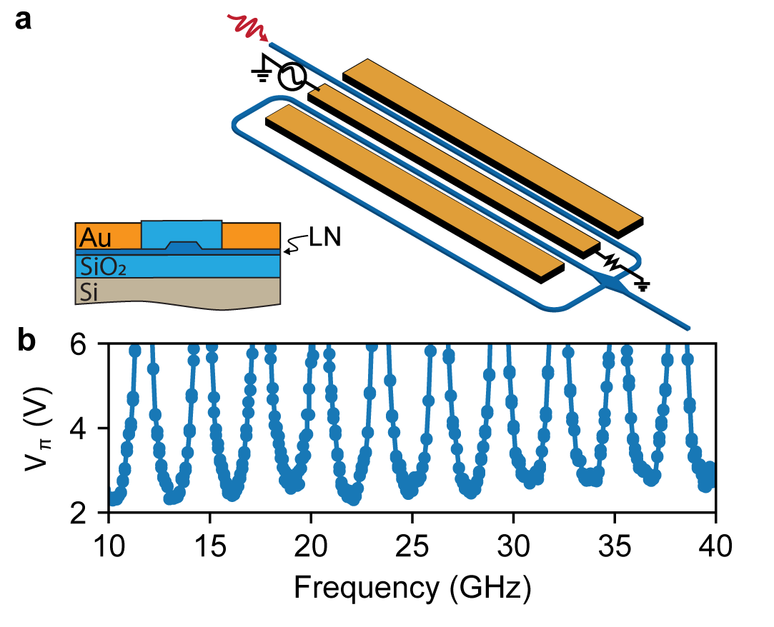
Figure S1. Device geometry and performance. a, Device layout and cross-section of the TFLN electro-optic phase modulator. The modulator adopts a double-pass configuration. This special design increases the interaction length between optical and RF fields, resulting in a reduced V_{π}. The physical size of the modulator (active area) is 2 cm × 600 μm. b, Measured V_{π} at 1550 nm wavelength. Efficient modulation happens when light is in-phase with the RF drive when it re-enters the coplanar waveguide electrode. At these phase-matched frequencies, the measured Vπ is between 2.3-2.8 V from 10 to 40 GHz.

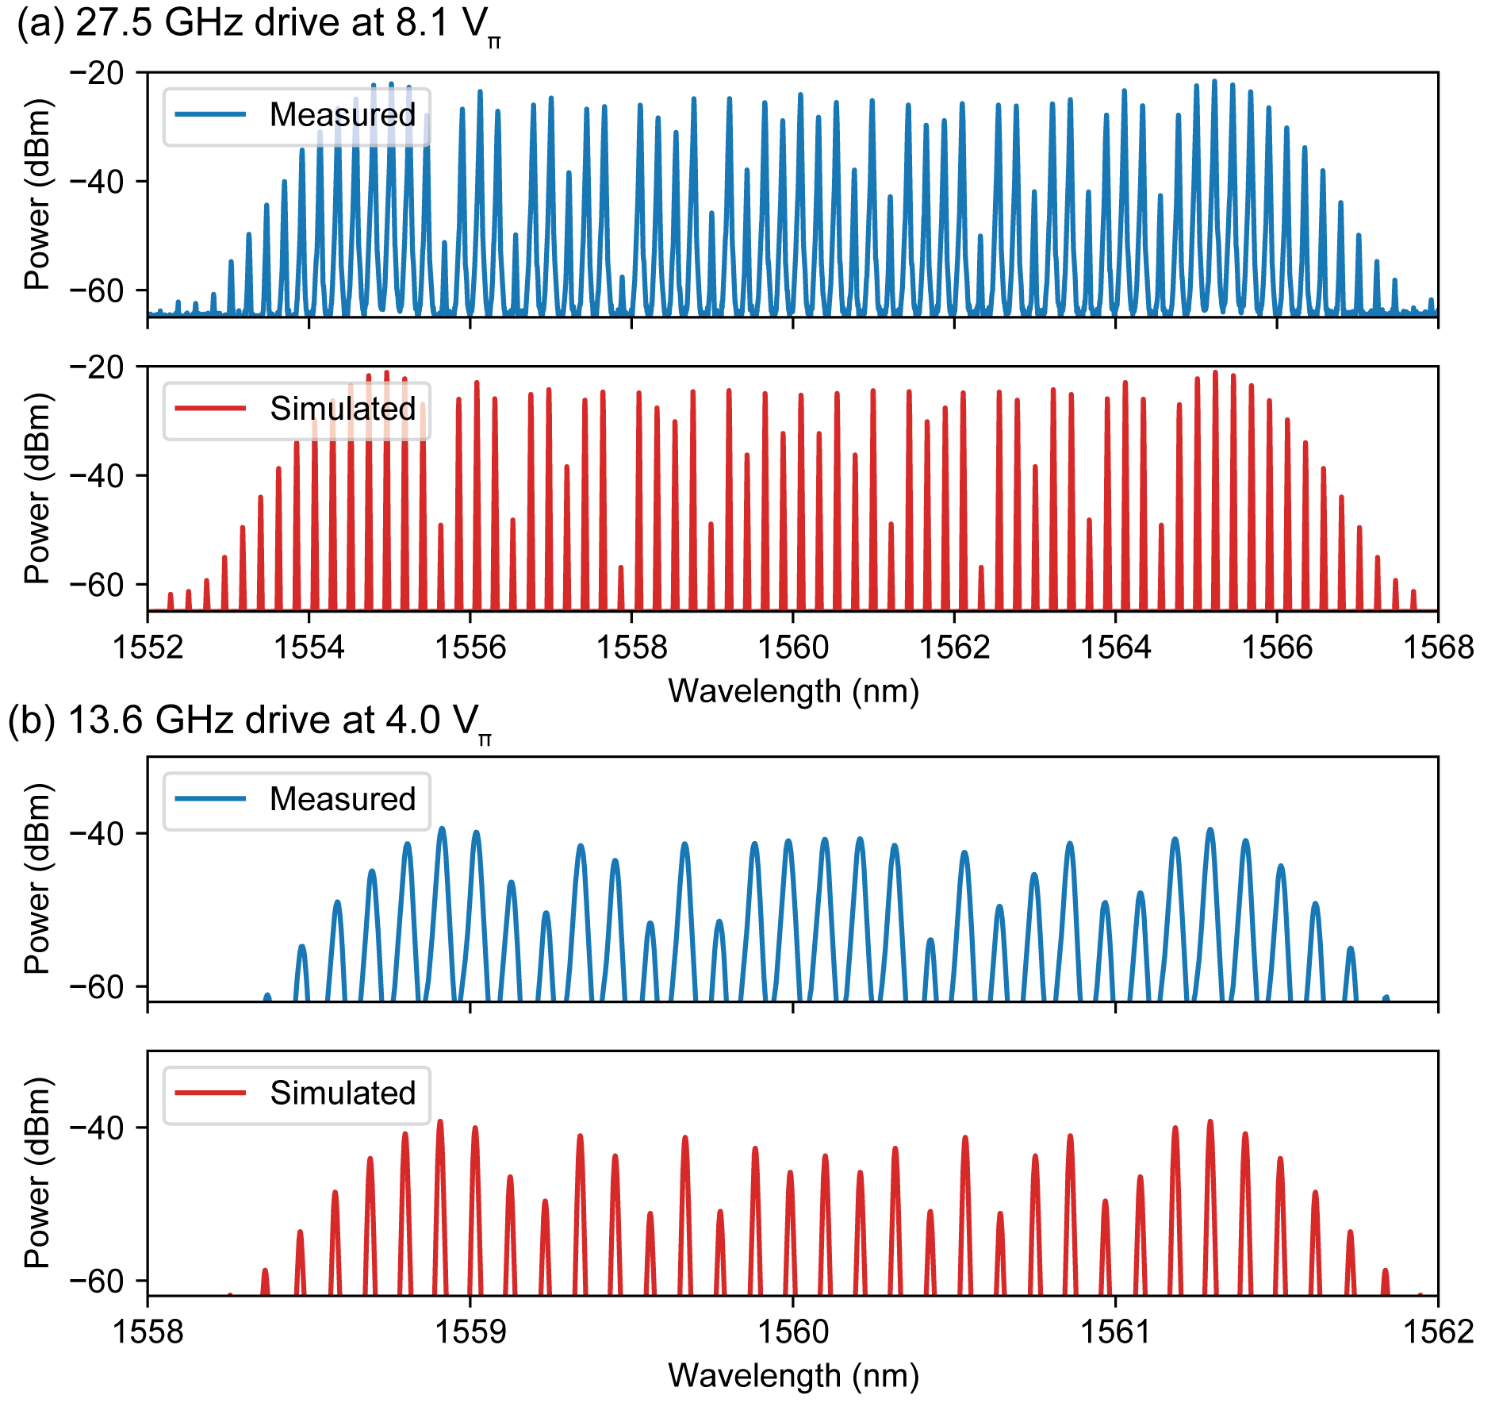
Figure S2. Modulation sidebands when the TFLN modulator was driven at conditions used in the main text. A classical continuous-wave laser was injected into the modulator and the output was measured using an optical spectrum analyzer. The driving amplitude in terms of number of V_{π} was estimated by fitting the measured spectra using a Bessel function. a, Driving condition in Figure 3 in the main text. b, Driving condition in Figure 4 and 5 in the main text.
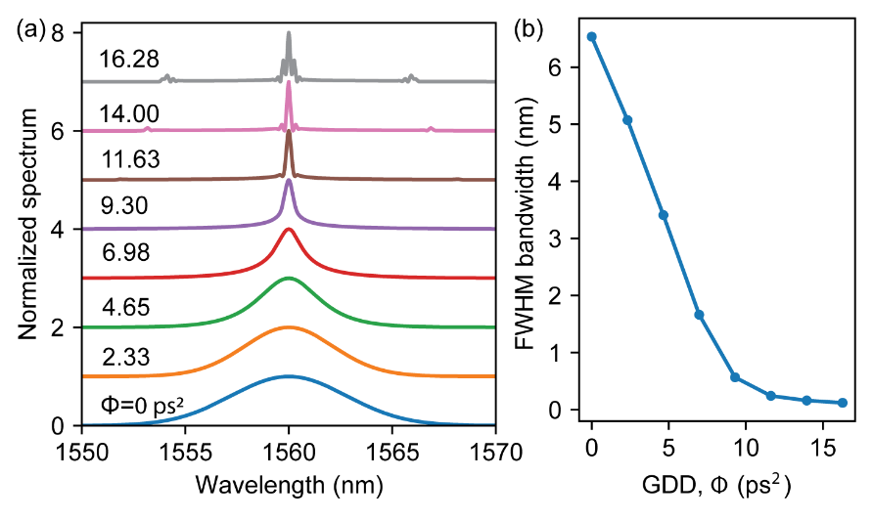
Figure S3. Time lens simulation. Simulated spectral shape (a) and FWHM bandwidth (b) after time lensing with increasing group delay dispersion (GDD) applied. When GDD exceeds ~10 ps², the dispersed optical pulse that enters the time lens become too wide and starts to overfill the time lens’ effective aperture. As a result, spectral distortion as well as sidebands are generated. However, these fine features are difficult to resolve in experiments due to limited measurement resolution. Instead, they manifest as an effectively broadened spectrum, as shown in Fig. 5c in the main text. In this simulation, the input photon has a center wavelength of 1560 nm and FWHM bandwidth of 6.55 nm. RF modulation is at 13.6 GHz and 4.0 $V_{π}$.

