Supplementary Information

Self-clocking fast and variation tolerant true random number generator based on a stochastic mott memristor

Gwangmin Kim, Jae Hyun In, Hakseung Rhee, Woojoon Park, Hanchan Song and Kyung Min Kim*

Department of Materials Science and Engineering, Korea Advanced Institute of Science and Technology (KAIST)
291 Daehak-ro, Yuseong-gu, Daejeon 34141, Republic of Korea
G. Kim and J. H. In contributed equally to this work.
*Correspondence and requests for materials should be addressed to K.M.K. (email: km.kim@kaist.ac.kr).

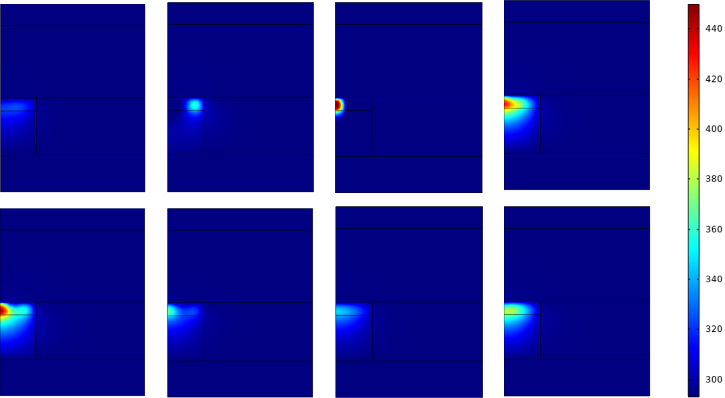
Figure S1 | Variation of heat distribution at the moment of threshold switching. The 8 heat maps were captured at the moment of the threshold switching, point 2 in Fig. 2e, during 8 pulse cycles. The simulation showed that not only the maximum temperature but also its position was changed at the moment of threshold switching. Such non-uniform variation of the heat can explain the thermal fluctuation during the switching cycle.

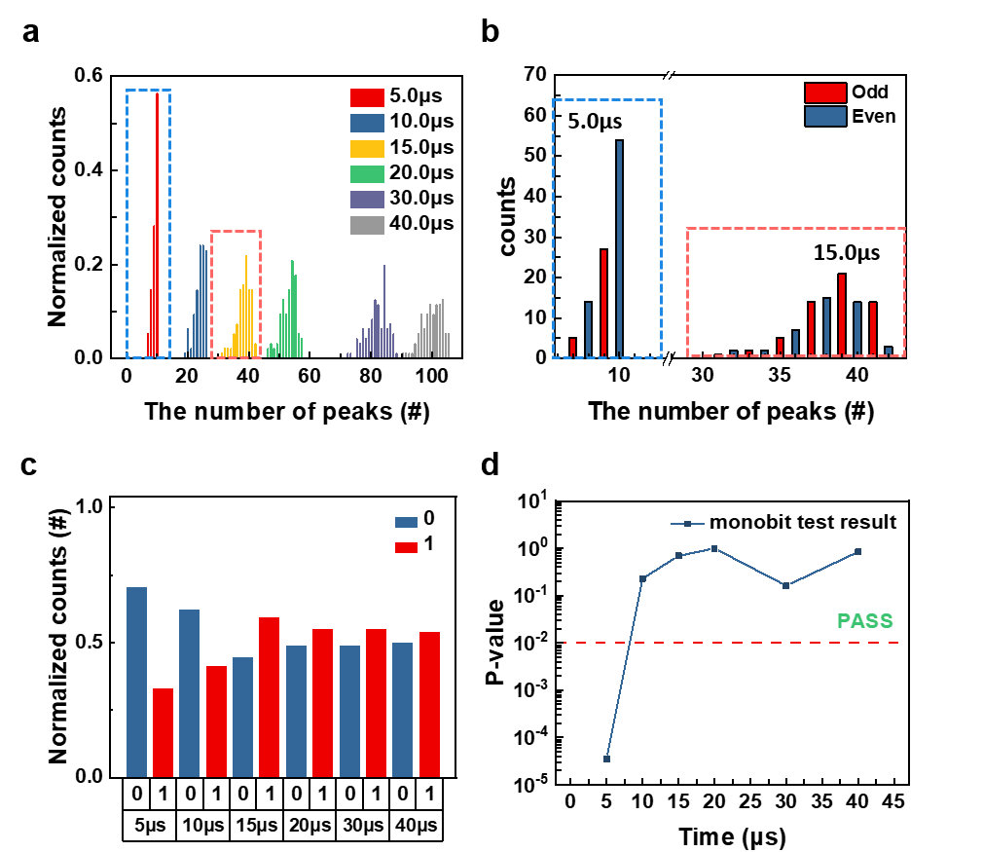
Figure S2 | Time-variant characteristic of the accumulation of stochasticity. a, The distribution of the total number of peaks at given pulse times. Each distribution was obtained from 100 cycles. b, The distribution of the number of peaks of 5 μs and 15 μs cases in a. It distinguishes the expected output, whether 1 or 0, as a function of the number of peaks. At a 5 μs of input pulse time, the number of peaks was ranging from 7 to 10, which is narrow. Also, their distribution was not uniform. Therefore, the 0 output was more frequent than 1, which was mainly determined by the majority case, 10. Whereas, at a 15 μs of input pulse time, the number of peaks was distributed broadly, ranging from 31 to 42. In this case, the portion of the odd and even numbers can be more random. c, A histogram showing the portion of 0 and 1 outputs for various input pulse time. At 5 µs and 10 µs pulse, the portion of ‘0’ is higher than ‘1’, inferring they are not true random numbers. The portion gets closer to 0.5 as the input pulse time gets longer, leading to the true random number generation. d, The P-value of the mono-bit test using the data of c.

