Supplementary Materials

Structural dynamics of AAA+ ATPase Drg1 and mechanism of benzo-diazaborine inhibition

Chengying Ma^{1,3}, Damu Wu^{1,3}, Qian Chen¹ and Ning Gao^{1, 2, *}

Affiliations:
¹ State Key Laboratory of Membrane Biology, Peking-Tsinghua Joint Center for Life Sciences, School of Life Sciences, Peking University, Beijing 100871, China.
² National Biomedical Imaging Center, Peking University, Beijing 100871, China
³ These authors contributed equally

*Correspondence to: gaon@pku.edu.cn

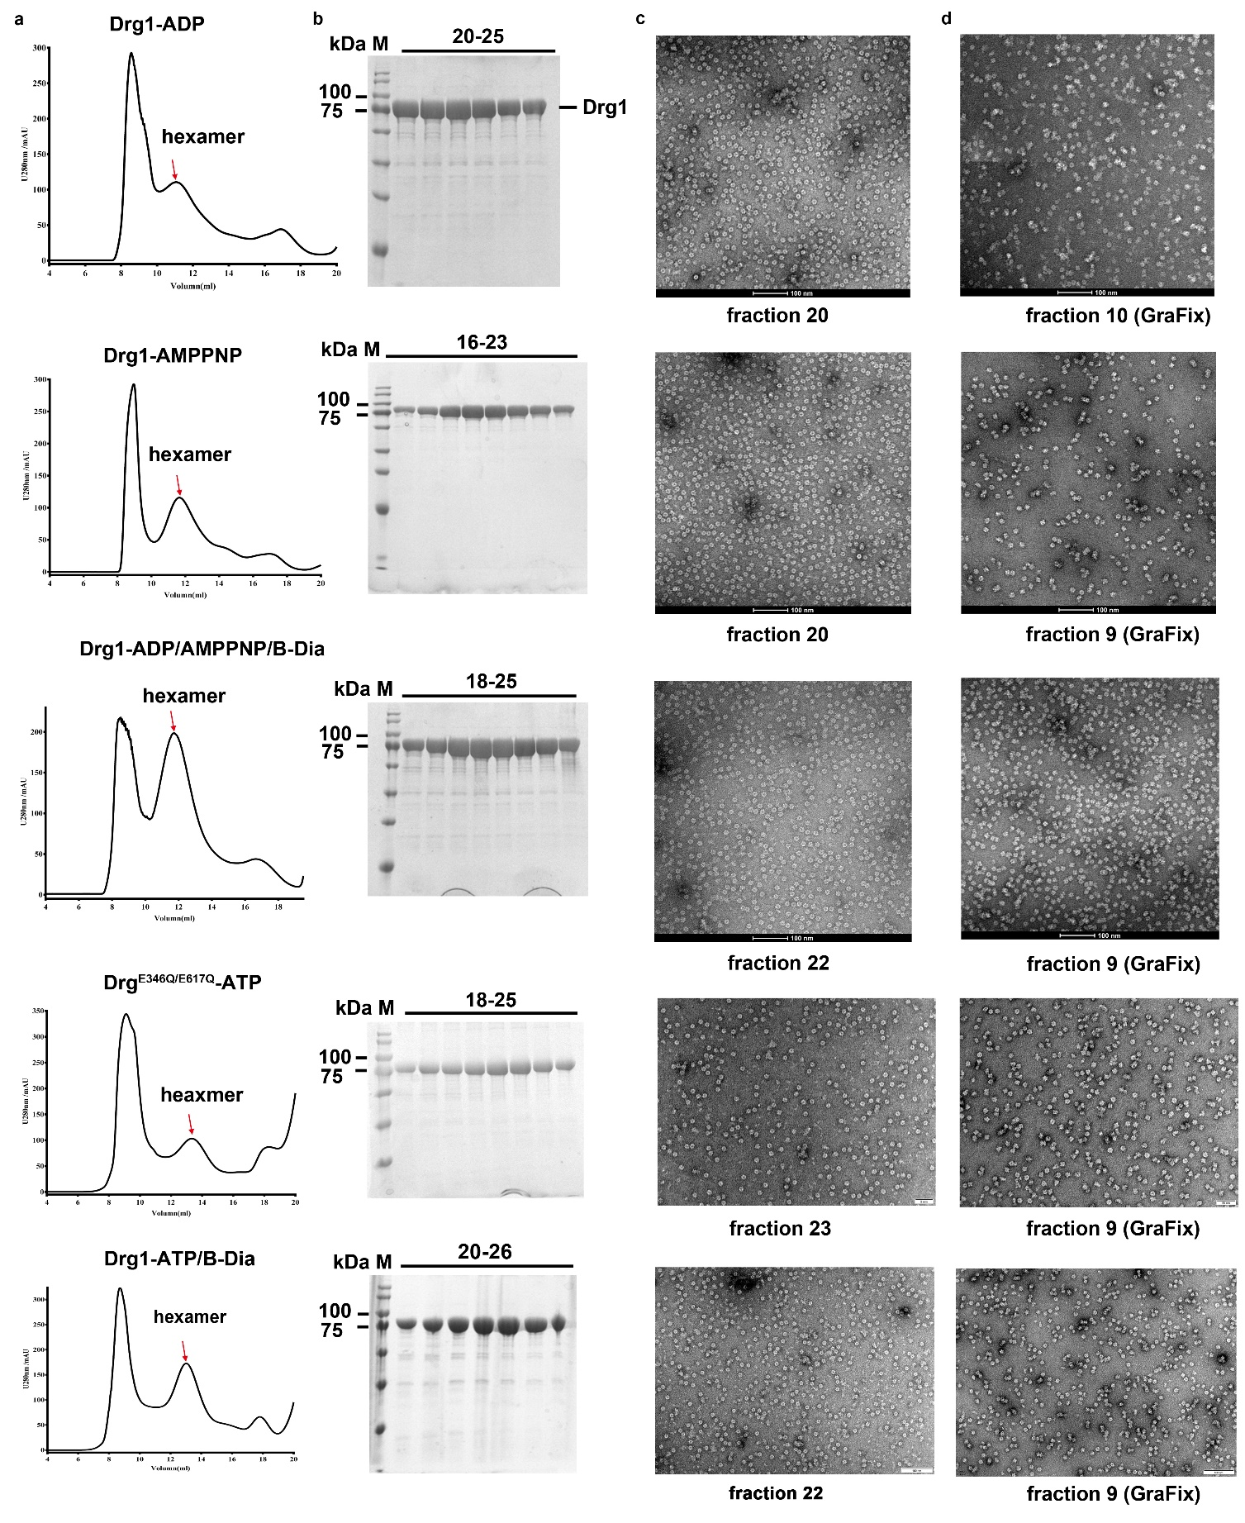
Supplementary Fig. 1 Sample preparation of Drg1 hexamers in different nucleotide or benzo-diazaborine binding states.
a, Purification of Drg1 hexamers in the presence ADP, AMPPNP, ADP/AMPPNP/B-Dia, ATP/B-Dia or ATP (for mutant Drg1^{E346Q/E617Q}) using size-exclusion chromatography. Hexamer fractions are indicated and labeled with arrows.
b, SDS-PAGE analysis of the hexamer fractions in (a).
c, Negative staining electron microscopy of the peak fraction of the hexamers in (a).
d, Negative staining electron microscopy of the hexamer fraction after the GraFix analysis.
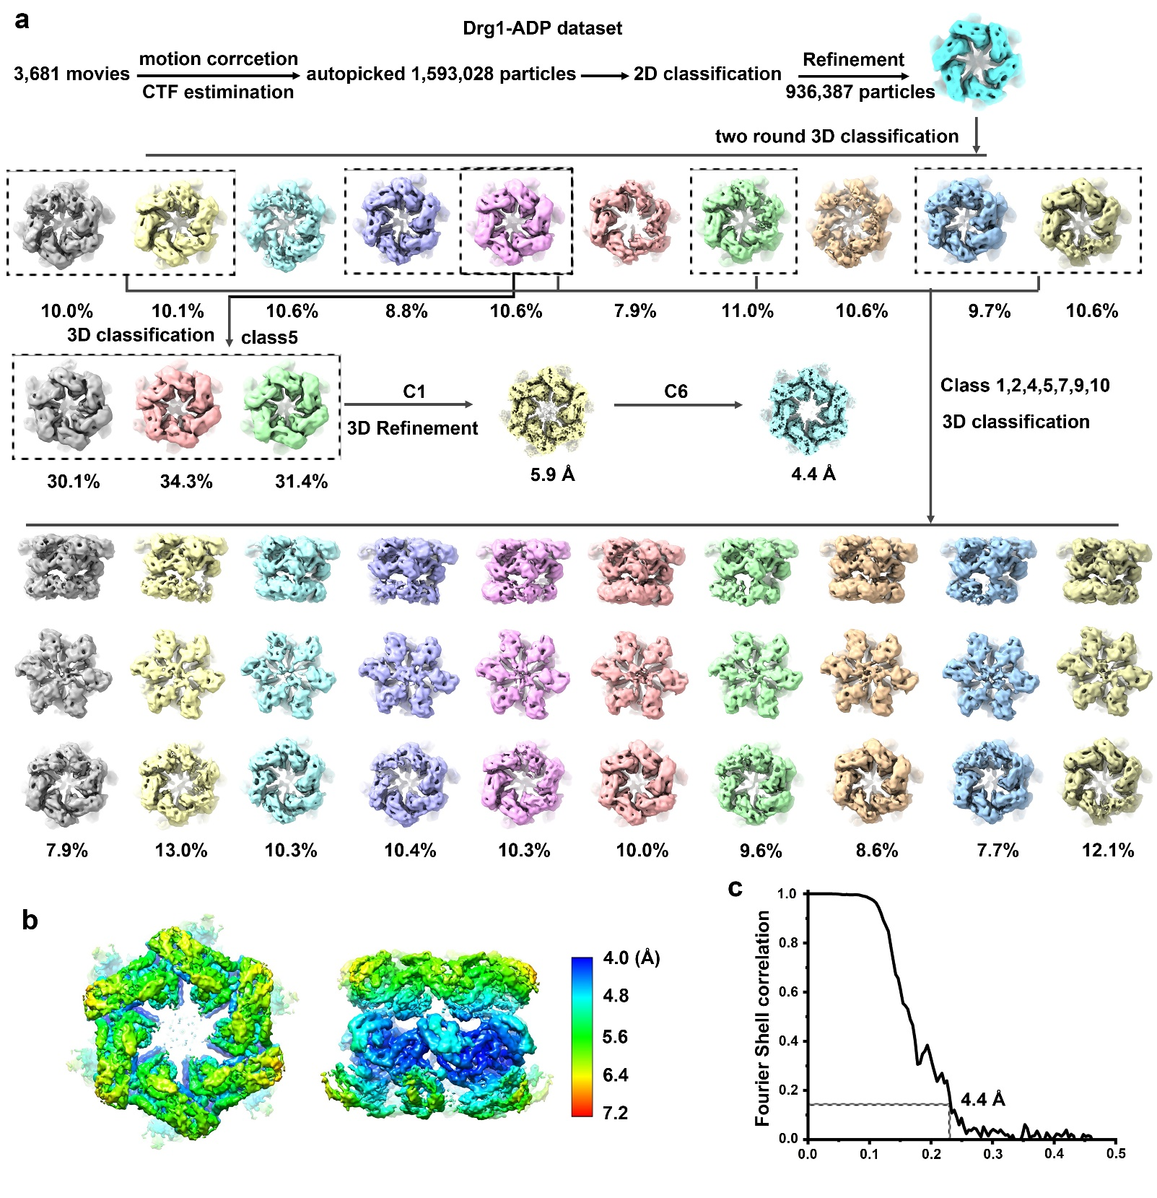
Supplementary Fig. 2 Image processing workflow of the Drg1-ADP dataset.
a, Image processing workflow of the Drg1-ADP dataset. The autopicked particles were subjected to multiple rounds of 2D and 3D classifications. Both the C1 and C6 symmetry were tested in the final refinement.
b-c, Local resolution estimation (b) and Fourier shell correlation (FSC) curves (c) of the final cryo-EM map (C6). The resolution was determined at the gold-standard FSC 0.143 criteria.

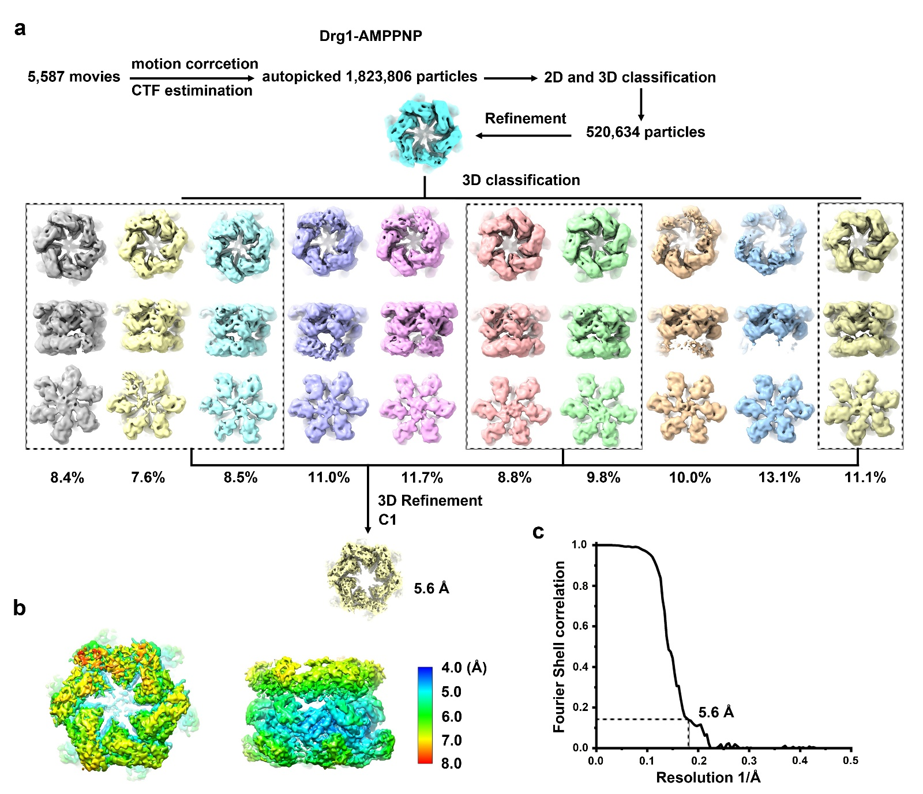

Supplementary Fig. 3 Image processing workflow of the Drg1-AMPPNP dataset.
a, Image processing workflow of the Drg1-AMPPNP dataset. The autopicked particles were subjected to multiple rounds of 2D and 3D classifications.
b-c, Local resolution estimation (b) and Fourier shell correlation (FSC) curves (c) of the final cryo-EM map (C1). The resolution was determined at the gold-standard FSC 0.143 criteria.

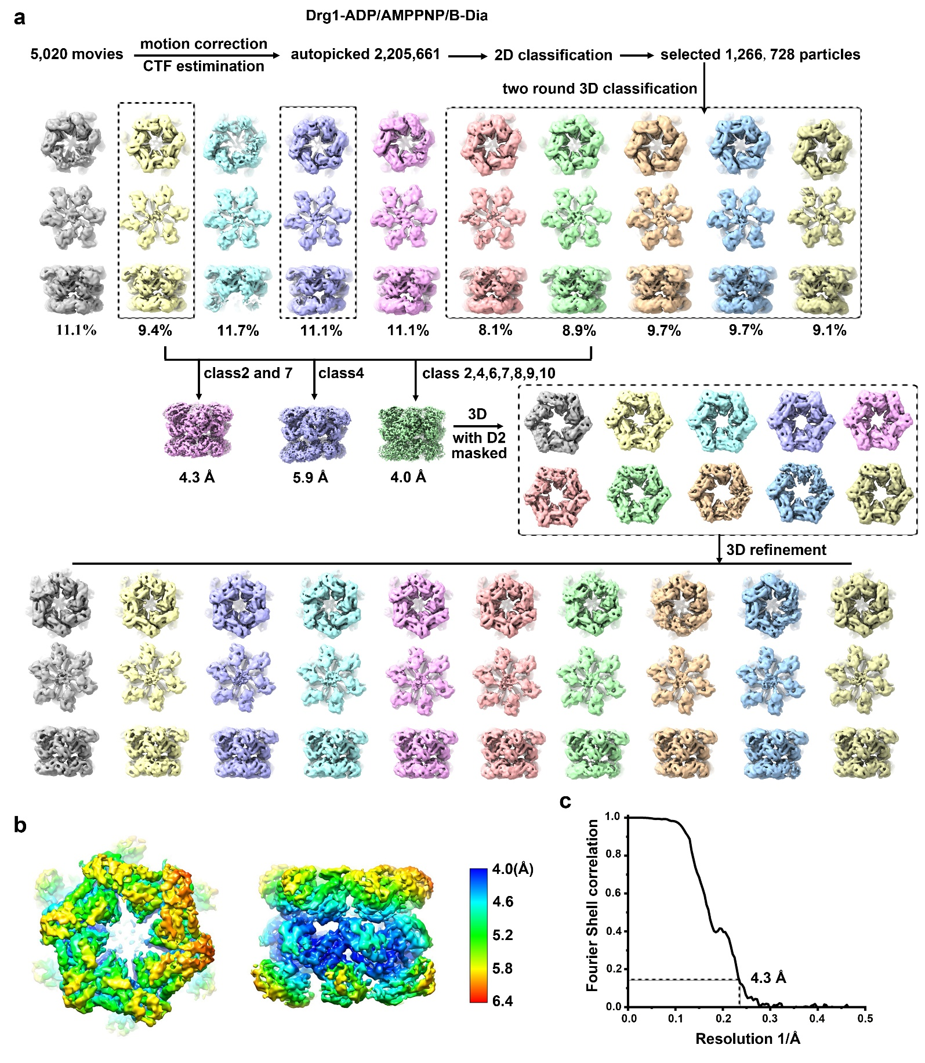
Supplementary Fig. 4 Image processing workflow of the Drg1-ADP/AMPPNP/B-Dia dataset.
a, Image processing workflow of the Drg1-ADP/AMPPNP/B-Dia dataset. The autopicked particles were subjected to multiple rounds of 2D and 3D classifications.
b-c, Local resolution estimation (b) and Fourier shell correlation (FSC) curves (c) of the final cryo-EM map (C1). The resolution was determined at the gold-standard FSC 0.143 criteria.

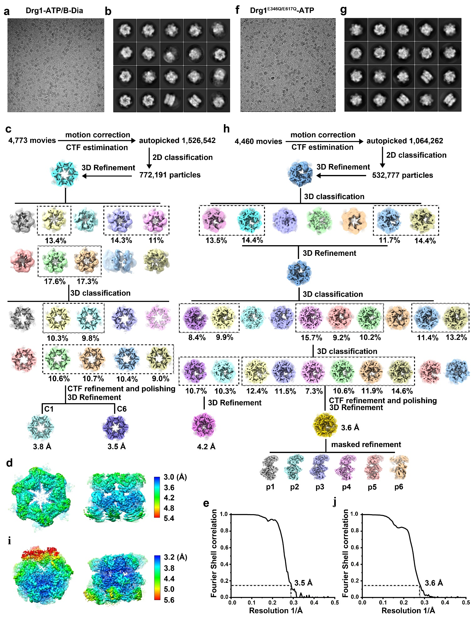
Supplementary Fig. 5 Image processing workflow of the Drg1-ATP/B-Dia and Drg1^{E346Q/E617Q}-ATP datasets.
a, A representative cryo-EM micrograph of the Drg1-ATP/B-Dia particles.
b, Representative 2D class averages of the Drg1-ATP/B-Dia particles.
c, Image processing workflow of the Drg1-ATP/B-Dia dataset. The autopicked particles were subjected to multiple rounds of 2D and 3D classifications. Both C1 and C6 symmetry were tested in the refinement.
d-e, Local resolution estimation (d) and Fourier shell correlation (FSC) curves (e) of the final cryo-EM map of the Drg1-ATP/B-Dia complex (C6). The resolution was determined at the gold-standard FSC 0.143 criteria.
f, A representative cryo-EM micrograph of the mutant Drg1-ATP particles.
g, Representative 2D class averages of the mutant Drg1-ATP particles.
h, Image processing workflow of the mutant Drg1-ATP dataset. The autopicked particles were subjected to multiple rounds of 2D and 3D classifications.
i-j, Local resolution estimation (d) and Fourier shell correlation (FSC) curves (e) of the final cryo-EM map of the mutant Drg1-ATP complex. The resolution was determined at the gold-standard FSC 0.143 criteria.

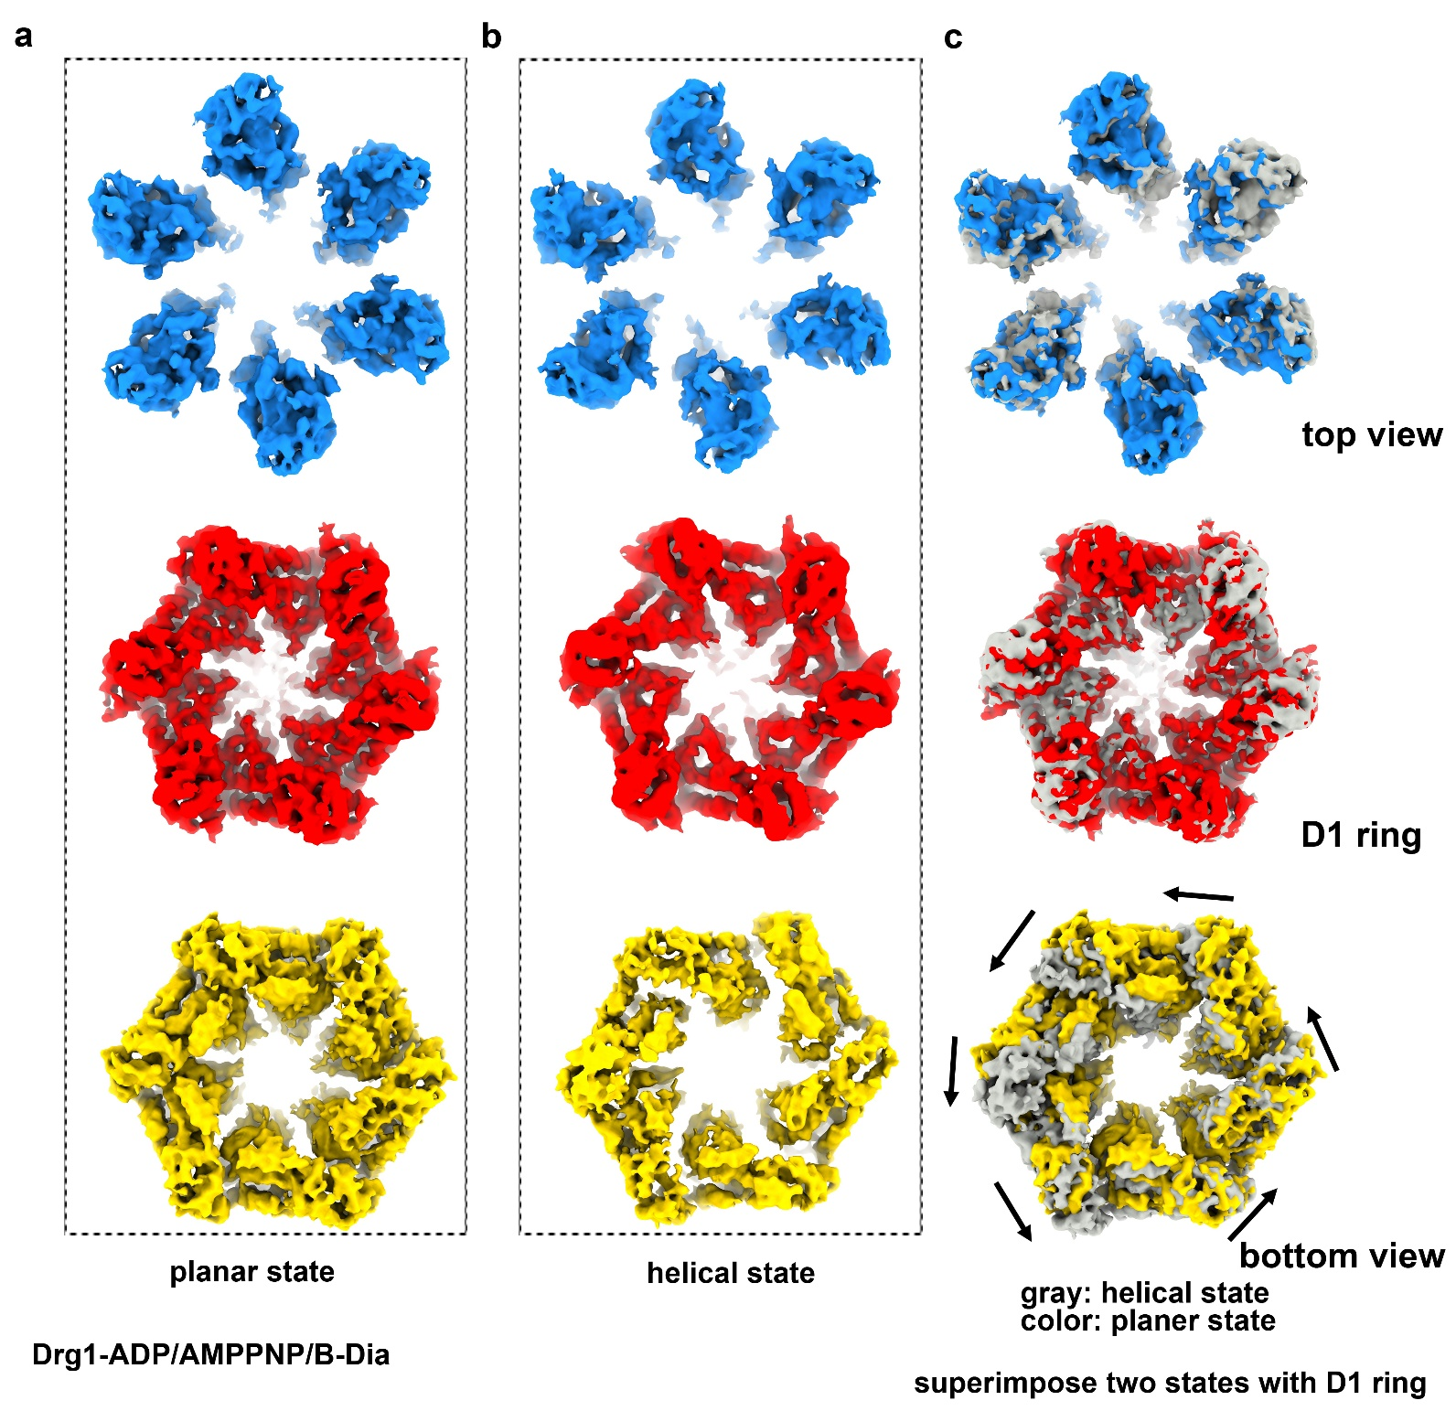
Supplementary Fig. 6 Structural comparison of planar and helical states of the Drg1 hexamers from the ADP/AMPPNP/B-Dia dataset.
a, Cryo-EM map of the NTD (top), D1 (middle) and D2 (bottom) rings of the Drg1 hexamer in the planar state from the Drg1-ADP/AMPPNP/B-Dia dataset.
b, Cryo-EM map of the NTD (top), D1 (middle) and D2 (bottom) rings of the Drg1 hexamer in the helical state from the Drg1-ADP/AMPPNP/B-Dia dataset.
c, Comparison of the NTD (top), D1 (middle) and D2 (bottom) rings of the planar and helical states. The two hexamer maps are aligned using the D1 rings as reference. Six subunits in the planar state are arranged more symmetrical while the subunits in the helical state adopt a spiral configuration. A large rotation of the D2 ring between the planar and helical states is shown and indicated by arrows.

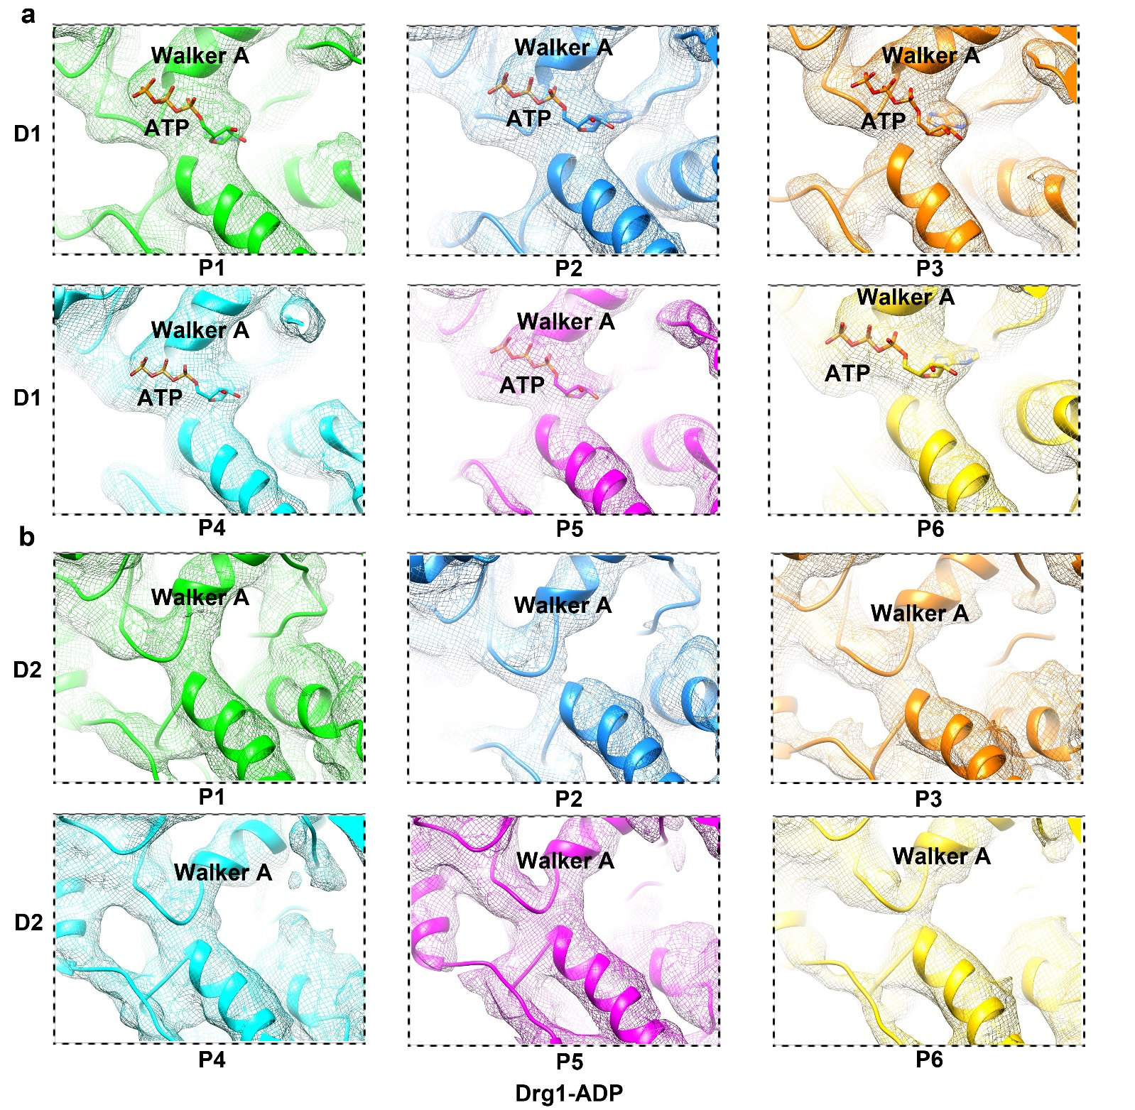
Supplementary Fig. 7 Nucleotide binding states of the 12 ATPase sites in a representative structure of the Drg1-ADP dataset.
a, ATP occupation of the six ATPase sites in the D1 ring. The atomic model and cryo-EM map are superimposed and color-coded for different protomers.
b, Empty pockets of the six ATPase sites in the D2 ring. The maps show that there is no obvious nucleotide binding to the pockets of the D2 domains.

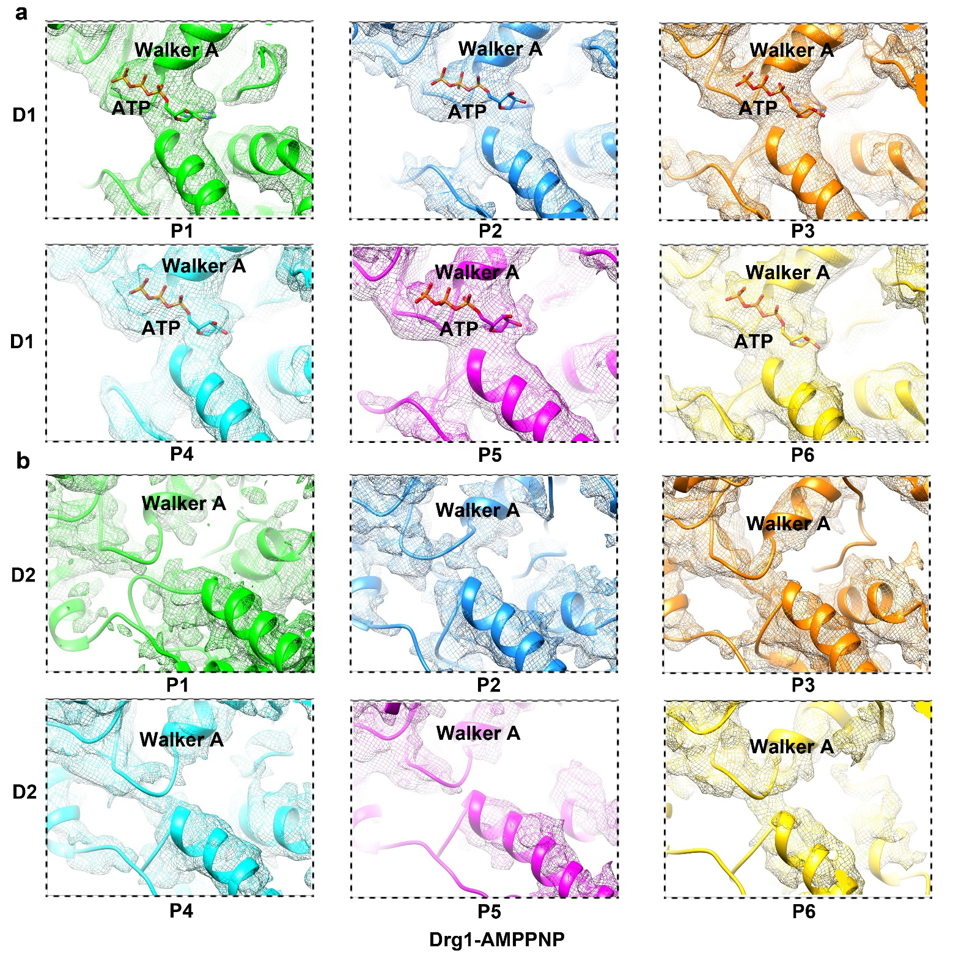
Supplementary Fig. 8 Nucleotide binding states of the 12 ATPase sites in a representative structure of the Drg1-ADP-AMPPNP dataset.
a, ATP occupation of the six ATPase sites in the D1 ring. The atomic model and cryo-EM map are superimposed and color-coded for different protomers. The map offers no distinction between ATP and AMPPNP.
b, Empty pockets of the six ATPase sites in the D2 ring. The maps show that there is no obvious nucleotide binding to the pockets of the D2 domains.

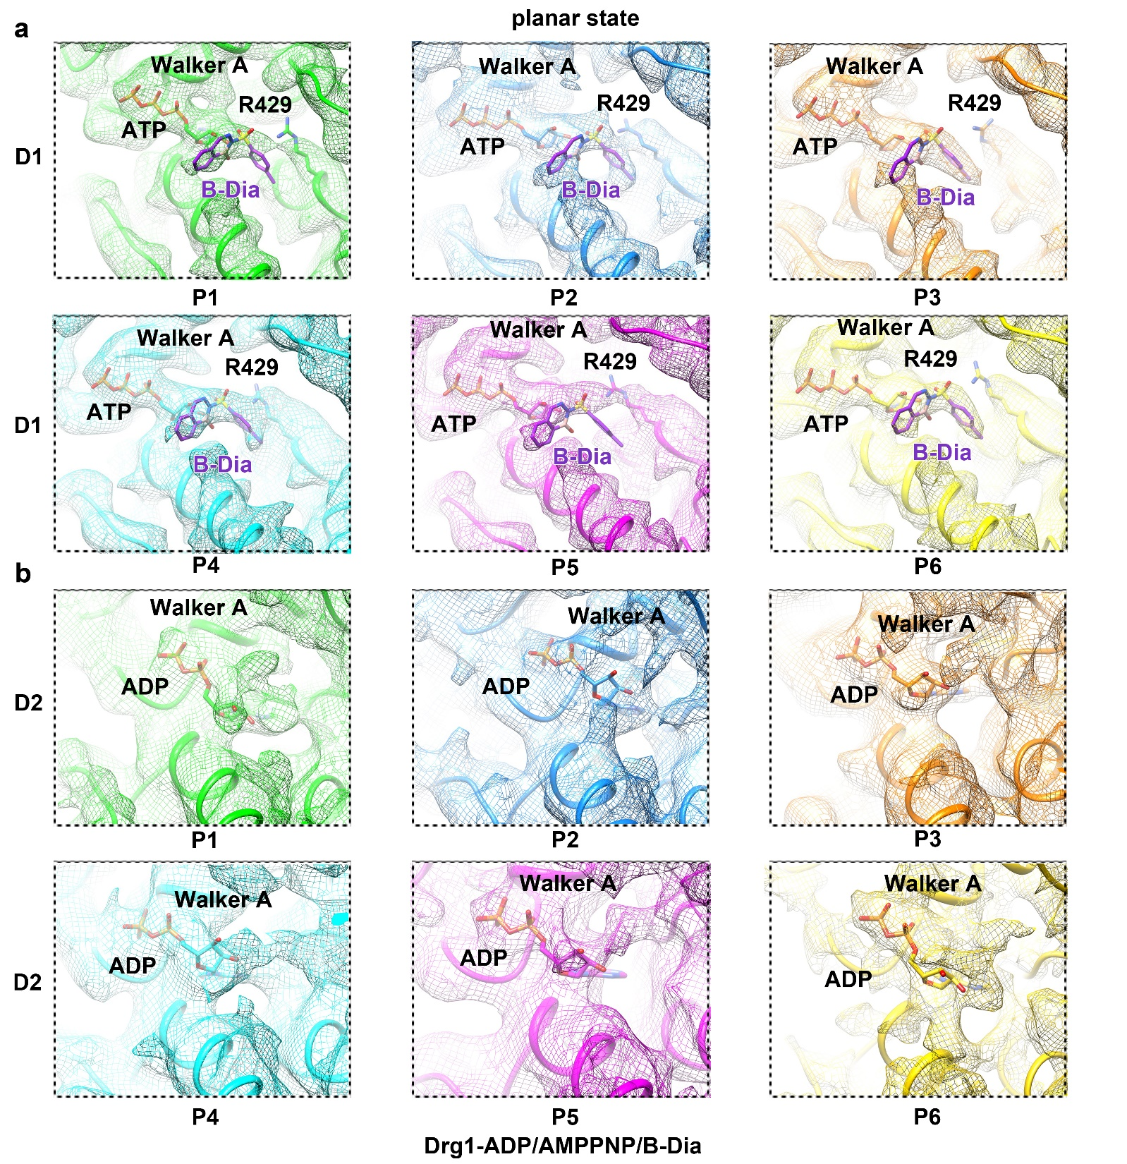
Supplementary Fig. 9 Nucleotide binding states of the 12 ATPase sites in the planar hexamer of the Drg1-ADP/AMPPNP/B-Dia dataset.
a, ATP and B-Dia occupation of the six ATPase sites in the D1 ring. The atomic model and cryo-EM map are superimposed and color-coded for different protomers.
b, Nucleotide occupation of the six ATPase sites in the D2 ring. The maps show that the six pockets of the D2 domains are all occupied. Fitting of ADP and ATP suggests a better fit for ADP in these sites. In addition, residual densities, very weak though, could be detected in expected B-Dia locations in the pockets of P1 and P6 (when displayed at low contour level).

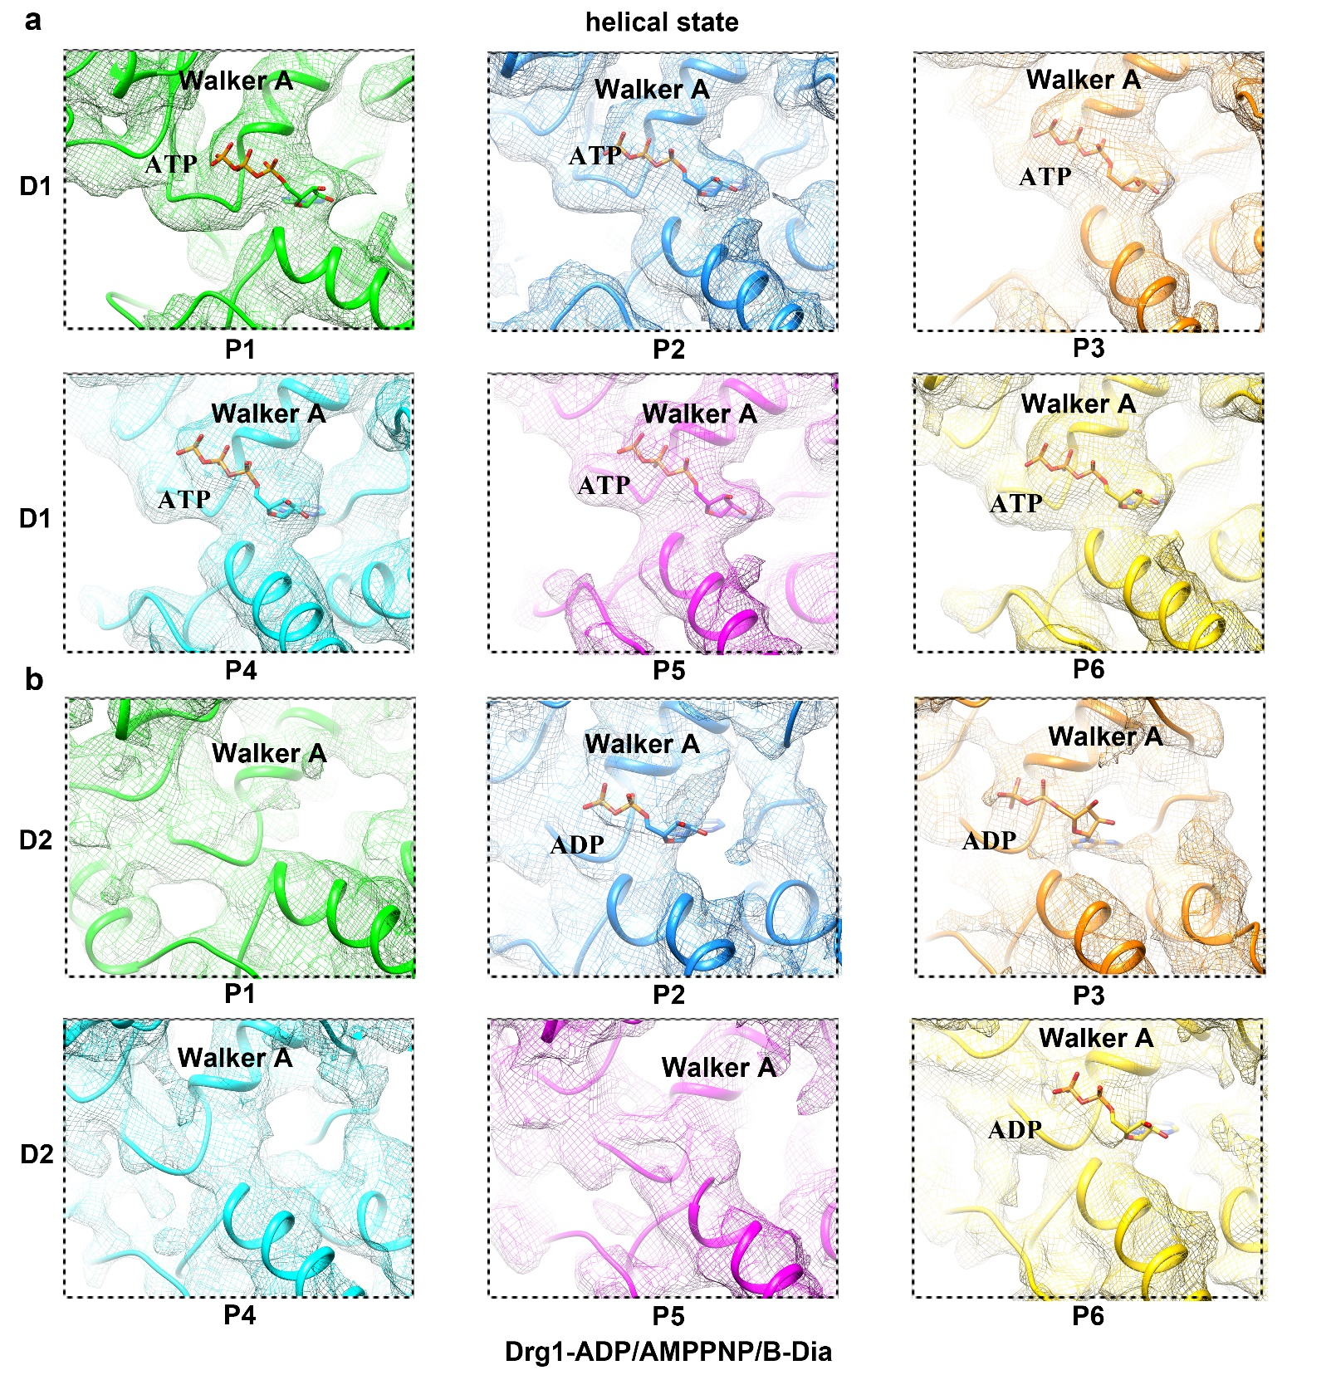
Supplementary Fig. 10 Nucleotide binding states of the 12 ATPase sites in the helical hexamer of the Drg1-ADP/AMPPNP/B-Dia dataset.
a, ATP occupation of the six ATPase sites in the D1 ring. The atomic model and cryo-EM map are superimposed and color-coded for different protomers.
b, Nucleotide occupation of the ATPase sites in the D2 ring. The local densities of the D2 pockets are not well ordered. The map suggests a presence of ADP in three D2 pockets, P2, P3 and P6.

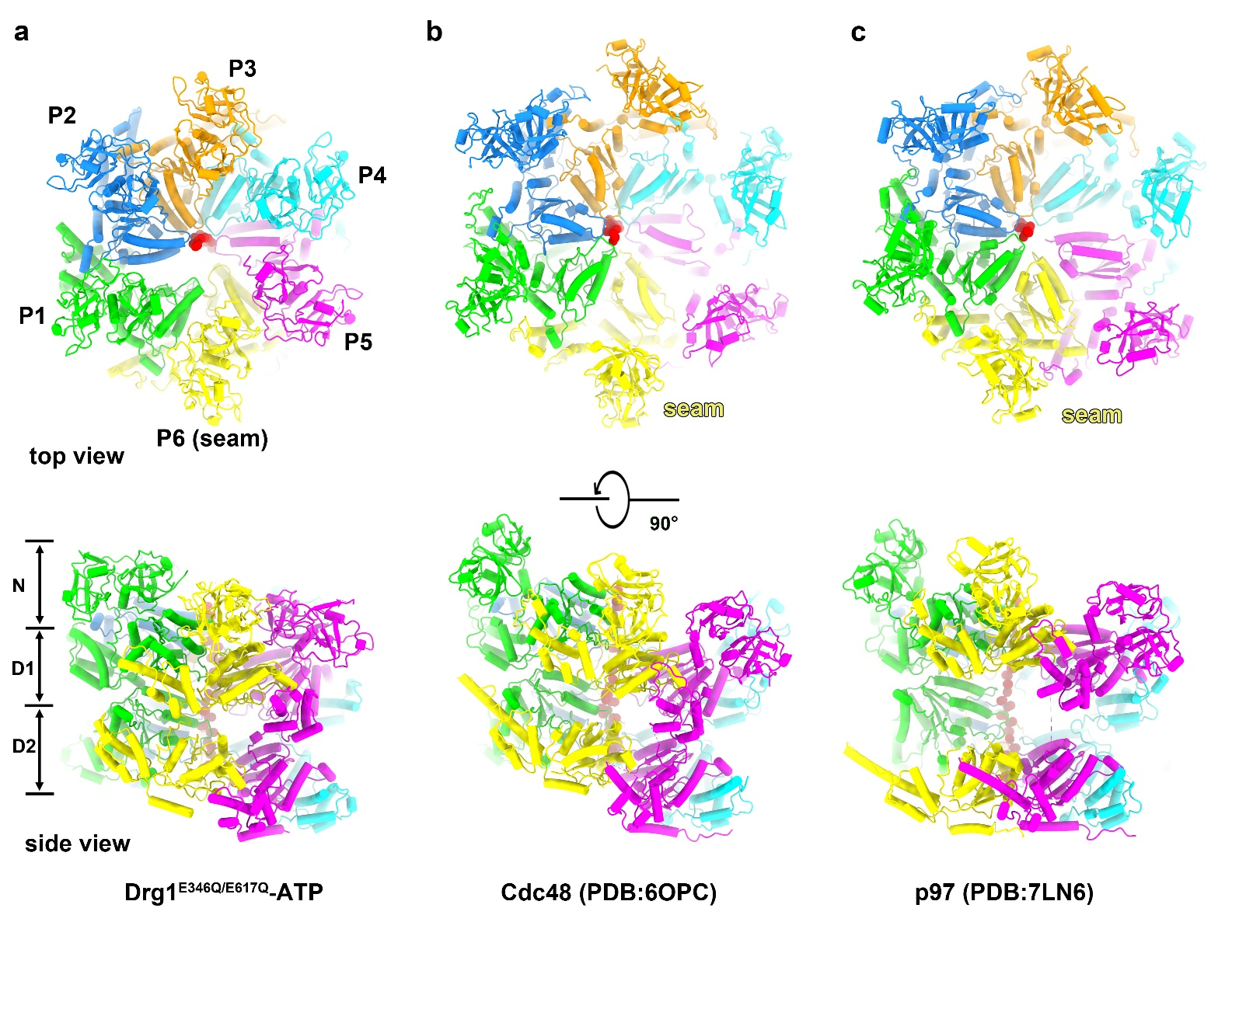
Supplementary Fig. 11 Structural comparison of S. cerevisiae Drg1, Cdc48 and H. sapiens p97 hexamers.
a, The atomic models of the Drg1, Cdc48 (PDB code: 6OPC) and p97 (PDB code: 7LN6) hexamers viewed from NTD.
b, The side view of Drg1, Cdc48 and p97 hexamers.

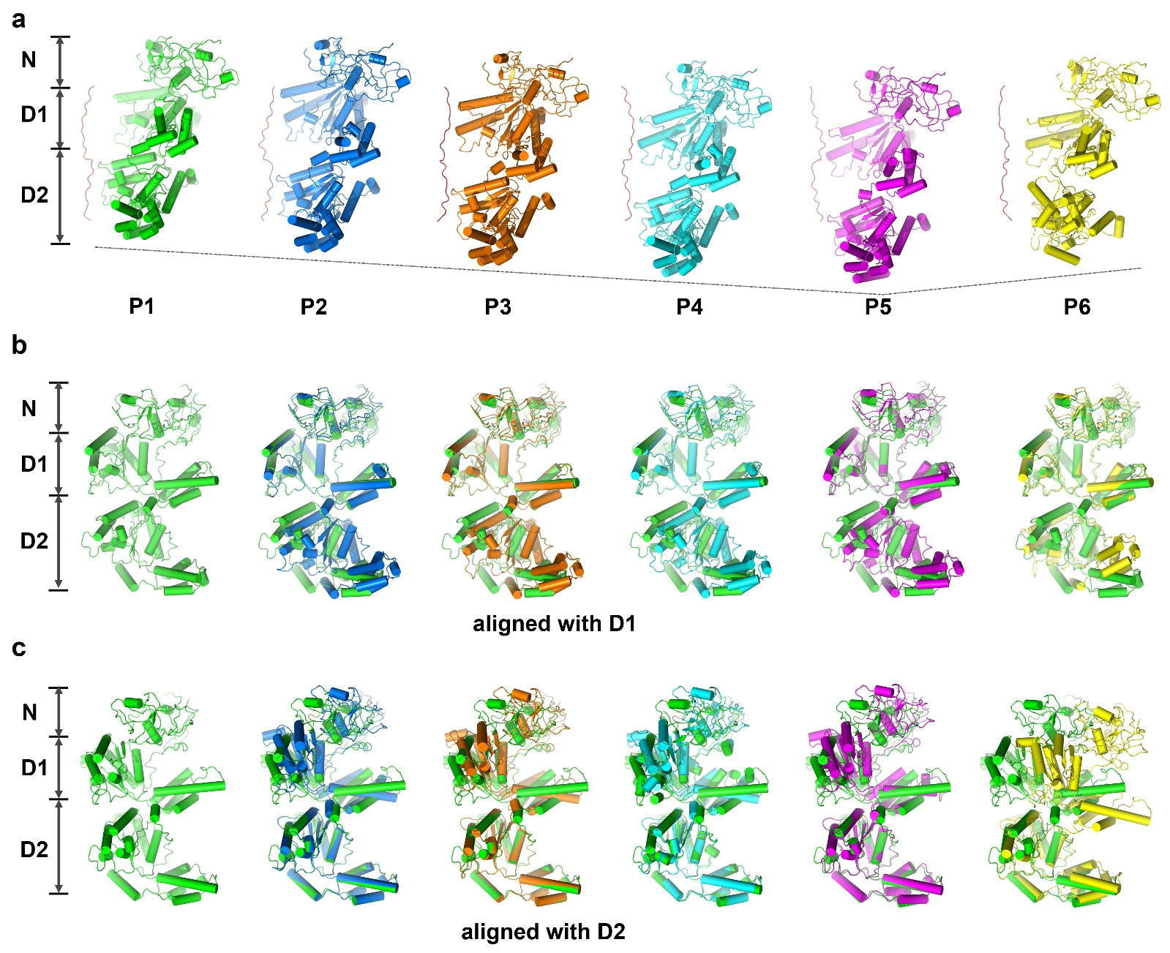
Supplementary Fig. 12 Structural comparison of the protomers from the Drg1^{E346Q/E617Q}-ATP complex.
a, Side-by-side comparison of the six protomers (P1 to P6). The view of each protomer was generated by consecutive 60º rotations around the substrate.
b, Pair-wise comparison of P1 with other five protomers using the D1 domain as reference. The NTD and D1 together show relative rigidity in all protomers. In contrast, the D2 domains could be grouped in three conformational groups, represented by P1, P2-P5, and P6.
c, Pair-wise comparison of P1 with other five protomers using the D2 domain as reference. Similar to b, the six protomers fall into three conformation groups according to the orientation of the D1 domain relative to the D2 domain.

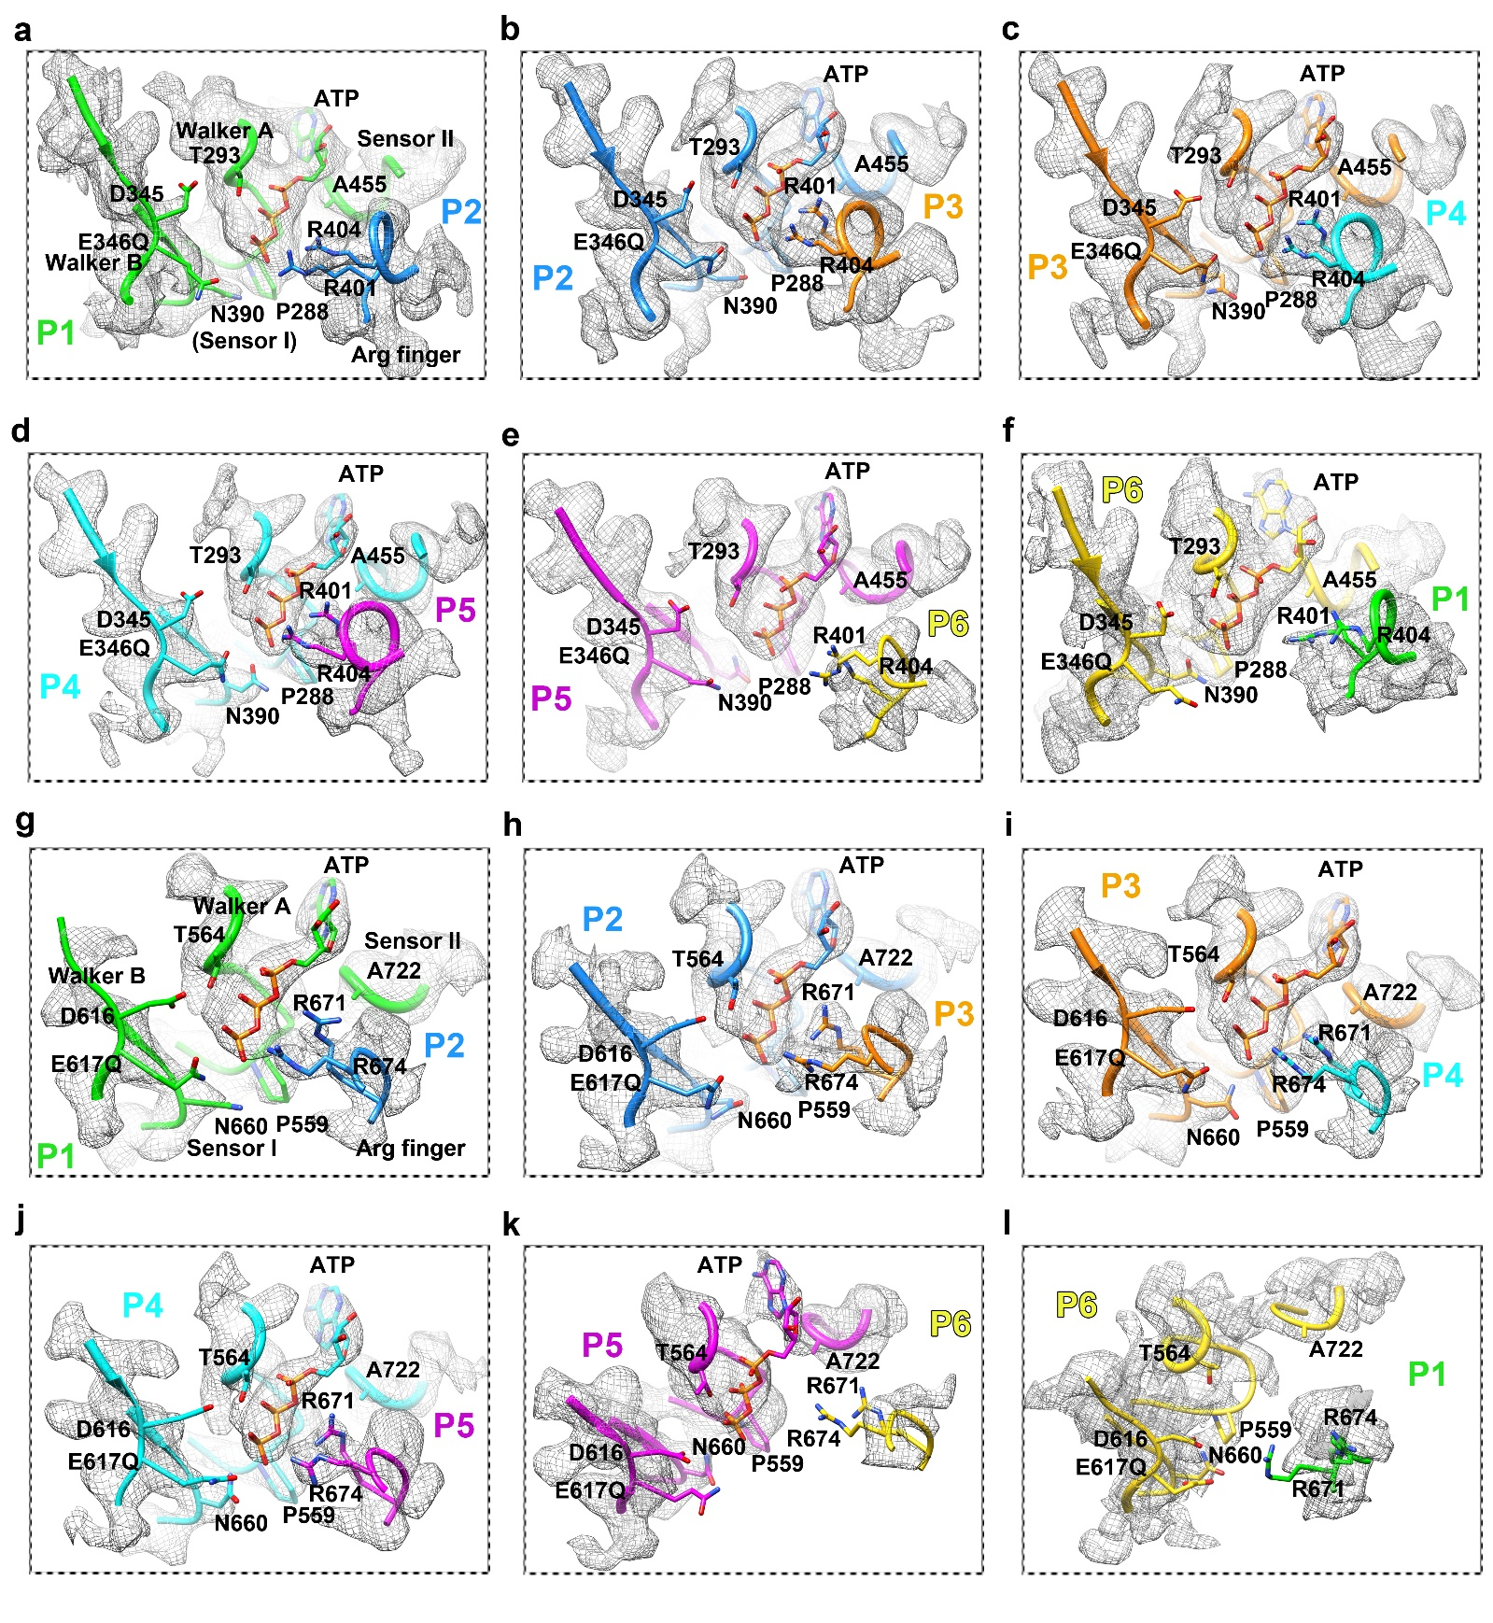
Supplementary Fig. 13 Atomic configuration of the 12 nucleotide binding sites in the Drg1^{E346Q/E617Q}- ATP complex.
a-f, Zoom-in views of the six nucleotide binding pockets in the D1 domains. Both the models and cryo-EM maps are shown. Selected residues of Walker A, Walker B, Sensor I, Sensor II and Arginine Finger are shown. All the six sites are occupied by ATP.
g-l, Zoom-in views of the six nucleotide binding pockets in the D2 domains. The sites of P1 to P5 are occupied by ATP. The pocket of P6 is empty.

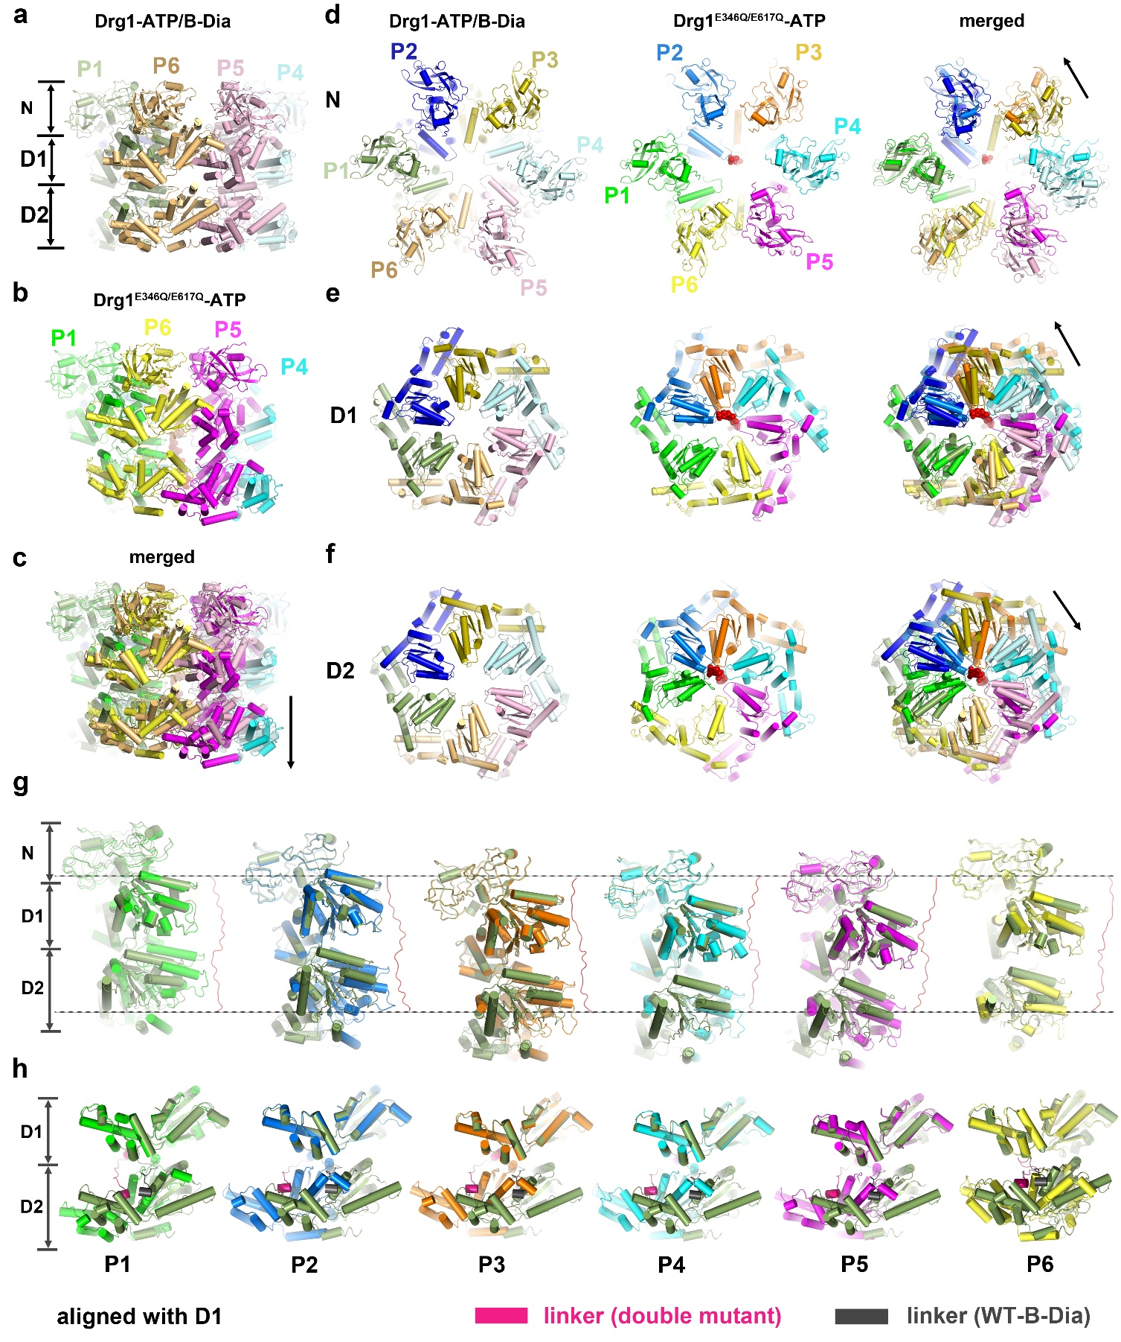
Supplementary Fig. 14 Structural comparison of the Drg1-ATP/B-Dia and Drg^{E346Q/E617Q}-ATP complexes.
a-c, Structural comparison of the Drg1-ATP/B-Dia and Drg1^{E346Q/E617Q}-ATP hexamers. Side views of the Drg1-ATP/B-Dia hexamer (a), the Drg1^{E346Q/E617Q}-ATP hexamer (b) and the superimposed models of these two structures (c) are shown. The two models were aligned using one of their D1 domains as reference. Specifically, since the Drg1-ATP/B-Dia hexamer display a near six-fold symmetry, the D1 domain of one of its subunits was used as reference of alignment to the D1 domain of P1 from the Drg^{E346Q/E617Q}-ATP complex.
d-f, Similar as a-c, for the comparisons of the NTD, D1 and D2 rings. Domain movements are indicated by arrows.
g, Protomer comparison between the Drg1^{E346Q/E617Q}-ATP and Drg1-ATP/B-Dia complexes. The six protomers of the Drg1^{E346Q/E617Q}-ATP hexamer (P1 to P6) are aligned with a typical subunit (forest green) of the Drg1-ATP/B-Dia hexamer using the D1 domain as reference. According to the orientation of the D2 domain relative to the D1 domain, the conformation of the protomer of the Drg1-ATP/B-Dia hexamer is different from those of the Drg1^{E346Q/E617Q}-ATP hexamer.
h, Similar to g, but displayed with a rotation to highlight that the protomer of the Drg1-ATP/B-Dia hexamer is conformationally distinct from all the six protomers of the Drg1^{E346Q/E617Q}-ATP hexamer. A landmark used for comparison is the linker between the D1 and D2 domain. As shown, this linker (containing a short helix) is in sharply different positions between the protomer of the Drg1-ATP/B-Dia hexamer and the six protomers of the Drg1^{E346Q/E617Q}-ATP hexamer.

Table S1. Statistics of data collection and image processing of the Drg1-ADP, Drg1-AMPPNP, Drg1-ADP/AMPPNP/B-Dia and Drg1-ATP/B-Dia datasets.

Data collection and processing
Datasets | Drg1-ADP | Drg1-AMPPNP | Drg1-ADP/AMPPNP/B-Dia |  | Drg1-ATP/Dia
Electron microscope | Titan Krios | Titan Krios | Titan Krios |  | Titan Krios
Voltage (KV) | 300 | 300 | 300 |  | 300
Electron detector | K2 | K2 | K2 |  | K2
Magnification | 130,000X | 130,000X | 130,000X |  | 130,000X
Electron dose (e-/Å²) | 64 | 80 | 64
Pixel size (Å) | 1.052 | 1.057 | 1.052 |  | 1.052
Defocus range (μm) | -1.0 to -2.5 | -1.0 to -2.5 | -1.0 to -2.5 |  | -1.0 to -2.5
Total micrographs | 3,681 | 5,587 | 5,020 |  | 4,773
Initial particle (no.) | 1,593,028 | 1,823,806 | 2,205,661 |  | 1,526,542
Final particle (no.) | 51,928 | 285,167 | 148,413 | 88,912 | 348,781
Symmetry imposed | C1 and C6 | C1 | C1 | C1 | C1 and C6
Map resolution (Å) | 5.9 Å (C1)  4.4 Å (C6) | 5.6 Å | 4.3 Å  (planar) | 5.9 Å  (helical) | 3.8 Å (C1)  3.5 Å (C6)
Refinement
Map sharping B-factor (Å²) | -100 (C1)  -100 (C6) | -334 | -100 | -50 | -50 (C1)  -100 (C6)
Fourier shell correlation | 0.143 | 0.143 | 0.143 | 0.143 | 0.143
Map resolution range (Å) | ~4.0 - 7.0 Å (C6) | ~4.0 - 7.5 Å | ~4.0 - 6.5 Å | ~4.5 - 7.5 Å | ~3.0 - 5.0 Å  (C6)

Table S2. Statistics of data collection, processing and model validation of Drg1^{E346Q/E617Q}-ATP dataset.
Data collection
Dataset | Drg1^{E346Q/E617Q} -ATP
Electron microscope | Titan Krios
Voltage (KV) | 300
Electron detector | K2
Magnification | 130,000X
Electron dose (e-/Å²) | 64
Pixel size (Å) | 1.057
Defocus range (μm) | -1.5 to -2.5
Total micrographs | 4,460
Initial particle (no.) | 1,064,262
Final particle (no.) | 152,973
Symmetry imposed | C1
Map resolution (Å) | 3.6 Å
Refinement
Map sharping B-factor(Å²) | -30
FSC threshold | 0.143
Map resolution range (Å) | ~3.2-6.0 Å
Peptide chains | 7
Residues | 4,383
Number of atoms | 33,894
Ligands | 11 (ATP)
R.m.s. deviations
Bonds length (Å) | 0.005
Bonds angles (⁰) | 0.701
Ramachandran plot
Favored (%) | 92.97
Outliers (%) | 0.25
Allowed (%) | 6.77
Validation
Molprobity score | 2.07
Clashscore | 12.83
Poor rotamers (%) | 0

