Supplementary Figure 1

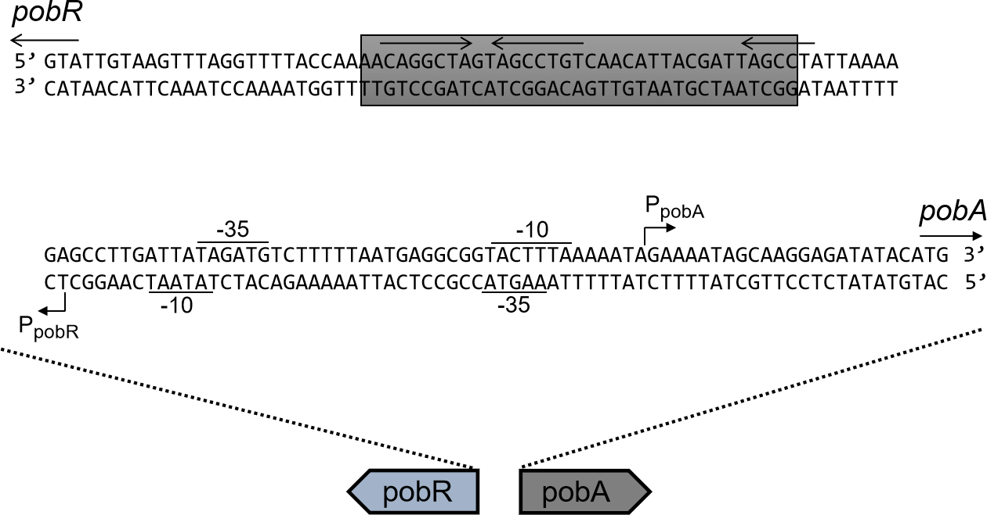

Supplementary Figure 1. The sequence of the pobR-pobA intergenic region. The transcription start sites (TSSs) are indicated by curved arrows. The proposed translation start points are shown by long arrows. The proposed -10/-35 region as RNA polymerase binding sites are denoted, and the PobR binding site is marked by a gray box, in which an inverted repeat is indicated.

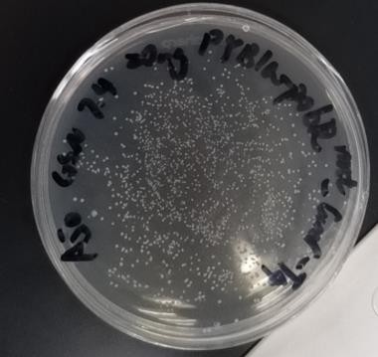

Supplementary Figure 2. The colonies formed on an exemplary plate after the plasmids harboring different PobR mutants were transformed into DH5α competent cell. Based on our calculation, 55 colonies were obtained by 1 ng of the plasmids.

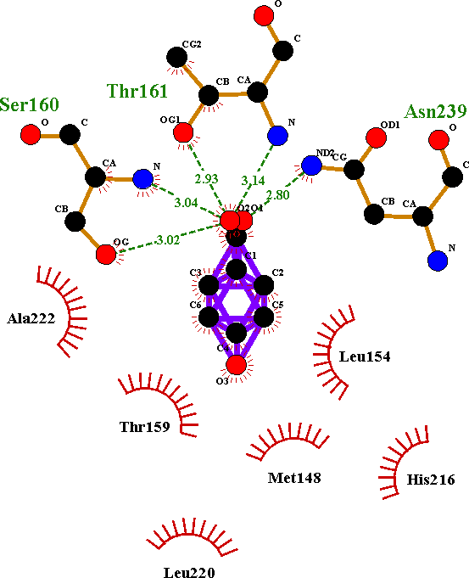

Supplementary Figure 3. Schematic diagram of the predicted interaction force between 4HB and the PobRWT protein. The green dotted lines represent hydrogen bond formation and bond lengths, and the red semicircles show hydrophobic interaction. Images were generated using Ligplus.

Strains and plasmids:

Strain | Description | Source
DH5α | deoR endA1 gyrA96 hsdR17 (rk- mk+)recA1 relA1 supE44 thi-1 Δ(lacZYA- argF)U169 Φ80lacZ ΔM15F - λ | Lab stock
BL21(DE3) | F-ompT hsdS(rB-mB-) gal dcm (DE3) | Lab stock
plasmid
PYB1a-eGFP | Ampicillin resistance, Green fluorescent  protein | this study
PYB1a-PobR-  eGFP-Cmr | Ampicillin resistance, PobR gene, Green fluorescent protein, Chloramphenicol resistance | this study
PYB1a-PobRmut(P5- B7)-eGFP-Cmr | Ampicillin resistance, PobR gene containing mutations encoding E16V, E124G, H125R respectively, Chloramphenicol resistance, Green fluorescent protein | this study
PYB1a-PobRmut (P7- E8)-eGFP-Cmr | Ampicillin resistance, PobR gene containing mutations encoding L122P, E126V respectively, Chloramphenicol Resistance, Green fluorescent protein | this study

Supplementary Table2: Primers:
No | Primer | Sequence (5’ to 3’) (Bold letters indicate mutation sites.) | Use
1 | Spm16-F | CGGTACGGATCACTTCCGAG  CTATGTGGGTGAG | Site-directed mutagenesis of PobR  to introduce E16V.
2 | Spm16-R | ATCCGTACCGAAGATTACAT CGCCGGTCTG | Site-directed mutagenesis of PobR to introduce E16V.
3 | Spm122-F | CGTGCTCGTCTGGGACAACG ATTGAGAAGGTCAG | Site-directed mutagenesis of PobR to introduce L122P.
4 | Spm122-R | AGACGAGCACGAGGTGGTG CCGGTTG | Site-directed mutagenesis of PobR to introduce L122P.
5 | Spm124-F | CCACCTCGTGCCCGTCTAGG ACAACGATTGAGA | Site-directed mutagenesis of PobR to introduce E124G.
6 | Spm124-R | CACGAGGTGGTGCCGGTTGC CAGAAGCTAT | Site-directed mutagenesis of PobR to introduce E124G.
7 | Spm125-F | GCACCACCTCGCGCTCGTCT AGGACAACGATTG | Site-directed mutagenesis of PobR to introduce H125R.
8 | Spm125-R | GAGGTGGTGCCGGTTGCCAG AAGCTATCTG | Site-directed mutagenesis of PobR to introduce H125R.
9 | Spm126-F | CGGCACCACCACGTGCTCGT CTAGGACAACG | Site-directed mutagenesis of PobR to introduce E126V.
10 | Spm126-R | GGTGGTGCCGGTTGCCAGAA GCTATCTGCC | Site-directed mutagenesis of PobR to introduce E126V.

11 | PobR- Gibson-F | AATTGTCTGATTCGTTACCA ATTAAACCAAGTTGCGCAGT TC | Construction of plasmid pYB1a- PobR
12 | PobR- Gobson-R | AGCTCCTCGCCCTTGGACAT ATGTATATCTCCTTGCTAT | Construction of plasmid pYB1a- PobR
13 | pYB1a- Gibson-F | ATGTCCAAGGGCGAGGAGC TGTTCACCGGGGT | Construction of plasmid pYB1a- PobR
14 | pYB1a- Gibson-R | TGGTAACGAATCAGACAATT GACGGCTTG | Construction of plasmid pYB1a- PobR
15 | Chl-F | ATGTCCAAGGGCGAGGAGC TGTTCACCGGGGT | Construction of plasmid pYB1a- PobR
16 | Chl-R | TGGTAACGAATCAGACAATT GACGGCTTG | Construction of plasmid pYB1a- PobR
17 | PobR- mut-F | TTAAACCAAGTTGCGCAGTT CAT | Construction of plasmid pYB1a- PobR-eGFP-Chl
18 | PobR- mut-R | ATGGAACAGCATCACCAAT ATCTAG | Construction of plasmid pYB1a- PobR-eGFP-Chl

