Supplemental figures

Supplementary Table 1. List of all results from RNAseq
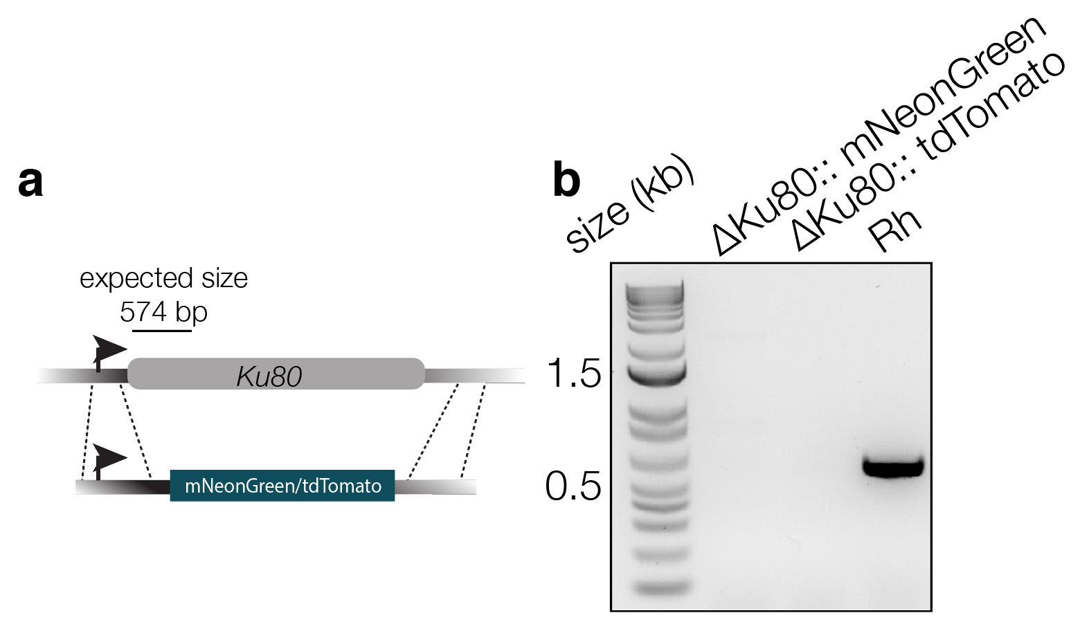
Figure S1. Creation of new ΔKu80 lines expressing mNeonGreen or tdTomato a. Schematic indicating how the endogenous ku80 gene was replaced with the mNeonGreen or tdTomato cassette. b. PCR reactions of region indicated in (a), confirming the loss of the endogenous gene.

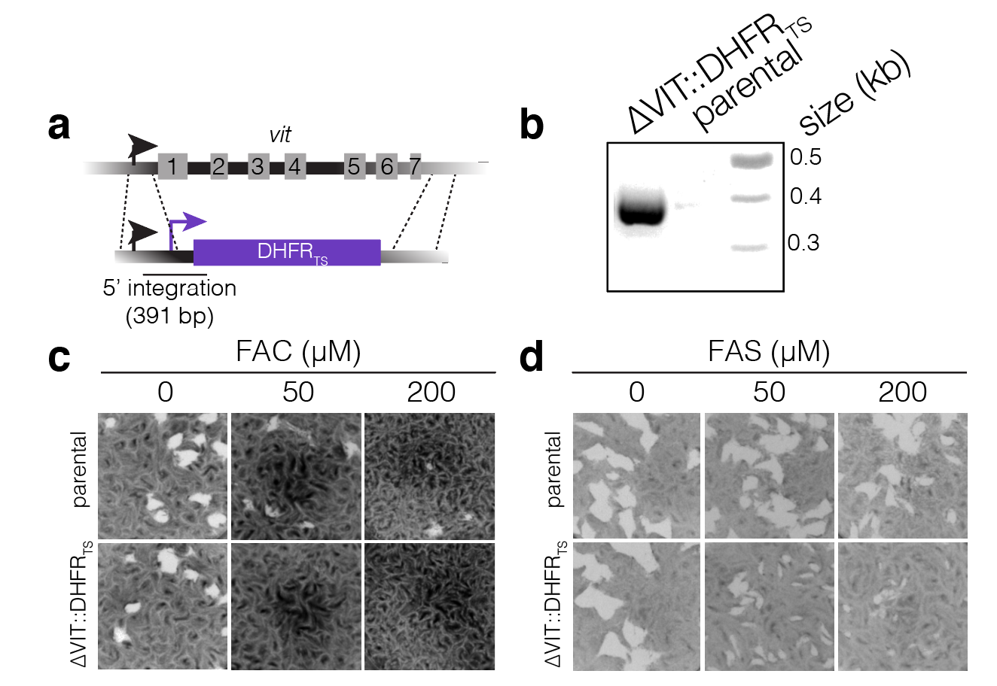

Figure S2. Construction of ΔVIT::DHFR_{TS} parasite line. a. Schematic showing how vit was replaced with the DHFR cassette. b. PCR showing the 5’ integration of the DHFR cassette. Plaque assays showing increased sensitivity of the ΔVIT::DHFR_{TS} line to excess ferric ammonium citrate (FAC) (c) and ferrous ammonium sulphate (FAS) (d) at the indicated concentration compared to the parental parasite line.

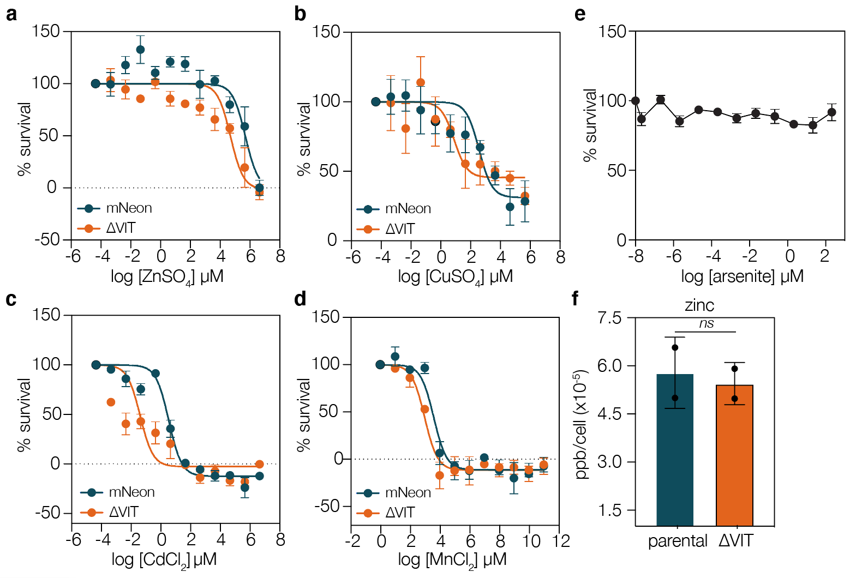
Figure S3. Dose response curves of mNeon and ΔVIT treated with excess metals. As described above, parasites were treated with the indicated concentration of ZnSO₄ (a), CuSO₄ (b), CdCl₂ (c), or MnCl₂ (d). All experiments are the mean of four (ZnSO4) or three (CuSO₄, CdCl₂, and MnCl₂) independent experiments performed in triplicate, ± SEM. e. Survival of uninfected HFF cells at the range of sodium arsenite concentrations used above. No change in fluorescence was seen at the concentrations used. Results are the mean n =3, ± SEM. f. ICP-MS quantifying zinc (66 Zn) from parental and ΔVIT parasites. Each point represents independent biological replicates, performed in technical duplicate. Bars at mean ± SD.

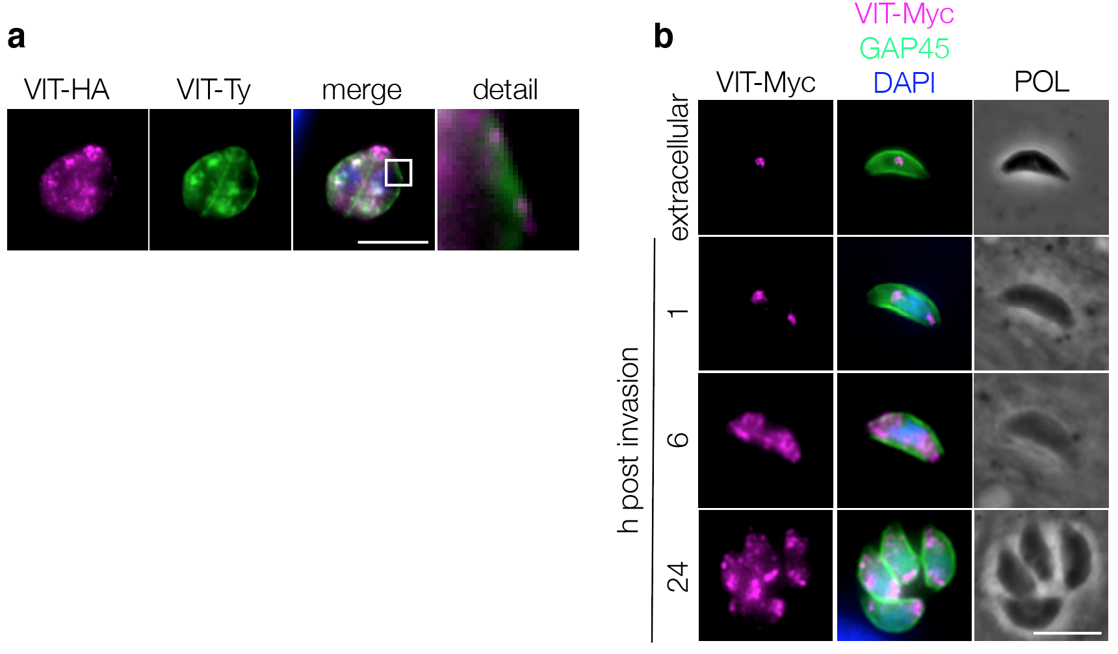
Figure S4. VIT-HA colocalises with VIT-Ty. a. Colocalisation of endogenously expressed VIT-HA with overexpressed VIT-Ty. Scale bar 5 μm. b. Endogenously tagged VIT-Myc has a dynamic localisation and fragments between 1 and 6 h post invasion. Scale bar 5 μm.

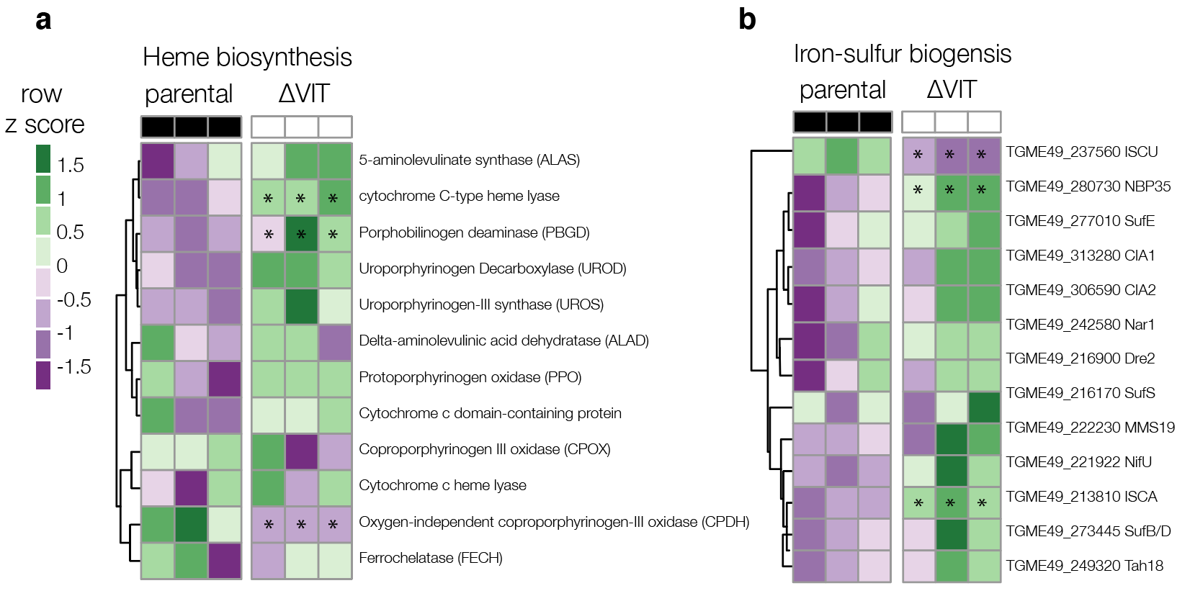
Figure S5. Heatmaps of genes from major iron pathways from parental and ΔVIT parasites a. Genes involved in the heme biosynthesis pathway, read counts normalised across rows. * indicates adj. p value of < 0.05 between parental and ΔVIT strain. b. Genes involved in Fe-S biogenesis read counts, normalised across rows. * indicates adj. p value of < 0.05 between parental and ΔVIT strain.

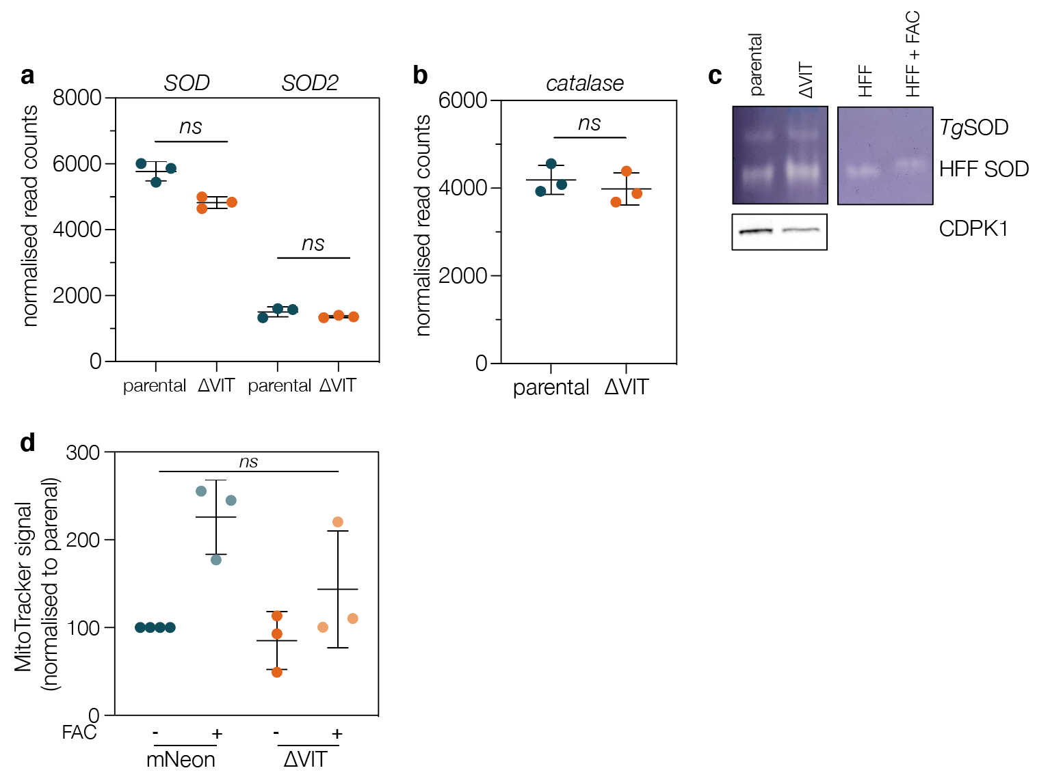

Figure S6. ΔVIT parasites do not alter transcription of oxidative stress genes a. Normalised read counts for SOD (TGME49_316310) and SOD2 (TGME49_316330) from RNAseq. SOD3 (TGME49_316190) is not expressed under these conditions (data not shown). Each point represents an independent experiment, performed in duplicate. Line at mean ± SD. b. Normalised read counts for catalase (TGME49_232250). Each point represents an independent experiment, performed in duplicate. Line at mean ± SD. p value from t test with FDR correction. c. In gel activity assay for SOD, enzyme activity results in cleared areas on gel. Host (HFF) and parasite enzymes indicated, CDPK used as a parasite loading control. No obvious differences were seen between the parental and ΔVIT parasite lines. Results representative of two independent experiments. d. MitoTracker signal was measured by flow cytometry and normalised to the mNeon untreated line. Although FAC treatment led to generally increased signal, no significant differences were seen (Kruskal-Wallis test, Dunns multiple comparison correction). Each point represents an independent experiment, line at mean ± SD.

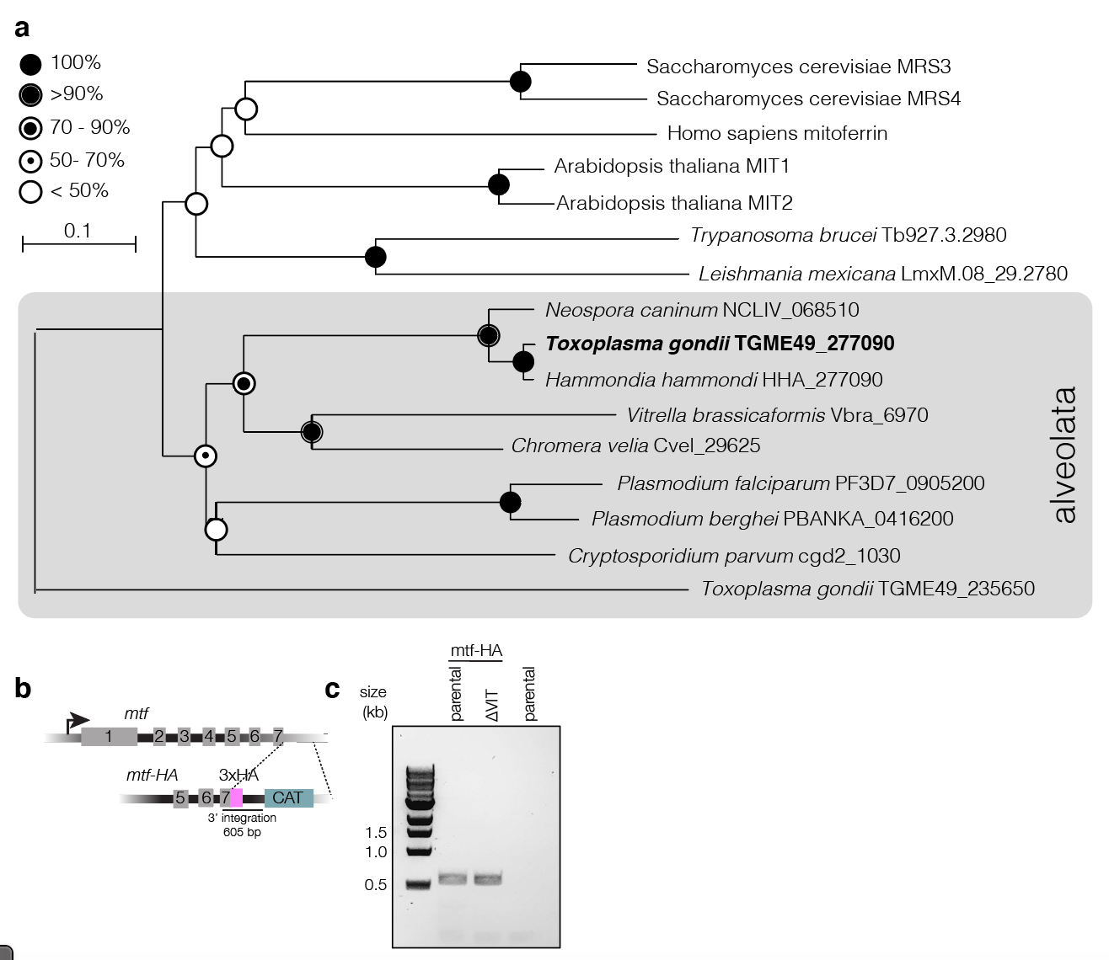
Figure S7. Identification and characterisation of T. gondii mitoferrin. a. Phylogenetic tree of mitoferrin sequences from a variety of species. TGME49_235650 represents an unrelated mitochondrial solute carrier. Bootstraps determined from 100 simulations. Scale indicates substitutions per site. b. Diagram demonstrating C-terminal HA endogenous tagging strategy. c. PCR confirming the integration of HA into mtf locus in the parental (Δku80) and ΔVIT parasite lines.

