Supplementary Materials

Artificial Ponds as Hotspots of Nitrogen Removal in Agricultural Watershed
Biogeochemistry
Min Cai¹, Shuai Li¹, Fei Ye¹, Yiguo Hong¹, Mingquan Lü², Huub J. M. Op den Camp³ Yu Wang^{1*}

¹Institute of Environmental Research at Greater Bay Area, Key Laboratory for Water Quality and Conservation of the Pearl River Delta, Ministry of Education, Guangzhou University, Guangzhou 510006, China
²Chongqing Institute of Green and Intelligent Technology, Chinese Academy of Sciences, Chongqing 401122, China
³ Department of Microbiology, RIBES, Radboud University Nijmegen, Nijmegen, the Netherlands

*Correspondence:
Yu Wang, E-mail: wangyu@gzhu.edu.cn

Contents of this file
5 Tables and 6 Figures

.
Additional Supporting Information
Table S1 The geographical location and characteristics of the ponds collected
Table S2 The primer sets and amplification conditions used in this study
Table S3 Estimated α diversity indexes of microbial community of nirS-type denitrifier
Table S4 Estimated α diversity indexes of microbial community of anammox bacteria
Table S5 Estimated the relative ratio of DIN, TOM, and nitrogen removal in the selected area
Figure S1 Pearson correlation analyses between environmental factors, microbial activities, and functional genes abundance
Figure S2 Alpha diversity indices of nirS (a) and Anammox-specific 16S rRNA (b) gene communities. Alpha diversity indices include Shannon, Simpson, Chao1 and ACE index. Different lowercase letters above the boxes indicate significant differences between different groups based on one-way ANOVA with Tukey’s test (P < 0.05)
Figure S3 Neighbor-joining phylogenetic tree of the most abundant nirS (a)and Anammox-specific 16S rRNA (b) gene OTUs and the reference sequences from GenBank. Bootstrap values were 1,000 replicates
Figure S4 Relative abundance of anammox bacteria based on the genus level
Figure S5 Bray-Curtis distances-based non-metric multidimensional scaling (NMDS) on the anammox bacteria
Figure S6 The RDA analysis between community of the (a) denitrification and (b) anammox and environmental factors

Table S1 The geographical location and characteristics of the ponds collected
Site | Longitude (°E) | Latitude (°N) | Altitude (m) | Surface area (m²) | Depth (m) | Usage | Surrounding crops
Pond 1 | 106.620 | 29.949 | 378 | 528.87 | 2.5 | Irrigation | Rice, corn
Pond 2 | 106.623 | 29.955 | 334 | 3824.44 | 3.1 | Irrigation | Rice, corn
Pond 3 | 106.626 | 29.950 | 292 | 9783.37 | 3.8 | Aquaculture | None
Pond 4 | 106.627 | 29.929 | 303 | 420.02 | 3.0 | Aquaculture | Corn, cowpea
Pond 5 | 106.637 | 29.954 | 296 | 1799.02 | 2.8 | Irrigation | Fruit tree
Pond 6 | 106.623 | 29.952 | 334 | 1303.19 | 2.6 | Irrigation | Fruit tree
Pond 7 | 106.637 | 29.962 | 290 | 7507.03 | 3.2 | Aquaculture | Corn

Table S2 The primer sets and amplification conditions used in this study

Target gene | Primer | Primer sequence (5’-3’) | Size (bp) | qPCR program | References
Bacterial  16S rRNA | 515F | GTGYCAGCMGCCGCGGTAA | 291 | 94℃ for 5 min, 40 ×  (94℃ for 30 s, 57℃ for 45 s, 72℃ for 45 s) | (Caporaso et al. 2011)
Bacterial  16S rRNA | 806R | GGACTACNVGGGTWTCTAA | 291 |  | (Caporaso et al. 2011)
Anammox 16S rRNA | 438F | GTCRGGAGTTADGAAATG | 246 | 95℃ for 3 min, 40 ×  (95℃ for 15 s, 56℃ for 30 s, 72℃ for 30 s) | (Han & Gu 2013)
Anammox 16S rRNA | 684R | ACCAGAAGTTCCACTCTC | 246 |  | (Han & Gu 2013)
nirS | cd3aF | GTSAACGTSAAGGARACSGG | 426 | 95℃ for 10 min, 40 ×  (95℃ for 15 s, 56℃ for 45 s, 72℃ for 45 s) | (Yergeau et al. 2007)
nirS | R3cd | GASTTCGGRTGSGTCTTGA | 426 |  | (Yergeau et al. 2007)
nirK | Flacu | ATCATGGTSCTGCCGCG | 473 | 95℃ for 2 min, 36 ×  (95℃ for 30 s, 56℃ for 45 s, 72℃ for 45 s) | (Hallin & Lindgren 1999)
nirK | R3cu | TTGGTGTTRGACTAGCTCCG | 473 |  | (Hallin & Lindgren 1999)
nosZ I | nosZ2F | CGCRACGGCAASAAGGTSMSSGT | 267 | 95℃ for 5 min, 40 ×  (95℃ for 30 s, 68℃ for 1 min, 72℃ for 1 min) | (Henry et al. 2006)
nosZ I | nosZ2R | CAKRTGCAKSGCRTGGCAGAA | 267 |  | (Henry et al. 2006)
nosZ II | nosZ F | CTIGGICCIYTKCAYAC | 746 | 95℃ for 2 min, 40 ×  (95℃ for 15 s, 60℃ for 1 min, 72℃ for 1 min) | (Jones et al. 2013)
nosZ II | nosZ R | GCIGARCARAAITCBGTRC | 746 |  | (Jones et al. 2013)

Table S3 Estimated α diversity indexes of microbial community of nirS-type denitrifier
Types | Samples | Reads | OTUs | Shannon | Simpson | ACE | Chao1 | Coverage
Pond | S_1 | 10007 | 158 | 2.626 | 0.178 | 413.09 | 370.13 | 0.991
 | S_2 | 8019 | 214 | 3.255 | 0.140 | 373.06 | 358.09 | 0.989
 | S_3 | 7753 | 303 | 4.032 | 0.044 | 616.87 | 505.73 | 0.983
 | S_4 | 15558 | 231 | 3.480 | 0.099 | 470.07 | 463.93 | 0.993
 | S_5 | 15323 | 207 | 3.088 | 0.085 | 422.26 | 402.50 | 0.993
 | S_6 | 8776 | 239 | 3.354 | 0.094 | 545.30 | 454.80 | 0.987
 | S_7 | 15090 | 200 | 3.172 | 0.092 | 501.48 | 437.69 | 0.993
 | M_1 | 9808 | 186 | 2.520 | 0.274 | 354.52 | 296.00 | 0.992
 | M_2 | 6970 | 308 | 3.808 | 0.071 | 621.05 | 559.15 | 0.981
 | M_3 | 9850 | 351 | 3.738 | 0.084 | 604.75 | 587.20 | 0.985
 | M_4 | 14842 | 253 | 3.597 | 0.080 | 476.08 | 460.00 | 0.993
 | M_5 | 17105 | 227 | 3.146 | 0.089 | 481.22 | 476.10 | 0.993
 | M_6 | 8606 | 319 | 3.710 | 0.072 | 521.34 | 525.34 | 0.985
 | M_7 | 10381 | 235 | 3.162 | 0.127 | 379.21 | 371.13 | 0.992
 | B_1 | 10059 | 193 | 2.970 | 0.155 | 347.35 | 348.16 | 0.992
 | B_2 | 8164 | 297 | 4.381 | 0.027 | 412.36 | 421.00 | 0.989
 | B_3 | 9935 | 329 | 4.034 | 0.050 | 567.53 | 548.15 | 0.986
 | B_4 | 8401 | 294 | 3.853 | 0.067 | 475.90 | 456.00 | 0.987
 | B_5 | 18219 | 247 | 3.298 | 0.078 | 461.65 | 484.31 | 0.995
 | B_6 | 10811 | 304 | 3.688 | 0.068 | 562.97 | 550.04 | 0.987
 | B_7 | 11974 | 251 | 2.920 | 0.185 | 441.26 | 438.20 | 0.992
Dryland | D_1 | 10420 | 266 | 3.934 | 0.059 | 362.75 | 369.18 | 0.994
 | D_2 | 7942 | 266 | 4.199 | 0.038 | 334.27 | 328.44 | 0.993
 | D_3 | 8179 | 126 | 3.181 | 0.075 | 249.12 | 203.04 | 0.994
 | D_4 | 17244 | 291 | 4.450 | 0.029 | 403.54 | 425.38 | 0.997
 | D_5 | 10749 | 179 | 3.814 | 0.044 | 259.02 | 265.12 | 0.996
 | D_6 | 6347 | 358 | 4.539 | 0.027 | 481.50 | 475.96 | 0.984
 | D_7 | 5174 | 305 | 4.560 | 0.020 | 370.80 | 362.13 | 0.986
Paddy | P_1 | 7737 | 465 | 5.015 | 0.014 | 615.12 | 638.33 | 0.983
 | P_2 | 5332 | 370 | 4.811 | 0.016 | 457.36 | 471.12 | 0.982
 | P_3 | 8469 | 523 | 5.274 | 0.010 | 749.23 | 764.00 | 0.981
 | P_4 | 7257 | 569 | 5.466 | 0.008 | 759.35 | 760.16 | 0.978

Table S4 Estimated α diversity indexes of microbial community of anammox bacteria
Types | Sample | Reads | OTUs | Shannon | Simpson | ACE | Chao1 | Coverage
Pond | S_1 | 13673 | 58 | 0.693 | 0.793 | 69.000 | 66.547 | 0.999
 | S_2 | 12344 | 81 | 2.569 | 0.153 | 87.111 | 89.949 | 0.999
 | S_3 | 13483 | 72 | 1.819 | 0.393 | 83.143 | 85.607 | 0.999
 | S_4 | 12728 | 60 | 2.019 | 0.326 | 72.000 | 66.372 | 0.999
 | S_6 | 13324 | 73 | 1.866 | 0.312 | 107.200 | 91.869 | 0.999
 | S_7 | 13346 | 61 | 1.176 | 0.600 | 70.167 | 72.216 | 0.999
 | M_1 | 12262 | 85 | 2.723 | 0.133 | 97.000 | 104.060 | 0.999
 | M_2 | 12536 | 76 | 2.145 | 0.201 | 81.000 | 81.752 | 0.999
 | M_3 | 13817 | 74 | 2.018 | 0.298 | 81.500 | 91.015 | 0.999
 | M_4 | 13201 | 71 | 1.673 | 0.450 | 93.750 | 92.643 | 0.999
 | M_5 | 13501 | 70 | 2.252 | 0.188 | 72.143 | 73.005 | 1.000
 | M_6 | 12547 | 95 | 2.508 | 0.166 | 102.091 | 104.725 | 0.999
 | M_7 | 12564 | 54 | 1.896 | 0.272 | 60.875 | 75.688 | 0.999
 | B_1 | 13107 | 63 | 2.944 | 0.094 | 65.500 | 66.957 | 1.000
 | B_2 | 13106 | 74 | 2.046 | 0.227 | 80.500 | 85.755 | 0.999
 | B_4 | 13893 | 56 | 1.316 | 0.572 | 71.000 | 72.933 | 0.999
 | B_5 | 13843 | 64 | 2.091 | 0.240 | 80.500 | 77.305 | 0.999
 | B_6 | 13105 | 71 | 1.413 | 0.551 | 86.167 | 84.821 | 0.999
 | B_7 | 12079 | 53 | 1.919 | 0.253 | 60.200 | 59.861 | 0.999
Dryland | D_1 | 8555 | 39 | 1.367 | 0.478 | 61.000 | 70.801 | 0.999
 | D_2 | 6987 | 27 | 1.642 | 0.281 | 34.200 | 44.207 | 0.996
 | D_3 | 10512 | 38 | 1.749 | 0.232 | 44.429 | 47.572 | 0.999
 | D_4 | 7247 | 29 | 1.913 | 0.234 | 44.000 | 44.192 | 0.997
 | D_5 | 5711 | 33 | 1.826 | 0.245 | 49.500 | 86.192 | 0.997
 | D_6 | 7783 | 23 | 0.726 | 0.687 | 29.000 | 46.340 | 0.997
 | D_7 | 11340 | 28 | 0.591 | 0.744 | 41.200 | 41.795 | 0.999
Paddy | P_1 | 8697 | 38 | 1.751 | 0.231 | 56.333 | 56.073 | 0.998
 | P_2 | 9874 | 25 | 1.645 | 0.252 | 47.000 | 46.467 | 0.993
 | P_3 | 8937 | 33 | 1.332 | 0.372 | 48.167 | 77.104 | 0.997
 | P_4 | 9081 | 24 | 1.553 | 0.327 | 39.000 | 41.000 | 0.992

Table S5 Estimated the relative ratio of DIN, TOM, and nitrogen removal in the selected area
Types | Area (km²) | Density  （g cm⁻³) | Depth  (cm) | DIN (t) | TOM content (t) | Nitrogen removal (t N yr⁻¹)
Dryland | 0.482 | 1.70-1.89 | 5.0 | 0.272 | 2573.606 | 47.836
Paddy field | 0.124 | 1.41-1.65 | 5.0 | 0.095 | 782.584 | 24.994
Farm pond | 0.068 | 1.41-1.65 | 5.0 | 0.084 | 589.271 | 14.031
Targeted region | 0.954

Fig. S1 Pearson correlation analyses between environmental factors, microbial activities, and functional genes abundance

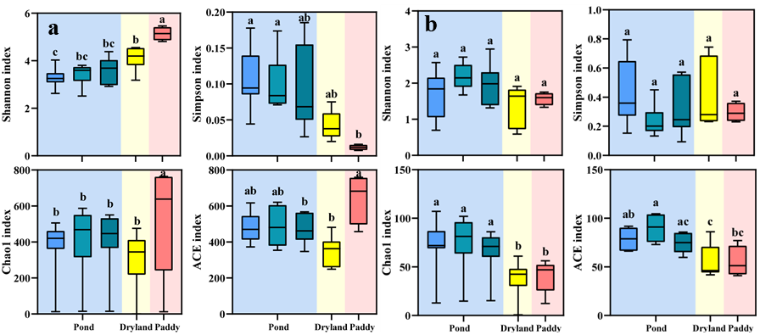
Fig. S2 Alpha diversity indices of nirS (a) and Anammox-specific 16S rRNA (b) gene communities. Alpha diversity indices include Shannon, Simpson, Chao1 and ACE index. Different lowercase letters above the boxes indicate significant differences between different groups based on one-way ANOVA with Tukey’s test (P < 0.05)

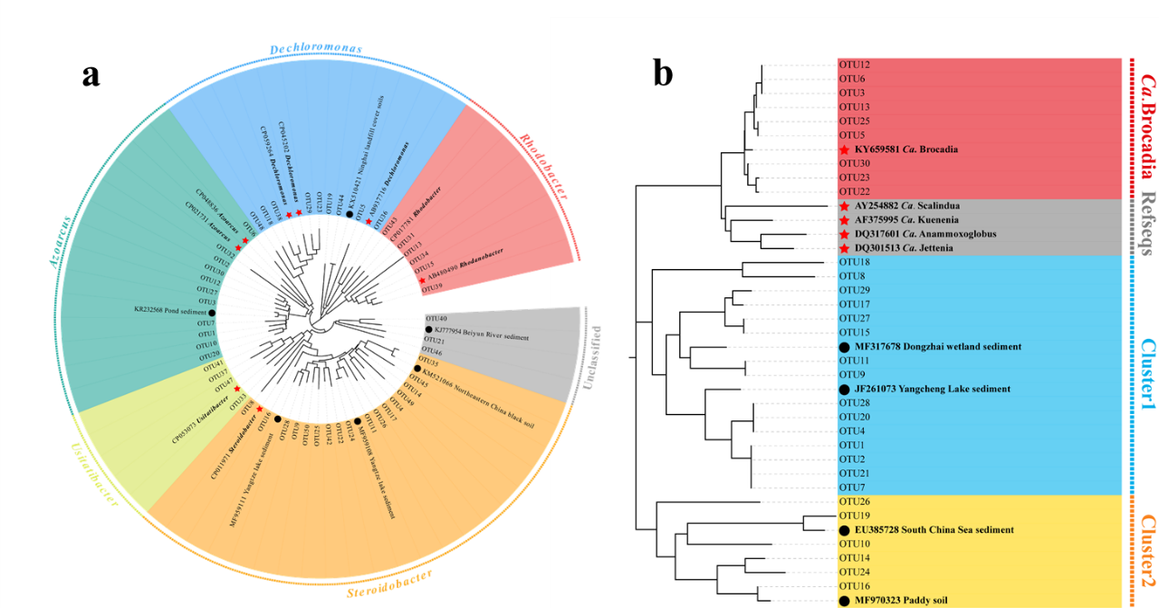
Fig. S3 Neighbor-joining phylogenetic tree of the most abundant nirS (a)and Anammox-specific 16S rRNA (b) gene OTUs and the reference sequences from GenBank. Bootstrap values were 1,000 replicates

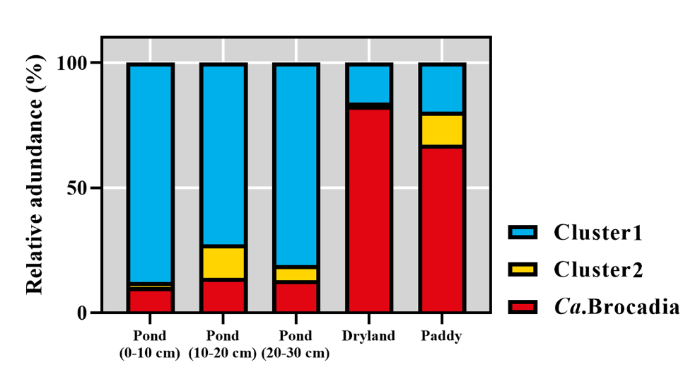
Fig. S4 Relative abundance of anammox bacteria based on the genus level

Fig. S5 Bray-Curtis distances-based non-metric multidimensional scaling (NMDS) on the anammox bacteria

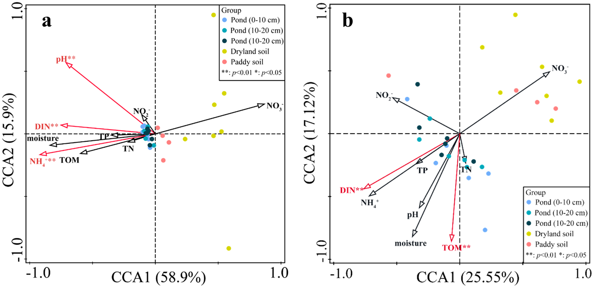
Fig. S6 The RDA analysis between community of the (a) denitrification and (b) anammox and environmental factors

References
Caporaso JG, Lauber CL, Walters WA, Berg-Lyons D, Lozupone CA, Turnbaugh PJ, Fierer N, Knight R (2011) Global patterns of 16S rRNA diversity at a depth of millions of sequences per sample. P. Natl. Acad. Sci. USA 108 Suppl 1: 4516-4522. 10.1073/pnas.1000080107
Hallin S, Lindgren PE (1999) PCR detection of genes encoding nitrite reductase in denitrifying bacteria. Appl. Environ. Microbiol. 65(4): 1652-1657. 10.1128/aem.65.4.1652-1657.1999
Han P, Gu J-D (2013) More refined diversity of anammox bacteria recovered and distribution in different ecosystems. Appl. Microbiol. Biotechnol. 97(8): 3653-3663. 10.1007/s00253-013-4756-6
Henry S, Bru D, Stres B, Hallet S, Philippot L (2006) Quantitative detection of the nosZ gene, encoding nitrous oxide reductase, and comparison of the abundances of 16S rRNA, narG, nirK, and nosZ genes in soils. Appl. Environ. Microbiol. 72(8): 5181-5189. 10.1128/aem.00231-06
Jones CM, Graf DRH, Bru D, Philippot L, Hallin S (2013) The unaccounted yet abundant nitrous oxide-reducing microbial community: a potential nitrous oxide sink. ISME J. 7(2): 417-426. 10.1038/ismej.2012.125
Yergeau E, Kang S, He Z, Zhou J, Kowalchuk GA (2007) Functional microarray analysis of nitrogen and carbon cycling genes across an Antarctic latitudinal transect. ISME J. 1(2): 163-179. 10.1038/ismej.2007.24

