Supporting Information

Implications of Additivity and Nonadditivity for Machine Learning and Deep Learning Models in Drug Design

Karolina Kwapien^{1,#,*}, Eva Nittinger^{1,#}, Jiazhen He², Christian Margreitter², Alexey Voronov², Christian Tyrchan¹
¹ Medicinal Chemistry, Research and Early Development, Respiratory and Immunology (R&I), BioPharmaceuticals R&D, AstraZeneca, Gothenburg, Sweden
² Molecular AI, Discovery Sciences, R&D, AstraZeneca, Gothenburg, Sweden
# Shared first authors
* Correspondence: karolina.kwapien@astrazeneca.com

Table S 1. Logarithmic conversion for the different properties analyzed; np = numpy library.
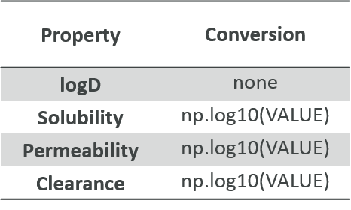

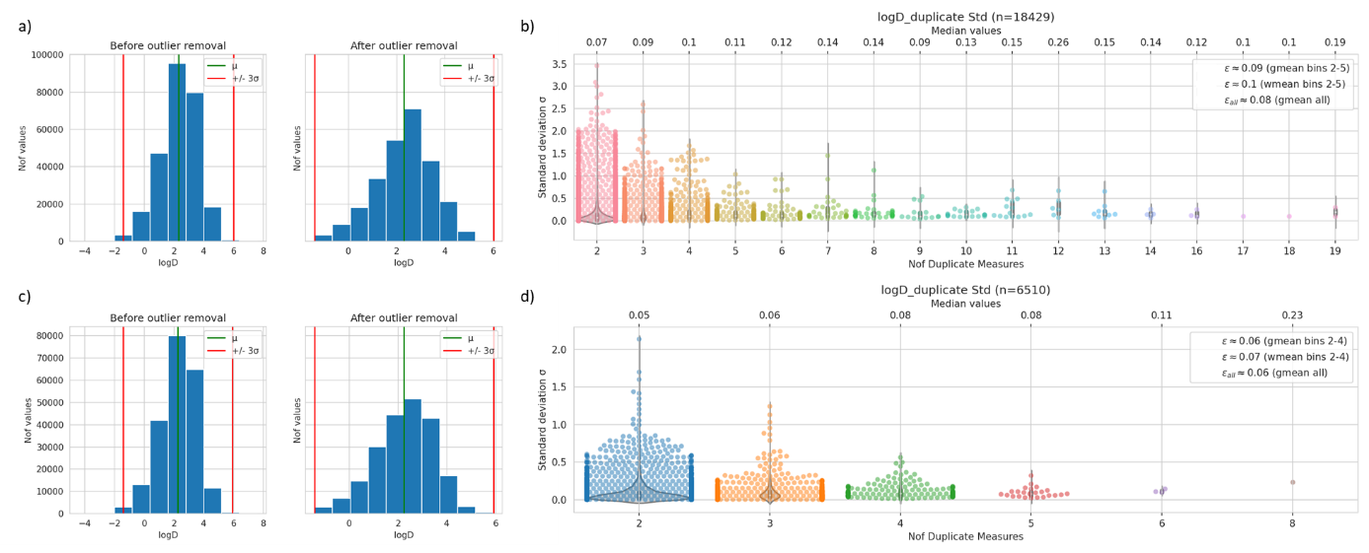
Figure S 1. Determination of experimental uncertainty for logD using a+b) multi measurements and c+d) stereo duplicates; a+c) Value distribution before (left) and after (right) outlier removal; b+d) distribution of standard deviation plotted by the number of measurements.

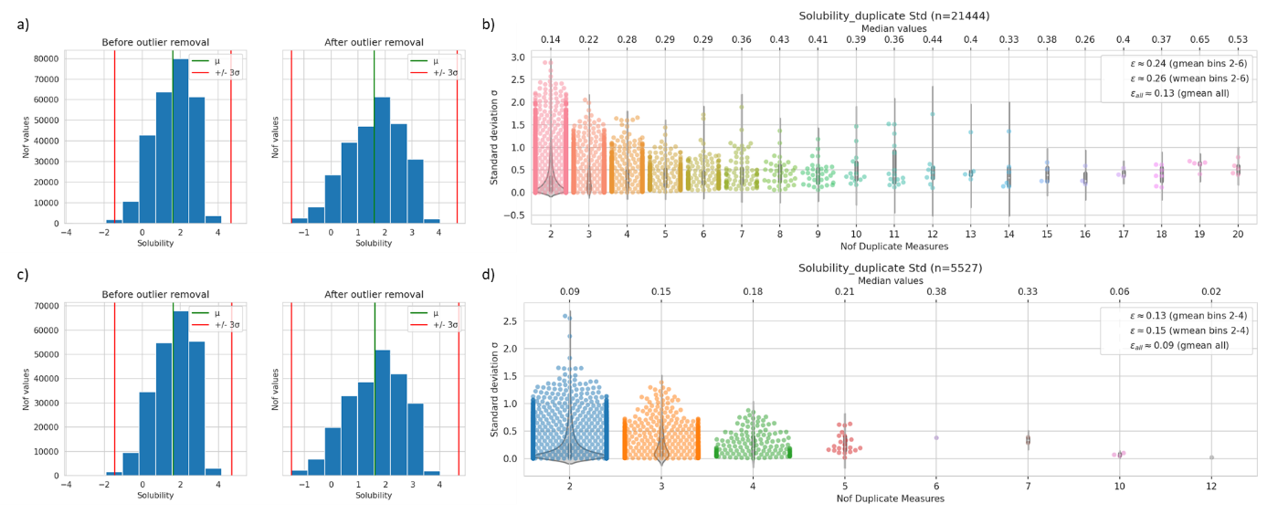
Figure S 2. Determination of experimental uncertainty for solubility using a+b) multi measurements and c+d) stereo duplicates; a+c) Value distribution before (left) and after (right) outlier removal; b+d) distribution of standard deviation plotted by the number of measurements.

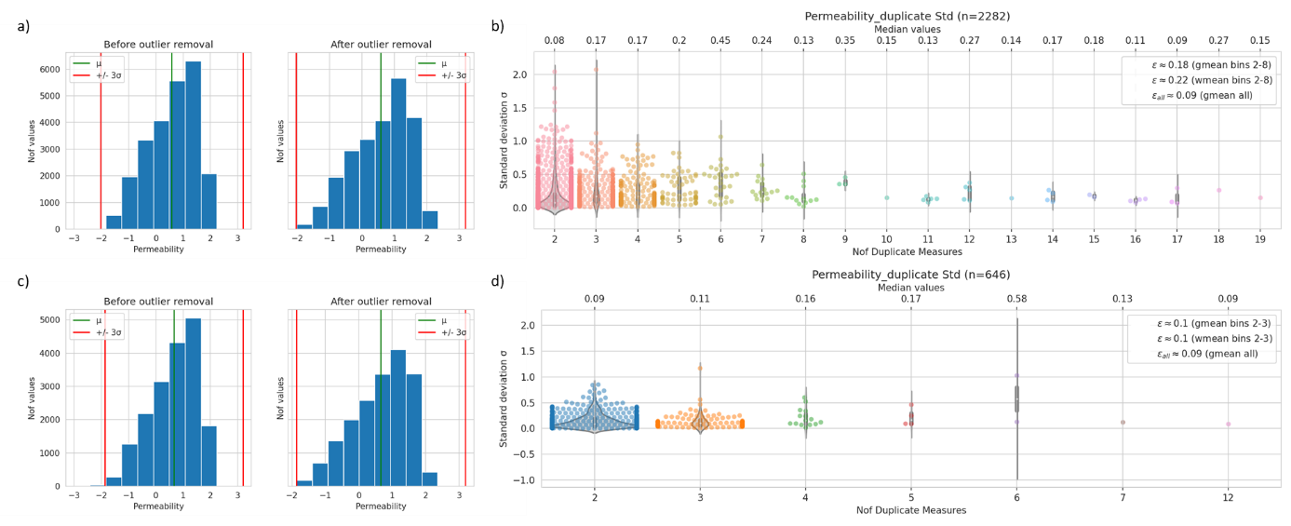
Figure S 3. Determination of experimental uncertainty for permeability using a+b) multi measurements and c+d) stereo duplicates; a+c) Value distribution before (left) and after (right) outlier removal; b+d) distribution of standard deviation plotted by the number of measurements.

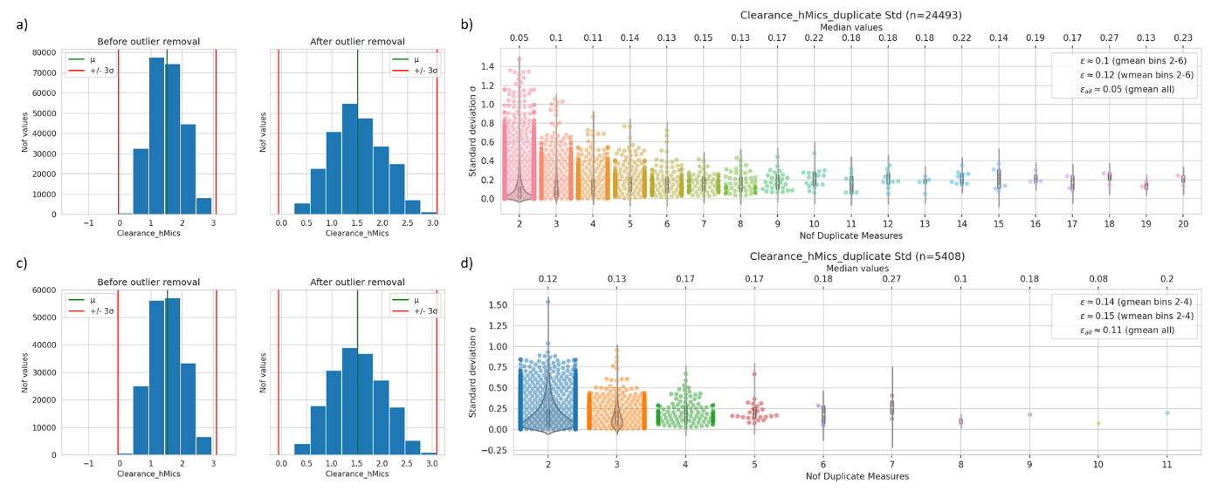
Figure S 4. Determination of experimental uncertainty for clearance using a+b) multi measurements and c+d) stereo duplicates; a+c) Value distribution before (left) and after (right) outlier removal; b+d) distribution of standard deviation plotted by the number of measurements.

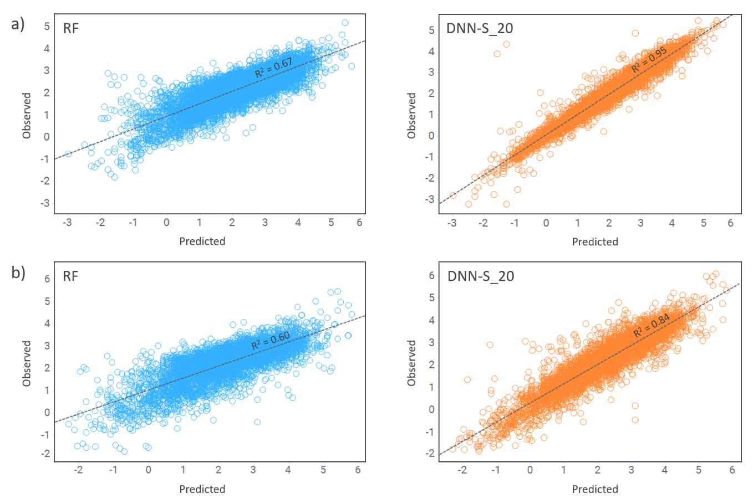
Figure S 5. Predicted versus measured values for logD. Comparison between RF (blue) and DNN-S_20 (orange) for a) Set 3 (only additive data) and b) Set 4 (only nonadditive data).

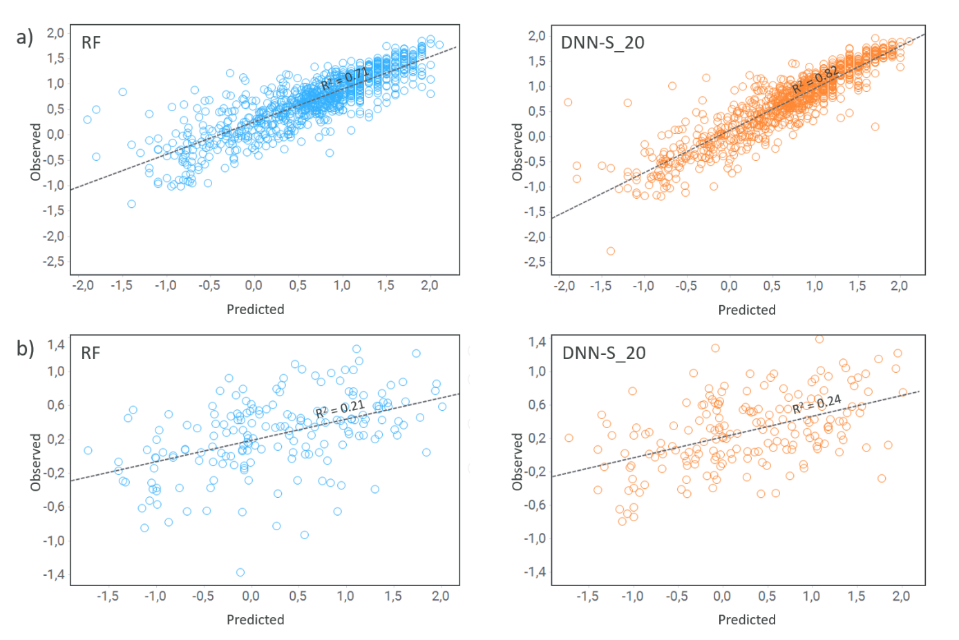
Figure S 6. Predicted versus measured values for permeability. Comparison between RF (blue) and DNN-S_20 (orange) for a) Set 3 (only additive data) and b) Set 4 (only nonadditive data). The values are in log units.

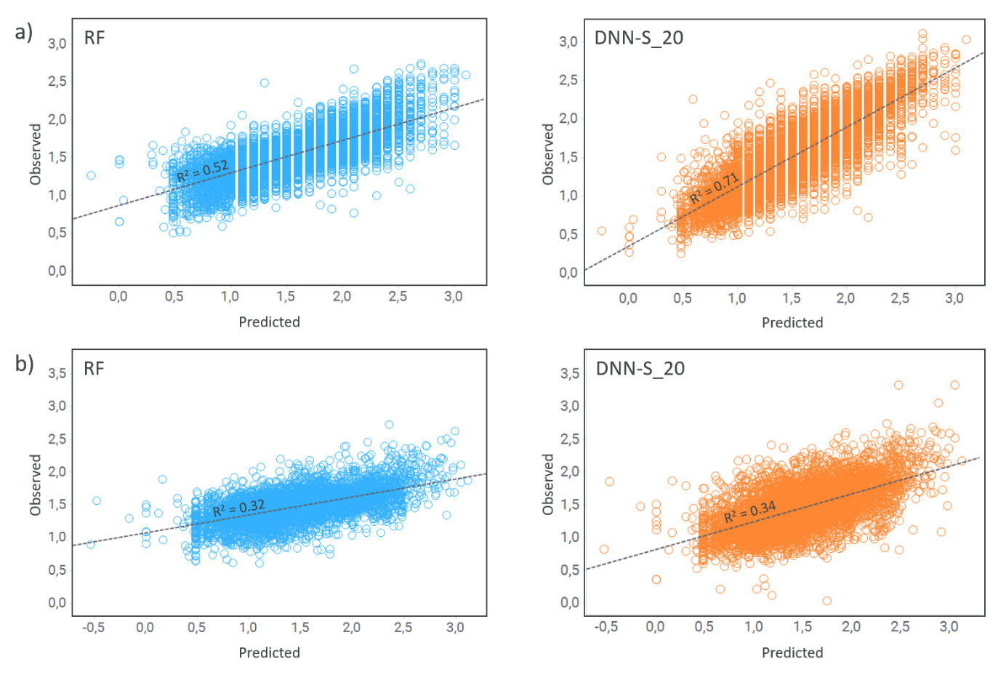
Figure S 7. Predicted versus measured values for clearance. Comparison between RF (blue) and DNN-S_20 (orange) for a) Set 3 (only additive data) and b) Set 4 (only nonadditive data). The values are in log units.

