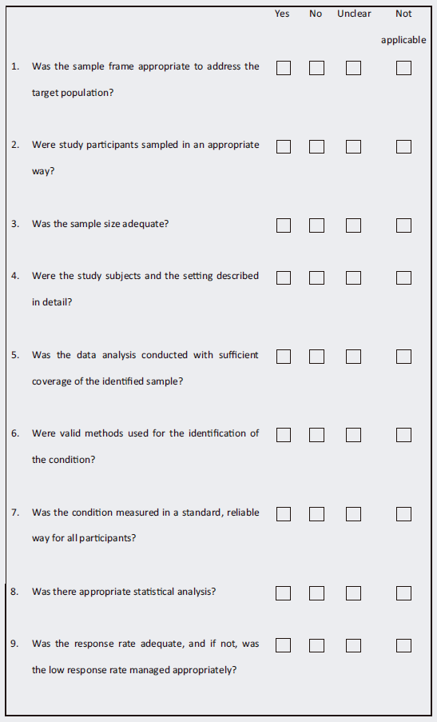
Joanna Briggs Institute assessment tool for methodological guidance for systematic reviews of observational epidemiological studies reporting prevalence and cumulative incidence data

