Amphiregulin regulates differentiation of dental pulp stem cells byactivation of mitogen-activated protein kinase and the phosphatidylinositol 3-kinase signaling pathways
Junqing Li,DDS, MS,^{1, 2a}Zhihua Wang, DDS, MS,^{1a} Juan Wang,DDS,MS,^{1a}Qian Guo, DDS, MS,¹Yi Fu, DDS, MS,^{1, 2}Zihan Dai, DDS, MS,¹MinghaoWang, DDS, PhD,¹ Yu Bai,DDS, PhD, ¹ Xin Liu,DDS, MS,¹Paul Cooper, DDS, PhD,²Jiayuan Wu, DDS, PhD,³* and Wenxi He, DDS, PhD,⁴*.

Supplementary Figure. 1
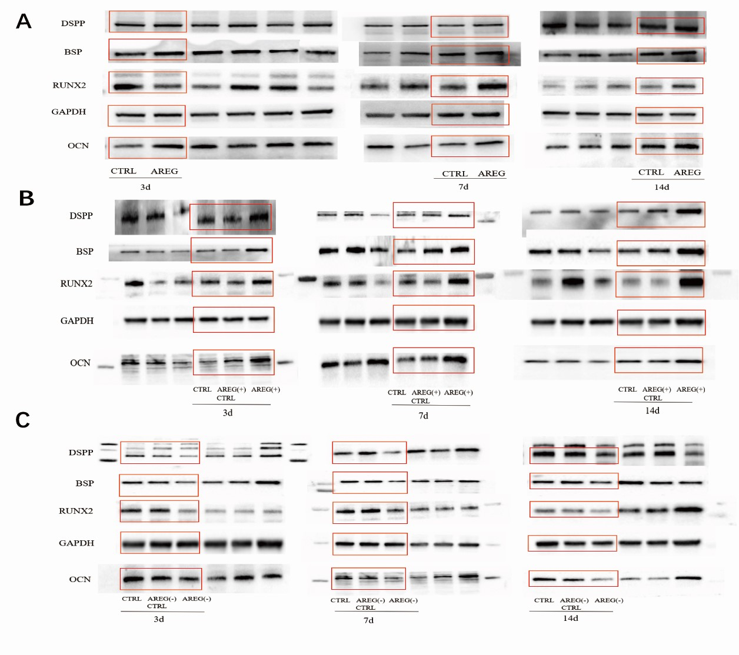
Supplementary Figure.1
The full length ofgels and blots of protein expression of odontoblastic markers for Fig.3 and 5. A. The bands in the red boxes are used in the Fig.3C; B.The bands in the red boxes are used in the Fig.5C; C.The bands in the red boxes are used in the Fig.5E;

Supplementary Figure.2
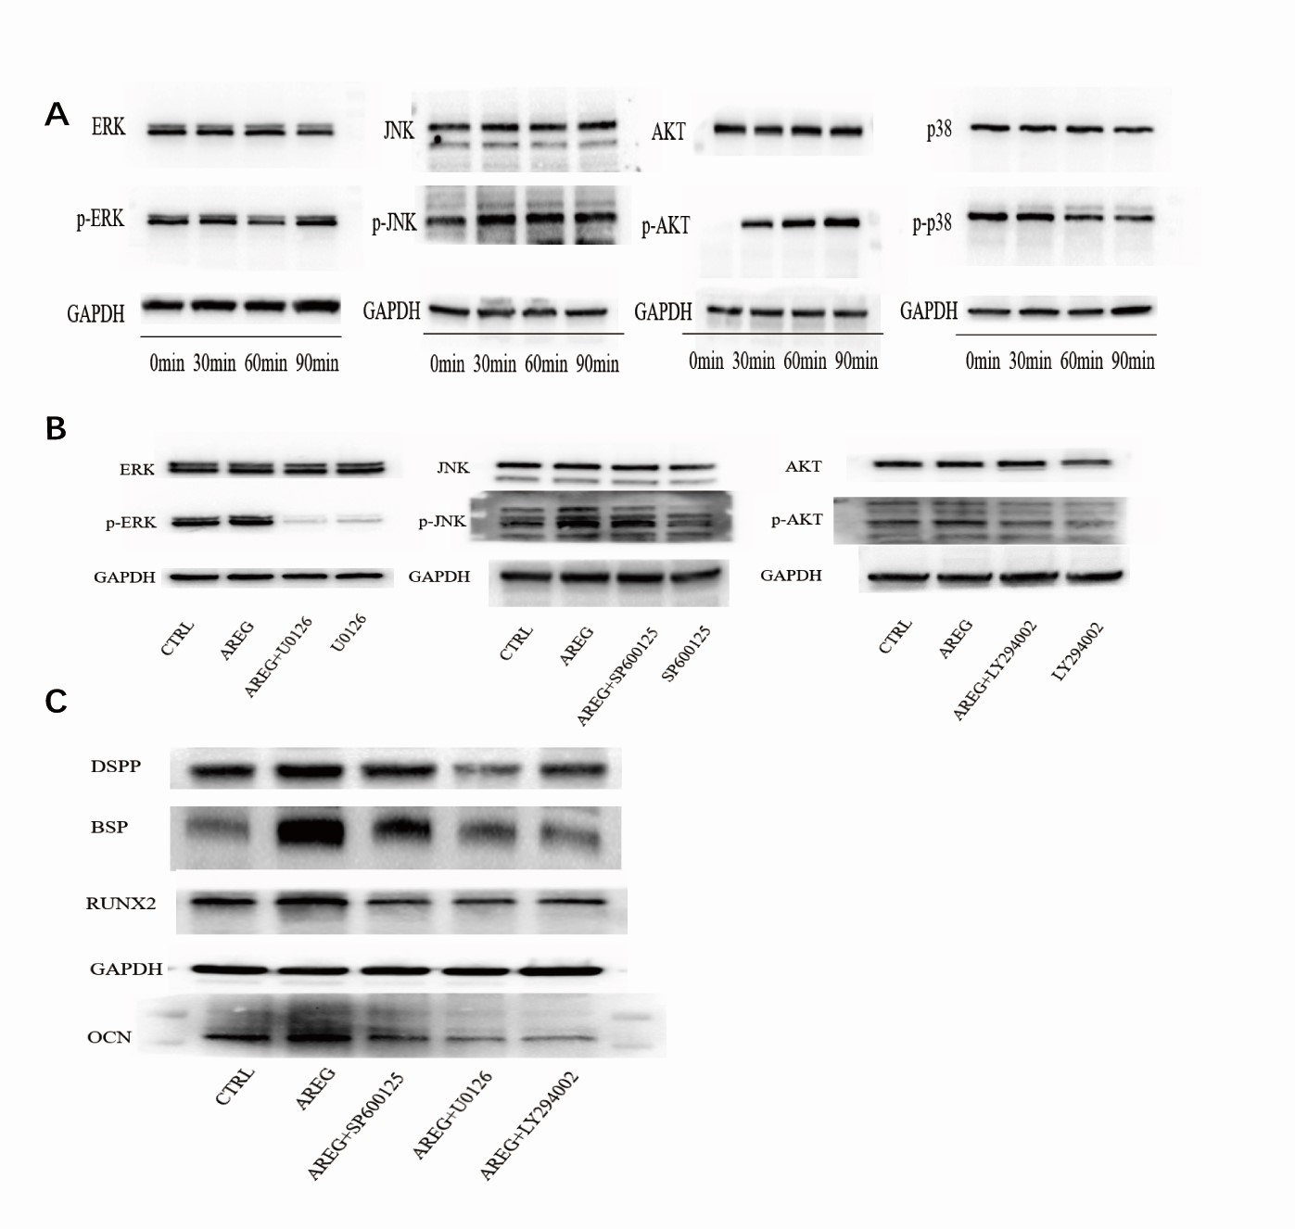
Supplementary Figure.2
The full length of gels and blots of protein expression for Fig.6. A. The bands are used in the Fig.6A; B. The bands are used in the Fig.6C; C.The bands are used in the Fig.6G.

