SUPPORTING INFORMATION SECTION

Quantitative Study on the Structure-bioavailability Relationship of Dissolved Organic Nitrogen in Wastewater Treatment Plant Effluent
Cihang Yanª, Zhiyu Weiª, Jiayin Liuª, Jie Chen^{c}, Lu Fan^{a, b *}
ªCollege of Chemistry and Materials Science, Sichuan Normal University, Chengdu 610066, China;
^{b}Key Laboratory of Land Resources Evaluation and Monitoring in Southwest, Ministry of Education of China, Chengdu 610066, China;
^{c}Sichuan Academy of Environmental Science, Chengdu 610041, China.
*Corresponding author: Lu Fan; Email: fanlu0923@gmail.com, Tel: +86 28 86006795

Table of Contents
Table S1 Nitrogen and phosphorus composition in wastewater treatment plant effluents S3
Table S2 Chemical composition analysis. S4
Table S3 DIN concentration before and after ion exchange... S5
Table S4 DON concentration before and after ion exchange. S6
Figure S1 Basic characteristics of wastewater samples from the main process stages of E₁-E₈ WWTPs. S8

Table S1 Nitrogen and phosphorus composition in wastewater treatment plant effluents
Sample | Advanced Nutrient  Removal Technology | Location | TN  (mg/L) | NO₃-N  (mg/L) | NO₂-N  (mg/L) | NH₄-N  (mg/L) | TDN  (mg/L) | PN  (mg/L) | TP  (mg/L) | SRP  (mg/L) | TDP  (mg/L) | PP  (mg/L) | SnRP  (mg/L)
E₁ | A2O + Denitrification filter | Jinjiang District, CD | 7.3 | 5.7 | 0.0 | 0.2 | 7.0 | 0.3 | 0.3 | 0.2 | 0.3 | 0.0 | 0.0
E₂ | SBR | Longquan District, CD | 6.7 | 3.8 | 0.1 | 1.0 | 6.4 | 0.4 | 0.9 | 0.7 | 0.8 | 0.1 | 0.1
E₃ | Bardenpho + Denitrification filter | Longquan District, CD | 8.4 | 4.5 | 0.0 | 0.1 | 8.1 | 0.3 | 0.4 | 0.3 | 0.3 | 0.0 | 0.0
E₄ | A2O+MBR | Longquan District, CD | 7.9 | 6.0 | 0.0 | 0.2 | 7.3 | 0.5 | 0.6 | 0.4 | 0.5 | 0.1 | 0.1
E₅ | A2O | Huayang, CD | 10.4 | 9.0 | 0.0 | 0.6 | 9.9 | 0.5 | 0.5 | 0.4 | 0.4 | 0.1 | 0.0
E₆ | CASS | Huayang, CD | 12.5 | 6.2 | 1.6 | 3.6 | 11.8 | 0.7 | 0.6 | 0.4 | 0.5 | 0.1 | 0.1
E₇ | DE oxidation ditch + Denitrification filter | Xindu District, CD | 7.1 | 4.4 | 1.2 | 0.0 | 6.7 | 0.4 | 0.5 | 0.4 | 0.5 | 0.0 | 0.1
E₈ | A2O + Precise Filter | Xindu District, CD | 10.5 | 8.9 | 0.0 | 0.2 | 10.0 | 0.5 | 0.4 | 0.4 | 0.4 | 0.0 | 0.0

Table S2 Chemical composition analysis
Chemical composition | Analytical methods
TDN/TN | Water quality-Determination of total nitrogen-Alkaline potassium persiflage digestion-UV spectrophotometric method (GB 1184-89)
NO₃⁻-N | Water quality-Determination of nitrate-nitrogen-Ultraviolet spectrophotometry (HJ/T 346-2007)
NO₂⁻-N | Water quality-Determination of nitrogen nitrite-Spectrophotometric method (GBT 7493-1987)
NH₄⁺-N | Water quality-Determination of ammonia nitrogen -Nessler's reagent spectrophotometric (HJ 535-2009)

Table S3 DIN concentration before and after ion exchange
Sample | Before ion exchange DIN (mg/L) | After ion exchange DIN (mg/L) | Removal rate (%)
E₁ | 5.8 | 0.7 | 87.9
E₂ | 5.3 | 0.4 | 92.5
E₃ | 4.8 | 0.5 | 89.6
E₄ | 6.1 | 0.5 | 91.8
E₅ | 9.5 | 0.5 | 94.7
E₆ | 11.5 | 0.5 | 95.7
E₇ | 6.2 | 0.3 | 95.2
E₈ | 9.1 | 0.2 | 97.8
After the pretreatment using ion exchange, the removal rate of DIN ranged from 87.9% to 97.8%, and the average removal rate of DIN was 93.1%.

Table S4 DON concentration before and after ion exchange
Sample | Before ion exchange DON (mg/L) | After ion exchange DON (mg/L) | Recovery rate (%)
E₁ | 1.1 | 1.1 | 100.0
E₂ | 1.1 | 1.4 | 127.3
E₃ | 2.1 | 1.5 | 71.4
E₄ | 1.2 | 1.0 | 83.3
E₅ | 0.3 | 1.2 | 400.0
E₆ | 0.5 | 0.9 | 180.0
E₇ | 1.0 | 1.1 | 110.0
E₈ | 0.9 | 1.1 | 122.2
After pretreatment using ion exchange, the recovery of DON ranged from 71.4% to 400%, and the average recovery rate of DON was 149.3 %. Methods capable of quantifying low DON concentrations in untreated waters with high DIN tend to be inaccurate, resulting in recovery rates greater than one(Lee and Westerhoff 2005).

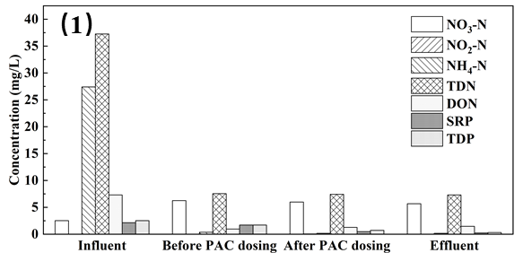
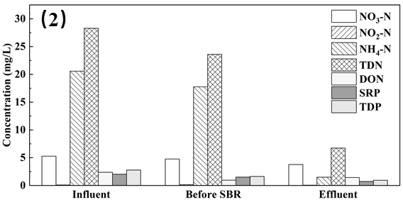
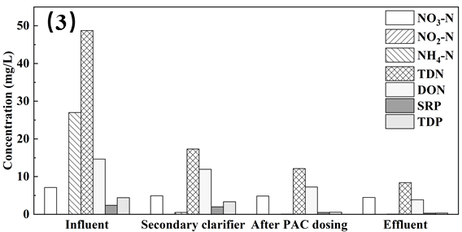
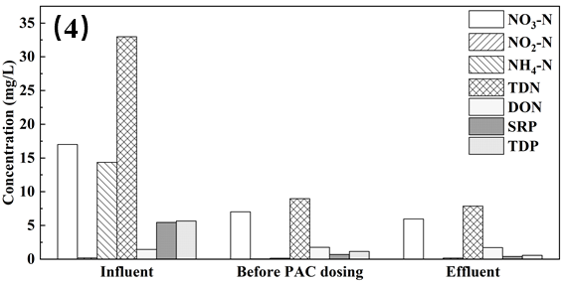
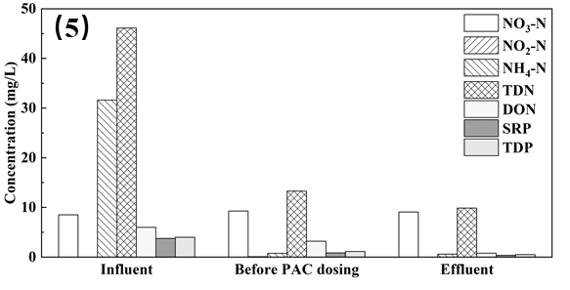
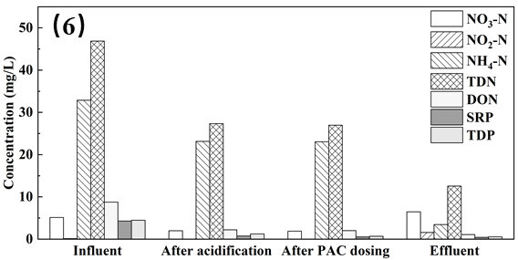
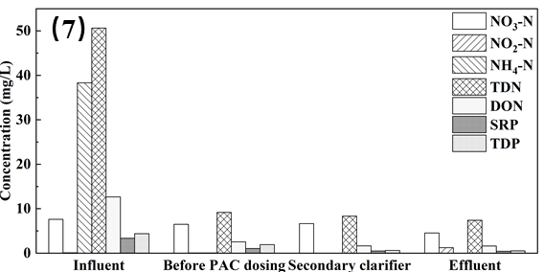
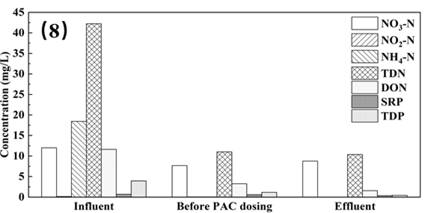
Figure S1 Basic characteristics of wastewater samples from the main process stages of E₁-E₈ WWTPs.

References
Lee, W. and P. Westerhoff, 2005. Dissolved organic nitrogen measurement using dialysis pretreatment. Environ Sci Technol 39:879-884.

