APPENDIX A
FIGURES

Figure 1
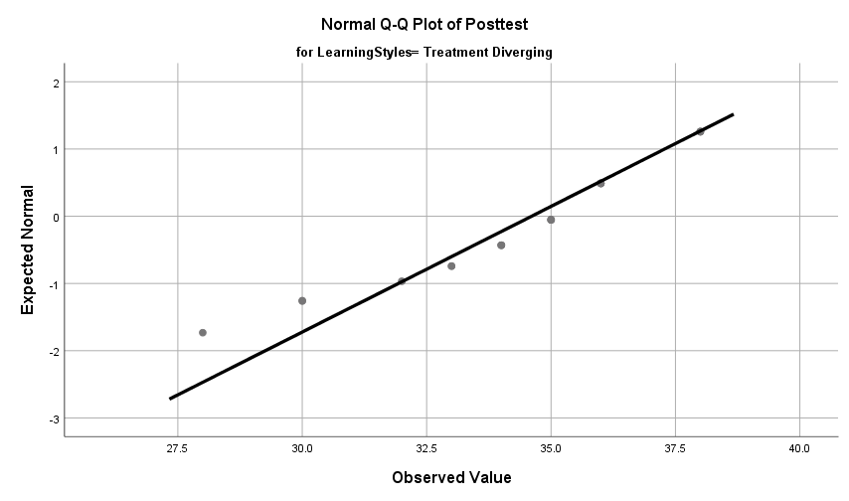
Q-Q Scatterplot Testing Normality for 4MAT

Figure 2

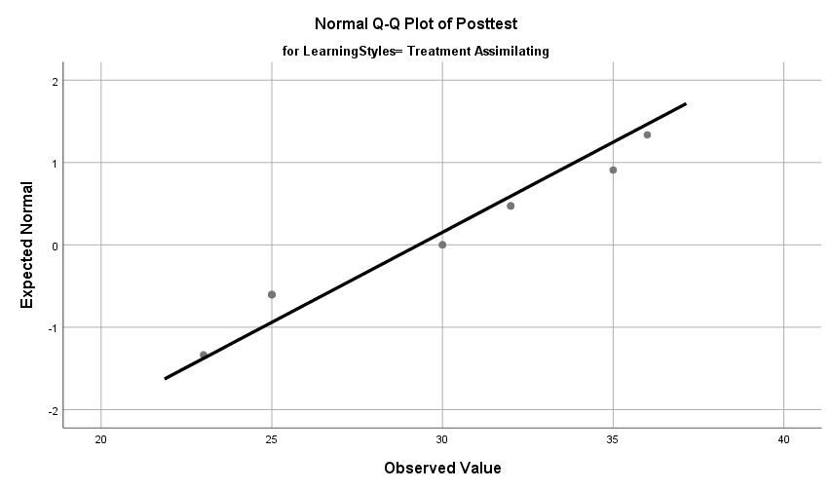
Q-Q Scatterplot Testing Normality for 4MAT

Figure 3

Q-Q Scatterplot Testing Normality for 4MAT
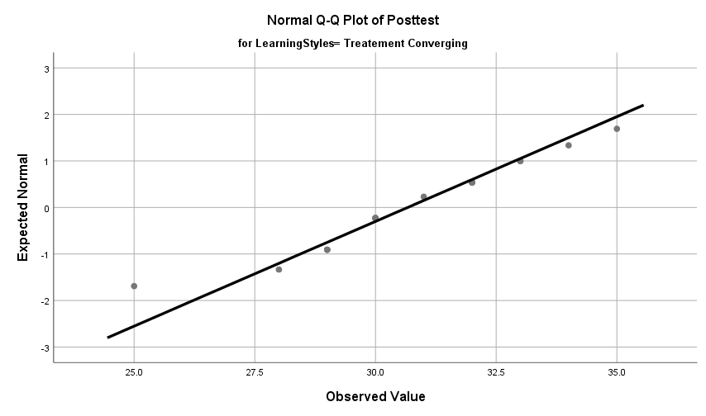

Figure 4

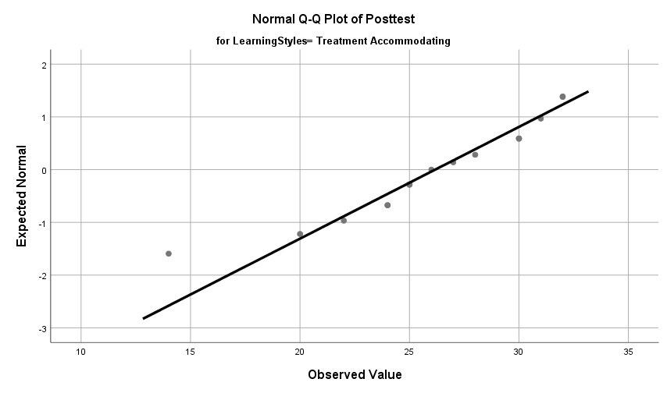
Q-Q Scatterplot Testing Normality for 4MAT

Figure 5

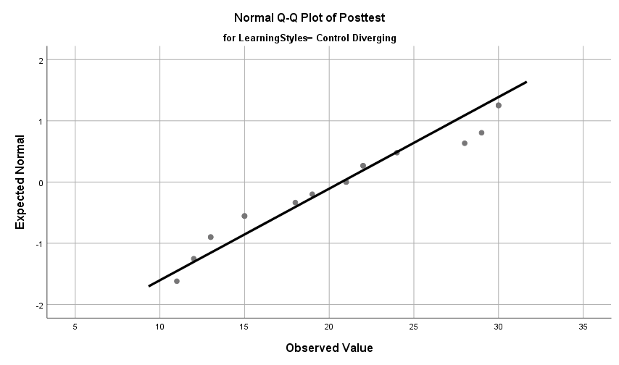
Q-Q Scatterplot Testing Normality for 4MAT

Figure 6

Q-Q Scatterplot Testing Normality for 4MAT
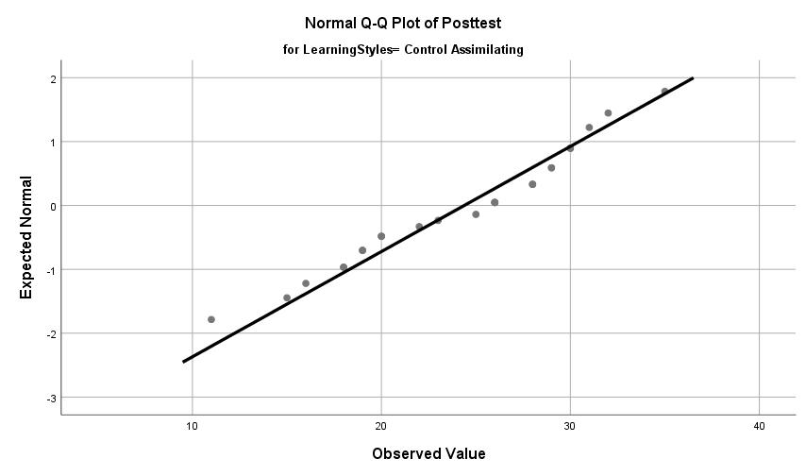

Figure 7

Q-Q Scatterplot Testing Normality for 4MAT

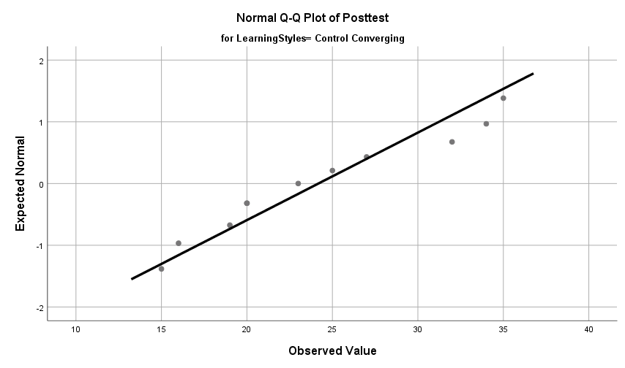

Figure 8

Q-Q Scatterplot Testing Normality for 4MAT

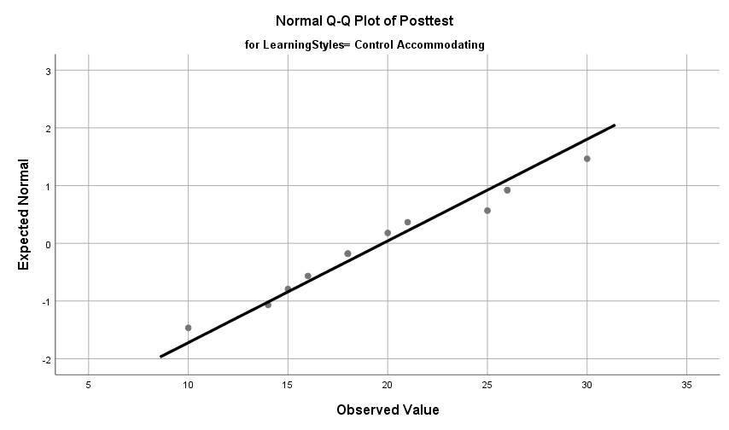

Figure 9

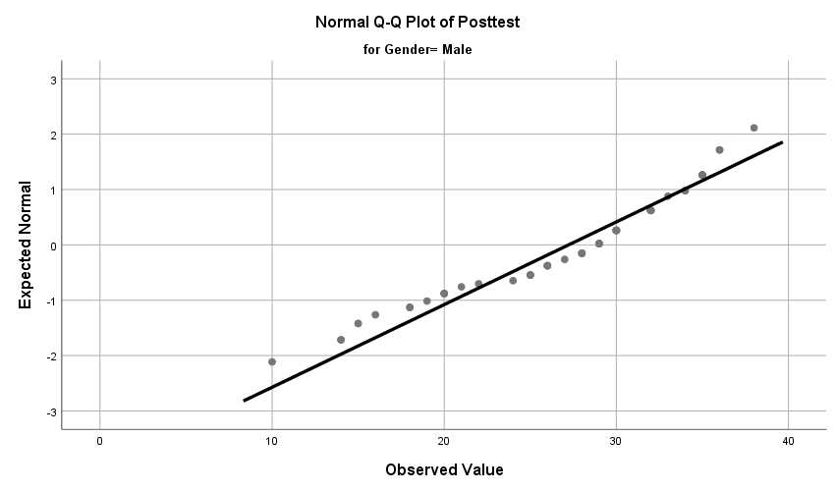
Q-Q Scatterplot Testing Normality for Male

Figure 10

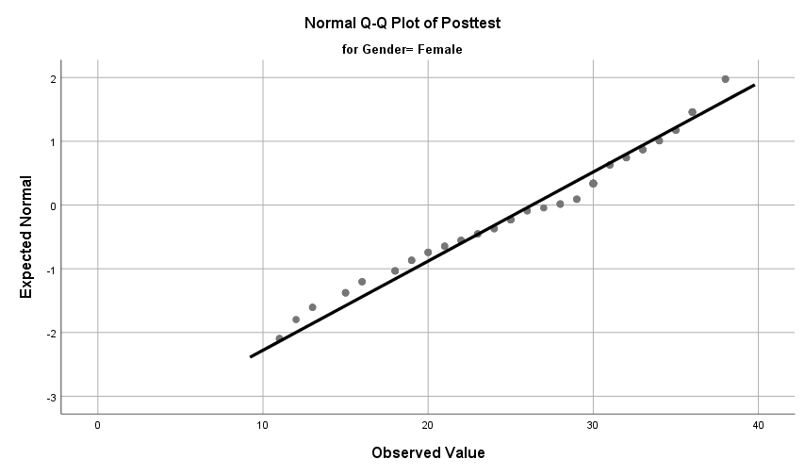
Q-Q Scatterplot Testing Normality for Female

Figure 11
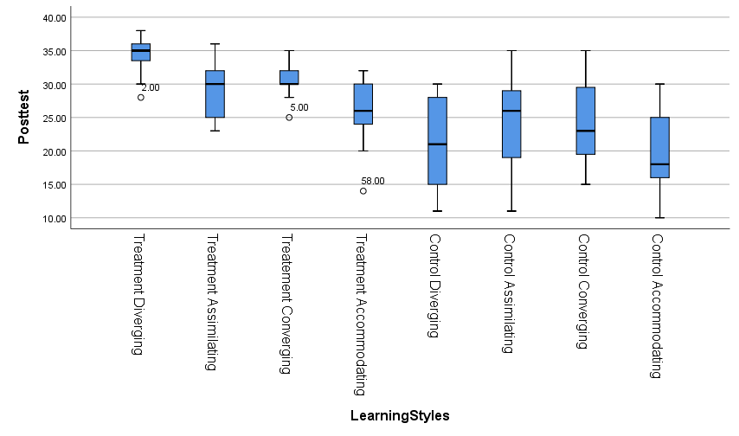
Box Plot Testing for Outliers

Figure 12
Box Plot Testing for Outliers
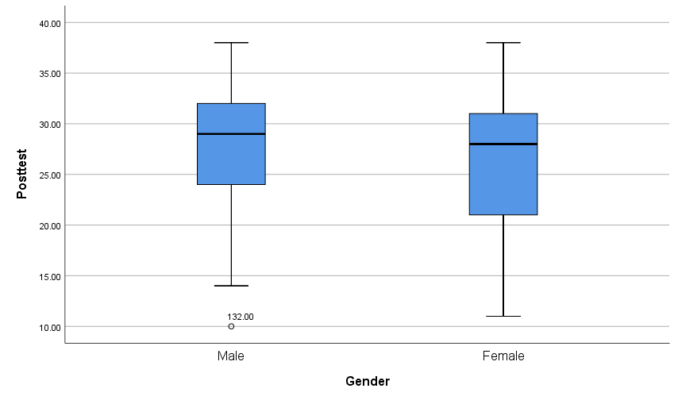

Figure 13

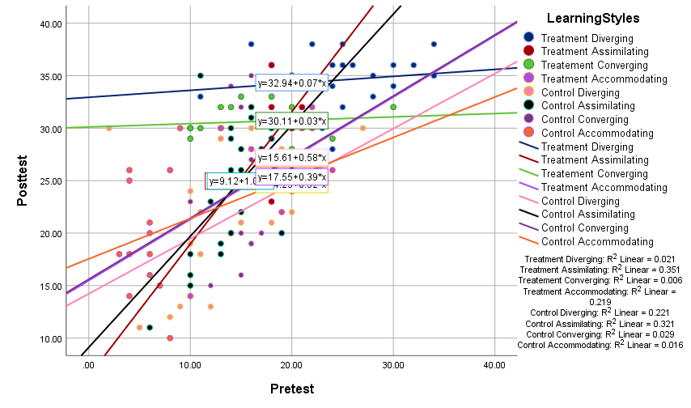
Linear Relationship between Dependent and Covariate by Each Level of the Independent Variable

Figure 14

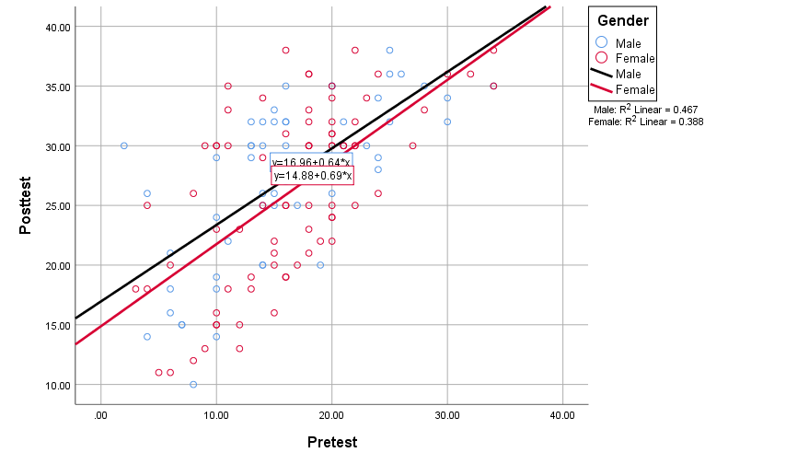
Linear Relationship between Dependent and Covariate by Each Level of the Independent Variable

Figure 15

Simple Bar Mean of Posttest by Learning Styles
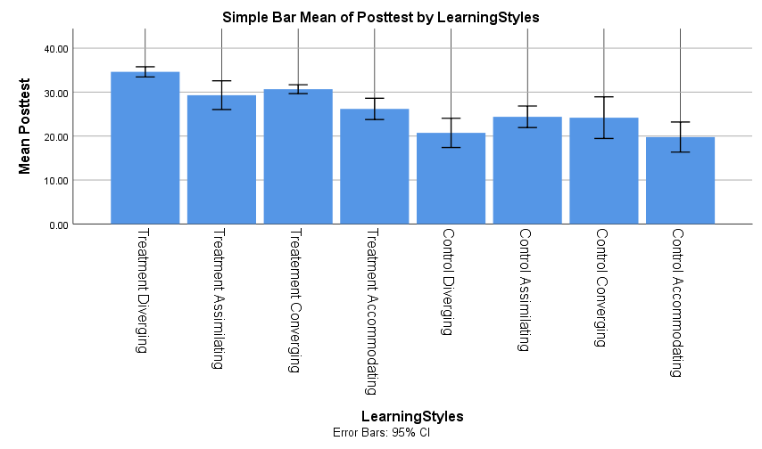

Figure 16
Simple Bar Mean of Posttest by Gender
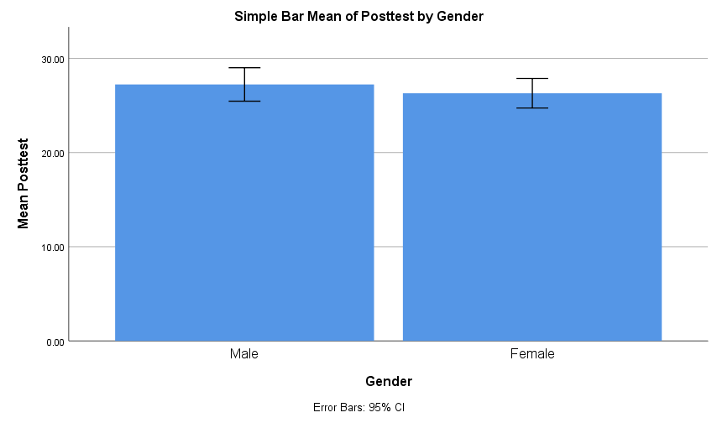

Figure 17
Power Analysis for calculation of sample size

Figure 18
Power Analysis for calculation of sample size

