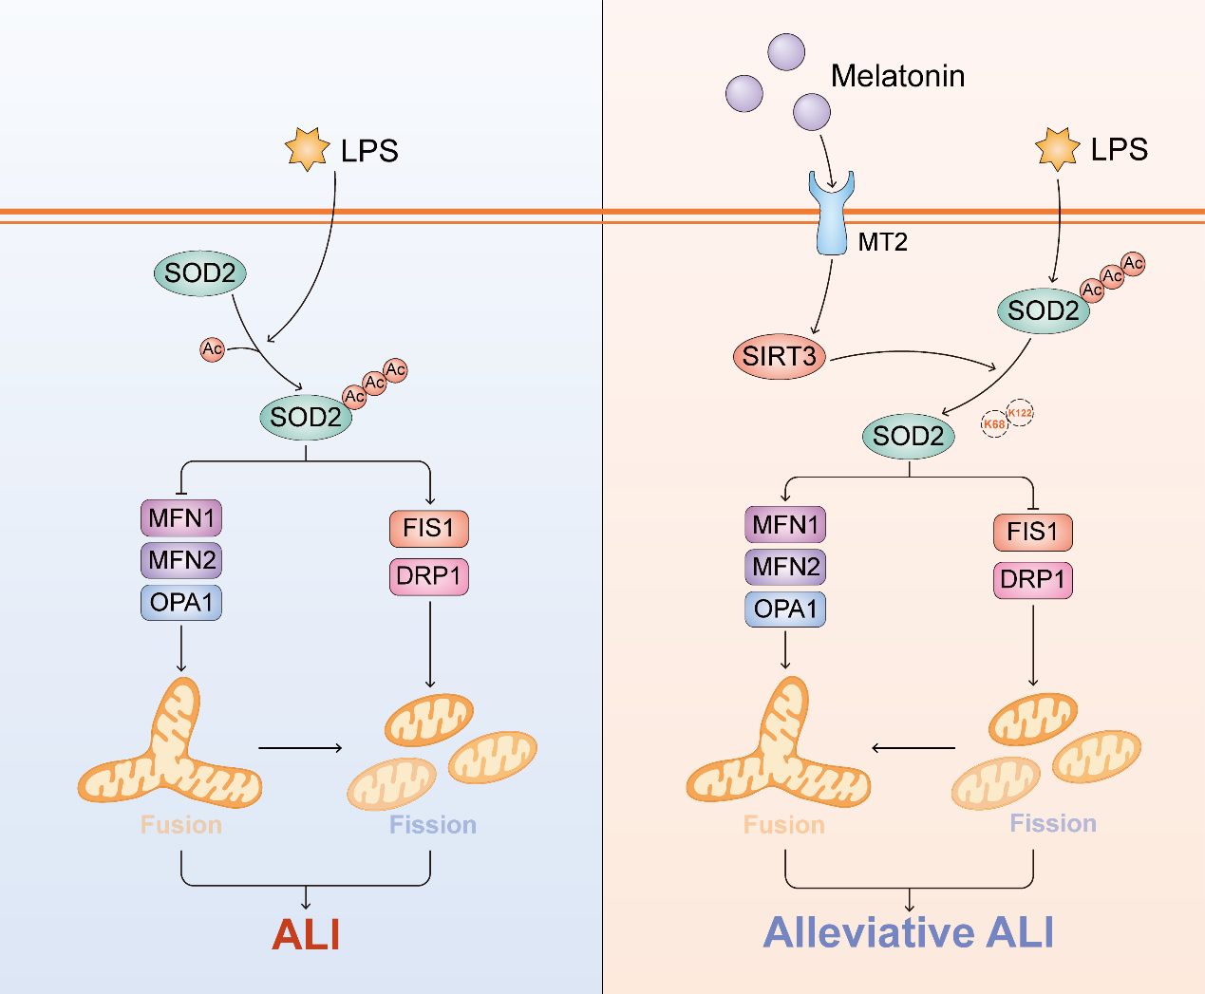LPS could promote the acetylation of SOD2 in lung epithelial cells. Acetylated SOD2 further promoted the expression of FIS1 and DRP1 while inhibiting the expression of MFN1, MFN2 and OPA1, which shifted the dynamic course of mitochondria from fusion to fission and triggering ALI. After melatonin pretreatment, it activated melatonin receptor 1B (MTNR1B, MT2) but not MT1 in lung epithelial cells. Subsequently, the expression and activity of SIRT3 were enhanced, which further deacetylated SOD2 at K68 and K122. Deacetylated SOD2 restore its antioxidant activity and shifted the dynamic course of mitochondria from fission to fusion, eventually preventing ALI.

