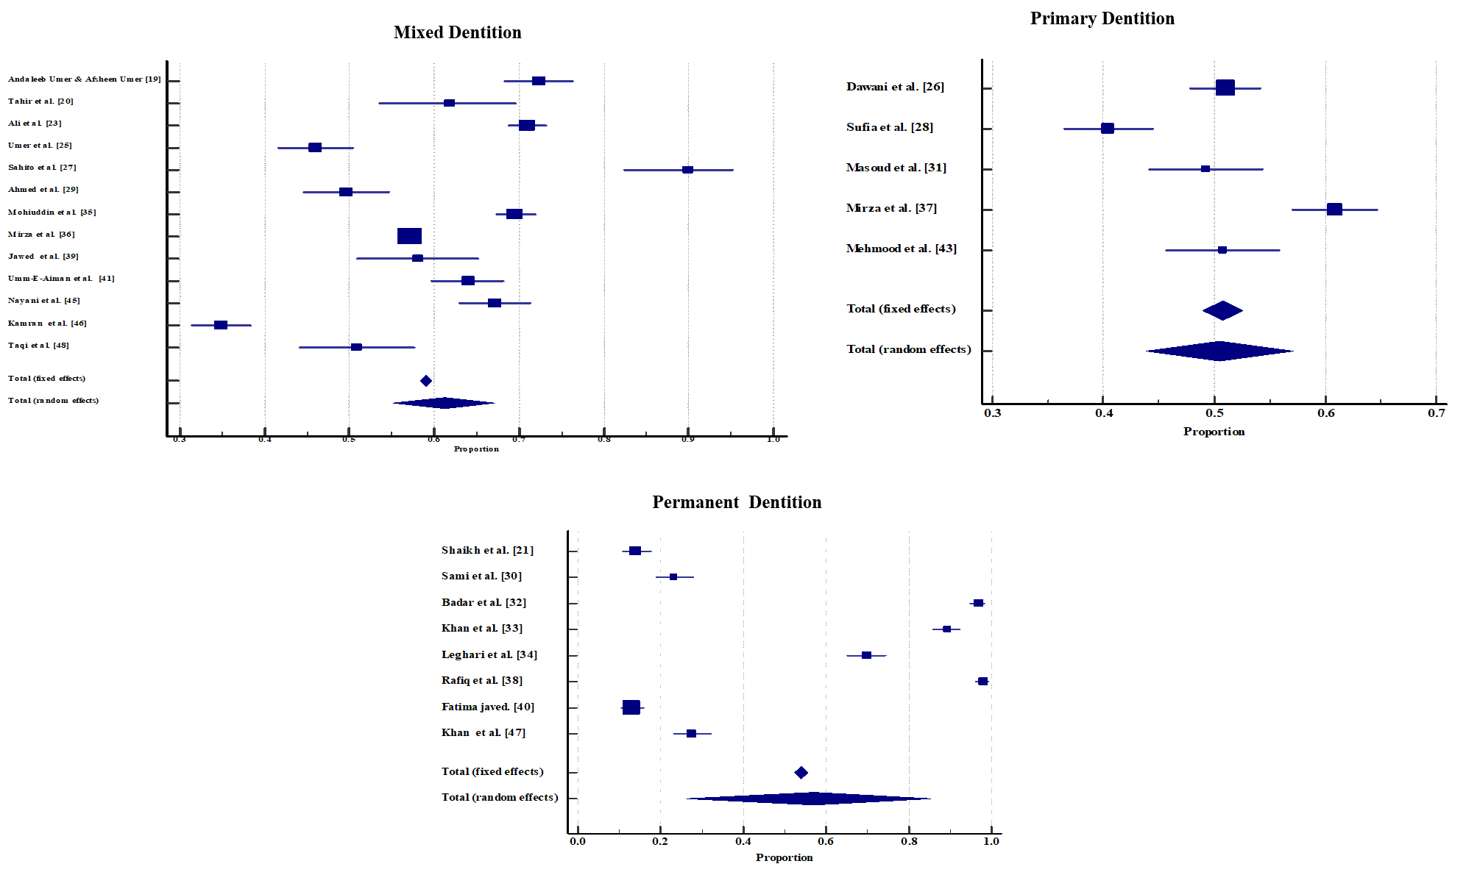
Figure S1. Forest plot showing effect of different studies and overall effect at 95 % CI regarding dental caries from (2009-2020) for primary, mixed and permeant dentitions

