Supplementary Figures
Figure 1 SYV template for planning a school-based healthy eating or physical activity intervention
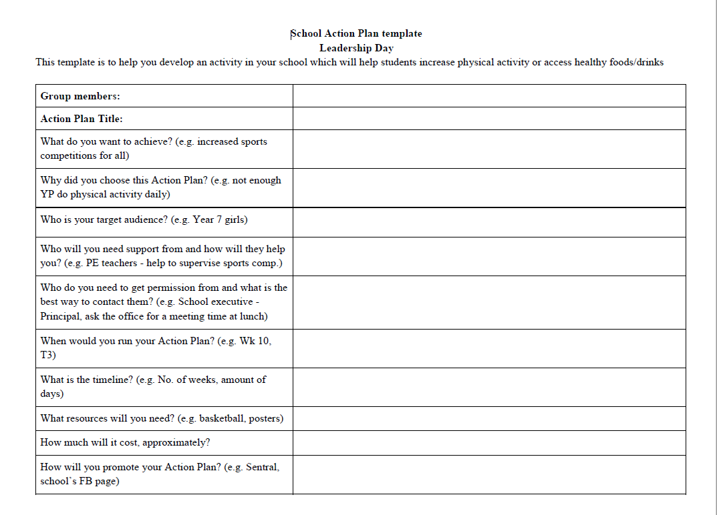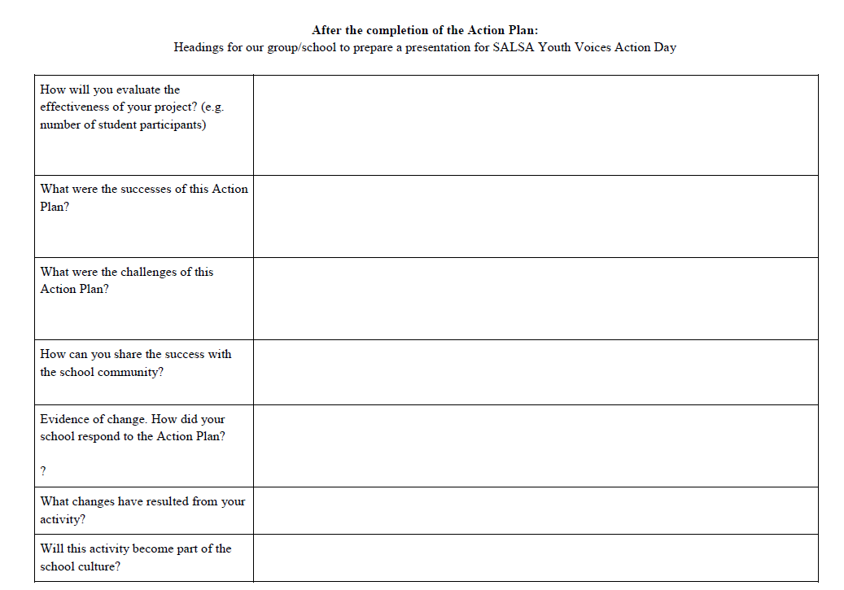

Figure 2. Leadership Day peer leader evaluation survey
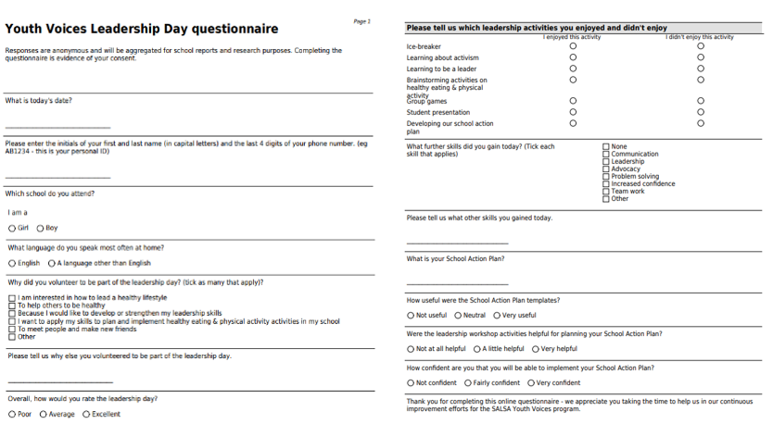

Figure 3. Action Day peer leader evaluation survey
