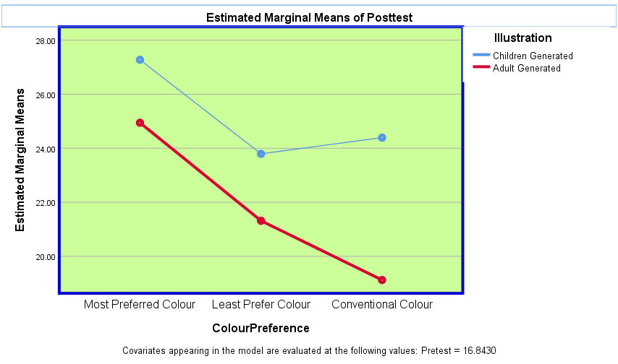
FIGURES

Fig. 1: Achievement score by mode of illustration and colour

APPENDIX A

RESULT OF THE PRELIMINARY STUDY ON COLOUR PREFERENCES

MOST PREFERRED COLOUR BY PRIMARY 2

COLOUR | NO. OF RESPONDENTS
Yellow | 41
Red | 5
Blue | 15
Orange | 14
Green | 9
Purple | 6
TOTAL | 90

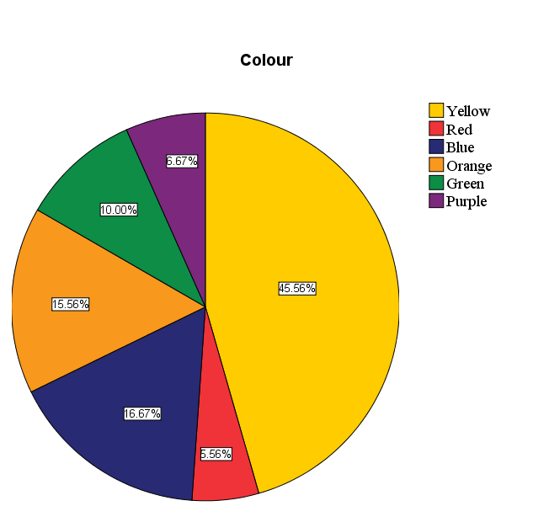

APPENDIX B

RESULT OF THE PRELIMINARY STUDY ON COLOUR PREFERENCES

LEAST PREFERRED COLOUR BY PRIMARY 2

COLOUR | NO. OF RESPONDENTS
Yellow | 10
Red | 6
Blue | 16
Orange | 18
Green | 13
Purple | 27
TOTAL | 90

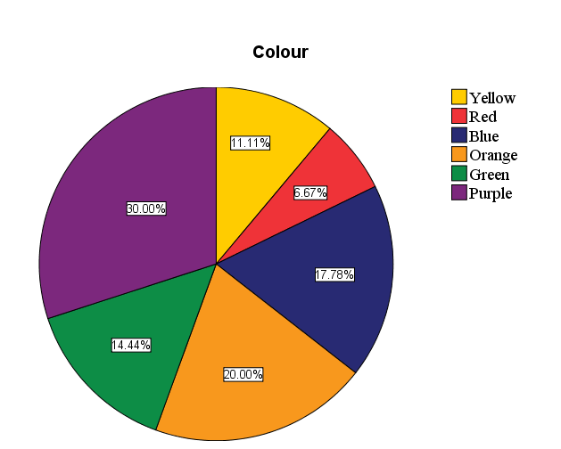

APPENDIX C

RESULT OF THE PRELIMINARY STUDY ON COLOUR PREFERENCES

MOST PREFERRED COLOUR BY PRIMARY 5

COLOUR | NO. OF RESPONDENTS
Yellow | 29
Red | 9
Blue | 16
Orange | 12
Green | 16
Purple | 8
TOTAL | 90
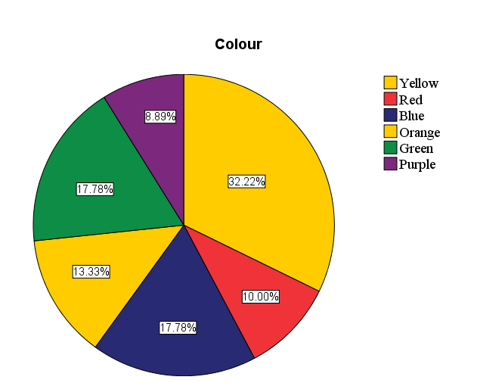

APPENDIX D

RESULTS OF THE PRELIMINARY STUDY ON COLOUR PREFERENCES

LEAST PREFERRED COLOUR BY PRIMARY 5

COLOUR | NO. OF RESPONDENTS
Yellow | 13
Red | 12
Blue | 16
Orange | 22
Green | 6
Purple | 21
TOTAL | 90

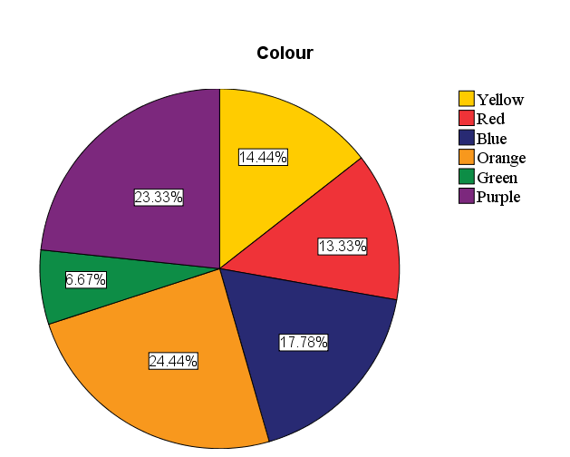

APPENDIX E

RESULT OF THE PRELIMINARY STUDY ON COLOUR PREFERENCES

TEACHERS MOST PREFERRED COLOUR

COLOUR | NO. OF RESPONDENTS
Yellow | 5
Red | 6
Blue | 3
Orange | 1
Green | 1
Purple | 0
TOTAL | 16

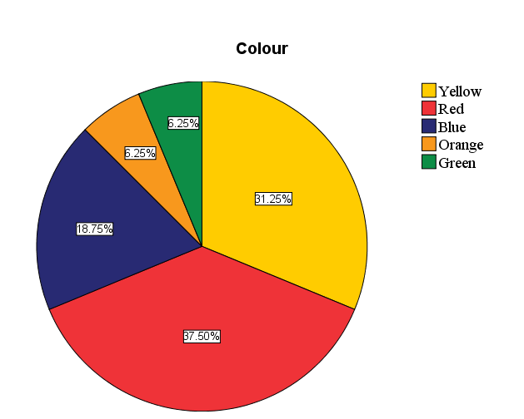

APPENDIX F

RESULT OF THE PRELIMINARY STUDY ON COLOUR PREFERENCES

TEACHERS LEAST PREFERRED COLOUR

COLOUR | NO. OF RESPONDENTS
Yellow | 1
Red | 1
Blue | 1
Orange | 1
Green | 0
Purple | 12
TOTAL | 16

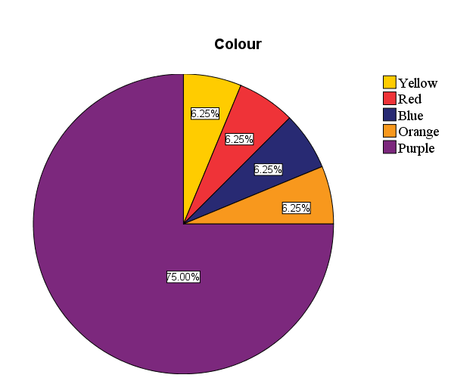

APPENDIX G

Examples of Adult-Generated Illustrations

Most Preferred Colour Least Preferred Colour

Conventional Colour

Fig. A2
Examples of Adult-
generated illustrations in the
most preferred colours, least
preferred colours and
conventional colours
APPENDIX G

Children-Generated Illustrations

Most Preferred Colour Least Preferred Colour

Conventional Colour

Fig. A2
Examples of children-
generated illustrations in the
most preferred colours, least
preferred colours and
conventional colours

