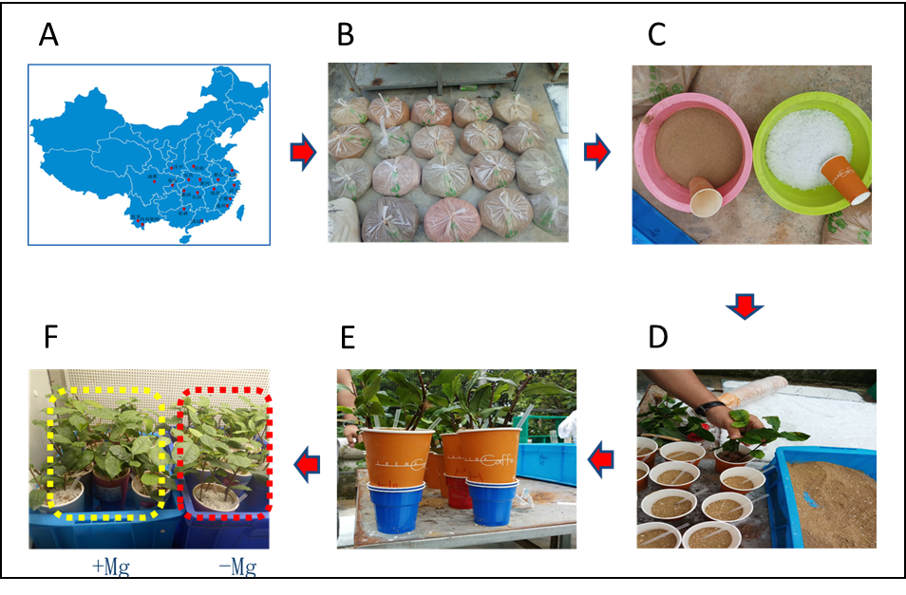

Figure S1. Tea plant and experimental design

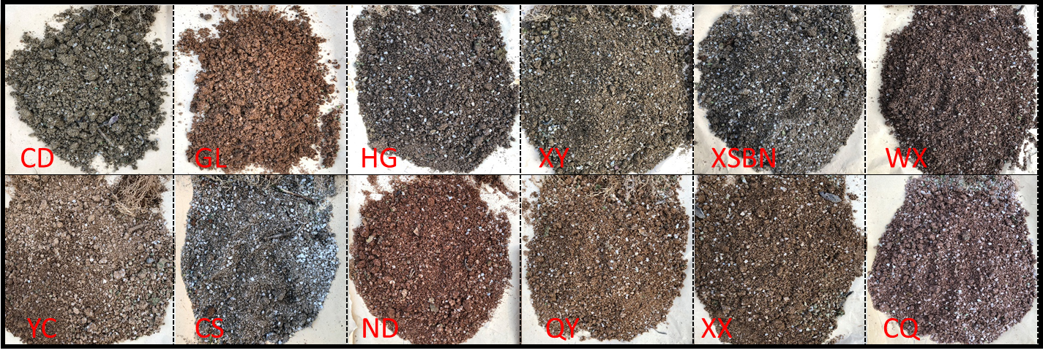

Figure S2. Appearance of Soil from 12 tea plantations in china after plant harvest.

