A
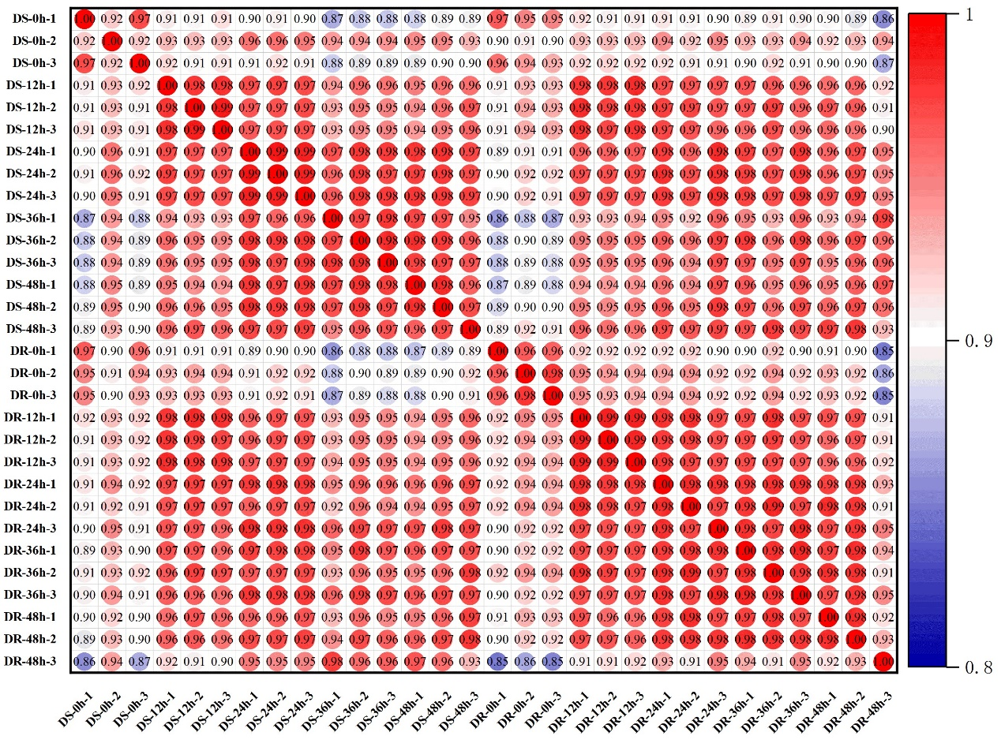
B
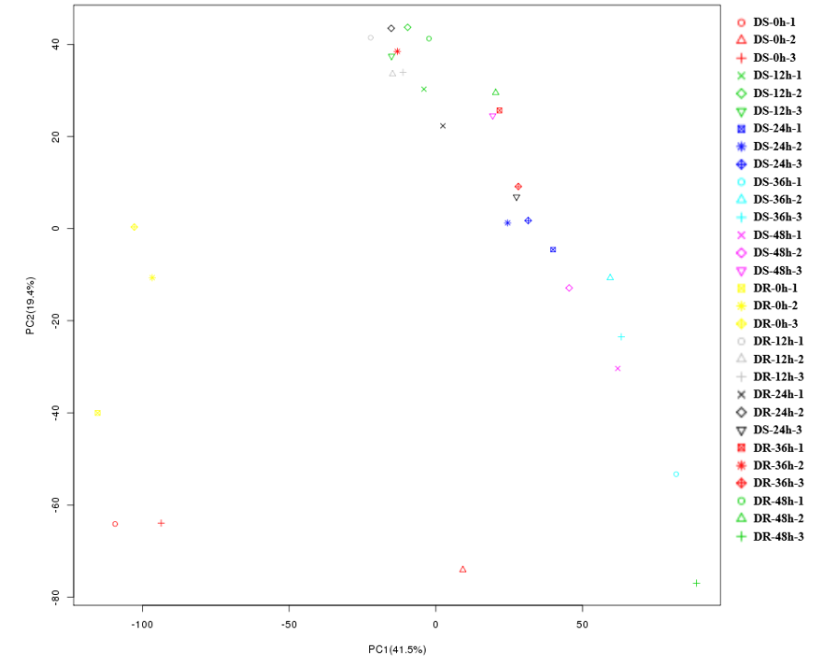
Figure S1. Correlation of 30 samples. A. Pearson correlation coefficients of all 30 samples (The expression level of each gene for each pair of samples was used to calculate the Pearson correlation coefficients). B. PCA of 30 samples.

