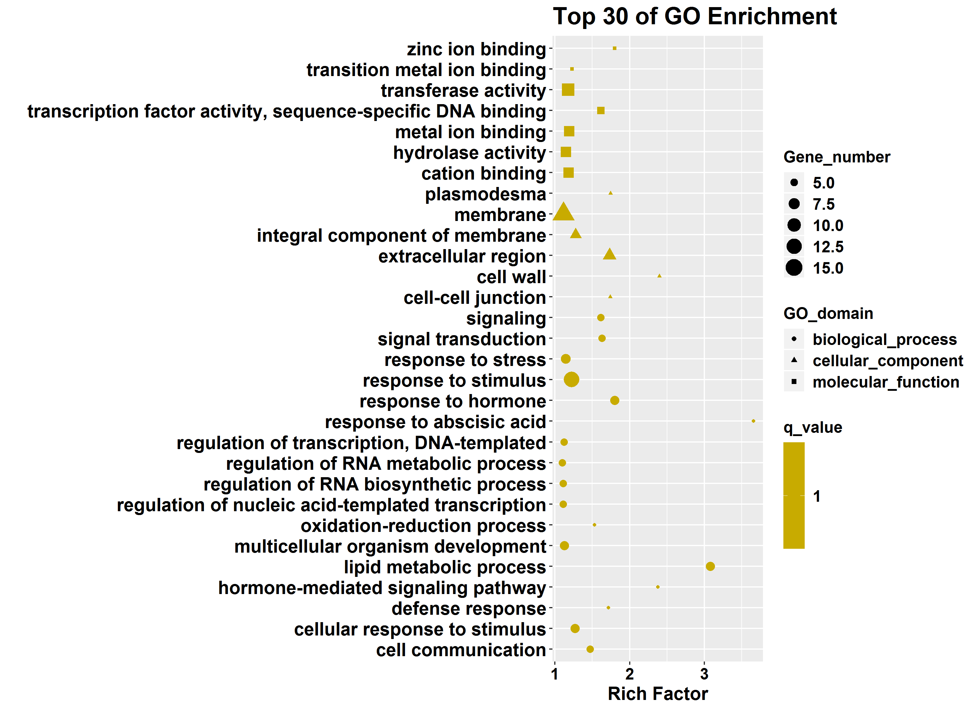
Figure S4. Top 30 GO terms enriched function categories of 52 common DEGs between DR and DS.

