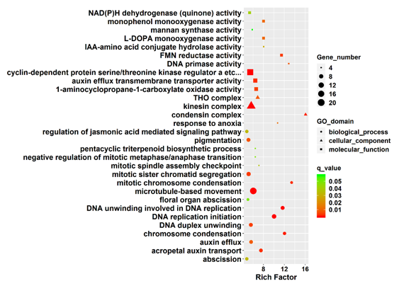
Figure S3. Top 30 GO terms enriched function categories of DEGs between DR and DS before-innoculation (0h).

