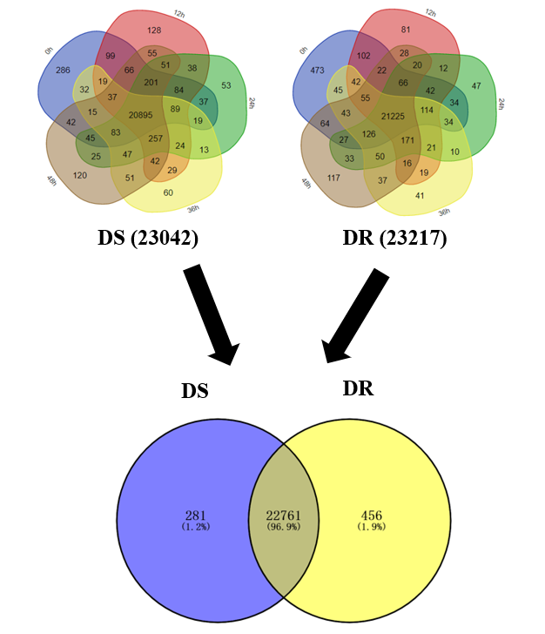
B
A
Figure S2. Overview of gene expression (FPKM>0.1) in DS and DR. A. Gene numbers expressed at five time points post-inoculation. B. Overall gene numbers expressed in DS and DR.

