Supporting Information for: Density functional theory (DFT) investigation of the oxidative degradation of NaAsO₂ via hydroxyl radical
Ashlyn M. Koval†,‡,$, Harley McAlexander‡, and Manoj Shukla‡
†Oak Ridge Institute for Science and Education (ORISE), Oak Ridge, Tennessee 37830 United States
$Current affiliation: Simetri, Inc., 7005 University Blvd, Winter Park, FL 32792, United States
‡Environmental Laboratory, US Army Engineer Research and Development Center, 3909 Halls Ferry Road, Vicksburg, Mississippi 39180, United States
Email: Ashlyn.M.Koval@usace.army.mil; Manoj.K.Shukla@usace.army.mil
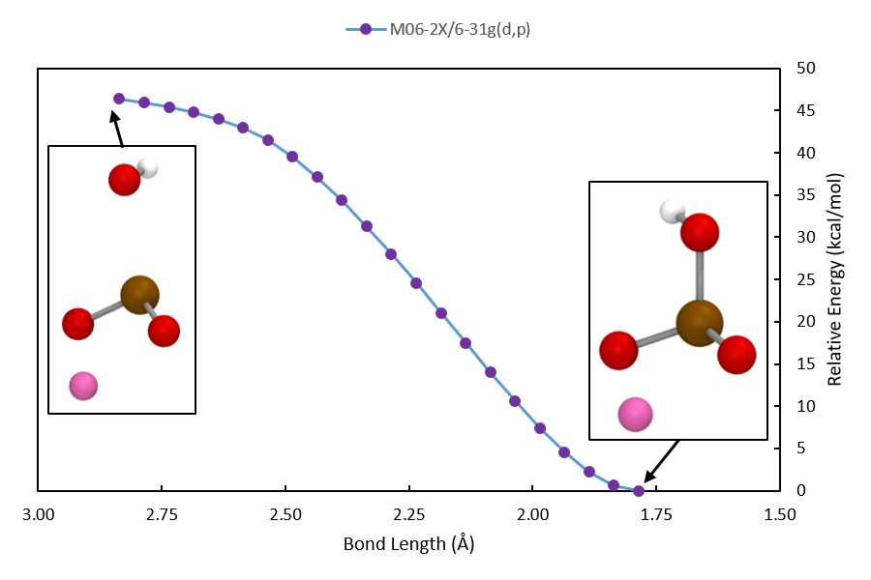
Figure S1. Relative potential energy in response to As-OH bond formation utilizing M06-2X/6-31G(d,p). Geometry was allowed to relax at each step. Implicit solvation was accounted for using PCM approach with default parameters for water in Gaussian16. Inset images show the structure at either end of the scan. The atoms involved in the reaction are show in ball and stick model and the explicitly calculated solvent molecules are shown in tube model. Arsenic is shown in brown, oxygen in red, hydrogen in white, and sodium in pink.
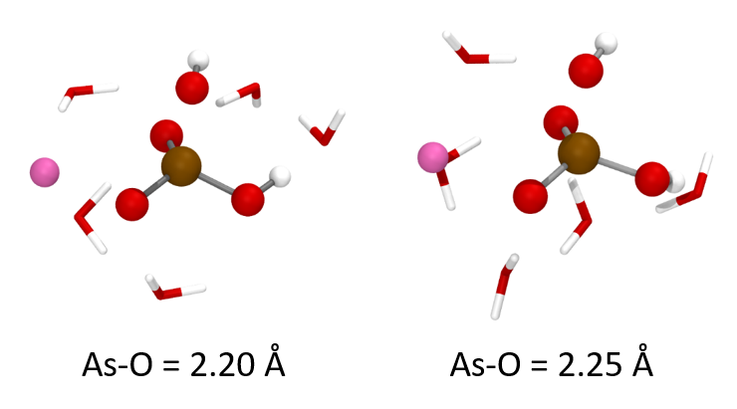
Figure S2. Structures found for As-O for the non-bonded hydroxyl at 2.20 Å and 2.25 Å in the relaxed potential energy scan in Figure 2B utilizing M06-2X/6-31G(d,p). Implicit solvation was accounted for using PCM approach with default parameters for water in Gaussian16. Inset images show the structure at either end of the scan. The atoms involved in the reaction are show in ball and stick model and the explicitly calculated solvent molecules are shown in tube model. Arsenic is shown in brown, oxygen in red, hydrogen in white, and sodium in pink. The sharp change in energy observed in the scan in Figure 2B is due to rearrangement of the water molecules.
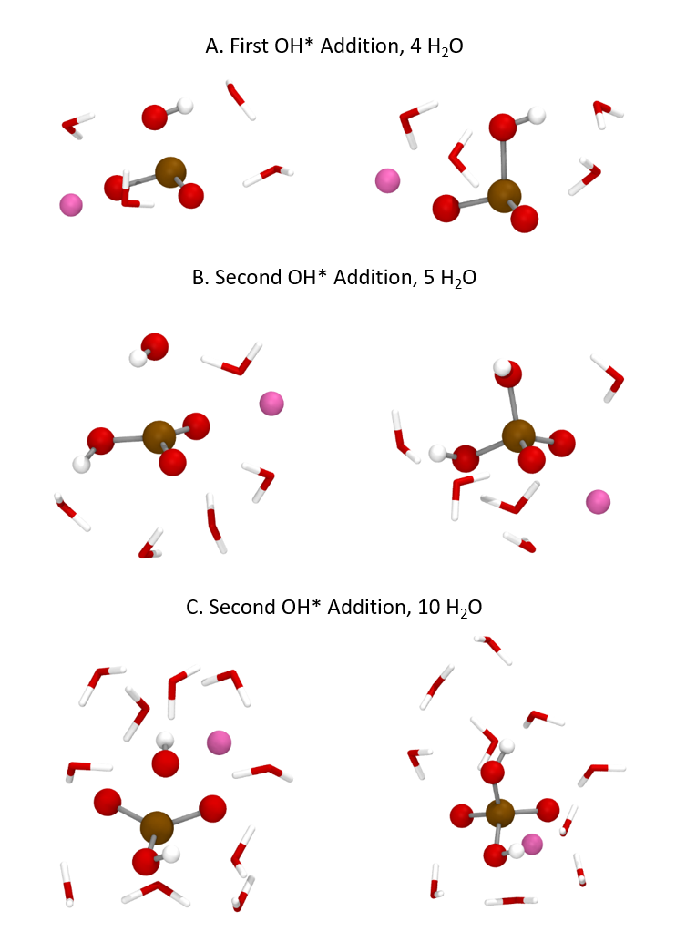
Figure S3. Example structures from relaxed potential energy scans in Figure 2 utilizing M06-2X/6-31G(d,p) (Purple line with circle markers). Implicit solvation was accounted for using PCM and default parameters for water in Gaussian16. The atoms involved in the reaction are show in ball and stick model and the explicitly calculated solvent molecules are shown in tube model. Arsenic is shown in brown, oxygen in red, hydrogen in white, and sodium in pink. A. From Figure 2A. B. From Figure 2B. C. From Figure 2C.
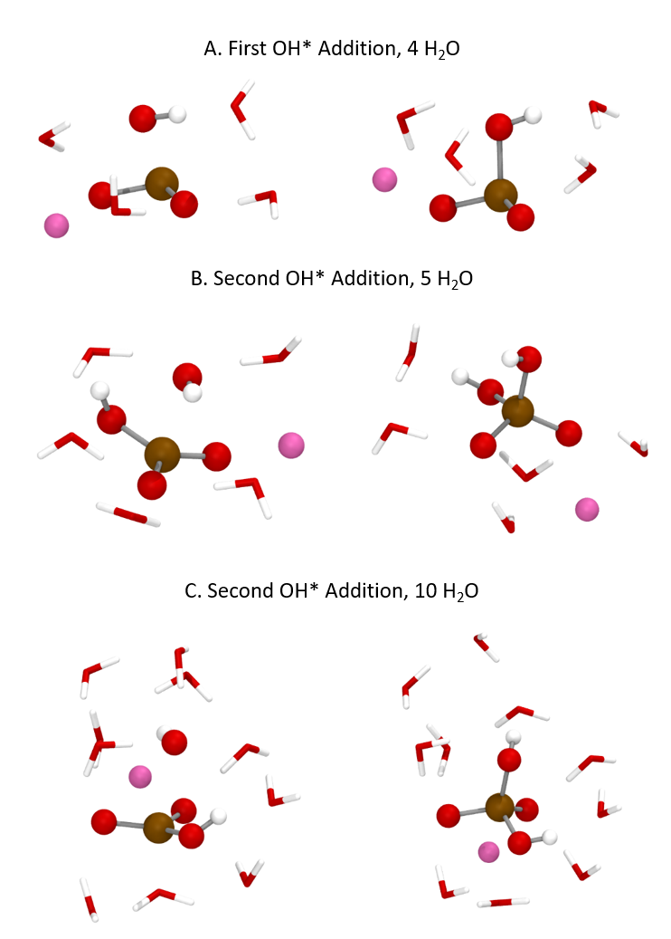
Figure S4. Example structures from relaxed potential energy scans in Figure 2 utilizing M06-2X/6-311G(d,p) (orange line with triangle markers). Implicit solvation was accounted for using PCM approach with default parameters for water in Gaussian16. The atoms involved in the reaction are show in ball and stick model and the explicitly calculated solvent molecules are shown in tube model. Arsenic is shown in brown, oxygen in red, hydrogen in white, and sodium in pink. A. From Figure 2A. B. From Figure 2B. C. From Figure 2C.

