Supplementary information

Genome-wide identification and expression profiling of WOX family proteins encoded genes in Triticeae plant species
Lei Shi^{1,2} ·Huihui Li¹ · Ke Wang¹ · Lipu Du¹ · Yuxia Song² ·Xingguo Ye^{1,3*}
¹ Institute of Crop Sciences, Chinese Academy of Agricultural Sciences, Beijing 100081, China.
² Key Laboratory of Agricultural Biotechnology of Ningxia, Ningxia Academy of Agriculture and Forestry Sciences, Yinchuan 750002, China.
³ National Key Facility of Crop Gene Resources and Genetic Improvement, Chinese Academy of Agricultural Sciences, Beijing 100081, China.
E-mail
Shi L: s5266@126.com
Li H: Lihuihui@caas.cn
Wang K: wangke03@caas.cn
Du L: dulipu@caas.cn
Song Y: Songyx666@163.com
Ye X: yexingguo@caas.cn
*Correspondence author
Prof. Dr. Xingguo Ye, Institute of Crop Sciences/National Key Facility of Crop Gene Resources and Genetic Improvement, Chinese Academy of Agricultural Sciences, Beijing 100081, China.

Additional file 1: Table S1. Characteristics of AtaWOX gene family members in A. tauschii.

Gene | Gene locus | Chromosome | Gene stretch region | mRNA length  (bp) | Protein Sequence Length (aa) | Uniprot ID | RefSeq ID
AtaWOX2 | AET1Gv20131800 | 1D | 36,944,248-36,945,654:-1 | 1256 | 243 | R7VZP3 | XM_020308608.1
AtaWOX12 | AET1Gv20953700 | 1D | 477,482,405-477,487,246:1 | 1750 | 461 | N1QTU6 | XM_020313635.1
AtaWOX11 | AET2Gv20201700 | 2D | 53,152,025-53,154,730:1 | 1402 | 285 | A0A453AN31 | XM_020326401.1
AtaWOX4 | AET2Gv21131600 | 2D | 604,547,042-604,548,705:1 | 1432 | 235 | M8BW89 | XM_020306027.1
AtaWOX10 | AET3Gv20162600 | 3D | 36,379,013-36,380,597:1 | 1250 | 261 | M8C4V1 | XM_020344627.1
AtaWOX7 | AET3Gv20594700 | 3D | 346,711,567-346,714,983:-1 | 1542 | 513 | M8BNX7 | XM_020303677.1
AtaWOX8 | AET3Gv20773400 | 3D | 455,036,105-455,039,875:1 | 1630 | 262 | M8CAA6 | XM_020332450.1
AtaWOX13 | AET3Gv20805500 | 3D | 471,027,549-471,091,495:-1 | 1156 | 285 | R7W9P1
AtaWOX14 | AET3Gv20805900 | 3D | 471,208,547-471,212,126:-1 | 1272 | 291 | N1QRI3
AtaWOX9 | AET3Gv20824700 | 3D | 482,688,233-482,689,713:-1 | 1271 | 210 | M8BYV0 T1WGH7
AtaWOX6 | AET4Gv20460500 | 4D | 314,146,370-314,149,574:1 | 1000 | 314 | M8CH34 | XM_020309078.1
AtaWOX5 | AET5Gv20233200 | 5D | 111,775,850-111,778,228:1 | 969 | 322 | A0A023R759 | XM_020308947.1
AtaWOX3 | AET5Gv20399900 | 5D | 260,643,657-260,644,829:1 | 1026 | 242 | R7W601 | XM_020339660.1
AtaWUS |  | 2D | 588,432,717-588,433,925:1 | 927 | 308

Additional file 2: Table S2. Characteristics of TdWOX gene family members in T. dicoccoides.
Gene | Gene locus | Chromosome | Gene stretch region | mRNA length  (bp) | Protein Sequence Length (aa)
TdWOX2a | TRIDC1AG007150 | 1A | 35,225,067-35,226,474:-1 | 1267 | 263
TdWOX12a |  | 1A | 562,999,481-563,003,353 | 1461 | 486
TdWOX2b | TRIDC1BG009160 | 1B | 56,235,853-56,237,613:-1 | 1514 | 264
TdWOX12b |  | 1B | 655,616,838-655,620,923 | 1458 | 485
TdWOX11a | TRIDC2AG011820 | 2A | 56,306,448-56,309,162:1 | 854 | 262
TdWOX4a | TRIDC2AG072250 | 2A | 731,229,384-731,230,228:1 | 690 | 229
TdWOX11b | TRIDC2BG014670 | 2B | 89,285,280-89,288,104:1 | 864 | 260
TdWOX4b | TRIDC2BG078290 | 2B | 736,558,472-736,559,499:-1 | 699 | 232
TdWOX10a | TRIDC3AG008680 | 3A | 42,317,316-42,318,397:1 | 810 | 193
TdWOX8.2a | TRIDC3AG012070 | 3A | 60,093,235-60,099,789:-1 | 1707 | 172
TdWOX7a | TRIDC3AG037080 | 3A | 472,489,137-472,490,767:1 | 1533 | 510
TdWOX8.1a | TRIDC3AG049280 | 3A | 584,617,832-584,621,605:1 | 1046 | 261
TdWOX13a | TRIDC3AG051560 | 3A | 602,962,138-602,964,193:-1 | 2042 | 181
TdWOX14a | TRIDC3AG051570 | 3A | 603,033,097-603,086,787:-1 | 1166 | 290
TdWOX9a | TRIDC3AG052920 | 3A | 613,614,879-613,616,278:-1 | 643 | 214
TdWOX10b | TRIDC3BG011840 | 3B | 62,220,403-62,221,372:-1 | 749 | 213
TdWOX7b |  | 3B | 447,470,878-447,473,971:-1 | 1548 | 515
TdWOX8b | TRIDC3BG055520 | 3B | 597,159,634-597,163,486:1 | 1513 | 261
TdWOX13b |  | 3B | 627,499,895-627,501,751:-1 | 900 | 299
TdWOX14b | TRIDC3BG058280 | 3B | 627,719,369-627,721,911:-1 | 1198 | 290
TdWOX9b | TRIDC3BG059490 | 3B | 641,913,687-641,914,697:-1 | 636 | 211
TdWOX6a | TRIDC4AG018040 | 4A | 170,474,653-170,477,215:-1 | 1001 | 315
TdWOX6b | TRIDC4BG031600 | 4B | 389,709,929-389,712,462:1 | 1009 | 317
TdWOX5a | TRIDC5AG013020 | 5A | 111,615,636-111,617,548:1 | 953 | 318
TdWOX3a | TRIDC5AG026090 | 5A | 334,542,650-334,543,892:1 | 1095 | 237
TdWOX5b | TRIDC5BG014980 | 5B | 122,875,190-122,877,486:1 | 966 | 321
TdWOX3b | TRIDC5BG027470 | 5B | 297,256,041-297,257,278:-1 | 1103 | 241
TdWUSa |  | 2A | 717,371,085-717,372,278:1 | 927 | 308
TdWUSb |  | 2B | 709,748,669-709,749,875:1 | 936 | 311

Additional file 3: Table S3. Characteristics of TtWOX gene family members in T. turgidum.
Gene | Gene locus | Chromosome | Gene stretch region | mRNA length  (bp) | Protein Sequence Length (aa)
TtWOX2a | TRITD1Av1G014400 | 1A | 30,266,253-30,267,185:-1 | 792 | 263
TtWOX12a | TRITD1Av1G210580 | 1A | 548,095,711-548,099,750:-1 | 1461 | 486
TtWOX2b | TRITD1Bv1G018490 | 1B | 47,977,816-47,978,741:-1 | 795 | 264
TtWOX12b | TRITD1Bv1G213780 | 1B | 645,322,215-645,325,522:1 | 1458 | 485
TtWOX11a | TRITD2Av1G026520 | 2A | 52,846,448-52,848,548:1 | 798 | 265
TtWOX4a | TRITD2Av1G275690 | 2A | 735,363,729-735,364,662:1 | 705 | 234
TtWOX11b | TRITD2Bv1G034440 | 2B | 83,084,542-83,086,937:1 | 786 | 261
TtWOX4b | TRITD2Bv1G239870 | 2B | 726,776,414-726,777,497:-1 | 714 | 237
TtWOX10a | TRITD3Av1G020310 | 3A | 41,781,579-41,782,652:1 | 807 | 268
TtWOX7a | TRITD3Av1G165910 | 3A | 468,275,958-468,279,104:1 | 1548 | 515
TtWOX8a | TRITD3Av1G210120 | 3A | 580,017,802-580,022,111:1 | 798 | 265
TtWOX13a | TRITD3Av1G217260 | 3A | 597,915,150-597,916,973:-1 | 906 | 301
TtWOX14.2a | TRITD3Av1G217280 | 3A | 597,987,122-597,990,043:-1 | 867 | 288
TtWOX9a | TRITD3Av1G222700 | 3A | 610,880,586-610,883,548:1 | 639 | 212
TtWOX14.1a | TRITD3Av1G223690 | 3A | 613,842,920-613,845,442:-1 | 873 | 290
TtWOX10b | TRITD3Bv1G023880 | 3B | 62,602,349-62,603,796:1 | 837 | 278
TtWOX8.2b | TRITD3Bv1G035130 | 3B | 90,684,051-90,690,161:-1 | 1608 | 535
TtWOX7b | TRITD3Bv1G141830 | 3B | 442,112,979-442,116,074:-1 | 1548 | 515
TtWOX8.1b | TRITD3Bv1G192740 | 3B | 588,758,146-588,761,021:-1 | 786 | 261
TtWOX13b | TRITD3Bv1G202750 | 3B | 620,225,076-620,226,932:-1 | 900 | 299
TtWOX14b | TRITD3Bv1G202810 | 3B | 620,444,973-620,447,190:-1 | 873 | 290
TtWOX9b | TRITD3Bv1G207240 | 3B | 634,976,698-634,977,442:-1 | 630 | 209
TtWOX6a | TRITD4Av1G066630 | 4A | 168,111,221-168,113,757:-1 | 948 | 315
TtWOX6b | TRITD4Bv1G109220 | 4B | 386,507,631-386,510,136:1 | 954 | 317
TtWOX5a | TRITD5Av1G044880 | 5A | 113,122,758-113,124,660:1 | 957 | 318
TtWOX3a | TRITD5Av1G117410 | 5A | 330,291,871-330,292,732:1 | 726 | 241
TtWOX5b | TRITD5Bv1G042650 | 5B | 118,715,492-118,717,394:1 | 966 | 321
TtWOX3b | TRITD5Bv1G098090 | 5B | 288,212,824-288,213,684:-1 | 726 | 241
TtWUSa |  | 2A | 721,813,175-721,814,364:1 | 927 | 308
TtWUSb |  | 2B | 702,358,638-702,359,840:1 | 949 | 314

Additional file 4: Table S4. Characteristics of TuWOX gene family members in T. urartu.
Gene | Gene locus | Scaffold | Gene stretch region | mRNA length  (bp) | Protein Sequence Length (aa) | UniProt ID
TuWOX 2 | TRIUR3_16981 | SuperContig scaffold27530 | 48,108-48,786:-1 | 489 | 162aa | M8AVP1
TuWOX 4 | TRIUR3_10705 | SuperContig scaffold10844 | 41,544-42,477:1 | 705 | 234aa | M7ZDD1
TuWOX 9 | TRIUR3_26391 | SuperContig scaffold13490 | 208,605-211,568:-1 | 702 | 233aa | M7ZY58 T1WG20 T1WGR3
TuWOX 13 | TRIUR3_08856 | SuperContig scaffold21038 | 53,497-55,135:1 | 723 | 240aa | M7ZSR7
TuWOX 10 | TRIUR3_34876 | SuperContig scaffold106890 | 6,018-9,912:-1 | 822 | 273aa | M7ZJ11
TuWOX 6 | TRIUR3_34808 | SuperContig scaffold17894 | 25,625-28,065:-1 | 948 | 315aa | M7ZHX8
TuWOX 8 | TRIUR3_23636 | SuperContig scaffold26222 | 49,368-52,088:1 | 702 | 233aa | M7YSU5
TuWOX 8.1 | TRIUR3_03990 | SuperContig scaffold246 | 165,849-169,056:-1 | 417 | 138aa | M7YTI6
TuWUS |  | SuperContig scaffold93256 | 32,437-33,449:-1

Additional file 5: Table S5. Primers for qPCR amplification.
Primer name | Primer sequence
qTaWUSF | 5’-GACAAGCAGAGCGTCATGTGG-3’
qTaWUSR | 5’-AGTAGAGGTCCTTGAGGATCTTGAC-3’
qTaWOX2F | 5’-GCTGATGATCCTGGAGGAGATGTAC-3’
qTaWOX2R | 5’-AAGACGTTCTTGCCCTCGATGC-3’
qTaWOX3F | 5’-ATCACCACCACACATACGCTACC-3’
qTaWOX3R | 5’-TGTTGTTAATGTTGCTGTTGTCCA-3’
qTaWOX4F | 5’-AGATCAAGGTGCTGGAGGCGCTG-3’
qTaWOX4R | 5’-GAAGACGTTCTTGCCCTCGATCC-3’
qTaWOX5F | 5’-ACAGGCCACCATGTACCACCA-3’
qTaWOX5R | 5’-GGGAACAGGTTCAGGGTCTCG-3’
qTaWOX6F | 5’-CTCGTCGTCCTCGTCTGGAAGCAC-3’
qTaWOX6R | 5’-GGCTCCCAACGAATCCCATCTGA-3’
qTaWOX7F | 5’-TCTTCTACTGGTTCCAGAACCGCA-3’
qTaWOX7R | 5’-GATGGAACTGCTTGGGAGGTGG-3’
qTaWOX8F | 5’-CAGGTATGAGGCTTGGTAATC-3’
qTaWOX8R | 5’-CTGAAATCTGTCCGTGCTG-3’
qTaWOX9F | 5’-GAACGTCTTCTACTGGTTCCAGAAC-3’
qTaWOX9R | 5’-TGTAGCCTCTGGCCTCACGCTT-3’
qTaWOX10F | 5’-GTGCCCGCCAGCTCCAGCAGTC-3’
qTaWOX10R | 5’-GGCGTCGTCTAACAAGAAACGG-3’
qTaWOX11F | 5’-GGAGTCCATCTTCAACAGCGGCAT-3’
qTaWOX11R | 5’-GGAACCAGTAGAAGACGTTGGCGT-3’
QTaWOX12F | 5’-GAGCAACACCCACACCAGATCCT-3’
qTaWOX12R | 5’-GTTCTTGGTGCGAGACTTGCGGT-3’
qTaWOX13F | 5’-AGCCTACTACTCGCAGATGCA-3’
qTaWOX13R | 5’-CTGTTGTTGGTCGAAGGAAAC-3’
qTaWOX14F | 5’-CTGTCCCTTTCCACTCCCCGTC-3’
qTaWOX14R | 5’-CGCGATCACCTGATGTATCTCCTC-3’
qTaActinF | 5’-TGTTGTTCTCAGTGGAGGTTCT-3’
qTaActinR | 5’-CTGTATTTCCTTTCAGGTGGTG-3’

Additional file 6: Table S6. Primers for PCR amplification.
Primer name | Primer sequence
WUSaF | 5’-CGTCGCTGCTGCCGGTGCTGG-3’
WUSaR | 5’-CAAAGCGACGCGAGACAAGAATCAG-3’
WUSbF | 5’-CTTGCTTCGAGTCCGAACTACTC-3’
WUSbR | 5’-TGTAAAAGCTGTGCTGCGGCTGC-3’
WUSdF | 5’-TGCTTCGAGTCCGAACTATAACC-3’
WUSdR | 5’-ACATGGCGTTGGTGTTGCTGGCA-3’
WOX2aF | 5’-CCGGCAGGACTTCTAGCATCATC-3’
WOX2aR | 5’-CTATGGGCAAAGAAACAAATCCG-3’
WOX2bF | 5’-CTGTCTTTCGCCGCTCTTGCCGT-3’
WOX2bR | 5’-GCTTGTGAGTTGTGACCACCACG-3’
WOX2dF | 5’-GGATCCGGTCTTGGTTTGTCTGC-3’
WOX2dR | 5’-GAGATACTATGGCCAAACCCTC-3’
WOX6aF | 5’-GTTCCTAAAAACACGAATATGTTAG-3’
WOX6aR | 5’-TGGCTGCCTGCCTGCCTGGC-3’
WOX6bF | 5’-GTCTTCCTTGAGATATAGTTCAGC-3’
WOX6bR | 5’-CATGCATGTTCACTATAAACGTTC-3’
WOX6dF | 5’-CTCGTCACTCTCTCTCTCTCTCTC-3’
WOX6dR | 5’-AGCCGAGGAGGCTGCTGCT-3’

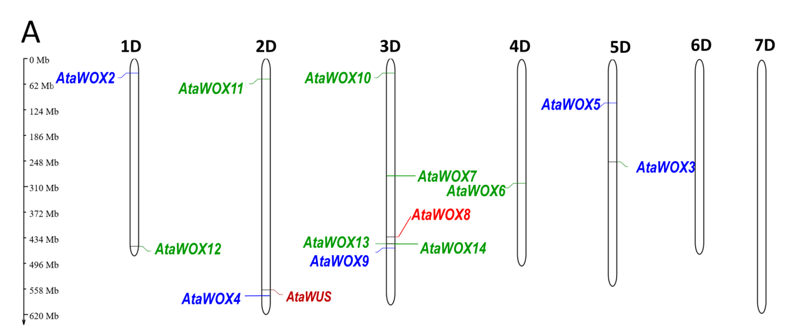
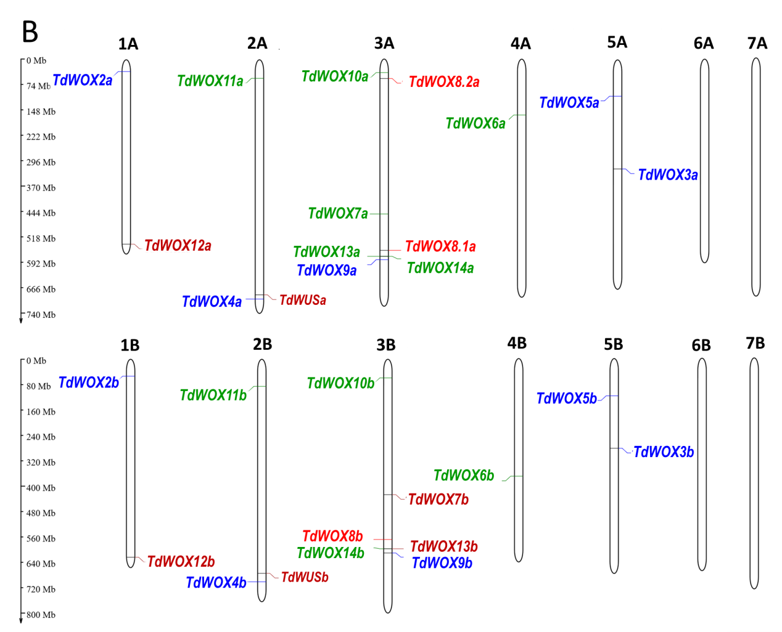
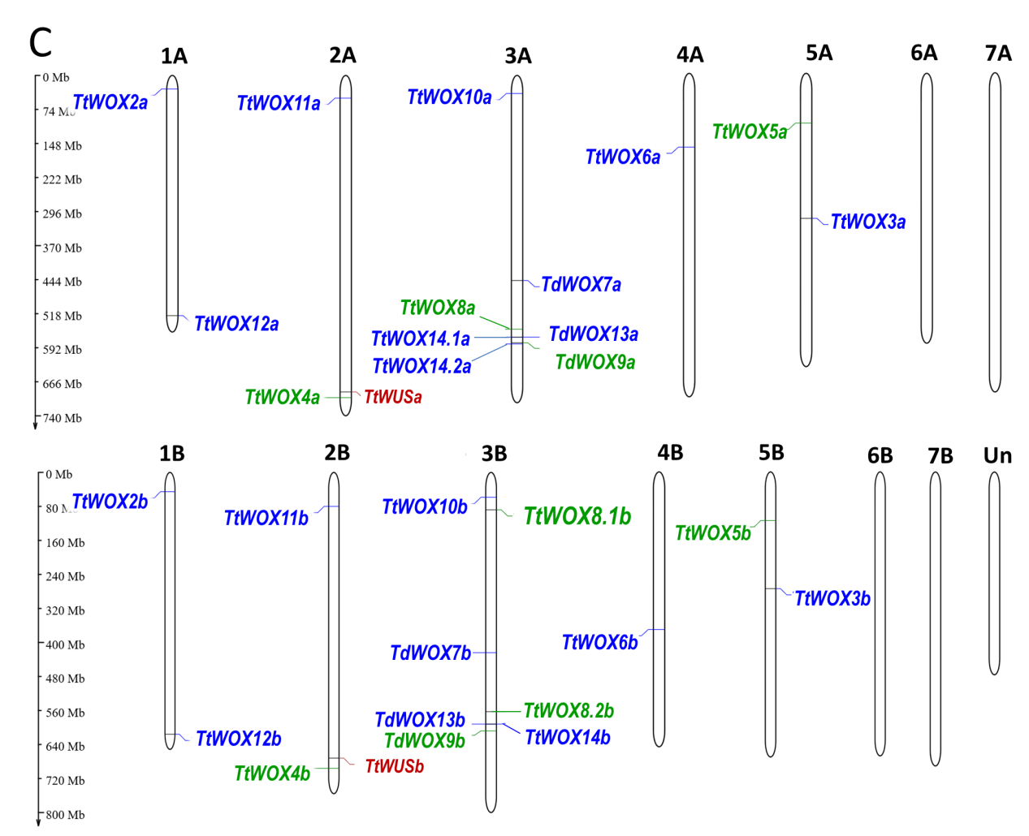
Additional file 7: Fig. S1. Chromosomal location of WOX genes in A. tauschii, T. dicoccoides and T. turgidum.
Chromosomal location of WOX genes in A. tauschii (A), T. dicoccoides (B), and T. turgidum (C). Vertical coordinate displayed length of chromosomes, The WOX members in WUS clade were shown as blue type, The WOX members in intermediate clade were shown as green type, the WOX members in ancient clade were shown as red type, the newly collected WOX members were shown as brown type.

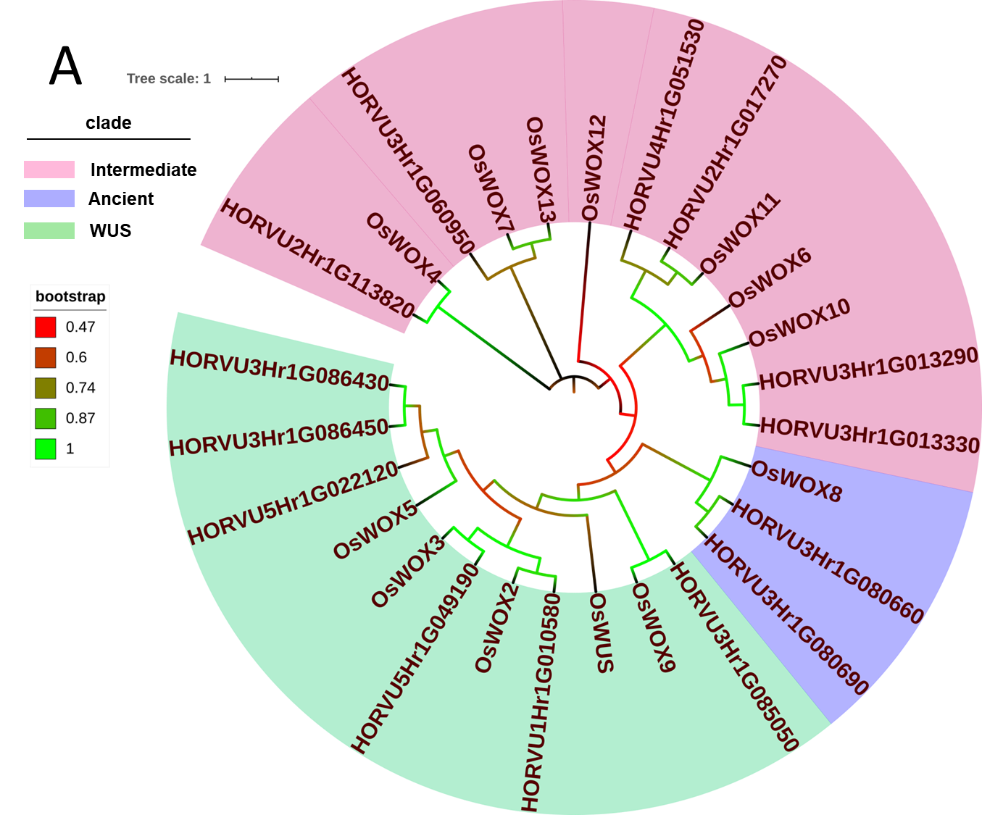
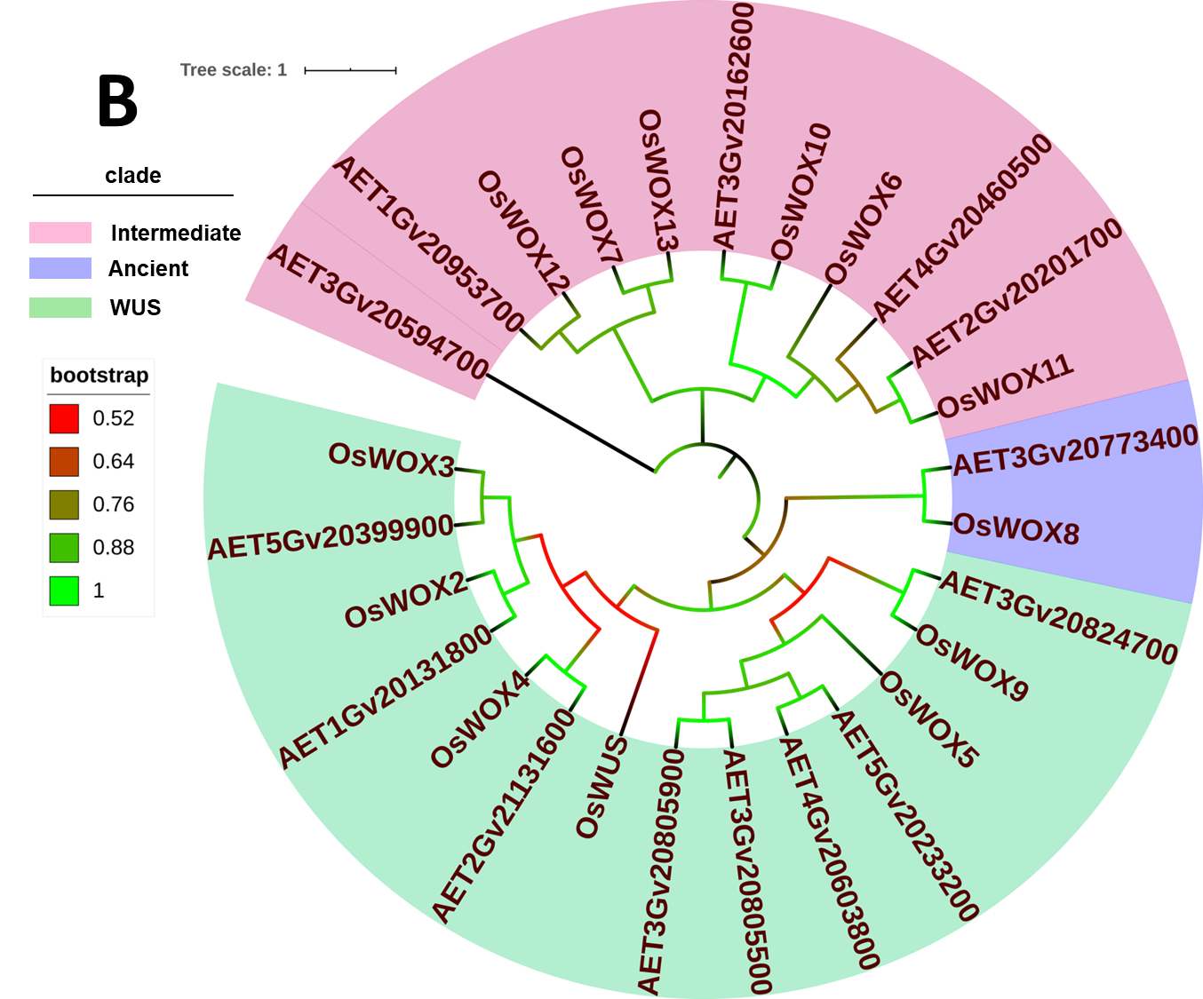
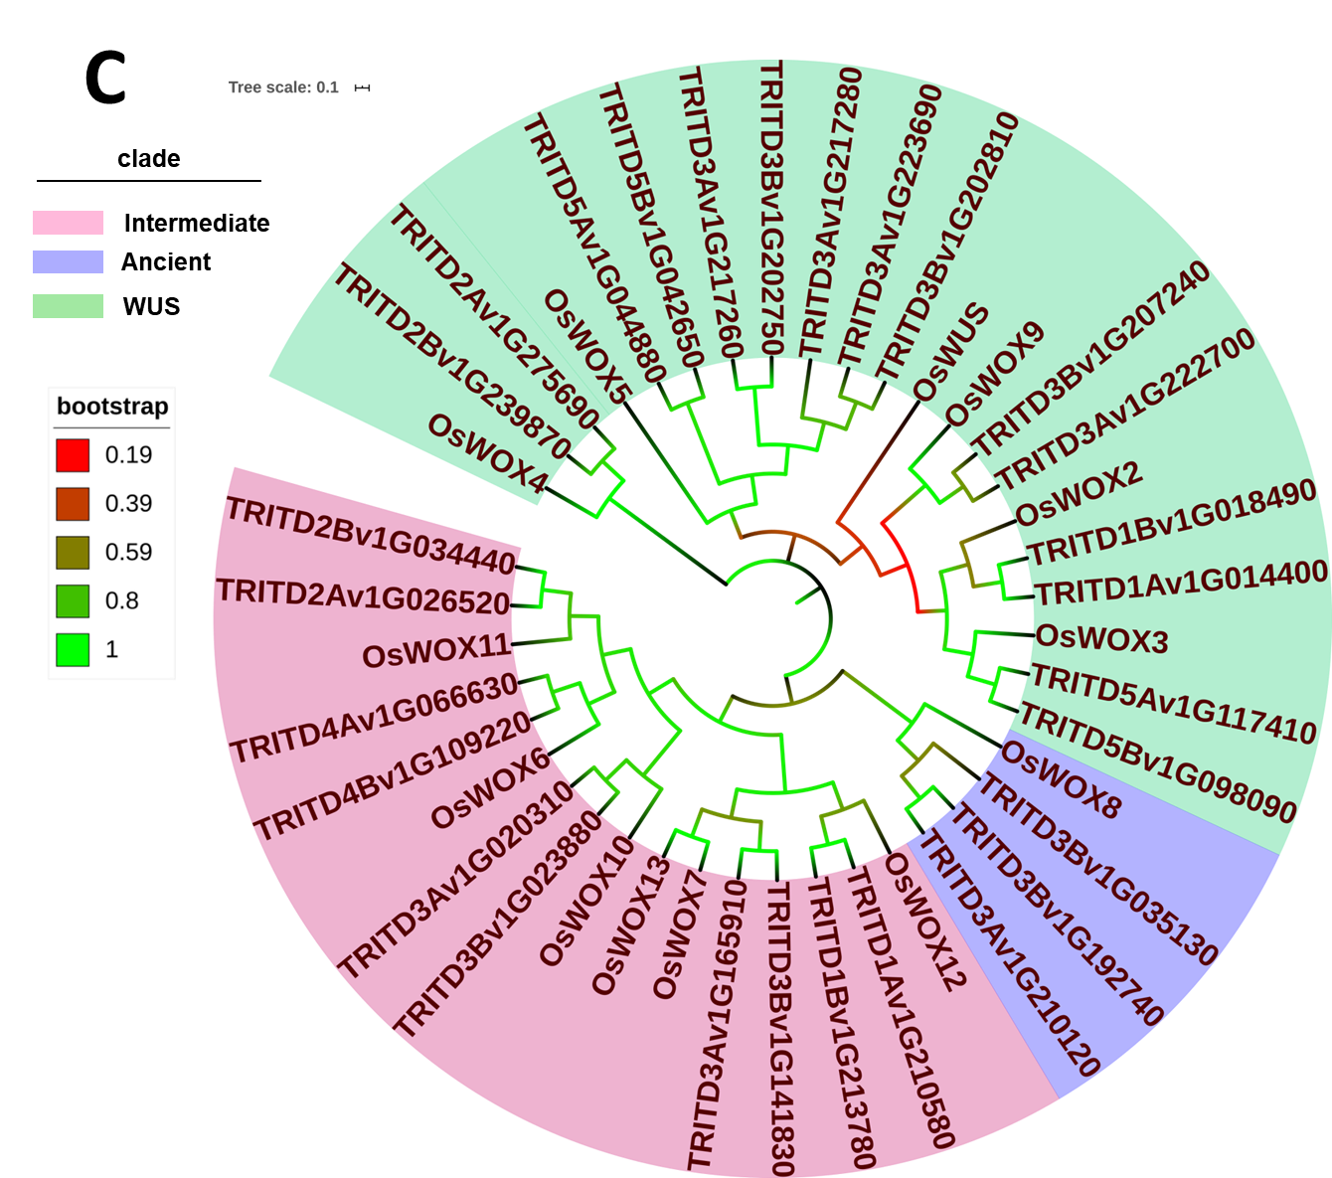
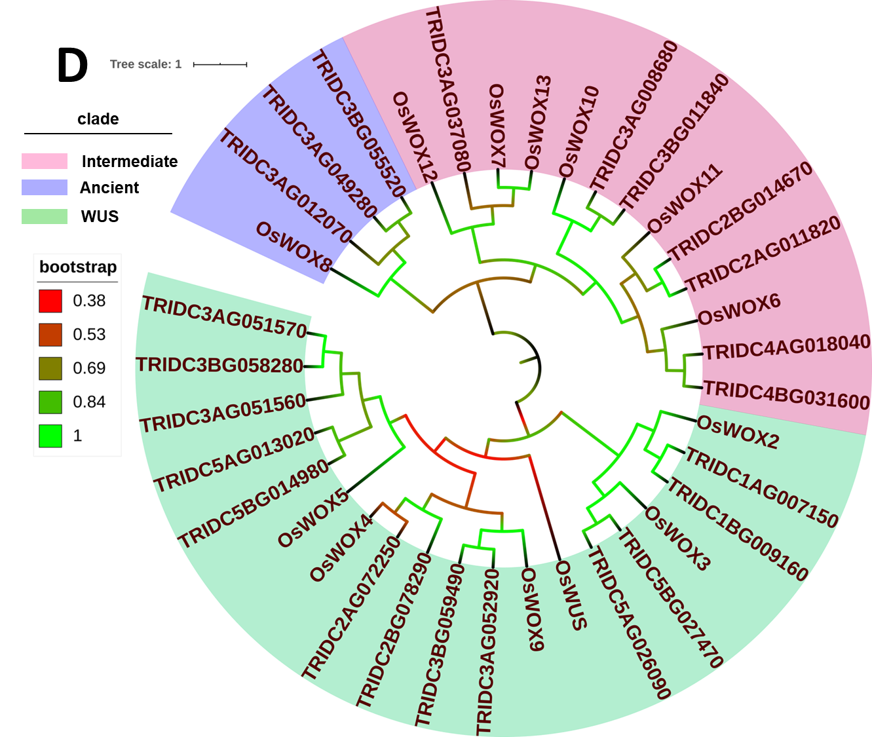
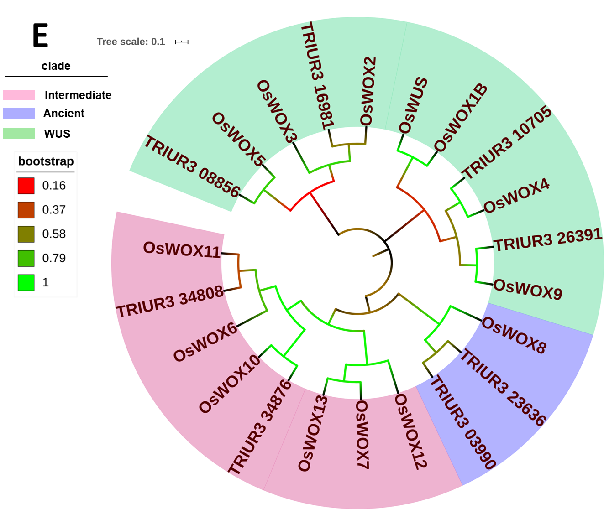
Additional file 8: Fig. S2. Phylogenetic relationships between WOX proteins in rice and barley, T. dicoccoides, T. turgidum, A. tauschii or T. urartu.
A. Phylogenetic tree derived from multiple sequence alignment generated with entire OsWOX and HvWOX protein sequences; B. Phylogenetic tree derived from OsWOX and AtaWOX protein sequences; C. Phylogenetic tree derived from OsWOX and TtWOX protein sequences; D. Phylogenetic tree derived from OsWOX and TdWOX protein sequences; E. Phylogenetic tree derived from OsWOX and TuWOX protein sequences. Phylogenetic tree was constructed based on the sequences of WOX proteins in rice and barley, T. turgidum, T. dicoccoides, A. tauschii or T. urartu, performed by the MEGA X using maximum likelihood approach and 1000 bootstrap replicates. WUS clade, intermediate clade and ancient clade were labeled in outside circle and displyed in different colored ranges. Scale plate and legend in upper left displayed tree scale and bootstrap value.

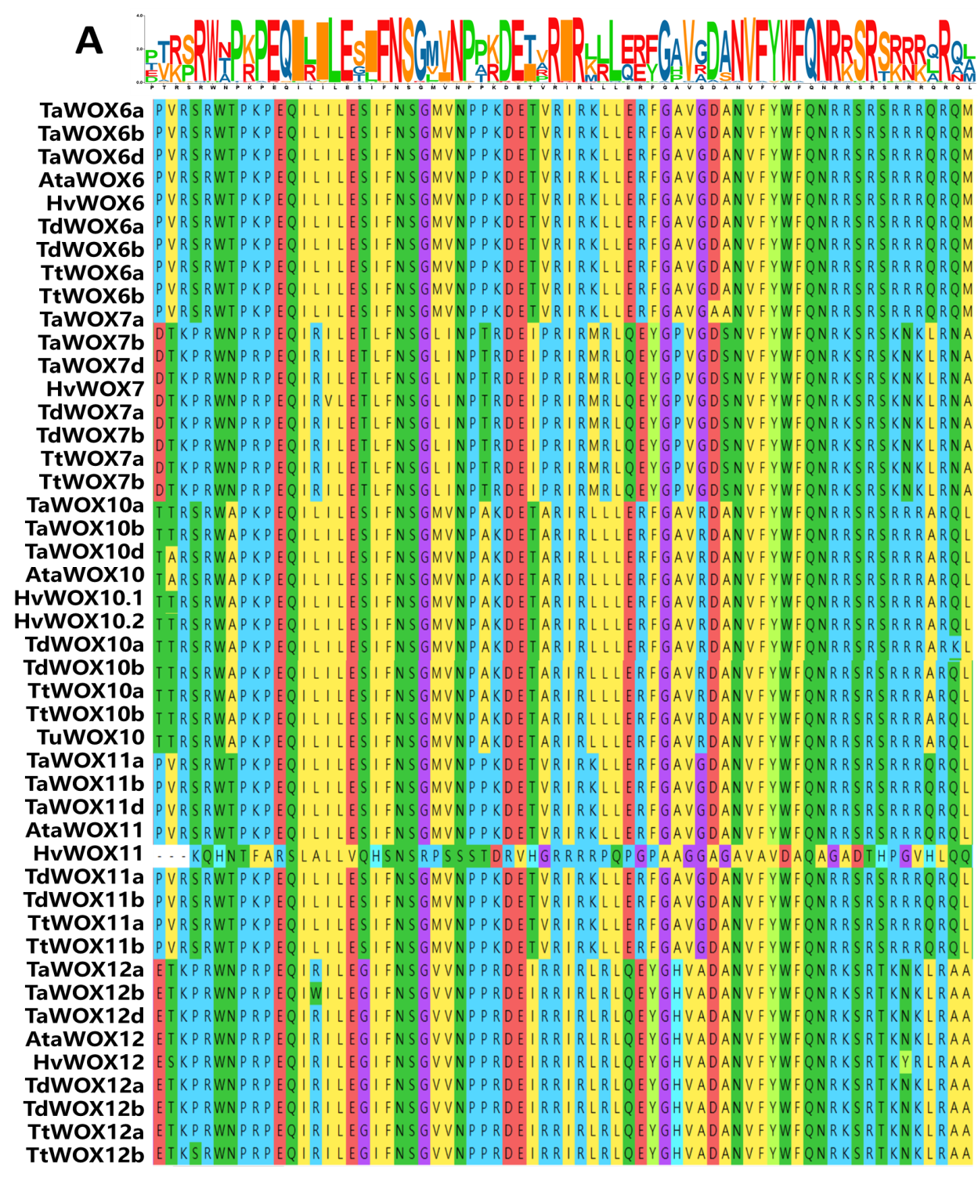
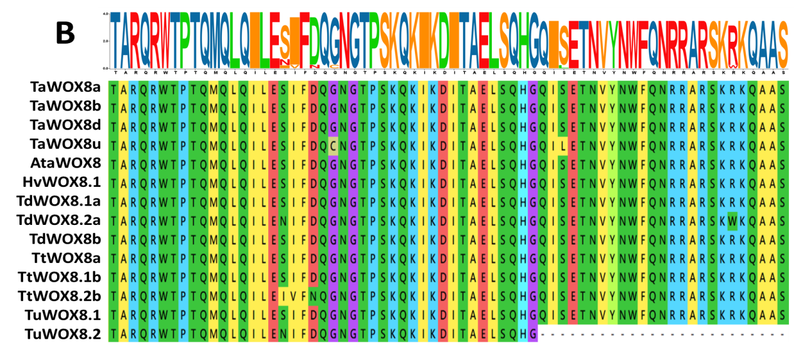

Additional file 9: Fig. S3. Alignment of WOX homeodomains from intermediate and acient clade of 6 Triticeae plant species.
Phylogenetic alignment of homeodomain sequences was conducted by ClustalW algorithm using MEGA X. LOGO of protein sequences represent the relative frequency of an amino acid at this position, and the content of the aligned sequences at a position in bit (max. 4.322 bit for proteins, i.e. log220). A. Multiple sequence alignment among the HOX homeodomain of all intermediate clade WOX proteins in the six Triticeae species. B. Multiple sequence alignment among the HOX homeodomain of all ancient clade WOX proteins in the six Triticeae species.

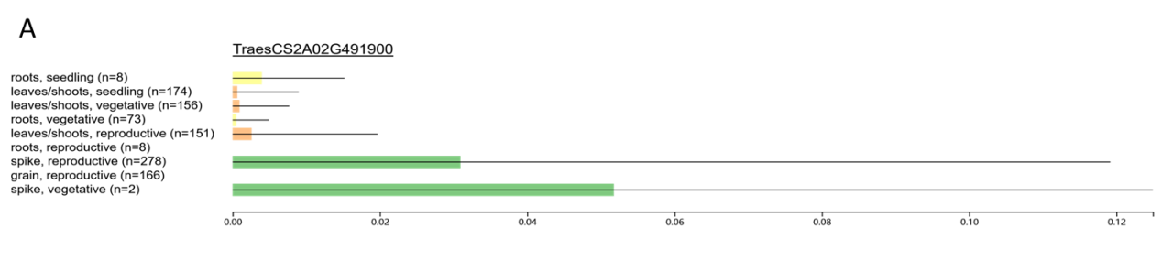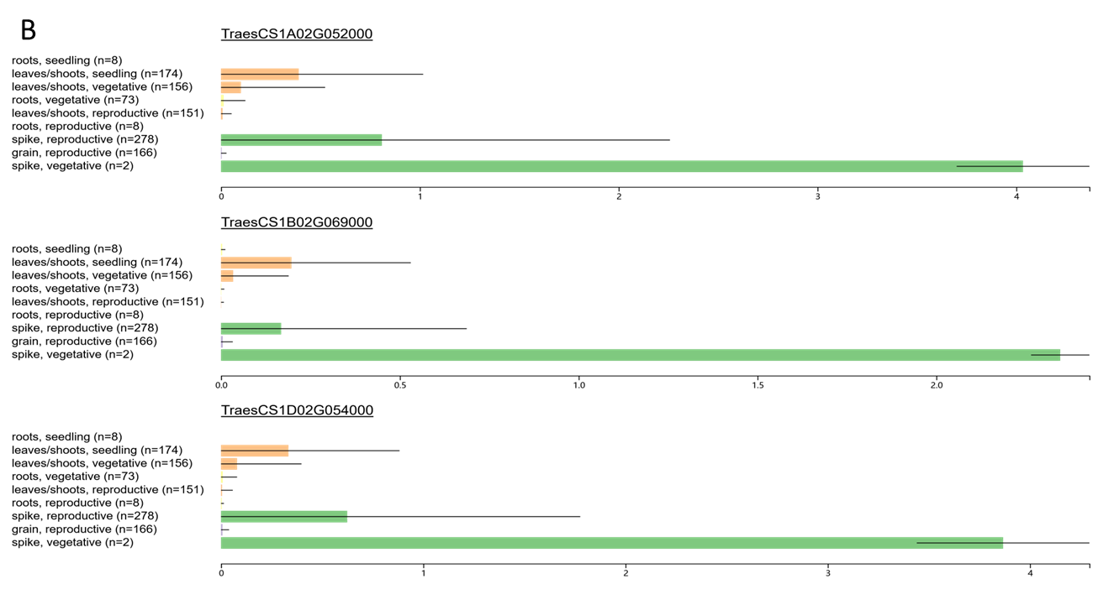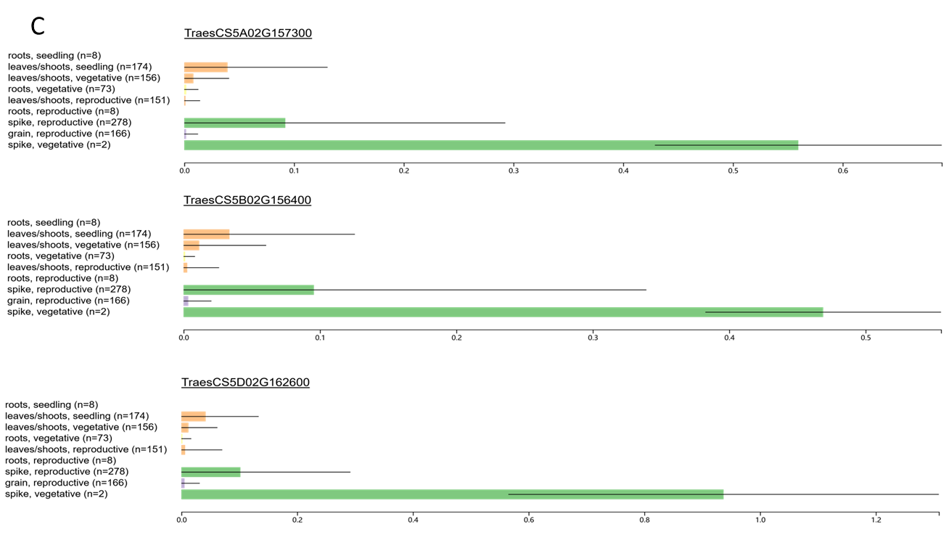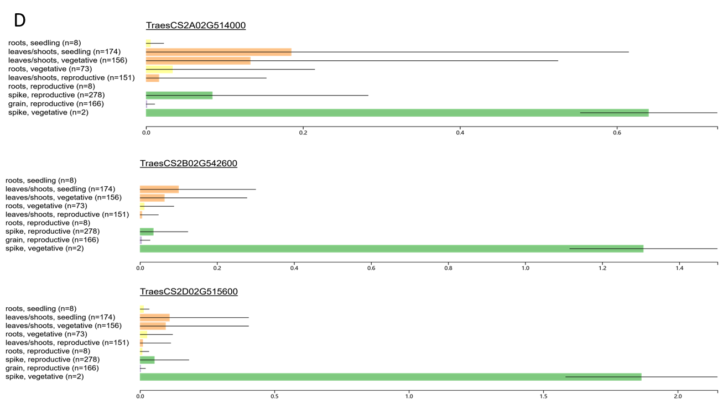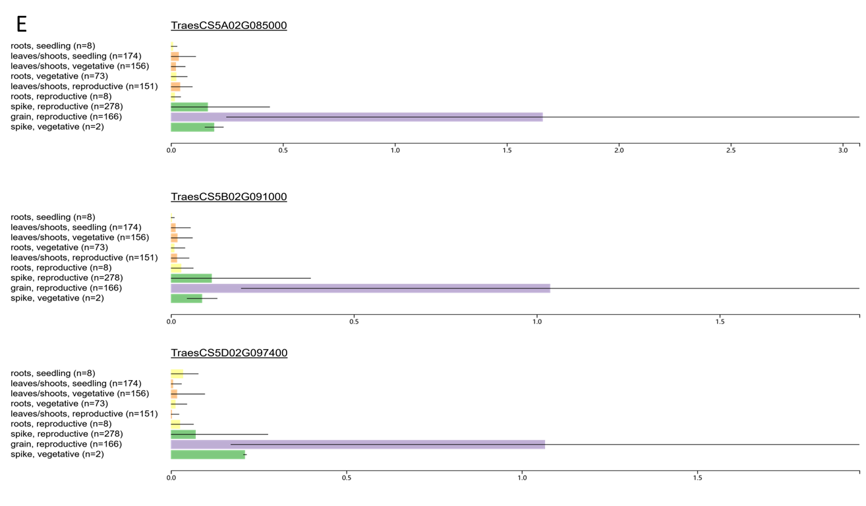
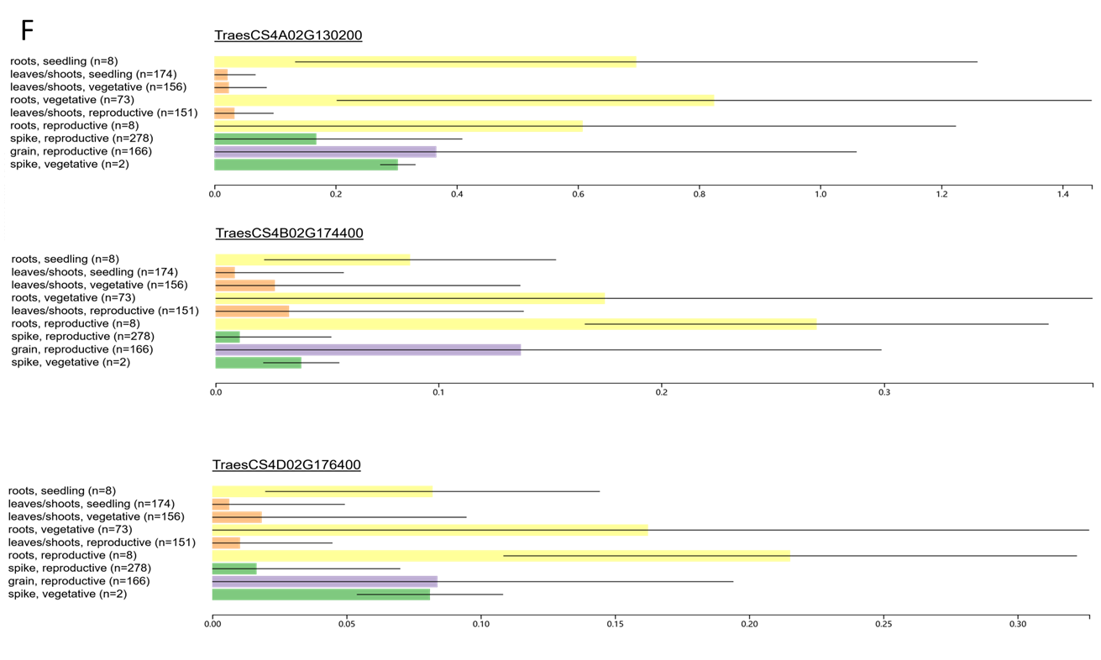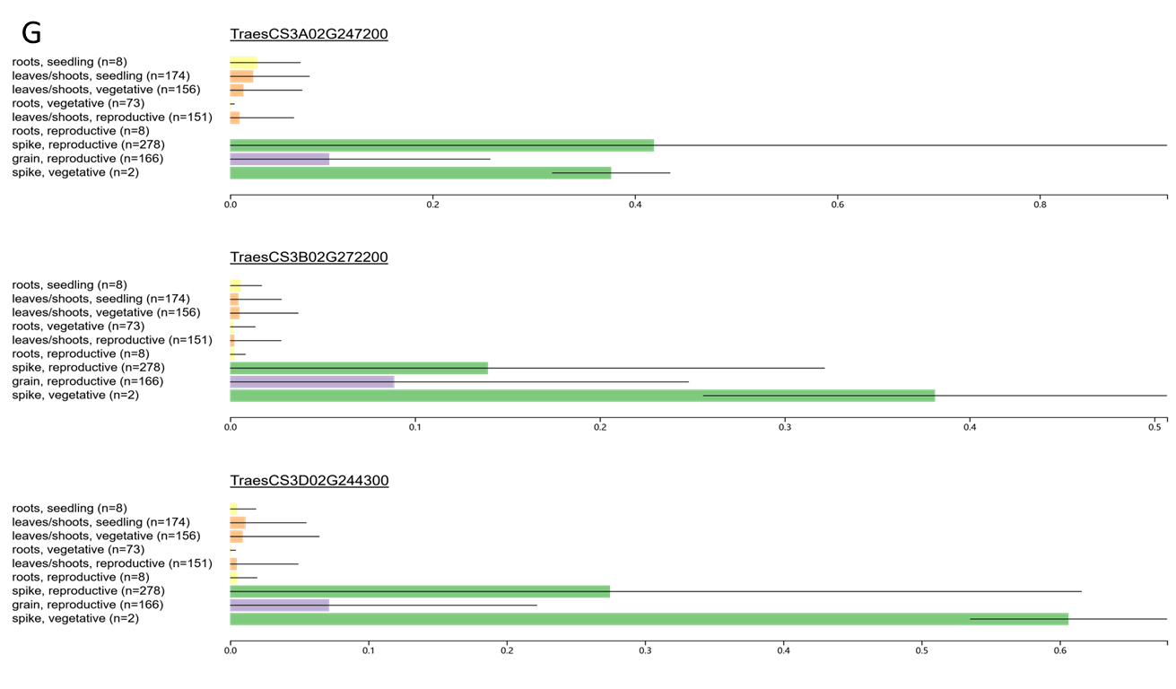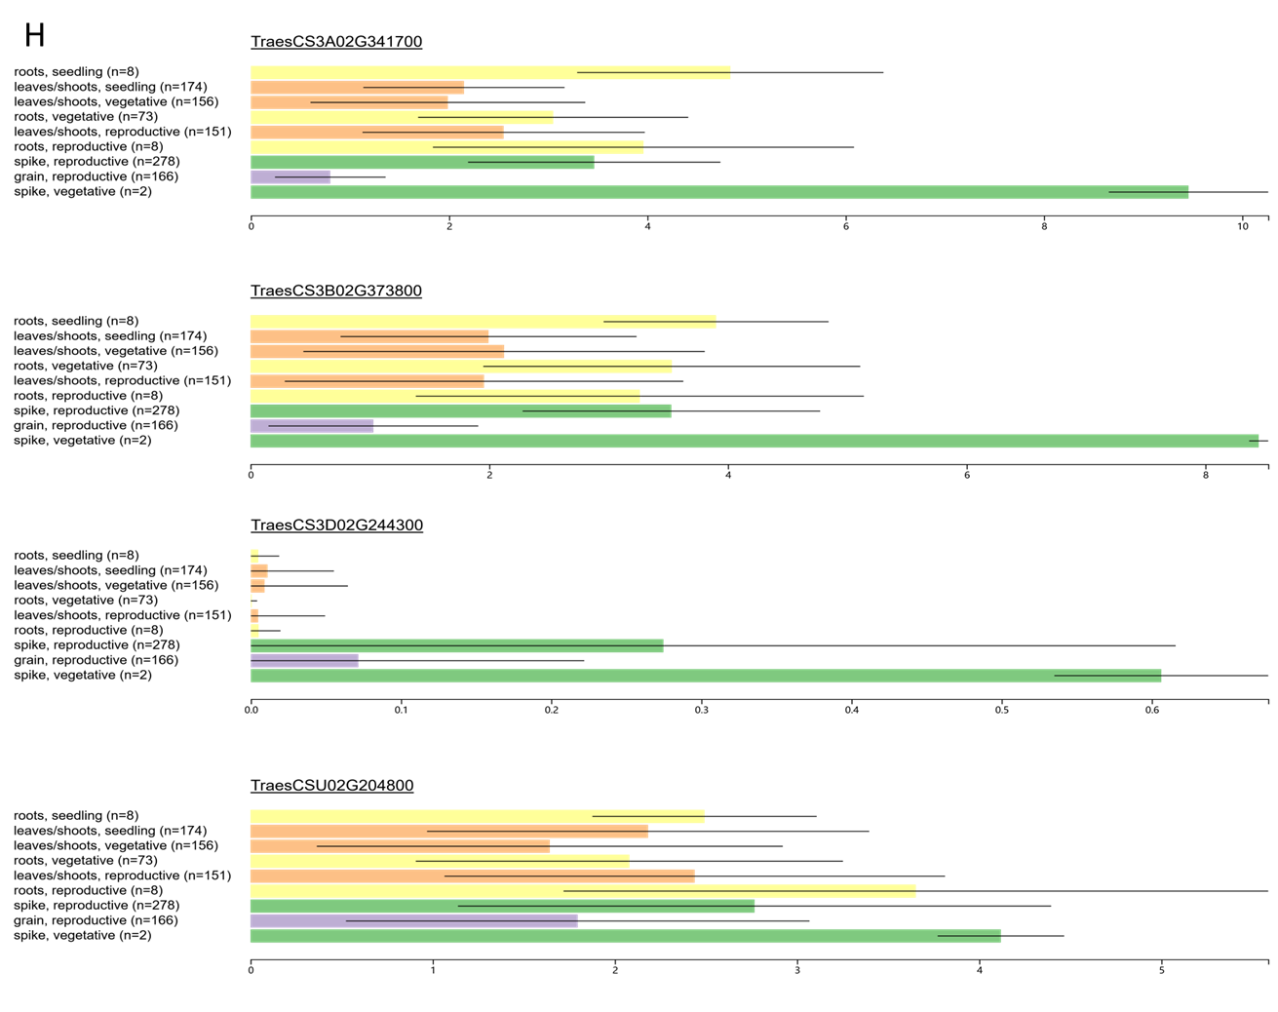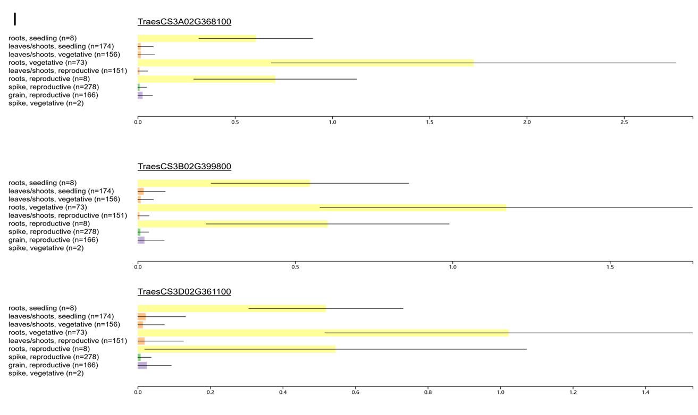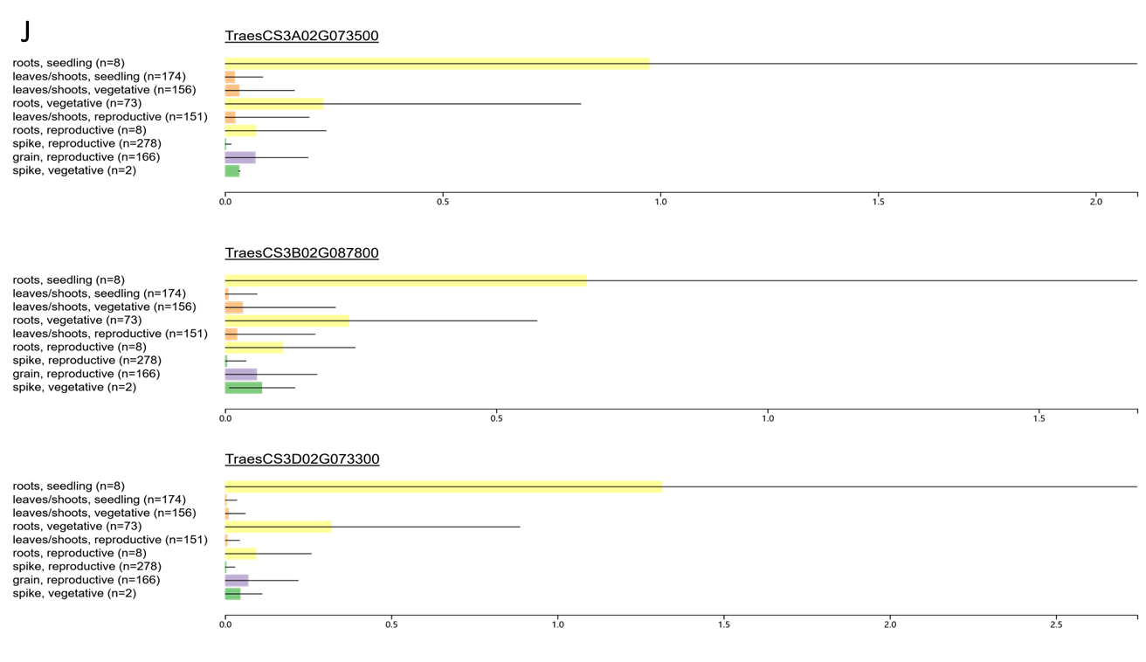
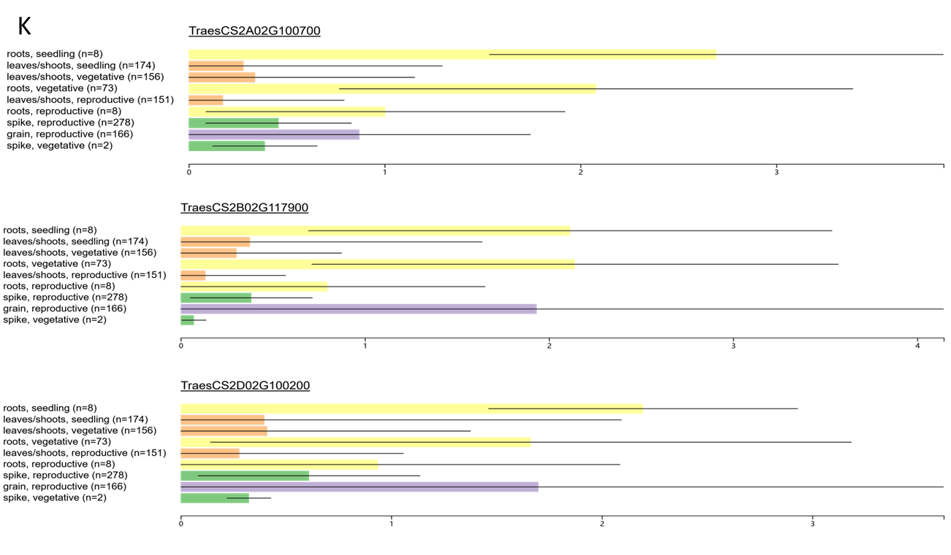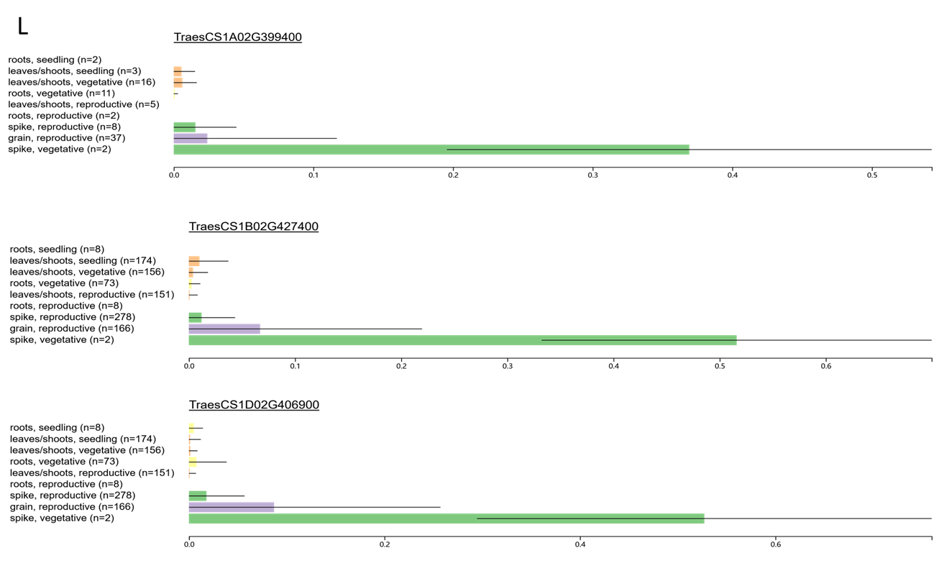
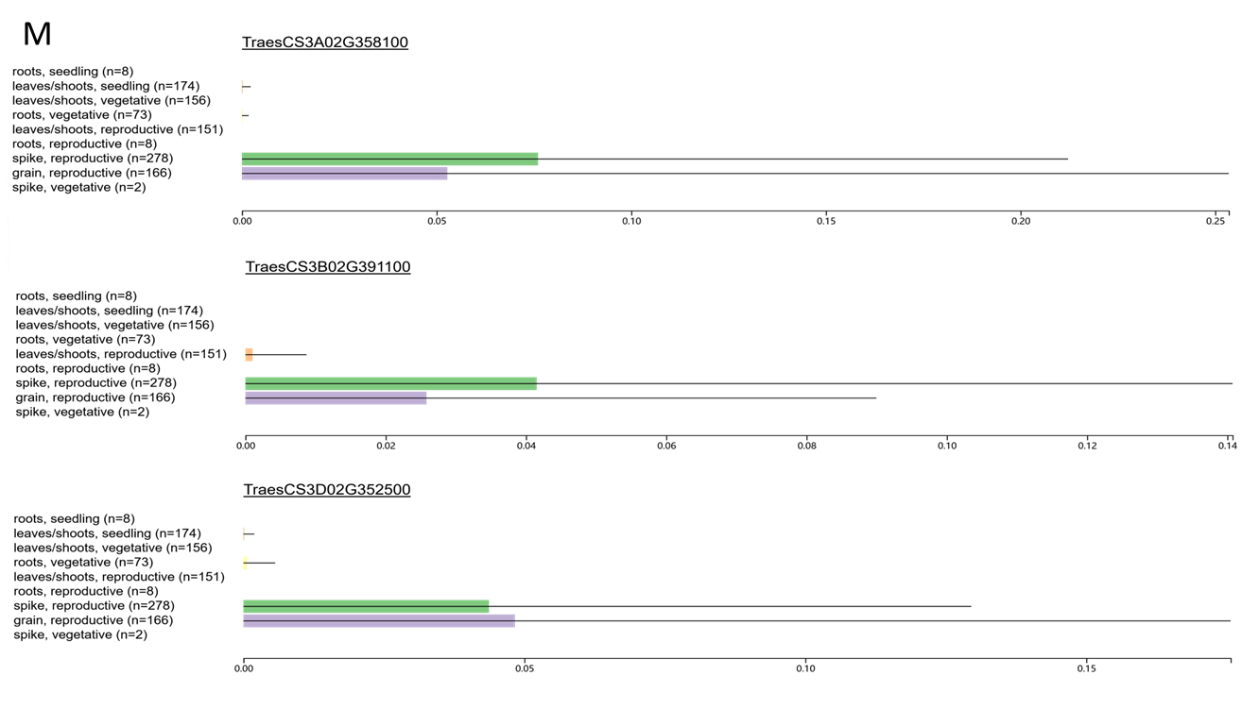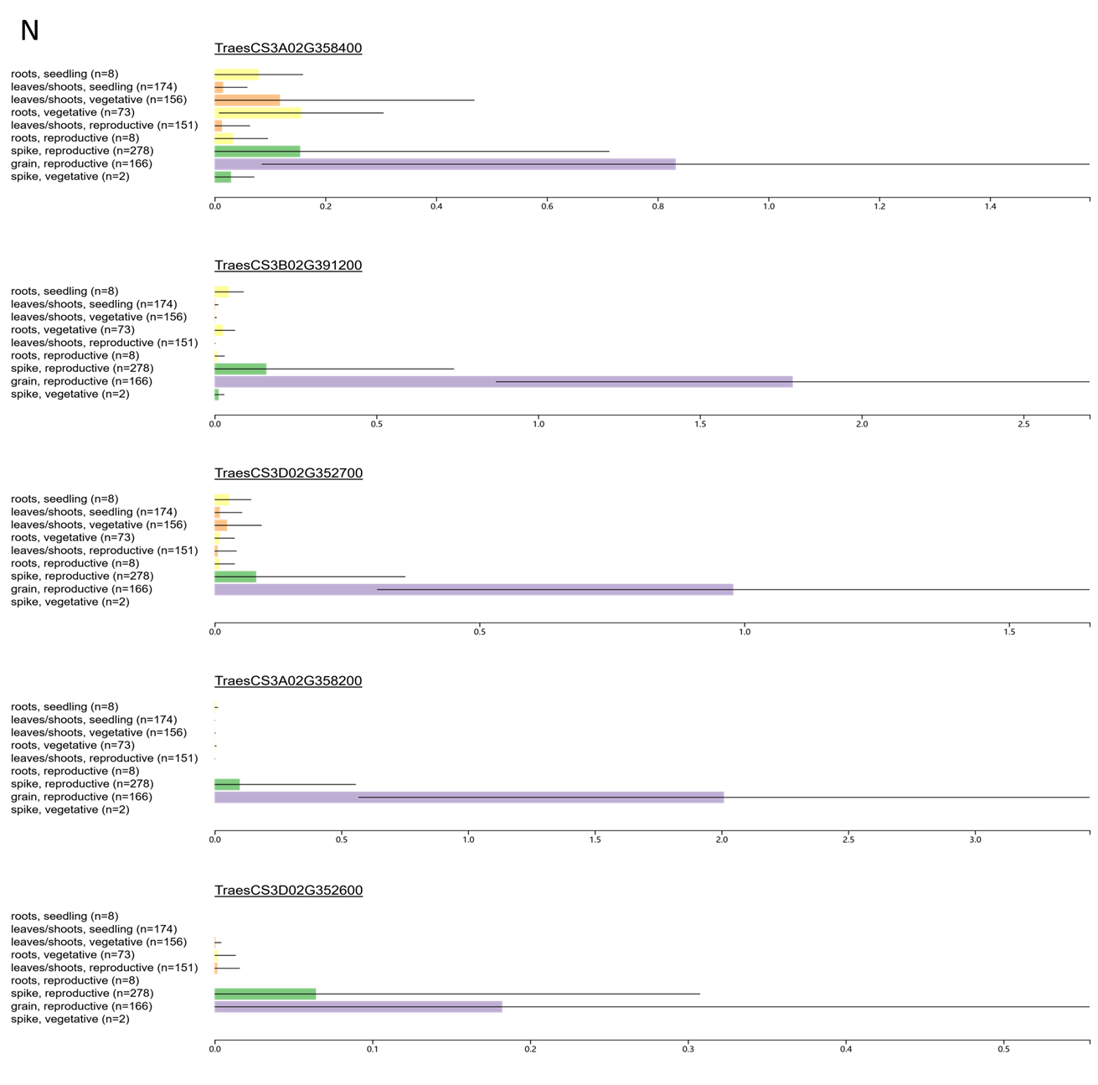

Additional file 10: Fig. S4. Expression profiling of TaWOX genes in different organs at different stages in wheat.
Data is downloaded from expVIP website(http://wheat-expression.com). A: TaWUS; B: TaWOX2; C: TaWOX3; D:TaWOX4; E: TaWOX5; F: TaWOX6; G: TaWOX7; H: TaWOX8; I: TaWOX9; J: TaWOX10; K: TaWOX11; L: TaWOX12; M: TaWOX13; N: TaWOX14. Vertical coordinate refers to organs, stages and sample number; horizontal ordinate refers to relative expression quantity of target genes.

