Supporting Informaion

Sequential four-component synthesis and antitumor activity screening of spiro[chromene-indolo[2,1-b]quinazoline] and spiro[indolo[2,1-b]quinazoline-pyrano[3,2-c]chromene]
Zahra Sadeghian¹, Mohammad Bayat¹*, Fatemeh Safari²*
¹Department of Chemistry, Faculty of Science, Imam Khomeini International University, Qazvin, Iran
*E-mail: m.bayat@sci.ikiu.ac.ir; bayat_mo@yahoo.com
²Department of Biology, Faculty of Science, University of Guilan, Rasht, Iran
* E-mail: fsafari@guilan.ac.ir

Contents

Figure 1. ¹HNMR spectra of compound 4a 5
Figure 2. ¹³CNMR spectra of compound 4a 6
Figure 3. IR spectra of compound 4a 7
Figure 4. Mass spectra of compound 4a 8
Figure 5. ¹HNMR spectra of compound 4b 9
Figure 6. ¹³CNMR spectra of compound 4b 10
Figure 7. IR spectra of compound 4b 11
Figure 8. Mass spectra of compound 4b 12
Figure 9. ¹HNMR spectra of compound 4c 13
Figure 10. ¹³CNMR spectra of compound 4c 14
Figure 11. IR spectra of compound 4c 15
Figure 12. Mass spectra of compound 4c 16
Figure 13. ¹HNMR spectra of compound 4d 17
Figure 14. ¹³CNMR spectra of compound 4d 18
Figure 15. IR spectra of compound 4d 19
Figure 16. Mass spectra of compound 4d 20
Figure 17. ¹HNMR spectra of compound 4e 21
Figure 18. ¹³CNMR spectra of compound 4e 22
Figure 19. IR spectra of compound 4e 23
Figure 20. Mass spectra of compound 4e 24
Figure 21. ¹HNMR spectra of compound 4f 25
Figure 22. ¹³CNMR spectra of compound 4f 26
Figure 23. IR spectra of compound 4f 27
Figure 24. Mass spectra of compound 4f 28
Figure 25. ¹HNMR spectra of compound 4g 29
Figure 26. ¹³CNMR spectra of compound 4g 30
Figure 27. IR spectra of compound 4g 31
Figure 28. Mass spectra of compound 4g 32
Figure 29. ¹HNMR spectra of compound 4h 33
Figure 30. ¹³CNMR spectra of compound 4h 34
Figure 31. IR spectra of compound 4h 35
Figure 32. Mass spectra of compound 4h 36
Figure 33. ¹HNMR spectra of compound 4i 37
Figure 34. ¹³CNMR spectra of compound 4i 38
Figure 35. IR spectra of compound 4i 39
Figure 36. Mass spectra of compound 4i 40

Figure 1. ¹HNMR spectra of compound 4a

Figure 2. ¹³CNMR spectra of compound 4a

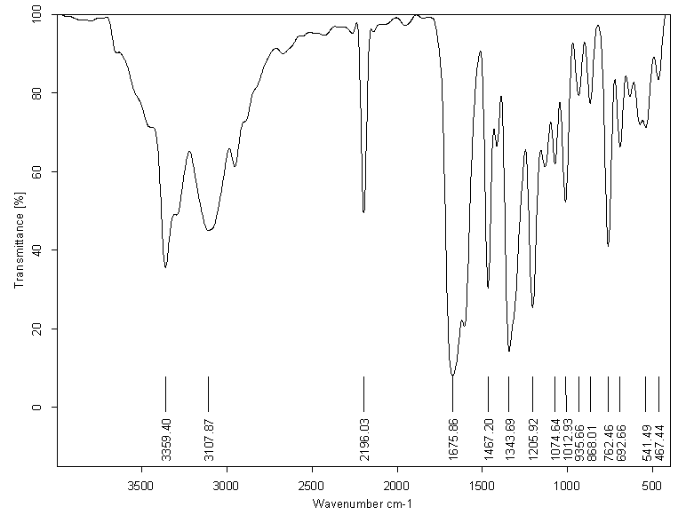

Figure 3. IR spectra of compound 4a

Figure 4. Mass spectra of compound 4a

Figure 5. ¹HNMR spectra of compound 4b

Figure 6. ¹³CNMR spectra of compound 4b

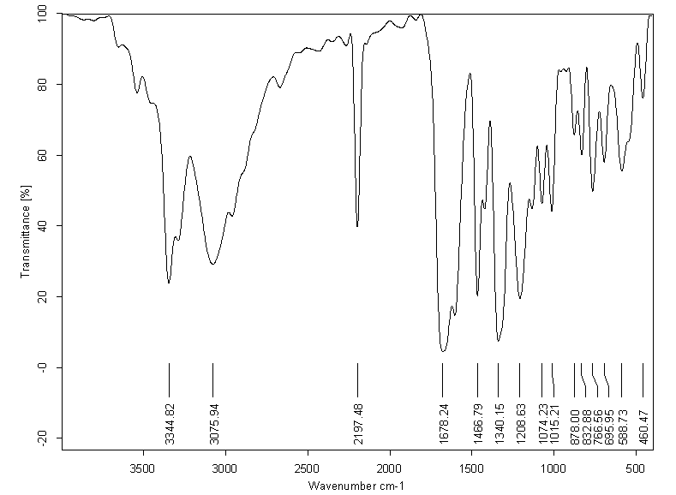

Figure 7. IR spectra of compound 4b

Figure 8. Mass spectra of compound 4b

Figure 9. ¹HNMR spectra of compound 4c

Figure 10. ¹³CNMR spectra of compound 4c

Figure 11. IR spectra of compound 4c

Figure 12. Mass spectra of compound 4c

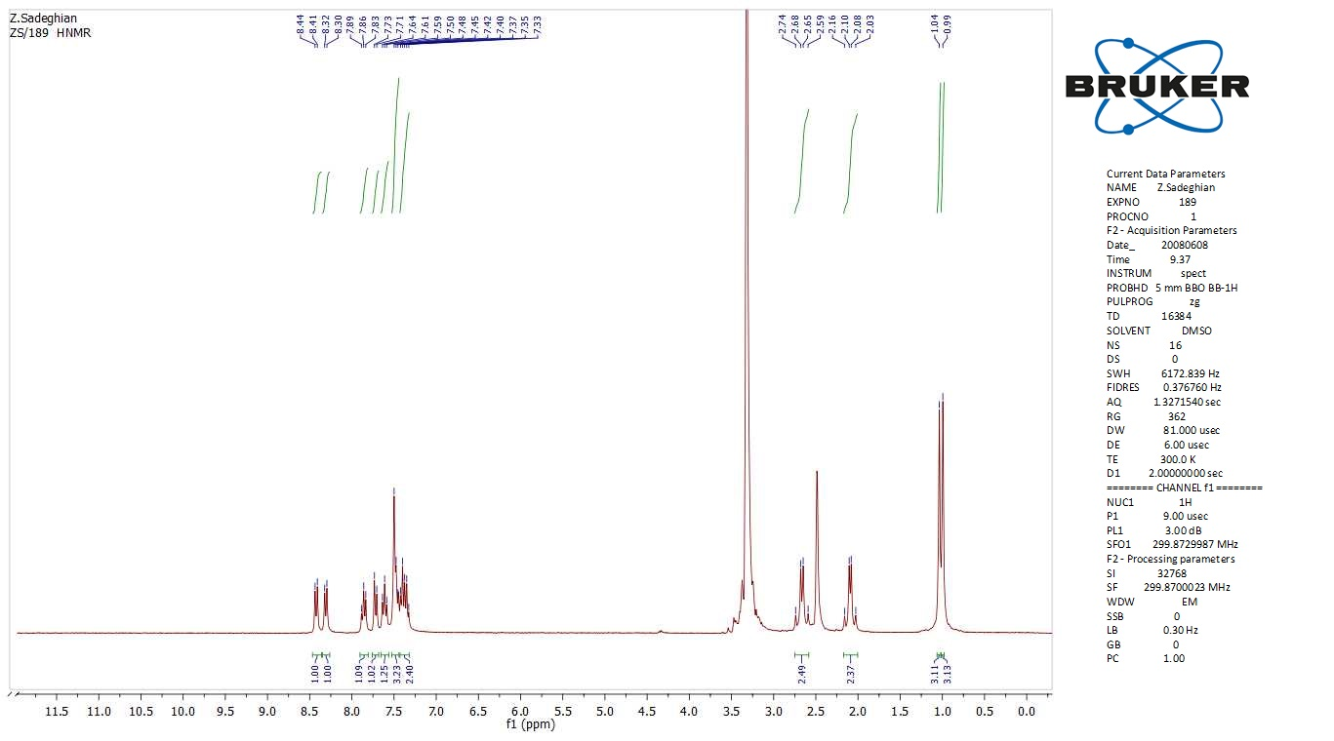

Figure 13. ¹HNMR spectra of compound 4d

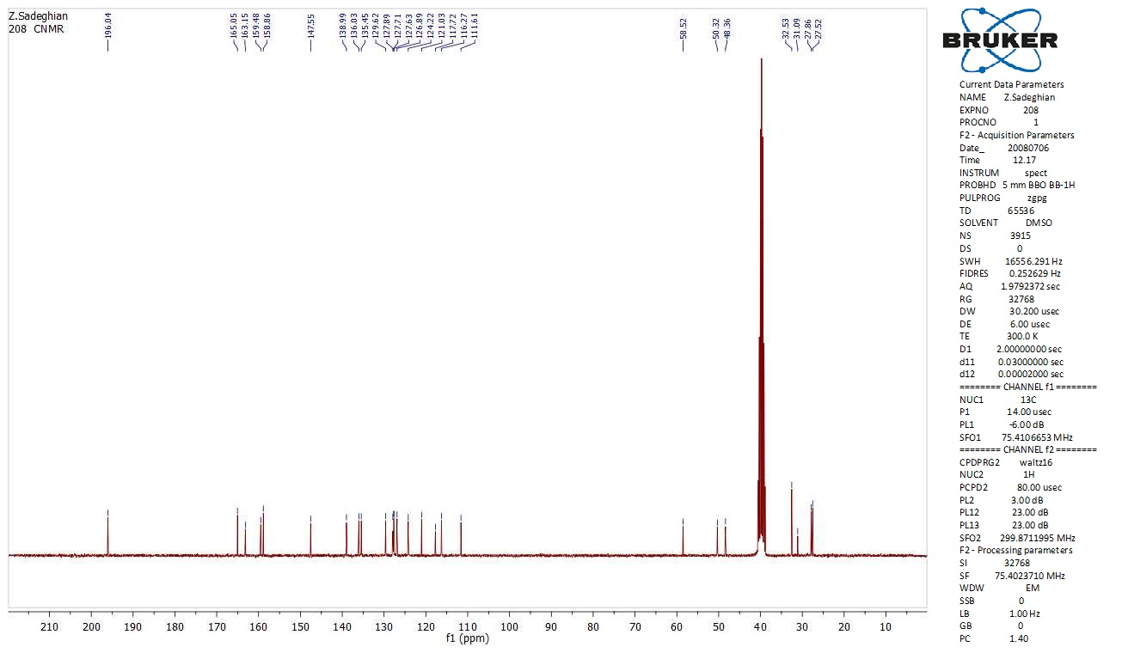

Figure 14. ¹³CNMR spectra of compound 4d

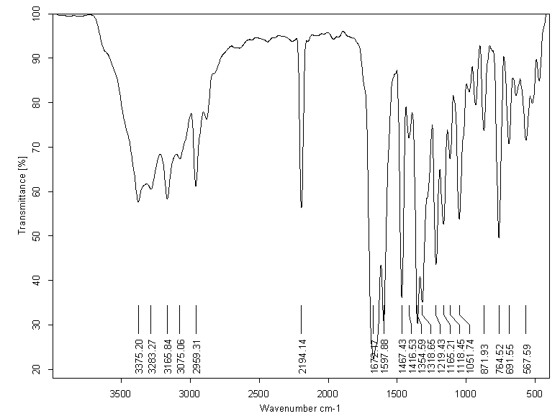

Figure 15. IR spectra of compound 4d

Figure 16. Mass spectra of compound 4d

Figure 17. ¹HNMR spectra of compound 4e

Figure 18. ¹³CNMR spectra of compound 4e

Figure 19. IR spectra of compound 4e

Figure 20. Mass spectra of compound 4e

Figure 21. ¹HNMR spectra of compound 4f

Figure 22. ¹³CNMR spectra of compound 4f

Figure 23. IR spectra of compound 4f

Figure 24. Mass spectra of compound 4f

Figure 25. ¹HNMR spectra of compound 4g

Figure 26. ¹³CNMR spectra of compound 4g

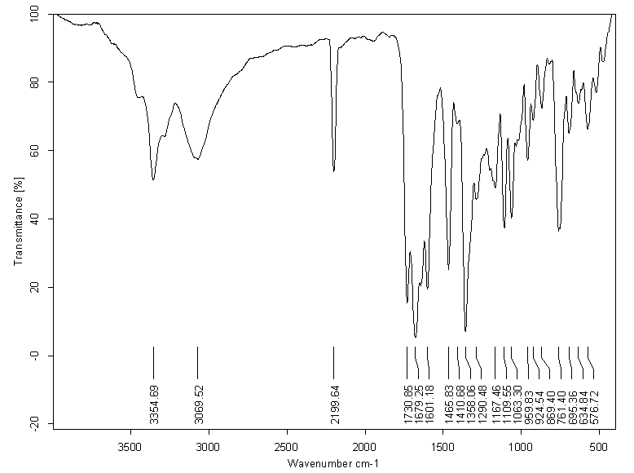

Figure 27. IR spectra of compound 4g

Figure 28. Mass spectra of compound 4g

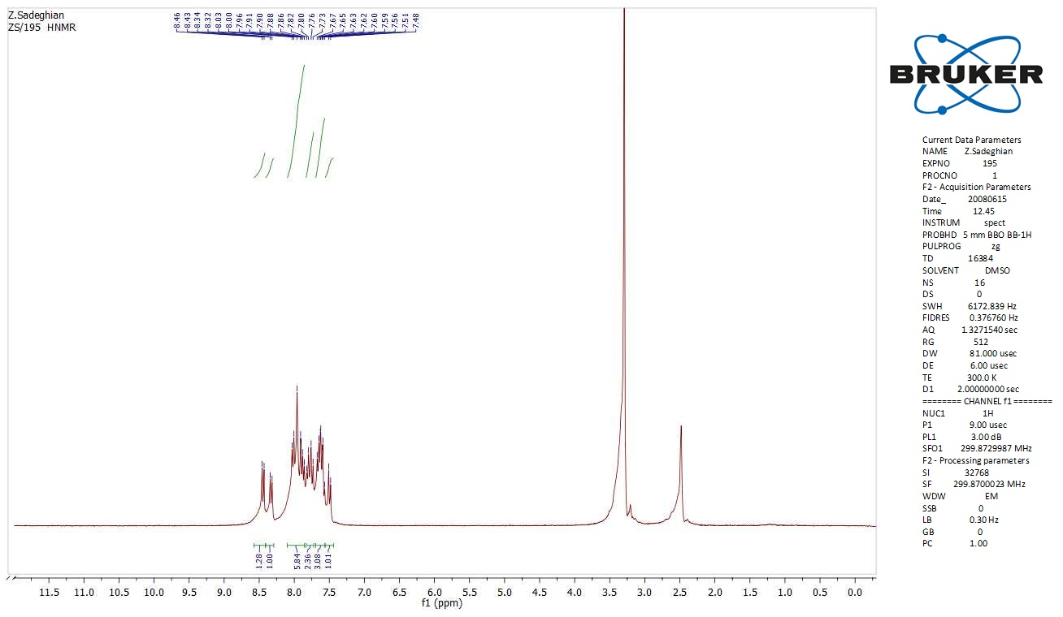

Figure 29. ¹HNMR spectra of compound 4h

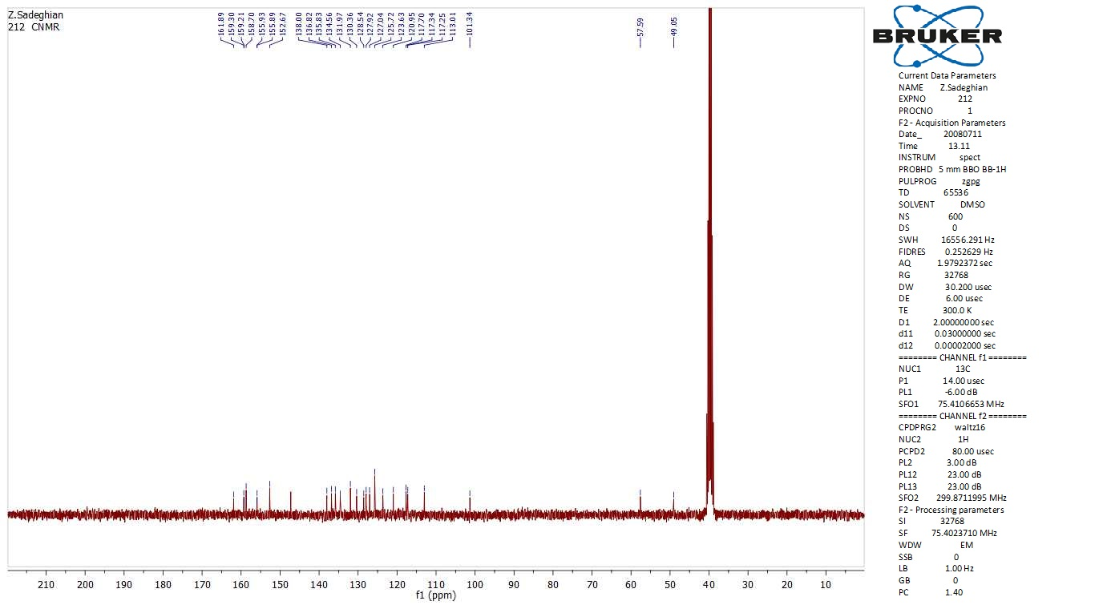

Figure 30. ¹³CNMR spectra of compound 4h

Figure 31. IR spectra of compound 4h

Figure 32. Mass spectra of compound 4h

Figure 33. ¹HNMR spectra of compound 4i

Figure 34. ¹³CNMR spectra of compound 4i

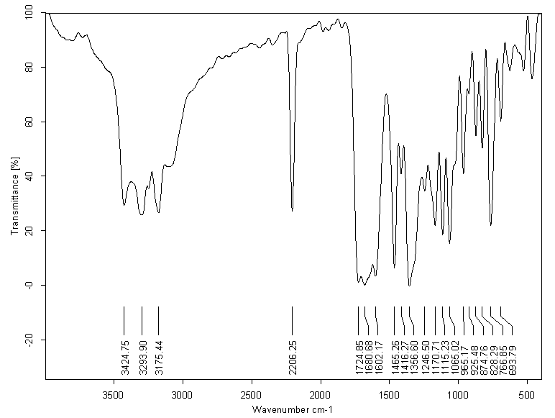

Figure 35. IR spectra of compound 4i

Figure 36. Mass spectra of compound 4i

