Bacteroidetes and Firmicutes drive differing microbial diversity and community composition between micro-environments in the bovine rumen

Supplementary Material
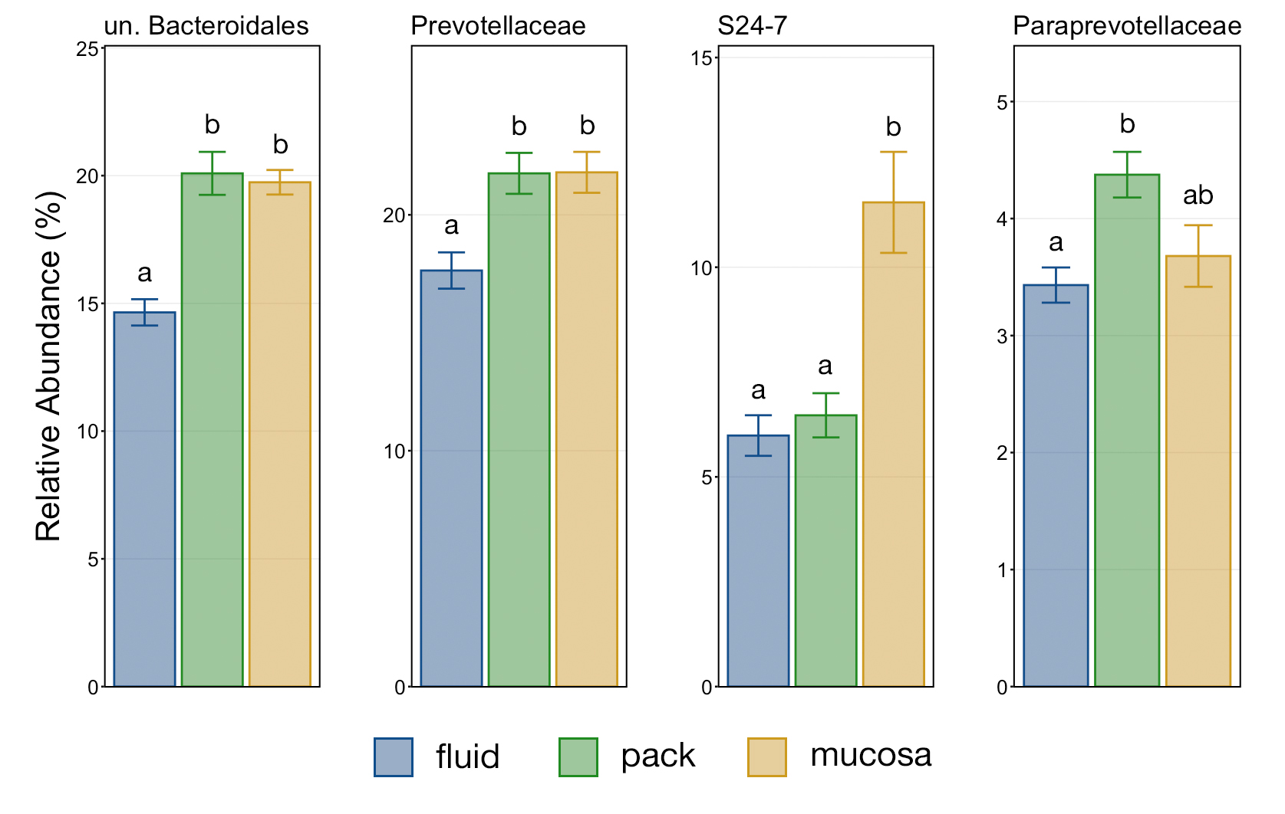
Figure S1. Barplot showing the relative abundances of discriminant taxa within the Bacteroidetes phylum. Error bars display the standard error of the mean of the relative abundance of unclassified Bacteroidales, Prevotellaceae, S24-7, and Paraprevotellaceae in fluid, pack, and mucosa-associated communities. Significant differences between the relative abundances of each family are illustrated by different letters (Pairwise Wilcoxon rank-sum with Benjamini-Hochberg correction, p < 0.05, n = 12). Abbreviations: un., unclassified

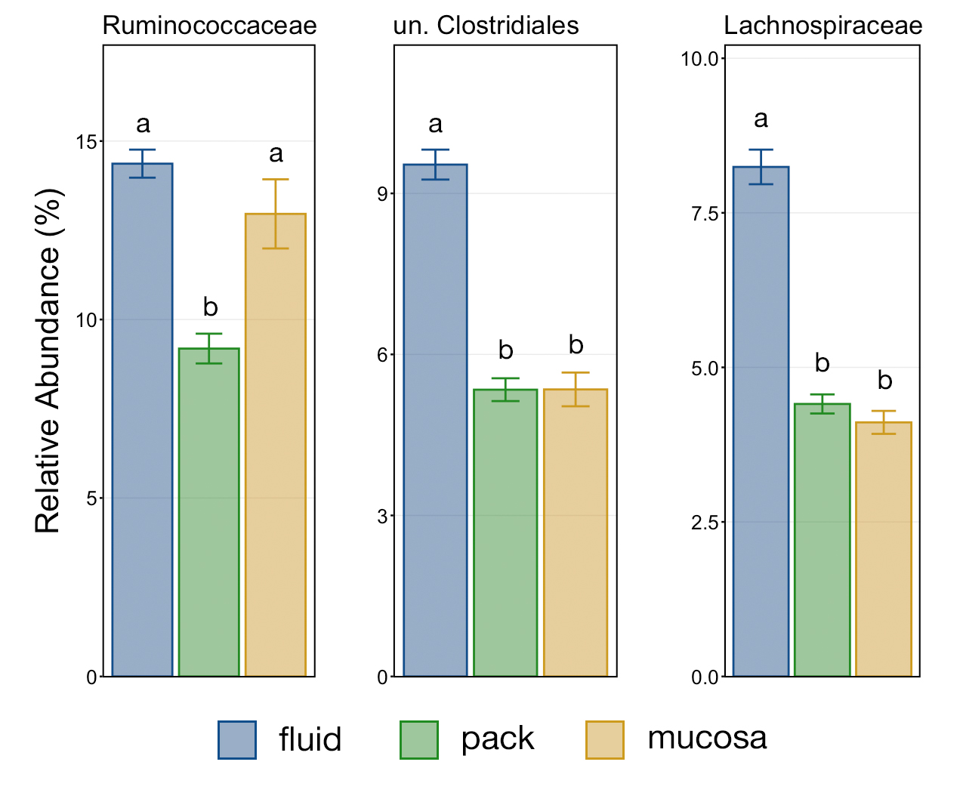

Figure S2. Barplot showing the relative abundances of discriminant taxa within the Firmicutes phylum. Error bars display the standard error of the mean of the relative abundance of unclassified Ruminococcaceae, un. Clostridiales, and Lachnospiraceae in fluid, pack, and mucosa-associated communities. Significant differences between the relative abundances of each family are illustrated by different letters (Pairwise Wilcoxon rank-sum with Benjamini-Hochberg correction, p < 0.05, n = 12). Abbreviations: un., unclassified

Table S1. PERMANOVA and PERMDISP results from comparisons between ruminal fluid, pack, and mucosa microbial communities using weighted, generalized, and unweighted UniFrac values. Significant results are bolded (p < 0.05).

Test | Df | SS | Pseudo-F | R² | p-adj. | PERMDISP (p-adj.)
weighted UniFrac
fluid vs pack | 1 | 0.104 | 15.674 | 0.416 | 0.0001 | 0.161
fluid vs mucosa | 1 | 0.100 | 15.739 | 0.417 | 0.0001 | 0.574
pack vs mucosa | 1 | 0.038 | 5.335 | 0.195 | 0.0001 | 0.613
generalized UniFrac
fluid vs pack | 1 | 0.368 | 7.268 | 0.248 | 0.0001 | 0.604
fluid vs mucosa | 1 | 0.312 | 5.844 | 0.210 | 0.0001 | 0.275
pack vs mucosa | 1 | 0.175 | 3.212 | 0.127 | 0.0001 | 0.452
unweighted UniFrac
fluid vs pack | 1 | 0.243 | 2.698 | 0.109 | 0.006 | 0.895
fluid vs mucosa | 1 | 0.238 | 2.473 | 0.101 | 0.006 | 0.120
pack vs mucosa | 1 | 0.166 | 1.723 | 0.073 | 0.011 | 0.045

Abbreviations: Df, degrees of freedom; SS, sum of squares; p-adj., adjusted p-value

