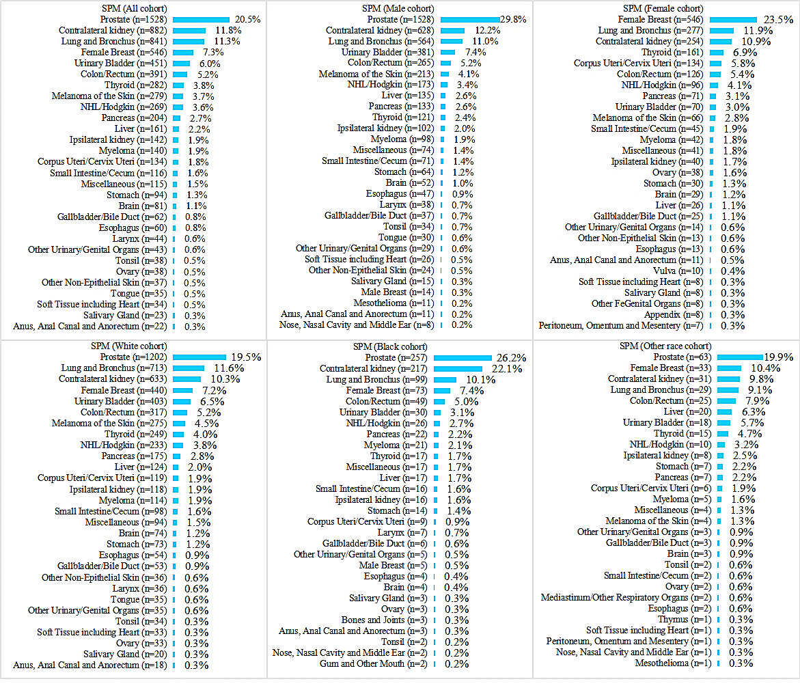
Supplementary figure 1. The distribution of second primary malignancy (SPM) among patients with first primary renal cell carcinoma stratified by sex and race (top 29 types). Note: 7461 renal cell carcinoma patients with histological confirmation were used for analysis, which included 1257 patients without detailed information based on the flow chart for the data screening.

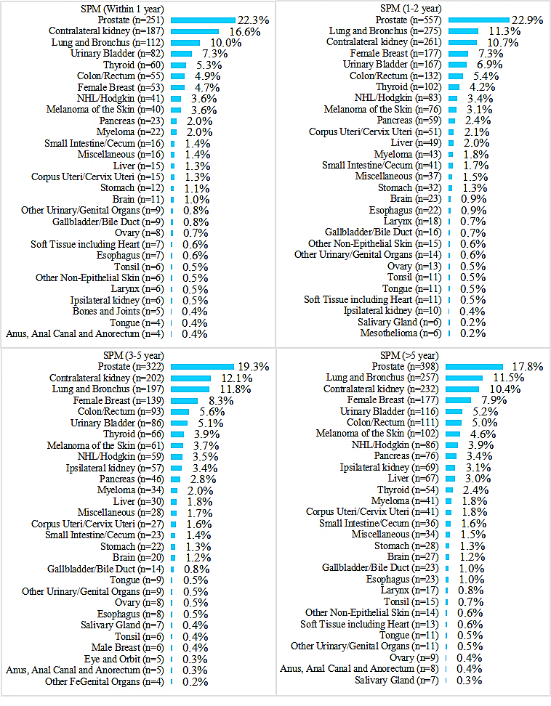
Supplementary figure 2. The distribution of second primary malignancy (SPM) among patients with first primary renal cell carcinoma stratified time to SPM (top 29 types). Note: 7461 renal cell carcinoma patients with histological confirmation were used for analysis, which included 1257 patients without detailed information based on the flow chart for the data screening.
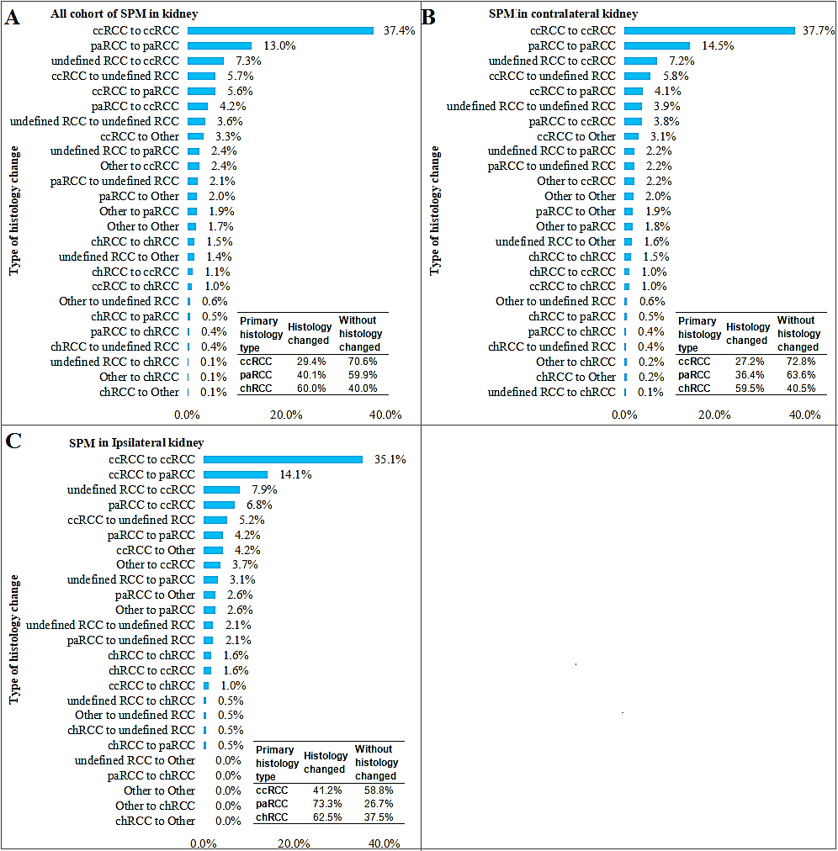
Supplementary figure 3. Distribution of histological changes between first primary renal cell carcinoma with second primary renal cell carcinoma.

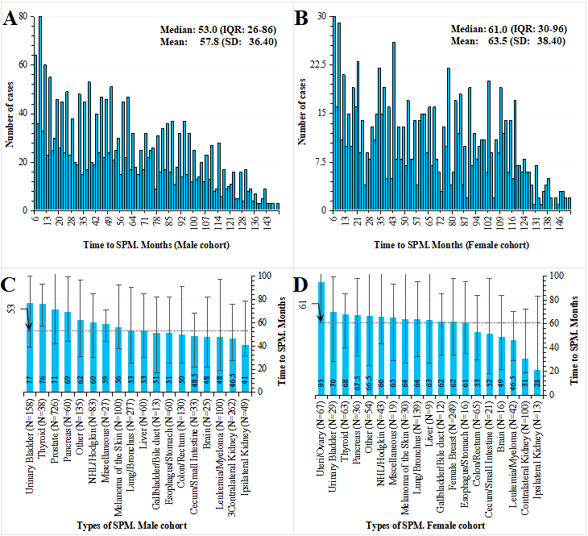
Supplementary figure 4. (A, B), The distribution of different time to second primary malignancy (SPM); (C, D), The median time to SPM from the first primary renal cell carcinoma (data come from 2004-2007 for more than 10-year follow-up time).

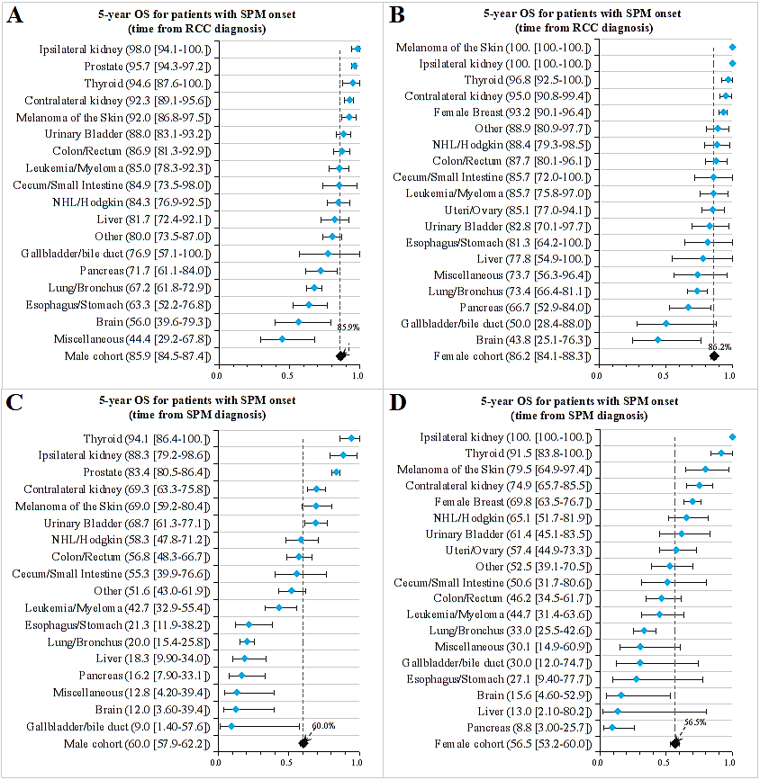
Supplementary figure 5. 5-year overall survival (OS) for patients with different sites of second primary malignancy (SPM) onset (A, B) after first primary renal cell carcinoma and (C, D) after the SPM onset (patients diagnosed in the time of 2004-2007 were used for survival analysis with the method of Kaplan-Meier)

