Appendix A – Zero-Order Tier 2 OSeMOSYS Model

The data described above were used to create a simple zero-order Tier 2 energy systems model for Kenya. As it is open-source and free, an OSeMOSYS model is calibrated and run with three example scenarios. Note that these scenarios in no way represent the development trajectories of the country. This model and its results are intended to act as an example of what can be produced using the data in this article and a starting point for further model development.

In the OSeMOSYS model, the electricity supply system is represented by importing and extraction technologies, conversion technologies, power plants, transmission and distribution network systems and final energy demands for the different available fuels considered. The Reference Energy System is shown below. The main modelling assumptions consist of power generation capacity per type of technology (centralized, decentralized), fuel prices, emissions, transmission and distribution network capacity and losses, and refineries, which are exogenous parameters in the model. Furthermore, the final exogenous energy demands entered into the model are disaggregated by fuel and sector. The data described in this article were used as input data to define these assumptions in the model.

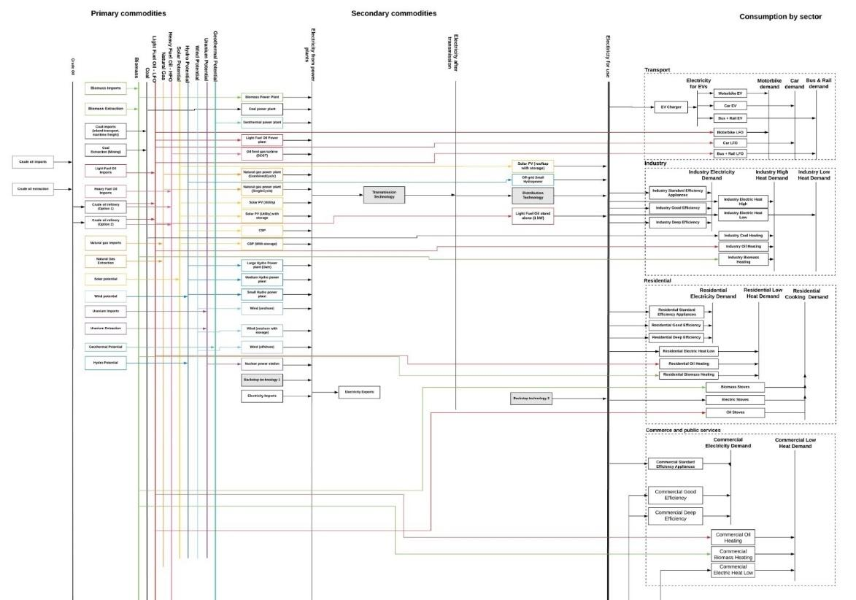
Figure 1: Reference Energy System

A1 Model Assumptions
Key assumptions used in model development are outlined below.

Supply-Side Assumptions
The share of total demand that can be met by off-grid solar PV is constrained based on the optimal balance of on- and off-grid provision in a least-cost scenario for 100% electricity access by 2030 from the Global Electrification Platform (source AQ). Other technologies were modelled to represent utility-scale solar PV and onshore wind with storage capacity. Utility-scale PV with two-hour storage and onshore wind with half-hour storage were modelled, with the additional costs of storage estimated based on data from the NREL ATB 2020 Database, which provides cost projections for different durations of storage up to 2050 (source AR). The maximum share of total demand that variable renewables can meet is constrained as follows: utility-scale PV, onshore wind and utility-scale PV with storage are each permitted to meet up to 15% of demand; offshore wind can meet up to 10% of demand and onshore wind with storage can meet up to 25% of demand. This analysis is not intended to offer a detailed study of system flexibility; however, these constraints ensure the system operates under high renewable shares. Biomass is permitted to meet up to 30% of electricity demand. Electricity imports and exports were modelled simplified, whereby single import and export technologies are constrained to import and export electricity in line with energy balance data (source AL).

Demand-Side Assumptions
Generic techno-economic data for demand-side technologies (cooking, heating and transport) were used (sources AS-AT). The total final electricity demand projection was split by sector based on the proportions of demand in historical energy balance data (source AL). In each sector, moderate and high energy efficiency technologies were modelled, with input activity ratios of 1 and output activity ratios of 1.15 and 1.3, respectively. This is a simplified way of allowing the model to invest in energy efficiency in each sector, with costs estimated based on electricity generation costs by a coal power plant in the model. In the Least Cost and Net Zero scenario (detailed in Section A2), there is a constraint on the speed at which fuel switching and energy efficiency investments can occur to align results to reality better. This is done by limiting the annual investment in electric vehicles, stoves, heating technologies and energy efficiency to 5% of the 2050 capacity.

Time Representation and Discount Rate

Within each model year, four seasons, each with two 12-hour dayparts, are defined. Daypart 1 starts at 06:00 and finishes at 18:00, while daypart 2 starts at 18:00 and finishes at 06:00. The seasons are defined so that season 1 runs from December to February, season 2 runs from March to May, season 3 from June to August, and season 4 from September to November. A discount rate of 10% is used.

A2 Scenario Definitions
Three stylized scenarios are modelled: Fossil Future, Least Cost and Net Zero by 2050. These scenarios are defined in the table below. Nuclear power is not considered in any of these scenarios; however, it can be added using the techno-economic data provided in the main article.

Table A1: Definitions of the three model scenarios.
Scenario | Definition
Fossil Future | No new investments in renewable or nuclear power generation, electric stoves and heating, electric transport or energy efficiency are permitted.
Least Cost | No new investment in nuclear power is permitted. Gradual investment constraints are applied to demand-side fuel-switching and energy efficiency. Only up to 5% of each technology’s 2050 capacity run without demand-side investment constraints can be invested annually. No additional constraints are applied to find the cost-optimal solution.
Net Zero by 2050 | Domestic production and imports of fossil fuels and biomass gradually decline to 0 in 2050, beginning in 2021, leading to zero carbon emissions by 2050. No new investment in nuclear power is permitted. Gradual investment constraints are applied to demand-side fuel-switching and energy efficiency. Only up to 5% of each technology’s 2050 capacity in a run without demand-side investment constraints can be invested annually from 2021-2039, rising to 10% from 2040-2050 to reflect greater ambition.

A3 Scenario Results for Kenya
The graphs below show selected results for the three modelled scenarios, including yearly electricity generation and supply capacity, fuel use in the transport sector and total annual carbon dioxide emissions for 2020-2050.

A3.1 Electricity Generation Results
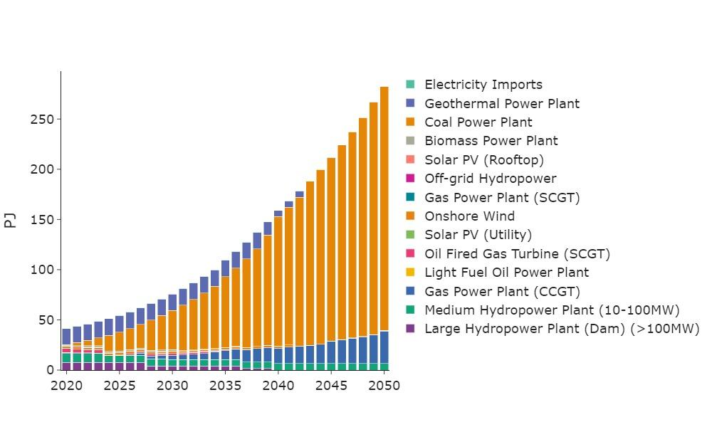
Figure A1: Electricity Generation in Kenya in the Fossil Future scenario
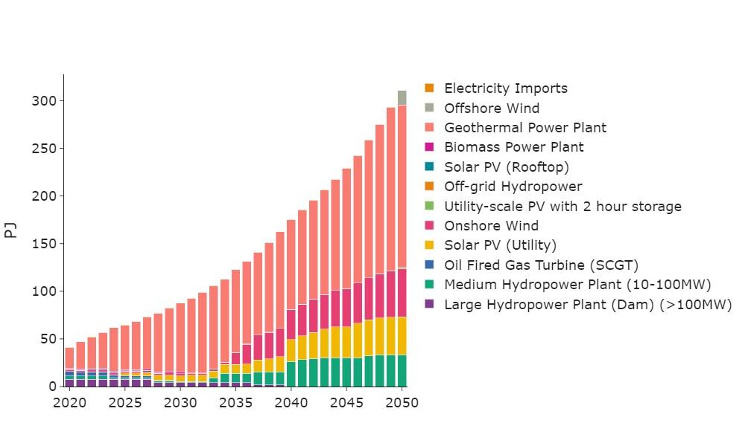
Figure A2: Electricity Generation in Kenya in the Least Cost scenario
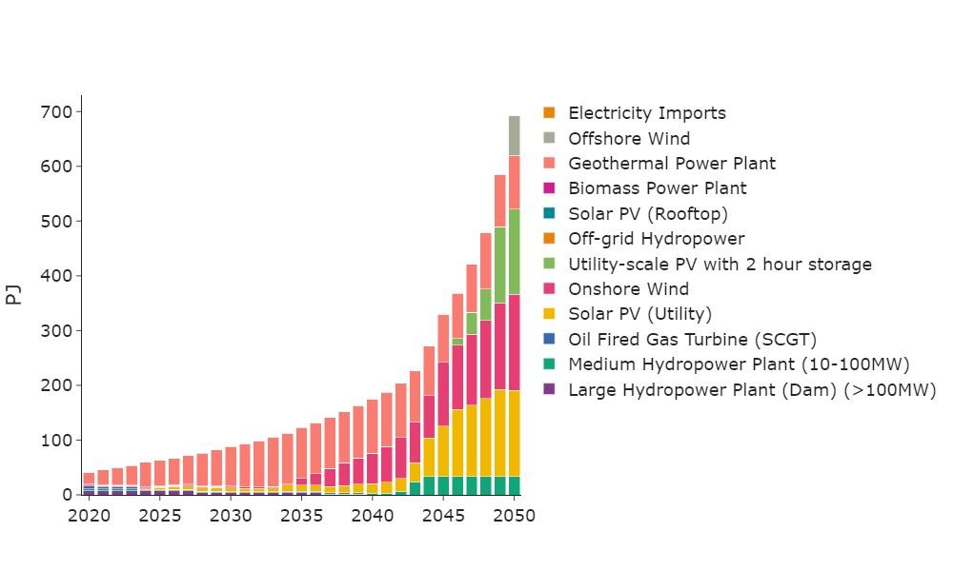
Figure A3: Electricity Generation in Kenya in the Net Zero by 2050 scenario

A3.2 Capacity Expansion Results
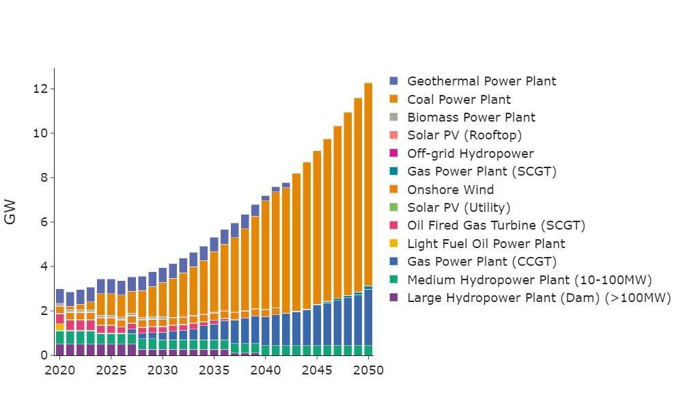
Figure A4: Installed capacity in Kenya in the Fossil Future scenario
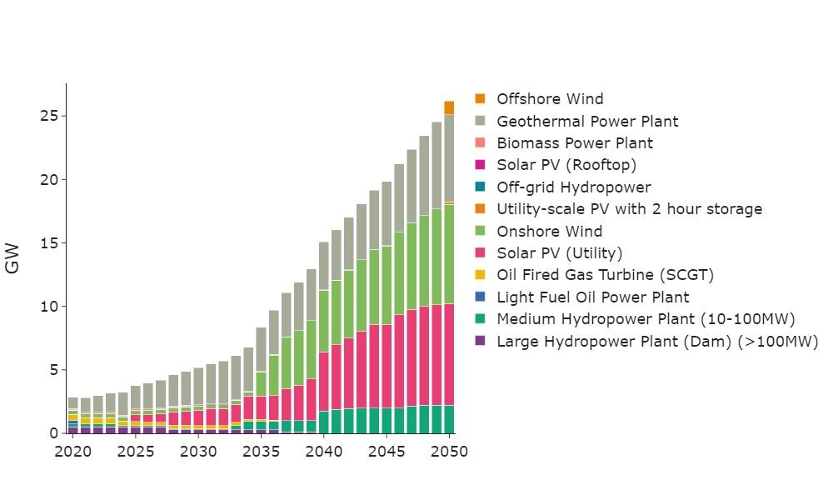
Figure A5: Installed capacity in Kenya in the Least Cost scenario
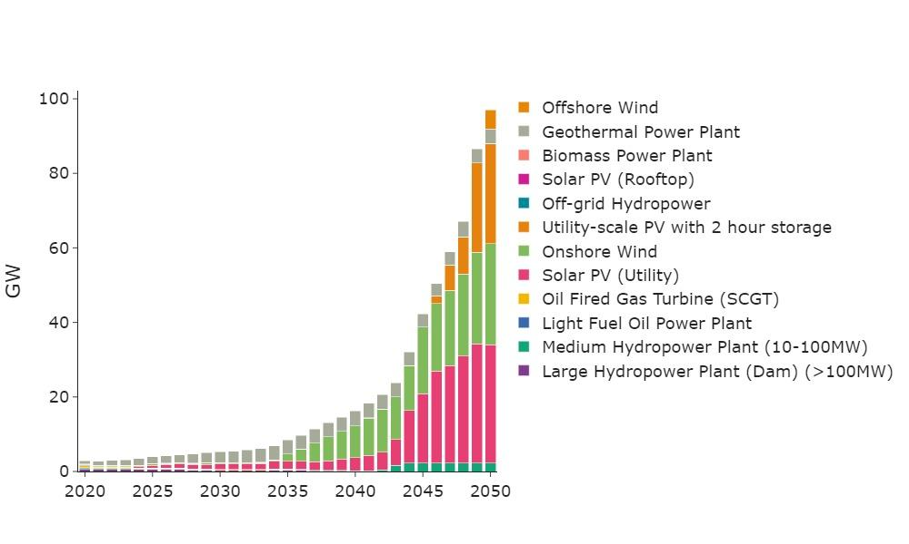
Figure A6: Installed capacity in Kenya in the Net Zero scenario

A3.3 Transport Results

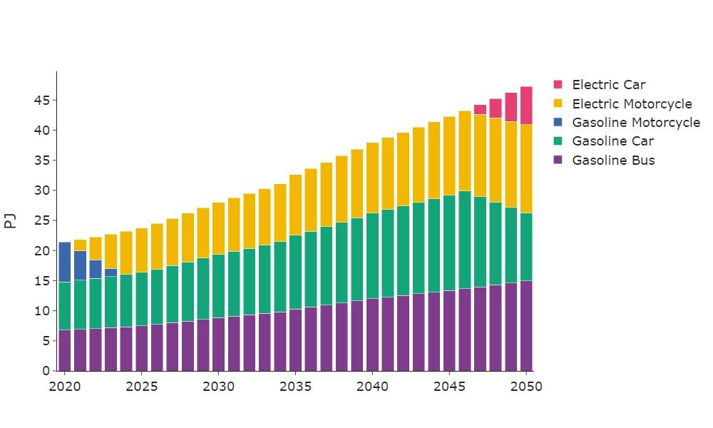
Figure A8: Transport demand met by each technology in Kenya in the Least Cost scenario
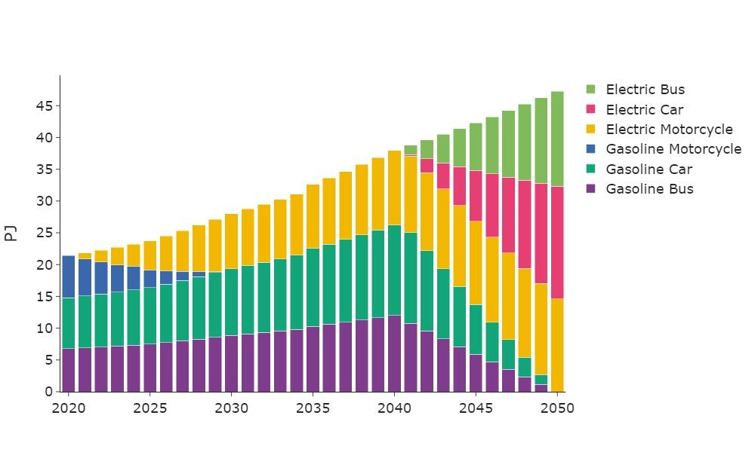
Figure A9: Transport demand met by each technology in Kenya in the Net Zero by 2050 scenario

A3.4 Annual Carbon Dioxide Emissions Results
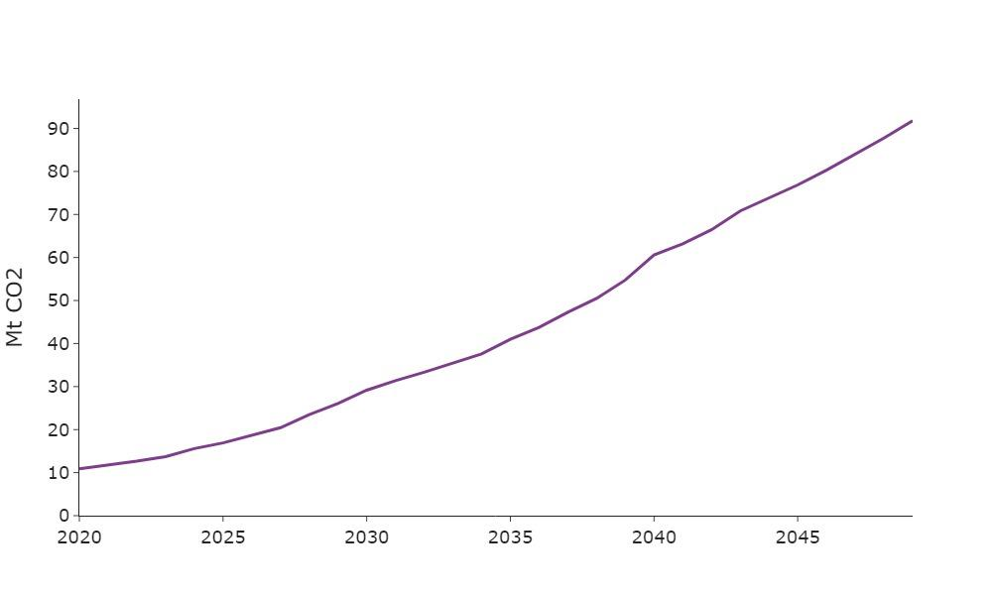
Figure A10: Annual Carbon Dioxide emissions in Kenya in the Fossil Future scenario
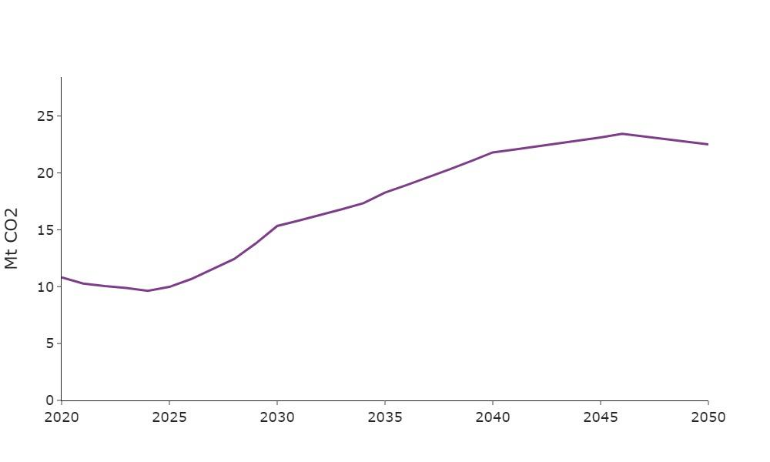
Figure A11: Annual Carbon Dioxide emissions in Kenya in the Least Cost scenario
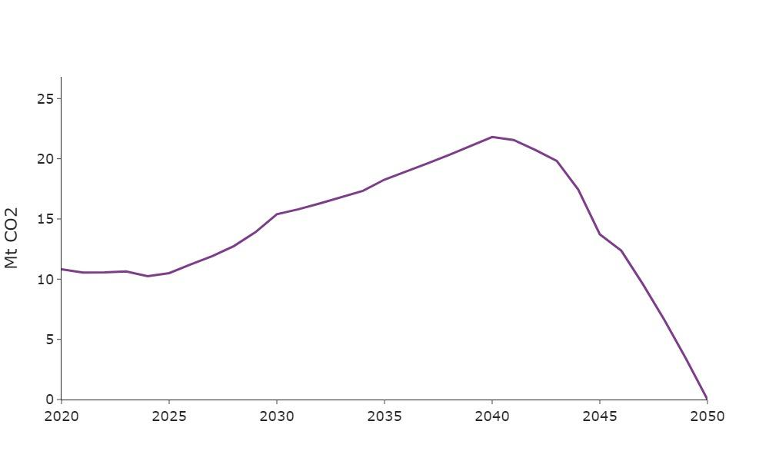
Figure A12: Annual Carbon Dioxide emissions in Kenya in the Net Zero scenario

A4 Further work
These example results represented zero-order models and were generated using the clicSAND Interface (7) and OSeMOSYS code (6). Those interested in further developing this work are directed to external comprehensive country datasets (see Appendix B) and guidance on model development using clicSAND and OSeMOSYS ().

Appendix B – Country Datasets

Table B1 lists the country-specific datasets that have been created using the data described in this article. For each country, there is a Zenodo dataset which includes the data in a set of csv tables, and a Research Square pre-print article that describes the data collection process and provides stylised example scenarios created using OSeMOSYS. These can act as the basis for country-level analyses such as those on Morocco (3), Ghana (4), and Kenya (5).

Table B1: External country datasets created using the data described in this article.
Region | Country | Zenodo Dataset | ResearchSquare Pre-Print
Africa | Algeria | https://doi.org/10.5281/zenodo.4728143 | https://www.researchsquare.com/article/rs-478421/v2
Africa | Angola | https://doi.org/10.5281/zenodo.4650810 | https://www.researchsquare.com/article/rs-478581/v2
Africa | Benin | https://doi.org/10.5281/zenodo.4725486 | https://www.researchsquare.com/article/rs-478594/v2
Africa | Botswana | https://doi.org/10.5281/zenodo.4650986 | https://www.researchsquare.com/article/rs-478620/v2
Africa | Burkina Faso | https://doi.org/10.5281/zenodo.4650942 | https://www.researchsquare.com/article/rs-478764/v2
Africa | Burundi | https://doi.org/10.5281/zenodo.4725445 | https://www.researchsquare.com/article/rs-478806/v2
Africa | Cameroon | https://doi.org/10.5281/zenodo.4650822 | https://www.researchsquare.com/article/rs-478850/v2
Africa | Central African Republic | https://doi.org/10.5281/zenodo.4650968 | https://www.researchsquare.com/article/rs-478906/v2
Africa | Chad | https://doi.org/10.5281/zenodo.4725466 | https://www.researchsquare.com/article/rs-478927/v2
Africa | Côte d'Ivoire | https://doi.org/10.5281/zenodo.4737634 | https://www.researchsquare.com/article/rs-493226/v1
Africa | Democratic Republic of the Congo | https://doi.org/10.5281/zenodo.4737640 | https://www.researchsquare.com/article/rs-493235/v1
Africa | Djibouti | https://doi.org/10.5281/zenodo.4725462 | https://www.researchsquare.com/article/rs-479210/v2
Africa | Egypt | https://doi.org/10.5281/zenodo.4652804 | https://www.researchsquare.com/article/rs-479263/v2
Africa | Equatorial Guinea | https://doi.org/10.5281/zenodo.4650904 | https://www.researchsquare.com/article/rs-479310/v2
Africa | Eritrea | https://doi.org/10.5281/zenodo.4725456 | https://www.researchsquare.com/article/rs-479568/v2
Africa | Eswatini (fmr. "Swaziland") | https://doi.org/10.5281/zenodo.4737638 | https://www.researchsquare.com/article/rs-493243/v1
Africa | Ethiopia | https://doi.org/10.5281/zenodo.4650876 | https://www.researchsquare.com/article/rs-479603/v2
Africa | Gabon | https://doi.org/10.5281/zenodo.4737642 | https://www.researchsquare.com/article/rs-493249/v1
Africa | Gambia | https://doi.org/10.5281/zenodo.4651140 | https://www.researchsquare.com/article/rs-479641/v2
Africa | Ghana | https://doi.org/10.5281/zenodo.4725480 | https://www.researchsquare.com/article/rs-479778/v2
Africa | Guinea | https://doi.org/10.5281/zenodo.4725454 | https://www.researchsquare.com/article/rs-480013/v3
Africa | Guinea-Bissau | https://doi.org/10.5281/zenodo.4650850 | https://www.researchsquare.com/article/rs-480393/v1
Africa | Kenya | https://doi.org/10.5281/zenodo.4650874 | https://www.researchsquare.com/article/rs-480458/v1
Africa | Lesotho | https://doi.org/10.5281/zenodo.4650866 | https://www.researchsquare.com/article/rs-480748/v1
Africa | Liberia | https://doi.org/10.5281/zenodo.4650794 | https://www.researchsquare.com/article/rs-480654/v1
Africa | Libya | https://doi.org/10.5281/zenodo.4650920 | https://www.researchsquare.com/article/rs-481132/v1
Africa | Malawi | https://doi.org/10.5281/zenodo.4652798 | https://www.researchsquare.com/article/rs-479507/v2
Africa | Mali | https://doi.org/10.5281/zenodo.4725447 | https://www.researchsquare.com/article/rs-479627/v2
Africa | Mauritania | https://doi.org/10.5281/zenodo.4650914 | https://www.researchsquare.com/article/rs-479591/v2
Africa | Morocco | https://doi.org/10.5281/zenodo.4725482 | https://www.researchsquare.com/article/rs-480023/v2
Africa | Mozambique | https://doi.org/10.5281/zenodo.4650902 | https://www.researchsquare.com/article/rs-481070/v1
Africa | Namibia | https://doi.org/10.5281/zenodo.4652808 | https://www.researchsquare.com/article/rs-481002/v1
Africa | Niger | https://doi.org/10.5281/zenodo.4725476 | https://www.researchsquare.com/article/rs-480051/v2
Africa | Nigeria | https://doi.org/10.5281/zenodo.4728145 | https://www.researchsquare.com/article/rs-480085/v2
Africa | Congo (Congo-Brazzaville) | https://doi.org/10.5281/zenodo.4651133 | https://www.researchsquare.com/article/rs-479154/v2
Africa | Rwanda | https://doi.org/10.5281/zenodo.4652800 | https://www.researchsquare.com/article/rs-480847/v1
Africa | Senegal | https://doi.org/10.5281/zenodo.4725484 | https://www.researchsquare.com/article/rs-480122/v2
Africa | Sierra Leone | https://doi.org/10.5281/zenodo.4725544 | https://www.researchsquare.com/article/rs-480371/v2
Africa | Somalia | https://doi.org/10.5281/zenodo.4725474 | https://www.researchsquare.com/article/rs-480695/v1
Africa | South Africa | https://doi.org/10.5281/zenodo.4652802 | https://www.researchsquare.com/article/rs-480636/v1
Africa | South Sudan | https://doi.org/10.5281/zenodo.4725468 | https://www.researchsquare.com/article/rs-479969/v2
Africa | Sudan | https://doi.org/10.5281/zenodo.4725460 | https://www.researchsquare.com/article/rs-479952/v2
Africa | Tanzania | https://doi.org/10.5281/zenodo.4652806 | https://www.researchsquare.com/article/rs-481182/v1
Africa | Togo | https://doi.org/10.5281/zenodo.4725451 | https://www.researchsquare.com/article/rs-480160/v2
Africa | Tunisia | https://doi.org/10.5281/zenodo.4725458 | https://www.researchsquare.com/article/rs-480566/v1
Africa | Uganda | https://doi.org/10.5281/zenodo.4652795 | https://www.researchsquare.com/article/rs-480512/v1
Africa | Zambia | https://doi.org/10.5281/zenodo.4725470 | https://www.researchsquare.com/article/rs-480042/v2
Africa | Zimbabwe | https://doi.org/10.5281/zenodo.4650816 | https://www.researchsquare.com/article/rs-479655/v2
Asia | Cambodia | https://doi.org/10.5281/zenodo.5139538 | https://www.researchsquare.com/article/rs-757472/v1
Asia | Indonesia | https://doi.org/10.5281/zenodo.4926858 | https://www.researchsquare.com/article/rs-757493/v1
Asia | Laos | https://doi.org/10.5281/zenodo.4926880 | https://www.researchsquare.com/article/rs-757542/v1
Asia | Malaysia | https://doi.org/10.5281/zenodo.5139480 | https://www.researchsquare.com/article/rs-757581/v1
Asia | Myanmar (formerly Burma) | https://doi.org/10.5281/zenodo.5139484 | https://www.researchsquare.com/article/rs-757622/v1
Asia | Philippines | https://doi.org/10.5281/zenodo.5139542 | https://www.researchsquare.com/article/rs-757671/v1
Asia | South Korea | https://doi.org/10.5281/zenodo.5139512 | https://www.researchsquare.com/article/rs-757722/v1
Asia | Taiwan | https://doi.org/10.5281/zenodo.5139520 | https://www.researchsquare.com/article/rs-757733/v1
Asia | Thailand | https://doi.org/10.5281/zenodo.5139498 | https://www.researchsquare.com/article/rs-757735/v1
Asia | Vietnam | https://doi.org/10.5281/zenodo.5139527 | https://www.researchsquare.com/article/rs-757746/v1
Asia | Papua New Guinea | https://doi.org/10.5281/zenodo.5139488 | https://www.researchsquare.com/article/rs-757653/v1
Latin America | Argentina | https://doi.org/10.5281/zenodo.5498081 | https://www.researchsquare.com/article/rs-893102/v1
Latin America | Bolivia | https://doi.org/10.5281/zenodo.5498083 | https://www.researchsquare.com/article/rs-893267/v1
Latin America | Brazil | https://doi.org/10.5281/zenodo.5498085 | https://www.researchsquare.com/article/rs-893535/v1
Latin America | Chile | https://doi.org/10.5281/zenodo.5498087 | https://www.researchsquare.com/article/rs-893607/v1
Latin America | Colombia | https://doi.org/10.5281/zenodo.5498091 | https://www.researchsquare.com/article/rs-893706/v1
Latin America | Ecuador | https://doi.org/10.5281/zenodo.5498093 | https://www.researchsquare.com/article/rs-893779/v1
Latin America | Paraguay | https://doi.org/10.5281/zenodo.5498099 | https://www.researchsquare.com/article/rs-895567/v1
Latin America | Peru | https://doi.org/10.5281/zenodo.5498101 | https://www.researchsquare.com/article/rs-895579/v1
Latin America | Uruguay | https://doi.org/10.5281/zenodo.5498103 | https://www.researchsquare.com/article/rs-895585/v1
Latin America | Venezuela | https://doi.org/10.5281/zenodo.5498105 | https://www.researchsquare.com/article/rs-895585/v1

