APPENDIX 1
Types of IDD
Four major types of IDD can be described: a) the causes that cannot or should not be used as underlying causes (impossible causes), b) the intermediate, c) the immediate and d) the unspecified causes [10].
The major part of IDD can be classified as (a) impossible CoD. This group comprises codes associated with morbidity but without the possibility of fatal outcomes. Examples are W50 Vitamin A deficiency or H10 - Conjunctivitis. Another grouping of impossible causes are R-codes which cover signs and symptoms but not directly a specific disease or injury and thus are not qualified to capture an underlying CoD. Examples for this group are R22.1 Localized swelling, mass and lump, neck or R53 Malaise and fatigue. Furthermore, implausible combinations of conditions with sex- or age information must be corrected.
Beside the impossible causes also (b) intermediate or (c) immediate causes which follow the actual underlying cause on the pathway of events leading to death are classified as IDD. Intermediate causes, such as heart failure, are clearly defined clinical entities that have always a precipitating event, which is the underlying CoD [10]. Immediate CoD are the final steps in the chain of events leading to death. Disseminated intravascular coagulation [defibrination syndrome] (D65) is one example of this type of IDD [10]).
Finally, (d) causes not clearly coded or classified are considered IDD within the GBD. The names of those codes typically include terms such as unspecified, other or with undetermined intent. The last one only applies to the category of injuries. Examples of this category are Y21 – Drowning and submersion, undetermined intent or C74.9 Endocrine gland, unspecified among the category malignant neoplasms.

APPENDIX 2
Table A1 Mapping level 1 to 3 (Source IHME/GBD 2019, own depiction)
Level 1 | Level 2 | Level 3
Communicable, maternal, neonatal, and nutritional diseases | Enteric infections | Diarrheal diseases
Communicable, maternal, neonatal, and nutritional diseases | Enteric infections | Invasive Non-typhoidal Salmonella (iNTS)
Communicable, maternal, neonatal, and nutritional diseases | Enteric infections | Other intestinal infectious diseases
Communicable, maternal, neonatal, and nutritional diseases | Enteric infections | Typhoid and paratyphoid
Communicable, maternal, neonatal, and nutritional diseases | HIV/AIDS and sexually transmitted infections | HIV/AIDS
Communicable, maternal, neonatal, and nutritional diseases | HIV/AIDS and sexually transmitted infections | Sexually transmitted infections excluding HIV
Communicable, maternal, neonatal, and nutritional diseases | Maternal and neonatal disorders | Neonatal disorders
Communicable, maternal, neonatal, and nutritional diseases | Maternal and neonatal disorders | Maternal disorders
Communicable, maternal, neonatal, and nutritional diseases | Neglected tropical diseases and malaria | Other neglected tropical diseases
Communicable, maternal, neonatal, and nutritional diseases | Neglected tropical diseases and malaria | Cystic echinococcosis
Communicable, maternal, neonatal, and nutritional diseases | Neglected tropical diseases and malaria | Malaria
Communicable, maternal, neonatal, and nutritional diseases | Neglected tropical diseases and malaria | Chagas disease
Communicable, maternal, neonatal, and nutritional diseases | Neglected tropical diseases and malaria | Schistosomiasis
Communicable, maternal, neonatal, and nutritional diseases | Nutritional deficiencies | Protein-energy malnutrition
Communicable, maternal, neonatal, and nutritional diseases | Nutritional deficiencies | Other nutritional deficiencies
Communicable, maternal, neonatal, and nutritional diseases | Nutritional deficiencies | Dietary iron deficiency
Communicable, maternal, neonatal, and nutritional diseases | Other infectious diseases | Other unspecified infectious diseases
Communicable, maternal, neonatal, and nutritional diseases | Other infectious diseases | Encephalitis
Communicable, maternal, neonatal, and nutritional diseases | Other infectious diseases | Meningitis
Communicable, maternal, neonatal, and nutritional diseases | Other infectious diseases | Varicella and herpes zoster
Communicable, maternal, neonatal, and nutritional diseases | Other infectious diseases | Acute hepatitis
Communicable, maternal, neonatal, and nutritional diseases | Other infectious diseases | Whooping cough
Communicable, maternal, neonatal, and nutritional diseases | Other infectious diseases | Measles
Communicable, maternal, neonatal, and nutritional diseases | Other infectious diseases | Rubella
Communicable, maternal, neonatal, and nutritional diseases | Respiratory infections and tuberculosis | Lower respiratory infections
Communicable, maternal, neonatal, and nutritional diseases | Respiratory infections and tuberculosis | Tuberculosis
Communicable, maternal, neonatal, and nutritional diseases | Respiratory infections and tuberculosis | Upper respiratory infections
Communicable, maternal, neonatal, and nutritional diseases | Respiratory infections and tuberculosis | Otitis media

Level 1 | Level 2 | Level 3
Non-communicable diseases | Cardiovascular diseases | Ischemic heart disease | Rheumatic heart disease
Non-communicable diseases | Cardiovascular diseases | Stroke | Aortic aneurysm
Non-communicable diseases | Cardiovascular diseases | Hypertensive heart disease | Peripheral artery disease
Non-communicable diseases | Cardiovascular diseases | Atrial fibrillation and flutter | Other cardiovascular and circulatory diseases
Non-communicable diseases | Cardiovascular diseases | Non-rheumatic valvular heart disease | Endocarditis
Non-communicable diseases | Cardiovascular diseases | Cardiomyopathy and myocarditis | Primary pulmonary arterial hypertension
Non-communicable diseases | Chronic respiratory diseases | Chronic obstructive pulmonary disease | Pneumoconiosis
Non-communicable diseases | Chronic respiratory diseases | Interstitial lung disease and pulmonary sarcoidosis | Other chronic respiratory diseases
Non-communicable diseases | Chronic respiratory diseases | Asthma
Non-communicable diseases | Diabetes and kidney diseases | Chronic kidney disease | Acute glomerulonephritis
Non-communicable diseases | Diabetes and kidney diseases | Diabetes mellitus
Non-communicable diseases | Digestive diseases | Cirrhosis and other chronic liver diseases | Other digestive diseases
Non-communicable diseases | Digestive diseases | Paralytic ileus and intestinal obstruction | Pancreatitis
Non-communicable diseases | Digestive diseases | Vascular intestinal disorders | Inflammatory bowel disease
Non-communicable diseases | Digestive diseases | Upper digestive system diseases | Inguinal, femoral, and abdominal hernia
Non-communicable diseases | Digestive diseases | Gallbladder and biliary diseases | Appendicitis
Non-communicable diseases | Mental disorders | Eating disorders
Non-communicable diseases | Musculoskeletal disorders | Other musculoskeletal disorders | Rheumatoid arthritis
Non-communicable diseases | Neoplasms | Tracheal, bronchus, and lung cancer | Other malignant neoplasms
Non-communicable diseases | Neoplasms | Colon and rectum cancer | Malignant skin melanoma
Non-communicable diseases | Neoplasms | Breast cancer | Other pharynx cancer
Non-communicable diseases | Neoplasms | Pancreatic cancer | Lip and oral cavity cancer
Non-communicable diseases | Neoplasms | Prostate cancer | Uterine cancer
Non-communicable diseases | Neoplasms | Stomach cancer | Cervical cancer
Non-communicable diseases | Neoplasms | Bladder cancer | Soft tissue and other extraosseous sarcomas
Non-communicable diseases | Neoplasms | Leukemia | Larynx cancer
Non-communicable diseases | Neoplasms | Kidney cancer | Mesothelioma
Non-communicable diseases | Neoplasms | Liver cancer | Non-melanoma skin cancer
Non-communicable diseases | Neoplasms | Non-Hodgkin lymphoma | Thyroid cancer
Non-communicable diseases | Neoplasms | Brain and central nervous system cancer | Malignant bone tumors
Non-communicable diseases | Neoplasms | Esophageal cancer | Hodgkin lymphoma
Non-communicable diseases | Neoplasms | Ovarian cancer | Eye cancer
Non-communicable diseases | Neoplasms | Multiple myeloma | Testicular cancer
Non-communicable diseases | Neoplasms | Other neoplasms | Nasopharynx cancer
Non-communicable diseases | Neoplasms | Gallbladder and biliary tract cancer | Neuroblastoma and other peripheral nervous cell tumors
Non-communicable diseases | Neurological disorders | Alzheimer's disease and other dementias | Motor neuron disease
Non-communicable diseases | Neurological disorders | Parkinson's disease | Other neurological disorders
Non-communicable diseases | Neurological disorders | Epilepsy | Multiple sclerosis
Non-communicable diseases | Other non-communicable diseases | Urinary diseases and male infertility | Hemoglobinopathies and hemolytic anemias
Non-communicable diseases | Other non-communicable diseases | Endocrine, metabolic, blood, and immune disorders | Sudden infant death syndrome
Non-communicable diseases | Other non-communicable diseases | Congenital birth defects | Gynecological diseases
Non-communicable diseases | Sense organ diseases | Other sense organ diseases
Non-communicable diseases | Skin and subcutaneous diseases | Bacterial skin diseases | Other skin and subcutaneous diseases
Non-communicable diseases | Skin and subcutaneous diseases | Decubitus ulcer | Scabies
Non-communicable diseases | Substance use disorders | Alcohol use disorders | Drug use disorders

Level 1 | Level 2 | Level 3
Injuries | Self-harm and interpersonal violence | Self-harm
Injuries | Self-harm and interpersonal violence | Interpersonal violence
Injuries | Self-harm and interpersonal violence | Executions and police conflict
Injuries | Self-harm and interpersonal violence | Conflict and terrorism
Injuries | Transport injuries | Road injuries
Injuries | Transport injuries | Other transport injuries
Injuries | Unintentional injuries | Falls
Injuries | Unintentional injuries | Adverse effects of medical treatment
Injuries | Unintentional injuries | Foreign body
Injuries | Unintentional injuries | Drowning
Injuries | Unintentional injuries | Fire, heat, and hot substances
Injuries | Unintentional injuries | Exposure to mechanical forces
Injuries | Unintentional injuries | Environmental heat and cold exposure
Injuries | Unintentional injuries | Other unintentional injuries
Injuries | Unintentional injuries | Poisonings
Injuries | Unintentional injuries | Animal contact
Injuries | Unintentional injuries | Exposure to forces of nature

APPENDIX 3
Figure A1 Redistribution of cases classified as IDD to Diabetes mellitus Type 1 and 2 on level 4, all IDD packages contributing
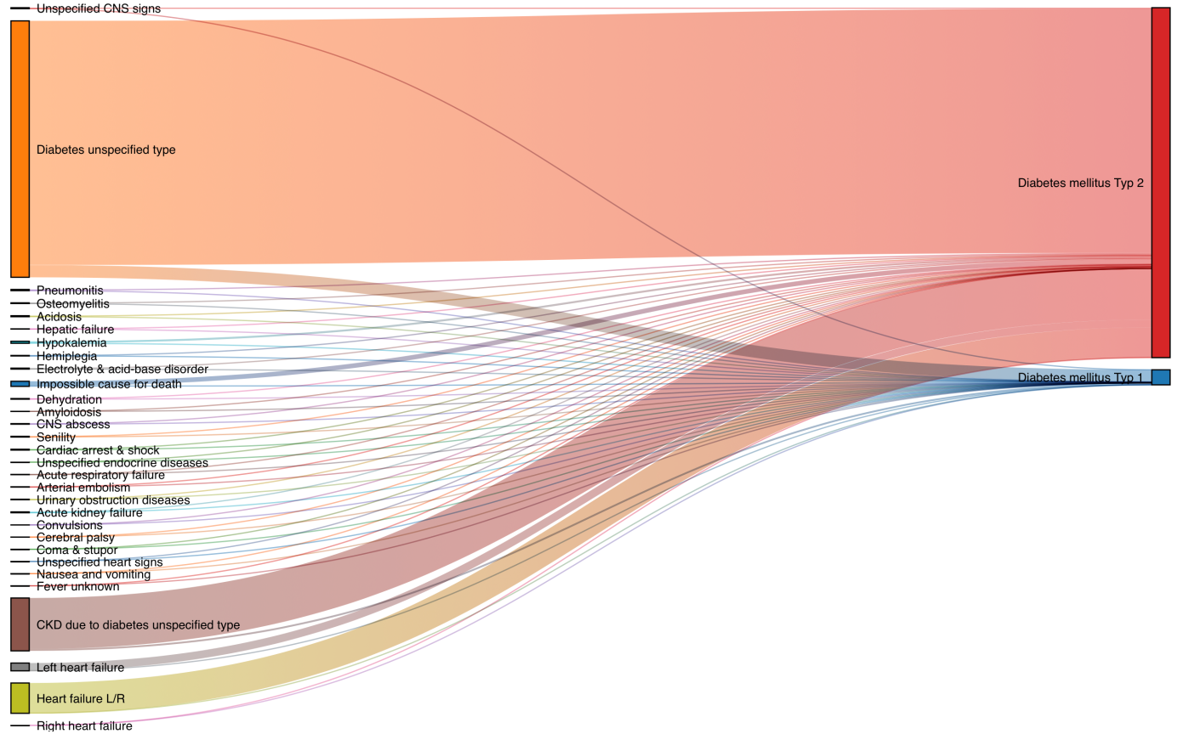
Source: causes of death statistics, Germany, 2017, own calculations

