Electronic Supplementary Information

Isolation of Clostridium perfringens type C from a neonatal Yangtze finless porpoise (Neophocaena asiaeorientalis asiaeorientalis)

Jia Li^{1, 5#} ∙ Richard William McLaughlin^{2#} ∙ Yingli Liu¹ ∙ Junying Zhou³ ∙ Xueying Hu⁴ ∙ Xiaoling Wan¹ ∙ Haixia Xie¹ ∙ Yujiang Hao^{1, 6} ∙ Jinsong Zheng^{1, 6}*

¹Institute of Hydrobiology, Chinese Academy of Sciences, Wuhan 430072, China.
²General Studies, Gateway Technical College, Kenosha, Wisconsin, United States of America.
³Department of Clinical Laboratory, Zhongnan Hospital of Wuhan University, Wuhan 430072, China.
⁴College of Veterinary Medicine, Huazhong Agricultural University, Wuhan 430070, China.
⁵University of Chinese Academy of Sciences, Beijing 100049, China.
⁶National Aquatic Biological Resource Center, Wuhan 430072, China.
#Authors contributed equally to this manuscript.
*Correspondence: zhengjinsong@ihb.ac.cn; Tel.: 86-27-87801331
Fig. S1 Histopathological diagnosis of the lung and the heart. A, mild inflammation in the left lung; B, mild focal degeneration and necrosis in the heart.

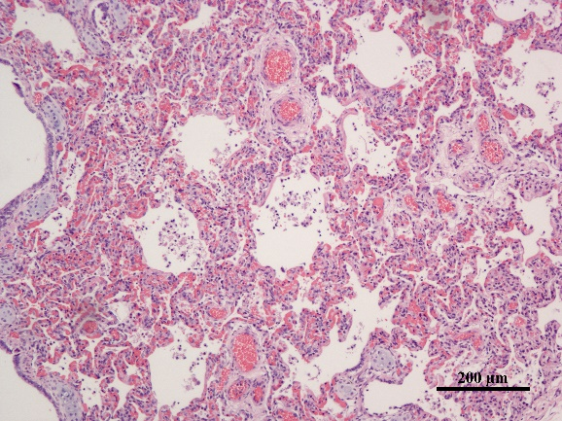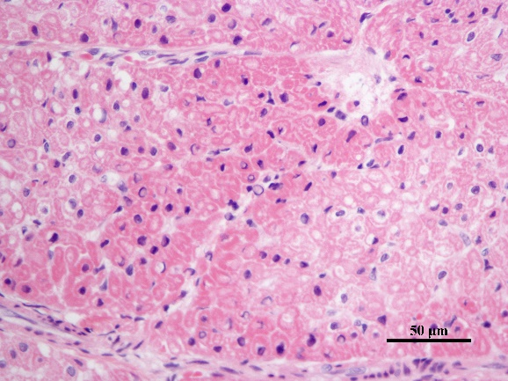
A
B

