Supplementary Materials for

Ultra-dense hydrogen in small pore hydridic framework

Hyunchul Oh, Nikolay Tumanov, Voraksmy Ban, Xiao Li, Bo Richter, Matthew R. Hudson, Craig M. Brown, Gail N. Iles, Dirk Wallacher, Luke Daemen, Rafael Balderas-Xicohtencatl, Yongqiang Cheng, Anibal J. Ramirez-Cuesta, Michael Hirscher*, Torben R. Jensen*, Yaroslav Filinchuk*

Correspondence to: hirscher@is.mpg.de; trj@chem.au.dk; yaroslav.filinchuk@uclouvain.be

This PDF file includes:

Materials and Methods
Supplementary Text
Figs. S1 to S24
Tables S1 to S10

Materials and Methods
Hydrogen isotherm measurements An automated Sievert’s type apparatus (PCTPro-2000) was used with a so-called micro-doser (MD) from HyEnergy. The original setup was upgraded by a heating and cooling device to regulate the sample temperature. The adsorption and desorption isotherms (0-20 bar) were measured at various temperature (77 K to 298 K) in a sample cell volume of ≈1.3 mL using ultra high purity hydrogen gas (99.999 %). Mg(BH₄)₂ (163 mg and 125 mg for γ and α phase, respectively) were evacuated under ultra-high vacuum at 335 K for over-night prior to the measurements in order to remove any adsorbed gas from the surface. The isosteric heat of adsorption is calculated from the absolute adsorbed hydrogen according to a variant of the Clausius-Clapeyron equation (details of calculation are shown in the Chapter 4, supporting information).
Cryogenic H₂ Brunauer-Emmet-Teller (BET) measurement The hydrogen adsorption isotherms of Mg(BH₄)₂ at 19.5 K were measured with laboratory-designed volumetric adsorption equipment with a temperature controlled cryostat and is described in detail elsewhere (27). Around 20 mg of γ- and α-Mg(BH₄)₂ was activated under ultra-high vacuum at 335 K overnight, prior to each measurement. For the laboratory-designed cryostat, the temperature control was calibrated by measuring the liquefaction pressure for hydrogen and nitrogen in the empty sample chamber at various temperatures.
Neutron powder diffraction at NIST NPD patterns were measured on the high resolution powder diffractometer BT1 at the NIST Center for Neutron Research (NCNR). The wavelength used was, λ = 2.074 Å. The sample was loaded into a vanadium can placed inside a closed-cycle refrigerator. First, the system was evacuated over night to empty the pores. Deuterium loading into the porous structure was performed in a two-step procedure. A known amount of gas was put into the system, which was slowly cooled to the liquefaction, and then the excess deuterium was pumped off upon heating slightly above the boiling point. The empty γ-Mg(¹¹BD₄)₂ was characterized, as well as a fully D₂-loaded framework, both measurement were at 10 K.
Neutron powder diffraction at HZB NPD patterns were taken on the high-resolution powder diffractometer E9 at the BER-II research reactor at the Helmholtz-Zentrum Berlin. The wavelength used was, λ = 1.7982 Å. The γ-Mg(¹¹BD₄)₂ sample was loaded into a vanadium can placed inside a liquid-helium ‘Orange’ cryostat. The system was evacuated and loaded with various amounts of deuterium gas at 25 K using DEGAS gas loading systems. Four NPD patterns were collected at equilibrium pressures of 0.21 mbar, 0.45 mbar, 27 mbar and 205 mbar at 25 K. The deuterium gas was evacuated by application of a vacuum at 100 K (which was confirmed by a subsequent measurement of the empty porous phase) after which 3 bar of N₂ gas was applied at 100 K. The diffraction patterns were collected under these conditions.
Analysis of diffraction data The identification of guest molecules was done by optimization in global space, using FOX software (28), followed by a complete Rietveld refinement in Fullprof (29, 30).
In situ inelastic neutron scattering experiments INS spectra were measured at the vibrational spectroscopy beamline VISION at SNS, ORNL (Spallation Neutron Source, Oak Ridge National Laboratory). A cryocooler cycle system which was used to control the temperature of the sample in a range of 5 K-100 K. Para-hydrogen (pH₂) was prepared by liquefying ultrahigh purity normal hydrogen over Oxisorb (CrO nanoparticles deposited over silica) at 17 K and bleeding the vapor off this system at 22 K. The samples were loaded in aluminum containers that were connected to a gas dosing system in the beamline. The samples were dosed in situ in the cryostat at 35K and cooled down to base temperature, 5 K for measurements. We dosed different amounts of almost pure pH₂ and normal hydrogen, (nH₂). Normal hydrogen is the equilibrium mixture at room temperature consisting of 25% pH₂ and 75% ortho-hydrogen (oH₂).

Supplementary Text
Contents

S1 Neutron diffraction study of the empty Mg(¹¹BD₄)₂ framework, N₂-loaded γ-Mg(¹¹BD₄)₂∙0.66N₂ and D₂-loaded Mg(¹¹BD₄)₂ framework up to the composition γ-Mg(¹¹BD₄)₂∙1.33D₂.

S2 Re-evaluation of the synchrotron radiation X-ray powder diffraction (SR-XPD) data collected under hydrogen pressures.

S3 Neutron diffraction study of the D₂-loaded Mg(¹¹BD₄)₂ framework, up to the composition γ-Mg(¹¹BD₄)₂∙2.33D₂.

S4 Volumetric measurements.

S5 Inelastic Neutron Scattering - In situ study of H₂-loaded Mg(¹¹BD₄)₂ framework.
S5.1 Quantum rotation of H₂
S5.2 INS roto-vibrational analysis
S5.2.1. Para and ortho INS spectra
S5.2.2 INS as function of pH₂ loading
S5.3 Simultaneous quantum rotational excitation (SQRE)
S5.4. Calculation of overtone vibrational modes and SQRE
S5.5 Comparison with H₂ at high-pressure
S5.6 Density of hydrogen confined in Mg(BD₄)₂

Chapter S1. Neutron diffraction study of the empty Mg(¹¹BD₄)₂ framework, N₂-loaded γ-Mg(¹¹BD₄)₂∙0.66N₂ and D₂-loaded Mg(¹¹BD₄)₂ framework up to the composition γ-Mg(¹¹BD₄)₂∙1.33D₂.
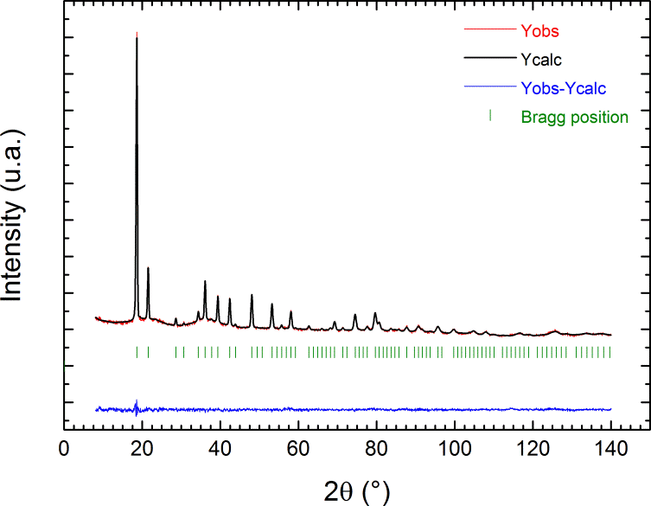
Fig. S1.
Rietveld refinement profile for the fresh empty-pore γ-Mg(¹¹BD₄)₂ sample, using NPD data (NIST) collected at 10 K, λ = 2.079 Å.

Atom | Wyckoff  site | x | y | z | Occupancy | B (Å²)
‘Empty’ γ-Mg(¹¹BD₄)₂, space group Ia-3d, Z = 24, a = 15.7401(11) Å,
V = 3899.7(5) Å³, R_{p} = 23.7%, R_{wp} = 15.7%, χ² = 0.866, R_{F} = 6.07%.
Mg | 24d | 1/4 | 1/8 | 1/2 | 1 | 1.7(2)
¹¹B | 48g | 0.3130(3) | x-1/4 | 3/8 | 1 | 1.66(9)
D1 | 96h | 0.2888(3) | 0.0202(3) | 0.4363(4) | 1 | 3.53(6)
D2 | 96h | 0.3001(3) | 0.1391(3) | 0.3814(2) | 1 | 3.53(6)

Table S1.
Structural data for empty γ-Mg(¹¹BD₄)₂ sample from NPD experiment (NIST) at 10 K, λ = 2.079 Å. Values in parentheses indicate one standard deviation.

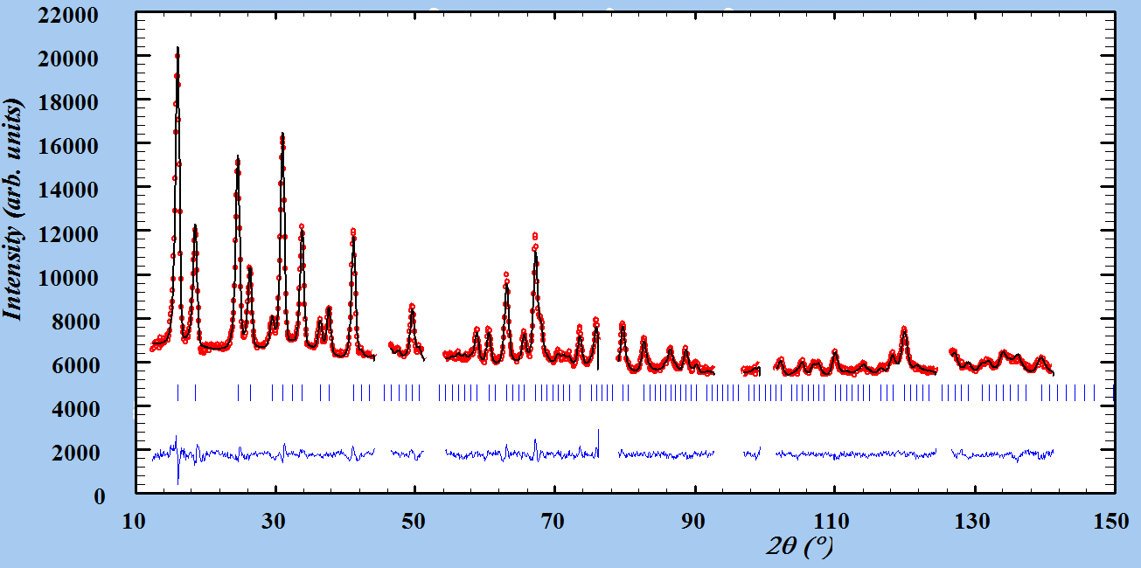
Fig. S2.
Rietveld refinement profile for the nitrogen-loaded γ-Mg(¹¹BD₄)₂ sample at 100 K and 3 bar (HZB). The angular ranges containing contributions from the Al can were excluded from the refinement. λ = 1.7982 Å.

Atom | Wyckoff  site | x | y | z | Occupancy | B (Å²)
N₂-loaded γ-Mg(¹¹BD₄)₂, space group Ia-3d, Z = 24, a = 15.7498(4) Å,
V = 3906.85(2) Å³, R_{p} = 10.2%, R_{wp} = 9.25%, χ² = 2.17, R_{F} = 2.32%.
Mg | 24d | 1/4 | 1/8 | 1/2 | 1 | 1.1(1)
¹¹B | 48g | 0.3130(2) | x-1/4 | 3/8 | 1 | 1.42(9)
D1 | 96h | 0.2910(3) | 0.0197(2) | 0.4352(3) | 1 | 3.21(7)
D2 | 96h | 0.3015(2) | 0.1402(2) | 0.3817(2) | 1 | 3.21(7)
N1 | 96h | 0.6349(9) | 0.6714(18) | 0.6650(19) | 0.1805(12)* | 4.7(7)
N2 | 96h | 0.628(2) | 0.628(2) | 0.6193(18) | 0.1805(12)* | 4.7(7)
* This value for the N-atoms' occupancy corresponds to 0.722(5) N₂ molecules per Mg atom. This value is correlated with the refined ADPs, and is reasonably close to the limiting composition of 0.667 N₂ molecules per Mg atom.

Table S2.
Structural data for the N₂-loaded γ-Mg(¹¹BD₄)₂ sample from NPD experiment (HZB) at 100 K and 3 bar of gas pressure, λ = 1.7986 Å.

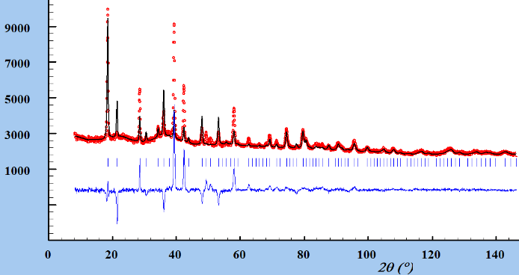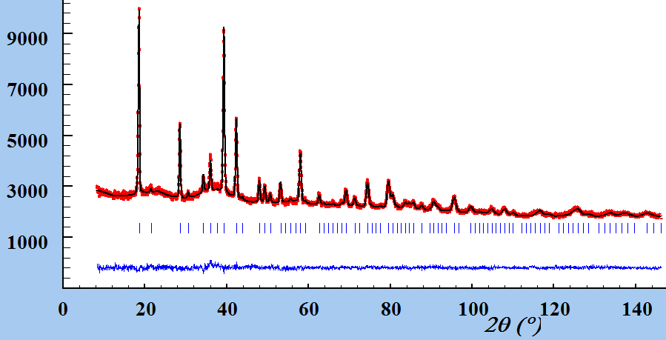
Fig. S3.
Rietveld refinement profile for NPD NIST data collected at 10 K on the D₂-loaded γ-Mg(¹¹BD₄)₂ sample using: left, the structural model for nitrogen localization based on XPD data assuming the limiting composition γ-Mg(¹¹BD₄)₂∙0.66D₂ (6), and right, the revised model that allows for the double hydrogen capacity, γ-Mg(¹¹BD₄)₂∙1.33D₂. λ = 2.079 Å.

Atom | Wyckoff  site | x | y | z | Occupancy | B (Å²)
D₂-loaded γ-Mg(¹¹BD₄)₂, space group Ia-3d, Z = 24, a = 15.7424(3) Å,
V = 3901.3(1) Å³, R_{p} = 21.0%, R_{wp} = 15.4%, χ² = 0.889, R_{F} = 4.83%.
Mg | 24d | 1/4 | 1/8 | 1/2 | 1 | 0.8(1)
¹¹B | 48g | 0.3115(3) | x-1/4 | 3/8 | 1 | 0.1(1)
D1 | 96h | 0.2886(3) | 0.0195(3) | 0.4349(4) | 1 | 2.90(7)
D2 | 96h | 0.3008(3) | 0.1375(3) | 0.3800(2) | 1 | 2.90(7)
D11 | 32e | 0.6843(2) | x | x | 2.156(18)* | 11.1(3)
* This value for the D₂ superatom occupancy corresponds to 1.078(9) occupancy of the individual atoms. This value is slightly over 1 due to a correlation in the ADP (refined B = 11.2(3) Å²), which falls within the expected range for the "superatom" model. When the B-factor is fixed to 8, the occupancy of the “superatom” refines exactly to 1. This corresponds to 1.33 D₂ per Mg atom.

Table S3.
Structural data for D₂-loaded γ-Mg(¹¹BD₄)₂ sample from NPD experiment (NIST) at 10 K. λ = 2.079 Å.

Atom | Wyckoff  Site | x | y | z | Occupancy | B (Å²)
γ-Mg(¹¹BD₄)₂ at 25 K and 0.21 mbar D₂, space group Ia-3d, Z = 24, a = 15.7678(4) Å, V = 3920.2(2) Å³, R_{p} = 9.5%, R_{wp} = 8.26%, χ² = 2.21, R_{F} = 2.10%.
Mg | 24d | 1/4 | 1/8 | 1/2 | 1 | 0.9(1)
¹¹B | 48g | 0.31256(19) | x-1/4 | 3/8 | 1 | 0.78(7)
D1 | 96h | 0.2903(2) | 0.0204(2) | 0.4354(3) | 1 | 2.55(5)
D2 | 96h | 0.3014(2) | 0.1399(2) | 0.38137(18) | 1 | 2.55(5)
D11 | 32e | 0.6597(5) | x | x | 0.526(8)* | 11.2
γ-Mg(¹¹BD₄)₂ at 25 K and 0.43 mbar D₂, space group Ia-3d, Z = 24, a = 15.7687(4) Å, V = 3920.9(2) Å³, R_{p} = 10.5%, R_{wp} = 9.31%, χ² = 2.75, R_{F} = 2.89%.
Mg | 24d | 1/4 | 1/8 | 1/2 | 1 | 1.3(1)
¹¹B | 48g | 0.31091(19) | x-1/4 | 3/8 | 1 | 0.65(7)
D1 | 96h | 0.2890(2) | 0.0188(2) | 0.4358(3) | 1 | 2.73(5)
D2 | 96h | 0.3004(2) | 0.1383(2) | 0.3815(2) | 1 | 2.73(5)
D11 | 32e | 0.6791(2) | x | x | 1.576(7)* | 11.2
γ-Mg(¹¹BD₄)₂ at 25K and 27 mbar D₂, space group Ia-3d, Z = 24, a = 15. 7741(4) Å, V = 3925.0(2) Å³, R_{p} = 10.9%, R_{wp} = 9.71%, χ² = 2.99, R_{F} = 2.33%.
Mg | 24d | 1/4 | 1/8 | 1/2 | 1 | 1.0(1)
¹¹B | 48g | 0.3116(2) | x-1/4 | 3/8 | 1 | 0.42(7)
D1 | 96h | 0.2891(2) | 0.0184(2) | 0.4355(3) | 1 | 2.59(6)
D2 | 96h | 0.3007(3) | 0.1383(2) | 0.3804(2) | 1 | 2.59(6)
D11 | 32e | 0.6849(2) | x | x | 2.29(1)* | 11.2
* The value of the superatom occupancy corresponds to double occupancy of the individual D-atoms. The full site occupation (2 for the superatom) corresponds to 1.33 D₂ per Mg atom.

Table S4.
Structural data for the D₂-loaded γ-Mg(¹¹BD₄)₂ from NPD experiment (HZB) at 25 K and 0.21 mbar, 0.43 mbar, 27 mbar equilibrium pressures, refined with one superatom (centroid) D₂ site. λ = 1.7982 Å.

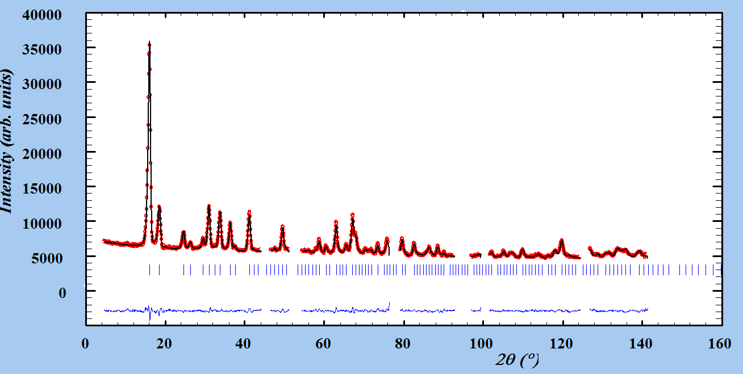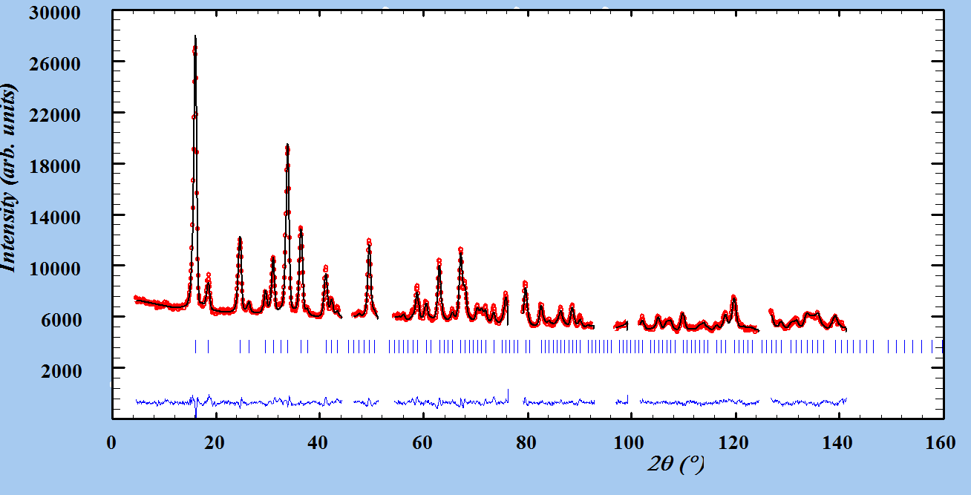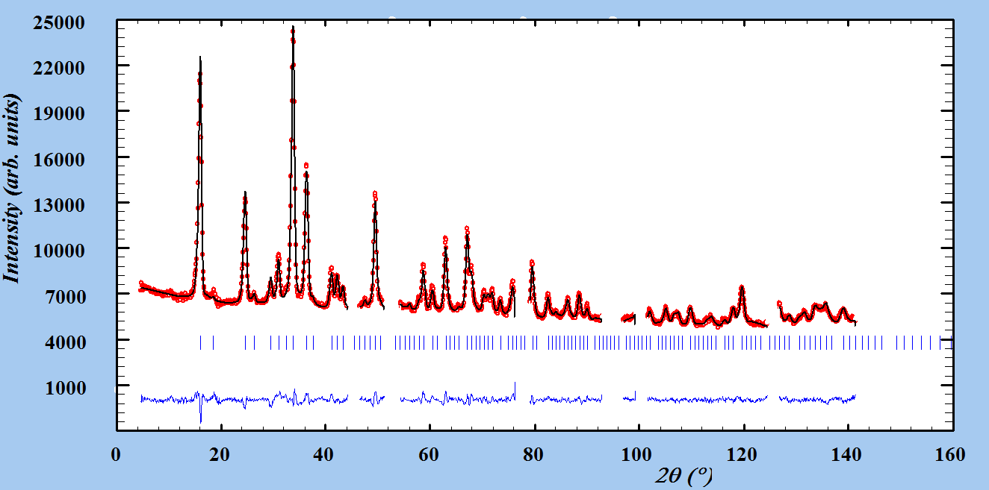
Fig. S4.
Rietveld refinement profiles for the deuterium-loaded γ-Mg(¹¹BD₄)₂ sample at 25 K and 0.21 mbar (top), 0.43 mbar (middle), 27 mbar (bottom) equilibrium pressures (HZB), refined with one superatom D₂ site. The angular ranges containing contributions from the Al can were excluded from the refinement. λ = 1.7982 Å.

Chapter S2. Re-evaluation of the synchrotron radiation X-ray powder diffraction (SR-XPD) data collected under hydrogen pressures.

The new H₂ localization obtained from the NPD experiments allowed us to re-evaluate the in situ SR-XPD data collected on γ−Mg(BH₄)₂ under different H₂ pressures and temperatures (6). Although such data were fitted well using a nitrogen localization model (see Fig. S5a), the quality of the Rietveld refinement was improved considerably using the new NPD model and the same SR-XPD data (see Fig S5b): χ² decreased to less than half the original value, from 1310 to 610. Importantly, the new geometric model corrects the original estimate of the maximum experimental hydrogen content from γ−Mg(BH₄)₂·0.80H₂ (6) to γ−Mg(BH₄)₂·1.32H₂. The obtained value is very close to the NPD values and to the value expected at full occupancy of the H₂ site (1.33 H₂ per Mg). Structural parameters for the revised SR-XPD experiment at 80 K on 105 bar of H₂ are listed in Table S5.

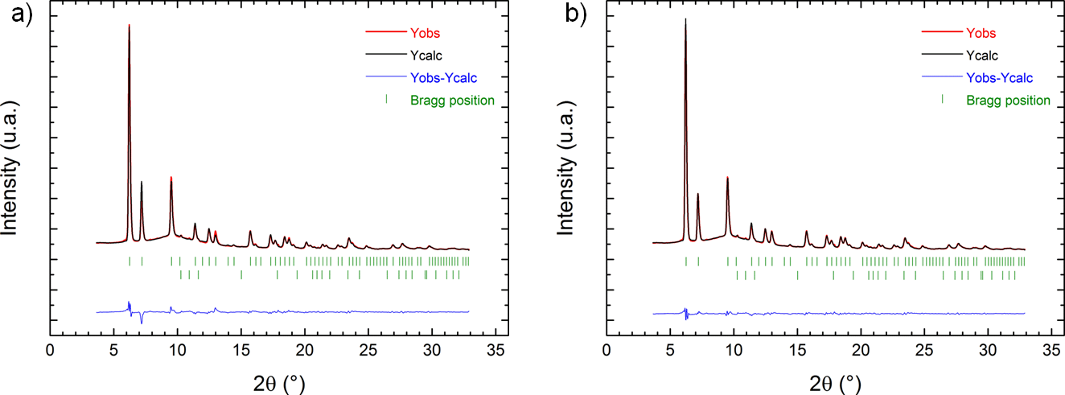
Fig. S5.
Rietveld refinement profile for the SR-XPD data collected on γ-Mg(BH₄)₂ at 80 K and 105 bar of H₂ using a) the X-ray model for nitrogen localization used previously in Ref (6), b) the revised NPD model, giving the resulting composition γ−Mg(BH₄)₂·1.32H₂. The lower line of Bragg reflection tick marks refer to ice forming on the outer side of the cold glass capillary. λ = 0.700930 Å.

Atom | Wyckoff  site | x | y | z | Occupancy | B (Å²)
Space group Ia-3d, Z = 24, a = 15.7771(6) Å, V = 3927.1(3) Å³
R_{p} = 8.3%, R_{wp} = 8.8%, χ² = 610, R_{F} = 2.2%.
Mg | 24d | 1/4 | 1/8 | 1/2 | 1 | 0.9(1)
B | 48g | 0.30981 | x-1/4 | 3/8 | 1 | 0.9(1)
H1 | 96h | 0.28571 | 0.02071 | 0.43730 | 1 | 2.9(1)
H2 | 96h | 0.29741 | 0.13551 | 0.13551 | 1 | 2.9(1)
H11 | 32e | 0.6843 | x | x | 1.98(4)* | 16.9(1)
* This value for the H₂ superatom occupancy practically corresponds to full occupancy of the site by H₂ molecules, the latter corresponds to 1.33 H₂ per Mg atom.

Table S5.
Structural parameters for γ-Mg(BH₄)₂ loaded at 80 K with 105 bar of H₂, using SR-XPD data and the revised model of hydrogen localization. Nearly double occupancy of H₂ "superatom" indicates the full occupation of the site and thus the composition γ−Mg(BH₄)₂·1.32H₂. λ = 0.700930 Å.

Fig. S6.
Hydrogen adsorption isobars for γ-Mg(BH₄)₂ extracted from in situ powder diffraction data using the previous structural model based on localisation of nitrogen (N₂- model) (black squares) and the new NPD model (red circles). Note that there is no drop in adsorbed amount of H₂ at lower temperature when using the new model.

Using the new model and previously reported in situ SR-XPD data at 3.34 bar and 105 bar, the H₂ site occupancies were refined as a function of temperature. Fig. S6 shows the amount of H₂ adsorbed per Mg atom, both for the old (black squares) and the new (red circles) models. The major differences are observed for the temperatures below 150 K, where an unexplained drop in capacity is eliminated for the new model.

Fig. S7.
Amount of adsorbed hydrogen in γ-Mg(BH₄)₂ extracted from in situ SR-XPD data collected at constant pressure of 33.7 bar and temperature varied from 80 K to 300 K. The fit of the logistic function to the experimental isobar yields the H₂ capacity per Mg atom at 1.29(4), which suggest an almost fully occupied site (1.33).

We employed the revised model to characterize hydrogen adsorption at 33.7 bar over a wide range of temperatures, from liquid nitrogen to ambient, using previously unpublished SR-XPD data. The fit of the logistic function to the data is shown in Fig. S7, although only a part of the S-curve was measured. The H₂ capacity per Mg atom on saturation refines to, A1 = 1.29(4), which suggest an almost fully occupied site (1.33). Very similar values are obtained at higher pressure, A1 = 1.30(2) at p(H₂) = 105 bar, and even for the low pressure of p(H₂) = 3.34 bar, A1 = 1.4(2). It is highly satisfactory that the saturation limit can be extrapolated so well using the adsorption data covering only the lower half of the loading curve at 3.34 bar. Although the uncertainties become higher at lower pressures, the fit of the logistic function to the data allows estimation of the limiting adsorption capacity. The A2 parameter reflects the capacity on complete desorption, which is indeed zero within three standard uncertainties. The temperature at which half of the maximum hydrogen adsorption capacity is adsorbed, x₀ = 112 ± 2 K.

Chapter S3. Neutron diffraction study of the D₂-loaded Mg(¹¹BD₄)₂ framework, up to the composition γ-Mg(¹¹BD₄)₂∙2.33D₂.

Atom | Wyckoff  Site | x | y | z | Occupancy | B (Å²)
γ-Mg(¹¹BD₄)₂ at 25 K and 27 mbar D₂, space group Ia-3d, Z = 24, a = 15.7738(3) Å, V = 3924.7(1) Å³, R_{p} = 9.81%, R_{wp} = 8.57%, χ² = 2.39, R_{F} = 2.12%.
Mg | 24d | 1/4 | 1/8 | 1/2 | 1 | 1.1(1)
¹¹B | 48g | 0.31105(19) | x-1/4 | 3/8 | 1 | 0.70(7)
D1 | 96h | 0.2888(2) | 0.0185(2) | 0.4357(3) | 1 | 2.94(6)
D2 | 96h | 0.2998(3) | 0.1386(2) | 0.3811(2) | 1 | 2.94(6)
D11 | 32e | 0.68489(18) | x | x | 2.183(14)* | 10.6(2)
D22 | 48g | 0.5310(19) | 0.7190(19) | 5/8 | 0.141(7)* | 10.6(2)
γ-Mg(¹¹BD₄)₂ at 25 K and 203 mbar D₂, space group Ia-3d, Z = 24, a = 15.8039(7) Å, V = 3947.3(3) Å³, R_{p} = 18.7%, R_{wp} = 17.1%, χ² = 6.72, R_{F} = 6.05%.
Mg | 24d | 1/4 | 1/8 | 1/2 | 1 | 1.4(2)
¹¹B | 48g | 0.3132(3) | x-1/4 | 3/8 | 1 | 0.93(9)
D1 | 96h | 0.2903(4) | 0.0212(4) | 0.4333(5) | 1 | 3.10(8)
D2 | 96h | 0.2996(4) | 0.1388(4) | 0.3812(3) | 1 | 3.10(8)
D11 | 32e | 0.6947(4) | x | x | 2.05(3)* | 16.5(6)
D22 | 48g | 0.5434(6) | 0.7066(6) | 5/8 | 0.971(13)* | 16.5(6)
* The value of the superatom occupancy corresponds to double occupancy of the individual D-atoms. The refined occupancies of the two superatom sites correspond to 1.47 D₂ per Mg atom (assuming the full occupancy for D11) at 27 mbar equilibrium pressure and to 2.33 D₂ per Mg atom (assuming the full occupancy of D11 and half occupancy for D22) at 203 mbar equilibrium pressure.

Table S6. Structural data for the D₂-loaded γ-Mg(¹¹BD₄)₂ from NPD experiment (HZB) at 25 K and 27 mbar and 203 mbar equilibrium pressures, refined with two superatom D₂ sites. λ = 1.7982 Å.

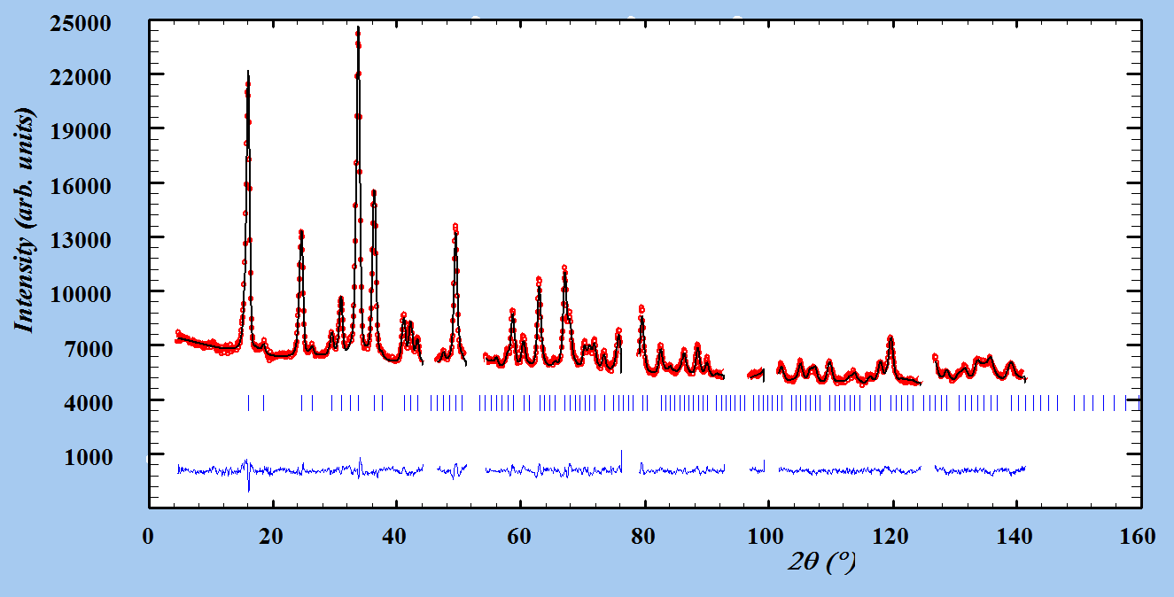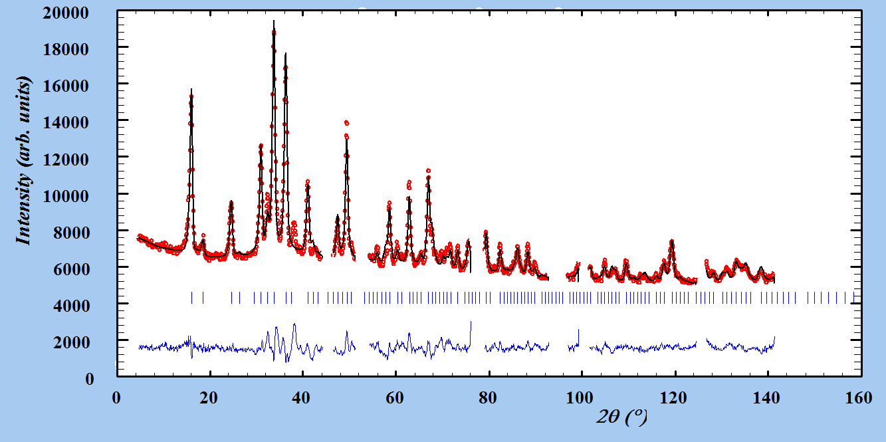
Fig. S8.
Rietveld refinement profiles for the deuterium-loaded γ-Mg(¹¹BD₄)₂ sample at 25 K and 27 mbar (top) and 203 mbar (bottom) equilibrium pressures (HZB), refined with two superatom D₂ site. The angular ranges containing contributions from the Al can were excluded from the refinement. λ = 1.7982 Å.

Chapter S4. Volumetric measurements.
Quantification of the crystalline fraction of γ-Mg(BH₄)₂ using volumetric measurements of nitrogen adsorption isotherm. Upon long-term storage of γ-Mg(BH₄)₂ the crystallinity of the sample degrades and the sample slowly transforms into an amorphous phase, manifested by a decreasing diffracted intensity, diffraction peak broadening and appearance of a wavy background. The amorphization also strongly affects the gas adsorption properties for the bulk γ-Mg(BH₄)₂ sample. Since a significant fraction of the amorphous phase is always present in each sample, the consistent NPD and X-ray data on N₂ adsorption (2/3 N₂ per Mg on saturation) allowed us to quantify the amount of the amorphous phase by volumetric measurements. We attribute the amount of the adsorbed nitrogen, as determined from a volumetric isotherm, to the adsorption in the crystalline phase only. Direct comparisons of N₂ and H₂ isotherm of bulk γ-Mg(BH₄)₂ synthesized on the same sample batch are shown in Fig. 4. Note that the difference between fig. 4a (short-term) and 4b (long-term) is only aging time upon storage. The volumetric N₂ uptake at saturation can be converted to the number of N₂ per crystalline/porous Mg in γ-Mg(BH₄)₂, resulting in the estimation of amorphous fraction in bulk γ-Mg(BH₄)₂ from the NPD and X-ray data (2/3 N₂ per Mg on saturation). Remarkably, the volumetric H₂ uptake corrected for the amorphous phase consistently exhibits γ-Mg(BH₄)₂∙2.04~2.06 H₂, very close to the limiting composition obtained from the crystallographic data (γ−Mg(BH₄)₂⋅2.33H₂).
Crystal structure of α- and γ−Mg(BH₄)₂ and their hydrogen storage capacities. The highly symmetric cubic crystal structure of γ−Mg(BH₄)₂ (space group Id-3a), which possesses a 3D net of interpenetrated channels with many corners is shown in Fig. S9a. The narrowest part of the channels, 5.8 Å in diameter, is defined by the space between the hydrogen atoms of BH₄ groups that comprise the walls of the channel. γ−Mg(BH₄)₂ contains 33 % empty space in the structure, suggesting pronounced gas adsorption potential for this material. Another less porous hexagonal polymorph of magnesium borohydride, α−Mg(BH₄)₂ (space group P6₁22), is also investigated in this study and its structure is illustrated in Fig. S9b. This polymorph contains unoccupied voids accounting for 6.4 % volume in the structure, the volume of each void approximately compares to the size of a water molecule (31).

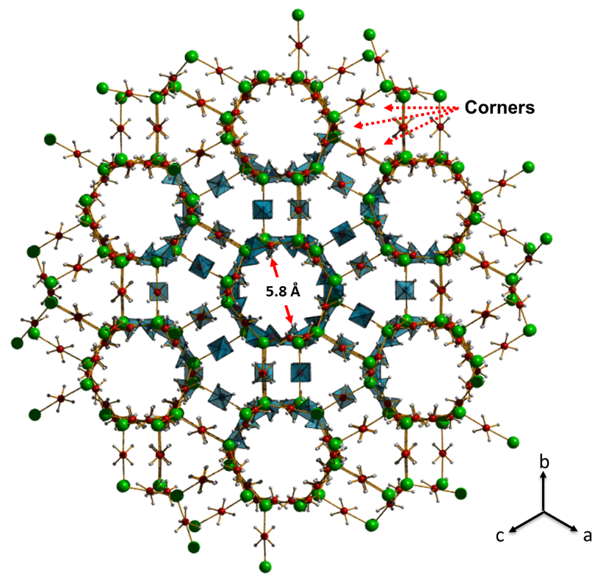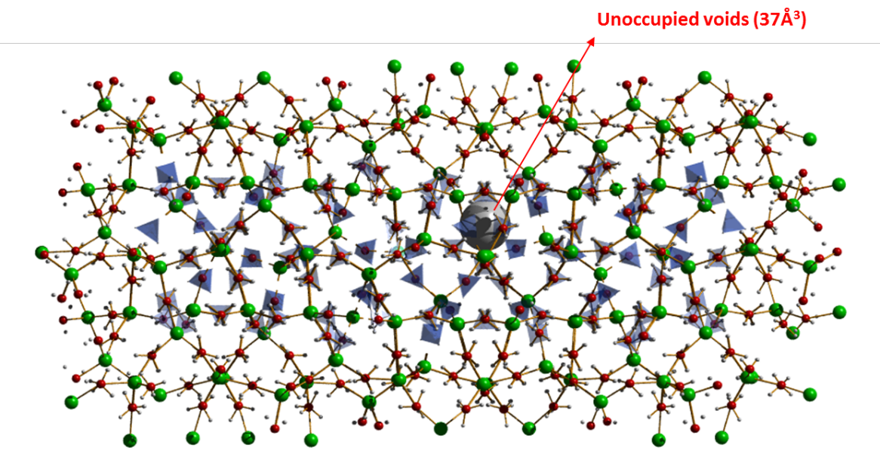
Fig. S9.
The structure of a) γ-Mg(BH₄)₂ and b) α-Mg(BH₄)₂, containing respectively empty channels (an aperture of 5.8 Å, the empty volume accounts for ~33% of space in the structure) and unoccupied voids (37 Å³ each void, accounting for 6.4 % of space in the structure). Symbols: Mg (green), B (red) and H (gray). BH₄ group inside unit cell are shown as dark blue tetrahedral.

Excess hydrogen isotherm adsorption curves of the α− and γ−Mg(BH₄)₂ measured at 77 K and 298 K are shown in Fig. S10. The data measured for γ−Mg(BH₄)₂ at 77 K exhibits the characteristic IUPAC type-I curve shape, which is typical for microporous materials. The maximum measured excess hydrogen uptake of γ−Mg(BH₄)₂ is 3.4 mass fraction (wt.%) and 0.12 mass fraction (wt.%) H₂ at 77 K and room temperature (RT), p(H₂) = 20 bar, respectively. This is in agreement with the high porosity observed by crystallographic investigations, which reveal a 3D net of interpenetrated channels having a wide mean pore diameter (see Table S7).
In contrast, the excess hydrogen uptake of the polymorph α−Mg(BH₄)₂ is significantly lower over the entire pressure range at either temperature. α−Mg(BH₄)₂ only absorbs 0.26 mass fraction (wt.%) H₂ at 77 K, p(H₂) = 20 bar, which compares to 0.07 H₂ molecule per Mg atom, or 0.35 H₂ per void in the structure. According to previous crystallographic investigations (31), the unoccupied voids (37 Å³) might be large enough to accommodate a small molecule, such as H₂O (kinetic diameter ~ 2.6 Å). However, this theoretical value was obtained using a probe ‘atom’ of 1.0 Å radius and may be a suitable predictor of the hydrogen adsorption isotherm since the typical range of intermolecular H···H interaction in α−Mg(BH₄)₂ is around 2.7 Å to 2.9 Å. Therefore, the void windows are smaller or may be similar in size to the kinetic diameter of a hydrogen molecule, i.e. 2.8 Å to 2.9 Å. Thus, the small pore size in α−Mg(BH₄)₂ may pose a strong kinetic barrier, leading to diffusion limited hydrogen uptake and release in this material. It is notable though, that the well-studied α−Mg(BH₄)₂ demonstrates hydrogen adsorption in the small pores, making it the second nano-porous hydride after γ−Mg(BH₄)₂.

Fig. S10.
Reversibility of hydrogen uptake and release for α and γ−Mg(BH₄)₂ samples; squares, circle, triangles and diamond stand for 77 K - γ−Mg(BH₄)₂, 77 K - α−Mg(BH₄)₂, RT - γ−Mg(BH₄)₂ and room temperature (RT) - α−Mg(BH₄)₂, respectively. Cross stands for second measurement of all samples. Closed symbols show the adsorption isotherm and open symbols show the desorption isotherm. Samples were evacuated in vacuum at room temperature for overnight prior to each measurement.

 | N₂ BET ª (m²/g) | H₂ BET ^{b} (m²/g) | H₂ Uptake ^{c}  (wt.%) | ρ ^{d}  (g/cm³) | Pore window ^{e} (Å) | Pore Diameter (Å)
γ – Mg(BH₄)₂ | 610 | 1787 | 4.2 | 0.55 | 5.8 | 7.0 ^{f}
α – Mg(BH₄)₂ | - | - | - | 0.78 | 2.8 | 4.1 ^{g}
ª N₂ BET: nitrogen BET specific surface area at 77 K (P/P₀ = 3×10⁻⁵~0.02), ^{b} H₂ BET: hydrogen BET specific surface area at 20 K (P/P₀ = 5×10⁻⁴~0.02) using a cross-sectional area of the hydrogen molecule based on the liquid density, ^{c} H₂ uptake: Saturated hydrogen uptake at 19.5 K and 0.7 bar, ^{d} ρ: Skeletal density, ^{e} Pore window: Narrowest channel as pore window considering the van der Waals radius of atoms in the framework, ^{f} Pore diameter: calculated by BJH Adsorption dV/dD pore volume distribution, ^{g} Pore diameter: calculated from crystallographic data.

Table S7.
Structural characteristics of α- and γ−Mg(BH₄)₂ porosity.

Calculation of excess adsorption. To remove an influence of the temperature gradient between cooled sample cell and gas reservoir with pressure transducer (298 K) during isotherm measurement at between 77 K and 127 K, non-adsorbing samples (sea sand) possessing the same volume was measured under identical conditions. By subtracting these two measurements, the influence of the temperature gradients as well as systematic errors cancels out. Thus, the excess amount of hydrogen n_{excess}(p,T) adsorbed can be calculated by:
n_{excess}(p,T) = n_{experiment}(p,T) –n_{sea sand} (p,T)
The adsorbed amount is reported in wt.% which is defined as mass of hydrogen m_{ads} per mass of the system, which consists of the sample mass m_{S} and the adsorbed hydrogen.
Calculation of absolute adsorption out of excess adsorption. The excess uptake should be corrected in order to exactly represent the amount of hydrogen adsorbed on the surface, and that is the so-called absolute uptake. For estimating the absolute amount adsorbed, the volume of the adsorbed layer (V_{ads}) needs to be known. The density of the adsorbed layer is close to the density of the liquid ρ_{lq} and therefore the volume of the adsorbed layer is approximately

$$V_{ads}= \frac{n_{excess}·M_{H2}}{ρ_{lq}}$$
where M_{H2} is the molar mass of hydrogen.
If there was no adsorption, in the volume of the adsorbed layer the amount (n_{gas}) of gas would be present due to the external pressure. This can be calculated from the ideal gas equation

$$n_{gas}= \frac{{P ∙ V}_{ads}}{Z·R ∙ T_{Cold}}$$

with R the gas constant, Z the correction factor for non-ideal gas
Z = (1.000547- (6.07•10⁻⁷)T+(0.000912-(1.0653•10⁻⁶)T)•P+((7.373407-0.0901T)•10⁻⁷)•P²) at temperature T(K) and pressure P(atom).
The absolute amount adsorbed nabs is therefore:

$$n_{abs}=n_{gas}+n_{excess}=n_{excess}·(1+ \frac{P·M_{H2}}{Z·ρ_{lq}·R ∙ T_{Cold}})$$

Evaluation of the isosteric heat of adsorption.
The isosteric heat of adsorption is typically calculated from hydrogen isotherm measurements, e.g. at liquid nitrogen (77 K) and liquid Ar (87 K) temperature. This simple calculation, however, results in a high uncertainty due to the small temperature range. Therefore, hydrogen adsorption isotherms for γ−Mg(BH₄)₂ was measured over a wider temperature range within 77 to 297 K, allowing the determination of the heat of adsorption for a wide range of surface coverage in order to minimize the uncertainty.
Fig. S11 shows the temperature variation of the excess hydrogen adsorption curves, which provides the strength of the binding potential for hydrogen in γ−Mg(BH₄)₂. The steep initial increase of H₂ adsorption indicates a strong interaction between hydrogen and the scaffold, and therefore saturation is reached at low pressure. The isosteric heat of adsorption is calculated from the absolute adsorption isotherms and the Clausius-Clapeyron equation at different temperature (77 K to 117 K). In Fig. 5, the isosteric heat of adsorption is shown. Analysis of the hydrogen adsorption enthalpy gives a maximum value of 6.1 kJ/mol at near zero surface coverage, decreasing to 4.5 kJ/mol with increasing H₂ loading.

Fig. S11.
Excess hydrogen uptake in γ−Mg(BH₄)₂ at temperatures between 77 K and room temperature. Filled symbols for adsorption, open symbols for desorption.

The isosteric heat of adsorption is calculated from the measured absolute isotherms according to

$${∆H=R∙\left(\frac{∂ln⁡(P)}{∂\frac{1}{T}}\right)}_{θ}$$

where θ is the surface coverage, R is the gas constant, P the pressure and T the temperature. Therefore ln(P) is plotted versus the reciprocal temperature 1/T for different surface coverage θ. This is shown in Fig. S12 for γ−Mg(BH₄)₂. The slope of the linear fit to this data for each surface coverage θ is proportional to the isosteric heat of adsorption.

Fig. S12.
The plot of ln(P) versus 1/T for γ−Mg(BH₄)₂−H₂ system.

Hydrogen sorption isochoric measurement; Temperature dependent pressure change.
In order to understand in detail the hydrogen kinetic effect from the pore window of α- and γ−Mg(BH₄)₂, it is important to investigate the influence of temperature in the hydrogen storage system. Therefore, the activated material in the sample holder is loaded with 802 mm Hg hydrogen at room temperature and the connection valve is closed so that the volume available for the gas remains constant. Then, the sample holder is cooled to approximately 11 K where hydrogen should be liquid or solid. The pressure is monitored while the sample is heated to different intermediate temperatures; each temperature is kept constant for approximately 2 min at which point the pressure is recorded.
For the empty sample holder, the pressure is almost 0 mmHg at around 11 K as the hydrogen in the sample holder is liquefied. Slightly above 15 K the phase transition from liquid to gas is observed by a sudden increase of the pressure in the sample holder. Then, the slope becomes smaller with increasing temperature as the hydrogen remains in the gaseous phase and the pressure increases only due to thermal expansion, as Fig. S13 shown.
With γ−Mg(BH₄)₂ in the sample holder, the pressure develops differently. The pressure remains constant (~ 0 mm Hg) up to approximately 30 K. Afterwards, the pressure increases linearly until approximately 140 K. Thereafter the pressure matches that of the empty sample holder. This different pressure behavior is mainly caused by hydrogen adsorption on the material. At higher temperature, hydrogen starts to desorb, resulting in increasing pressure in the sample holder.
In contrastive, for α-Mg(BH₄)₂ the pressure develops almost same as was observed using an empty sample holder. This means that the pores inside α-Mg(BH₄)₂ are not accessible for hydrogen and the small pore window is effectively closed even at high temperature.

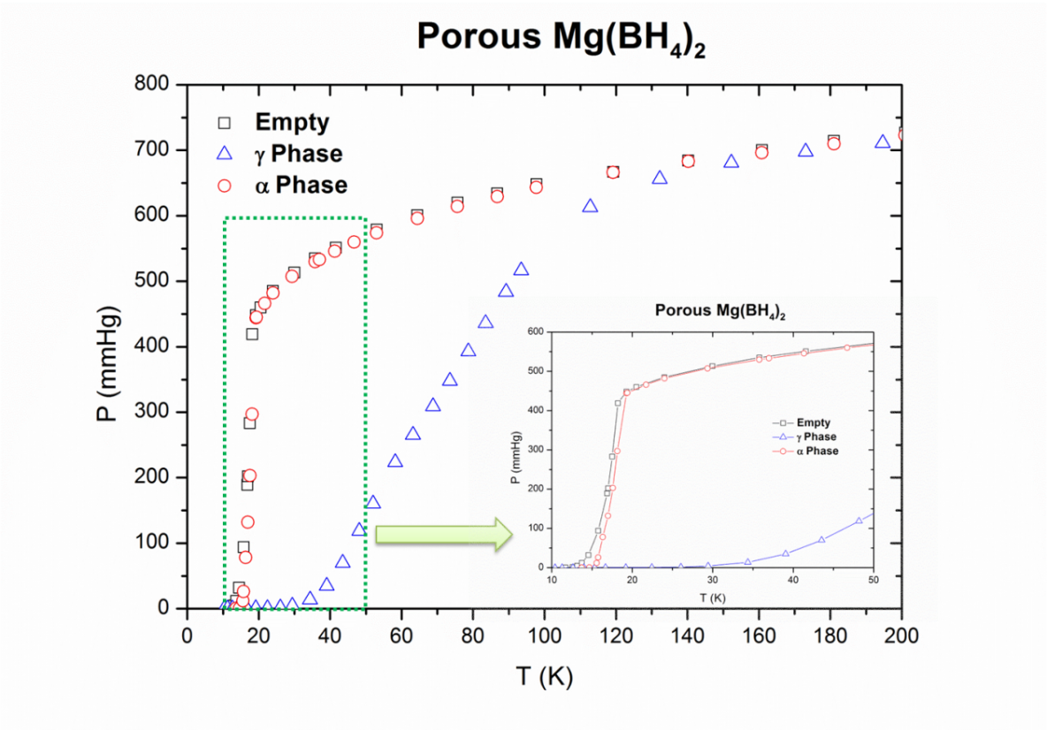
Fig. S13.
Pressure change in the sample holder with temperature variation (square: the empty sample holder, circle: containing α-Mg(BH₄)₂, triangle: containing γ−Mg(BH₄)₂.

Chapter S5. Inelastic Neutron Scattering - In situ study of H₂-loaded Mg(¹¹BD₄)₂ framework.

5.1 Quantum rotation of H₂
The quantum rigid rotor and the particle in a box are two of the most important applications of the Schrödinger equation. In the case of a diatomic molecule, the translational energy levels can be calculated using a simple model of a particle within a three-dimensional box, and rotational energy levels are given by $E_{J}=J\left(J+1\right)B_{rot}$, where $B_{rot}$ is the rotational constant (7.35 meV for solid hydrogen) and $J=0, 1, 2, ⋯$ is the rotational quantum number (Fig. S14) (9).
The hydrogen molecule is composed of two indistinguishable fermions that produce two different nuclear spin isomers and must preserve the overall wave function anti-symmetry. ${ H}_{2}$ molecules with antiparallel nuclear spins can only exist with even rotational states ($J=0, 2, ⋯,even$) parahydrogen (pH₂) While molecules with parallel nuclear spins must have odd rotational states ($J=1, 3, ⋯,odd$), orthohydrogen (oH₂) Due to the zero-point energy, molecular hydrogen’s behavior is dictated by quantum molecular dynamics, which is influenced by interaction potentials that may vary in a spatial dimension. Confined quantum particles entrapped in cage-like potentials provide an opportunity to probe the coupled translational-rotational states under model-like conditions (20).
INS spectra obtained from highly confined hydrogen using normal hydrogen (nH₂) represent a convolution of oH₂ and pH₂ excitations, which complicates subsequent interpretation. Even at boiling temperature (~20 K), a mixture of oH₂ and pH₂ persists for long times due to the inefficiency of angular momentum exchange in the absence of a catalyst. Owing to the different cross-sections of oH₂ and pH₂ is possible to differentiate the vibrational from the rotational features of hydrogen. We thus followed the method of Ulivi et al (20). We performed two independent measurements using different ortho-para concentrations (one formed from nH₂, and another using nearly pure pH₂) to extract the pure component spectra by a linear combination (Fig. S16) and make unambiguous assignments.
The spectral intensity is given by:
$$S_{Total}\left(Q,ω\right)\sim S_{{Self}_{CoM}}\left(Q,ω\right)⨂\sum_{JJ'}{δ\left(ω-ω_{JJ'}\right)⋅υ\left(J,J^{'},Q\right)}$$
where $ω$ is the energy tranfer, $Q$ is the momentum tranfer, $S_{{Self}_{CoM}}\left(Q,ω\right)$ is the dynamical structure factor for the motion of the center of mass (also called Density of States DoS), the $⨂$ symbol denotes a convolution product. The Dirac $δ$ functions are centered at the energies of the rotational transitions, $ω_{JJ'}$ of the $H_{2}$ molecule. The intensity factor $υ\left(J,J^{'},Q\right)$ is function of the momentum transfer $Q$ and depends on the rotational transition $J→J'$ of the molecule.
INS is not subject to selection rules. Therefore all transitions are allowed. At low temperatures, only the lowest rotational levels are populated, $J=0, 1$. The intensity factors are calculated using the rigid rotor approximation (32). The transitions contributing to the overall intensity are, for oH₂, the rotational elastic $J_{1→1}$ and the inelastic $J_{1→2}$, while for pH₂ only the $J_{0→1}$has an appreciable contribution, the $J_{0→0}$ is weighted by the coherent cross section of hydrogen and can be neglected. In practice, this means that for nH₂, the intensity below 12 meV corresponds to the rattling transitions of the $oH_{2}$ molecules (Fig. S16 left). In the case of highly enriched pH₂, there is no appreciable intensity below 13 meV. The intensity above the rotational features (red and blue peaks in Fig. S16) is the convolution of the rotational transitions with the vibrational tranistions.
In the case of nH₂ all transitions have intensity, Table S8 shows the observed transitions in the spectrum (SI) and the experimental positions of the peaks (the resolution of VISION is ${Δω}/ω=2\%$. It can be seen that all observed transitions are compatible with a value of $B_{rot}=7.22 meV$.
The presence of higher order rotational features in the spectra is highly unusual, it is a consequence of the trapping of the hydrogen molecule inside the cavity and a strong reduction of the Debye-Waler factor due to such confinement.
Fig. S14.
Scheme of rotational energy transitions of H₂. The transitions in black are observable transitions while the red arrow indicate a non-observable transition.

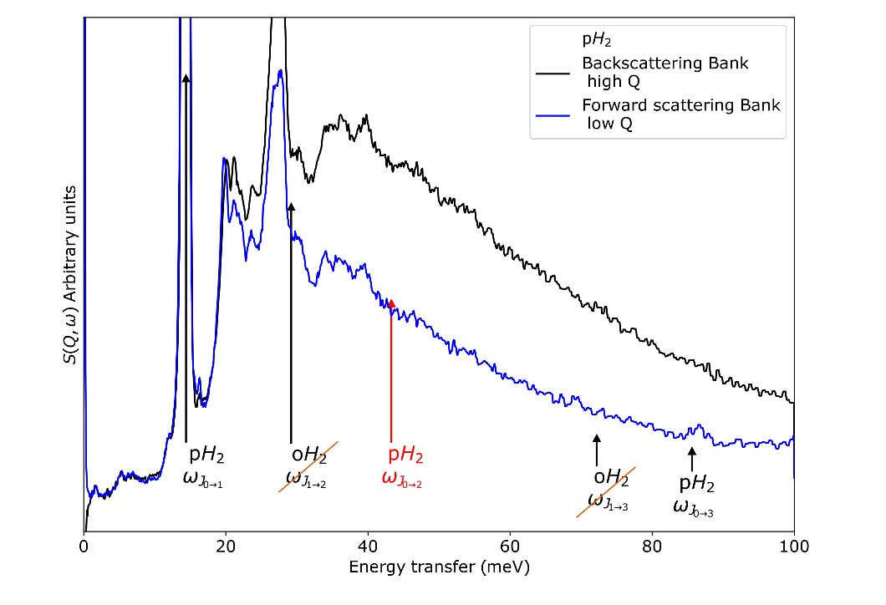
Fig. S15.
INS spectra of nH₂ (upper) and pH₂ (bottom) in Mg(BD₄)₂ for back and forward scattering. The arrows indicate the rotational transitions from para and ortho hydrogen. For $nH_{2}$, we observe the high energy transitions $J_{1→3}$ and $J_{0→3}$ that are not seen in most cases due to the high momentum transfer in VISION. For ${pH}_{2}$, the transitions $J_{1→3}$ and $J_{1→2}$ are not observable because they start from the ortho state $J_{1}$. The transition $J_{0→2}$ is not observed as it has a negligible cross section (17) (see Table S8).

$$B_{rot}=7.22 meV$$ | $$ω_{rot}$$ | Exp |  | $$ω_{rot}$$ | Exp |  | $$ω_{rot}$$ | Exp
$$J_{0→1}$$ | $$14.4$$ | $$14.4±0.2$$ | $$J_{0→2}$$ | $$43.3$$ | ----- | $$J_{0→3}$$ | 86.6 | $$85.6±1.7$$
$$J_{1→2}$$ | $$28.9$$ | $$29.2±0.4$$ | $$J_{1→3}$$ | $$72.2$$ | $$72.3±0.7$$ | $$J_{1→4}$$ | 130.0 | -----

Table S8.
Rotational energy transitions corresponding to the B_{rot} = 7.22 meV. Experimental data see Fig. 3 in the main text of the article. Uncertainties are 1 standard deviation.

5.2 INS roto-vibrational analysis

5.2.1 Para and normal hydrogen in Mg(BD₄)₂

Fig. S16 (left) shows the INS spectra of Mg(BD₄)₂ with a load of 2.8 mmol of nH₂ (black trace), nH₂ is around the statistical mixture at room temperature (75% oH₂ and 25% pH₂). The area shown in gray is the signal of orthohydrogen and it is proportional to the vibrational transitions $σ_{vib}$ of the hydrogen molecule. The vibrational transitions are given by low-energy phonons that correspond to the density of states (DoS) of the hydrogen molecule. The oH₂ spectrum (gray shaded area) show five well-defined phonon transitions located at 1.8 meV (a), 5.5 meV (b), 6.4 meV (c), 7.2 meV (d) and 11.9 meV (e). The peaks that are shown in red and blue are the peaks of parahydrogen rotational transitions $σ_{{rot}_{J(0→1)}} with a. cross-section of \sim 2×80 barn$. The intensity observed in the data above 15 meV are the overtones of vibrational phonon modes (DoS) of the oH₂ given by its combination with the rotational transitions $σ_{rot+vib}\sim σ_{{rot}_{J(0→1)}}⊗σ_{vib}$.
Fig. S16 (right) shows two rotational peaks that correspond to the transition (J_{0➝1}) located at 13.9 meV ((f) perturbed - red) and 14.6 meV ((g) unperturbed - blue). We used a Gaussian fitting for both rotor peaks. The analysis determines the area of each peak in arbitrary units, for the unperturbed (39.56) and the perturbed (14.26). The ratio of the areas that correspond to the population is 2.77 for the maximum load, Table S9 has all the relevant information for the peak fitting at maximum coverage.
The spectral intensity for molecular hydrogen for a roto-vibrational transition is given by $σ_{rot+vib}\sim σ_{rot}⊗σ_{vib}$. For the case of $pH_{2}$, the cross-section of the transition J_{0➝0} is very small ($σ_{{rot}_{J(0→0)}}\sim 0 barn$) (17). Hence, the vibrational model of the $pH_{2}$ are not well-visible below the rotational transition. In contrast, for $oH_{2}$, the cross-sectional area of the vibrational modes is given by $σ_{vib} \sim 2×80 barn$. This difference in cross-sectional area readily visible when comparing the spectra of nH₂ and pH₂ (see Fig. S16 left – grey area).

Fig. S16.
INS spectra of hydrogen in Mg(BD₄)₂. Left, spectrum of 16.8 mmol/g of nH₂ (Mg(BD₄)₂ ∙ 1.04H₂), right, the spectrum of 23.5 mmol/g of pH₂ (Mg(BD₄)₂ ∙1.46H₂). The peaks in red represent the rotational transition of $J_{0→1}$, centered around 14.6 meV, while the blue peak is a $J_{0→1}$ centered around 13.9 meV. The greyed area in the left panel is the extracted vibrational density of states of the hydrogen molecule.

 | Peak | Center [meV] | Area [a.u.] | FWHM | 𝜎 | 𝜸
nH₂  (16.8 mmol/g) | perturbed (f) | 13.20 | 4.05 | 1.18 | 0.654 | -1.33
nH₂  (16.8 mmol/g) | unperturbed (g) | 14.45 | 14.56 | 1.14 | 0.654 | -1.33
pH₂  (23.5 mmol/g) | perturbed (f) | 13.90 | 15.20 | 0.50 | 0.264 | -1.02
pH₂  (23.5 mmol/g) | unperturbed (g) | 14.65 | 40.90 | 0.50 | 0.264 | -1.02

Table S9.
Gaussian analysis parameters of the rotor transitions ${( J}_{0→1})$.

5.2.2 INS as function of pH₂ loading and temperature
Fig. S17 show the INS spectra as function of pH₂ loading collected at 5 K. At the lowest loading (5.88 mmol/g), the spectra show an overall higher resolution allowing us to clearly observe peaks at 1.6 meV, 16.3 meV and 22.0 meV that overlap or are overwhelmed at higher loadings. At lower concentrations, the vibrational transitions are better defined. A peak at 27.8 meV is well defined and doesn’t overlap other peaks. The overall intensity of the spectra increases with increasing pH₂ loading and with all the features remaining similar at similar energies for all dosing points. Table S10 show the results of the Gaussian analysis of the rotational peaks at 13.9 and 14.6 meV.
Fig. S18 show the INS spectra of the highest loading of pH₂ (23.5 mmol/g) (Mg(BD₄)₂ ∙1.46H₂) as function of temperature (5 – 215 K). The peak at 13.9 meV and 27.8 meV disappear simultaneously when the temperature reaches 95 K. The peak at 14.7 meV is clearly visible up to 155 K and some intensity remain even at 185 K.

Fig. S17.
INS spectra of Mg(BD₄)₂ for different pH₂ loading collected at 5 K. The spectra show an increasing uptake with loading, and similar features at all energies.

Loading nominal  (mmol) | Loading  (mmol/g) | H₂ per  unit cell | Peak 1  center  (meV) | Peak 2  center  (meV) | Ratio peak areas | Area  Peak1+ Peak2 (normalized) | Area spectra (normalized)
1.0 | 5.88 | 0.37 | 13.82 | 14.63 | 2.85 | 0.180 | 0.305
2.0 | 11.8 | 0.73 | 13.89 | 14.69 | 2.19 | 0.715 | 0.656
3.0 | 17.6 | 1.09 | 13.89 | 14.68 | 2.34 | 0.860 | 0.816
4.0 | 23.5 | 1.46 | 13.90 | 14.67 | 2.69 | 1 | 1

Table S10.
Fitting parameters for the rotational features of pH₂ as a function of coverage. Peak 1 is “perturbed rotor” while peak 2 is standard $pH_{2}$ $J_{0→1}$ rotor transition.

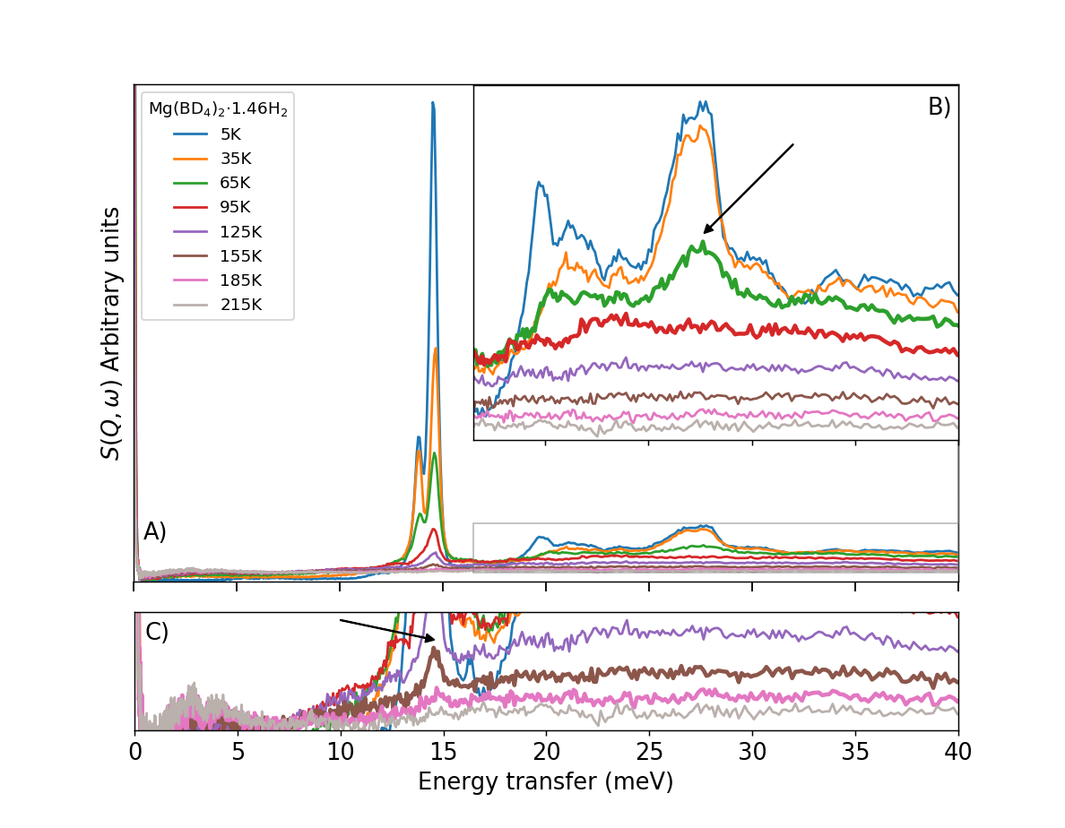
Fig. S18.
A) INS spectra of 23.5 mmol/g of pH₂ (Mg(BD₄)₂ ∙1.46H₂) collected at different temperatures. B) Zoom view of the peak around 17meV, the peak at 27.8 meV disappears after 65 K. C) Zoom view for higher temperatures. The peak at 14.7 meV is observable up to 185 K.

5.3. Simultaneous quantum rotational excitation (SQRE)
To fully account for all the intensity distribution of the $pH_{2}$ (Fig. S19) spectra, we note that there is a peak at 27.8 meV that has an energy that is twice the energy of the “perturbed rotor” peak (blue hatched area). If we have almost pure $pH_{2}$, there is no rotational transition that has such energy transfer (see Table S8). In the case of pH₂ under pressure (SI section 5.5) there is a peak that appears at an energy twice that of the rotational line when the pressure increases. This peak is due to a process that involves “one neutron” simultaneously exciting two rotational transitions on two neighboring molecules or a simultaneous quantum rotational excitation (SQRE). This should not be confused with multiple scattering. This a single quantum event that constitutes evidence of the strong coupling between these hydrogen molecules due to pressure.
Fig. S19 (red and blue area) shows the result of the convolution of the different rotor peaks. These peaks are calculated by convoluting the perturbed rotor (13.9 meV - blue) and unperturbed rotor (14.6 meV - red) with themselves, respectively. These convolutions produce the blue (27.8meV) and red (29.2 meV) modes, respectively. Of these peaks, only the one at 27.8 meV is observed for the experiment using pH₂.

Fig. S19.
INS spectra of Mg(BD₄)₂ with a load of 23.5 mmol/g of pH₂ (black). Two additional peaks are marked in blue and red located at 27.8 and 29.2 meV corresponding to the convolution of each peak with itself.

5.4. Calculation of overtone vibrational modes and SQRE
The higher energy part of the INS spectra (16 < E < 30 meV) above the rotational peak has several peaks that compose the overtones. These overtones are the combination of the vibrational modes (DoS) with the rotational peaks. Fig. S20 shows the product of convoluting the oH₂ DoS (purple upper area) with the pH₂ rotational lines (blue + red hatched areas). The resulting overtone curve (dark grey) is composed by the peaks located at (h)16.3 meV, (i)20.1 meV, (j)21.3 meV, (k)23.6 meV, and (l)26.6 meV, which correspond to the overtones of the phonon modes (a,b,c,d,e), respectively. Second order overtones (light grey area) are calculated by convoluting the overtones (dark grey area) with the oH₂ DoS (purple upper area).
The experimental data show another peak located exactly at 27.8 meV, this peak correspond to the SRQE (blue area) of the ‘perturbed’ rotor (see Fig. S19). The sum of the first and second order overtones (dark yellow) plus the calculated SQRE (blue area) result in a curve (green) that reproduce the experimental pH₂ INS spectra. The experiment (black) shows no signal located at 29.2 meV that would correspond to the SQRE of the ‘unperturbed’ rotor, that would correspond to the peak shown in red.
Only the SQRE at 27.8 meV is observable while the other at 29.2 meV is not, indicating that the rotor peaks are not coupled. This suggest that there are two independent environments for the hydrogen molecule. The ratio of the areas the rotors $J_{0→1}$ is 2.7 (see Table S3), which is a direct measurement of the ratio of hydrogen populating each environment.

Fig. S20.
INS spectra of Mg(BD₄)₂ with a load of 23.5 mmol/g of pH₂ (black). The vibrational modes DoS [a-e] (grey upper area) are convoluted with the rotor transitions [f,g] to obtain the overtones [h-l] (16-28 meV grey area). The sum of the overtones and the bifold rotor [m] (green line) reproduces the experiment (E > 16 meV). The blue peak m) in necessary to account for the intensity. The peak n) does not exist in the data. This is because peak f) and g) are distinct pH₂ molecules. Note that in the case of pH₂ there are no rotational transitions that can account for peak m).

5.5. Comparison with H₂ at high-pressure
As a means of comparison, we present additional INS experiments of pH₂ and nH₂ at high-pressure. The experiments were measured using VISION spectrometer at the Spallation Neutron Source (SNS) at Oak Ridge National Laboratory (ORNL) in Tennessee, USA. A high-pressure dosing device was used coupled with CuBe high-pressure cell at 5K to reach pressures up to 4000 bar.
Fig. S21 show the INS spectra of solid pH₂ at 200 bar and 2500 bar. In both cases, there is a peak near 14.6 meV that corresponds to the rotation J_{0➝1}, and overtones $ω_{J_{0→1}}⊗ ω_{vib}$ are located between 16 meV and 28 meV. The overtone modes located between 16 meV and 29 meV shift to higher energies with increasing pressure. Interestingly, at the higher pressure a SQRE is observed near 29.0 meV, which corresponds to the convolution of the rotor peak with itself. Because the experiment was performed using pH₂, the rotational transition (J_{1➝2}) that should be located at 29.2 meV is not observed as the J=1 state is not populated because it corresponds to an ortho-spin-state.
Fig. S22 a comparison of the experiment using pH₂ in Mg(BD₄)₂. The high-pressure experiment was scaled (y-axis) and translated (x-axis) so the rotational peak matches the high-pressure peak a 13.2 meV (red) and the unperturbed peak at 14.6 meV (blue) (see Fig. S16 right). Hence, the SQRE (Fig. S21) energy is shifted the same as the rotor, showing that the corresponding SQRE of the “perturbed” peak (m) is observable while the SQRE of the “unperturbed” (n) is not visible in the spectra.
Fig. S23 shows the INS spectra of solid nH₂ for two high-pressure points (~0 bar and 2400 bar), the spectra show the rotational transition (J_{0➝1}) shifting to lower energies with increasing pressure. The shift to lower energies of the rotor is due to the quadrupole interaction of oH₂. A vibrational mode (rattling) is located at lower energies (5 meV to 13 meV) and moves towards higher energies with increasing pressure. The overtones of the vibrational modes are located between 15 and 29 meV, and shift to higher energies with increasing pressure. Contrary to the pH₂ high-pressure experiment, the peak located at 29.2 meV is the ortho rotation (J_{1➝2}) (green-line), and a SQRE ($2ω_{J_{0→1}}$) is not well-defined.

Fig. S21.
INS spectra of solid pH₂ at 200 (black) and 2500 bar (blue). The peak near 14.6 meV correspond to the rotation J_{0➝1} and its intensity increases with pressure while its energy is reduced. At higher pressure, SQRE is located at 29.0 meV.

Fig. S22.
INS spectra Mg(BD₄)₂ with a load of 23.5 mmol/g of pH₂ (black). To compared intensities and energies the INS spectrum of pH₂@2500 bar is scaled (x- and y- wise) to correspond to both rotor intensities (13.9 meV (red) and 14.6 meV (blue)).

Fig. S23.
INS spectra of solid nH₂ at high-pressure collected at 5 K. The INS spectra near 0 bar and at 2400 bar show a mode that is located at 5.52 meV and 10.89 meV, respectively. The peaks located near 14.0 meV and at 29.2 meV correspond to rotational transitions J_{0➝1} and J_{1➝2}, respectively.

5.6 Density of hydrogen confined in Mg(BD₄)₂
By looking at the effect of pressure on highly enriched $pH_{2}$ and $nH_{2}$ (see SI section 5.5) on the phonon spectrum of hydrogen; we can calibrate a “representative density” required for the effect of pressure to be observable.
Fig. S24 upper left show a linear interpolation of the phonon energies of nH₂ as a function of the pressure (orange line). The phonon energies (blue triangles) were taken from the full experiment of solid nH₂ (0 bar to 4000 bar) (Fig. S23).
The different vibrational modes observed in the DoS (Fig. S16 left) are shown as green points correspond to a vibration in the three directions. The highest energy is 11.9 meV represents the higher vibration mode that correspond to a high-pressure environment of 2915 bar (Fig. S24 green circle).
The density of bulk hydrogen has been previously reported as function of pressure by Silvera et al. (33) (Fig S24 upper right). Assuming a pressure of 2915 bar (red- dotted), the corresponding density is 132 g/L. A value much higher than bulk -liquid (70.9 g/L) and -solid (86.7 g/L) density at 1 bar. This value is 1.51 times higher than the bulk-solid density at 1 bar.
The cross-sectional area of the H₂ molecule as function of pressure (Fig. S24 bottom left) was calculated assuming a hexagonal close packing and is given by:
$$σ=f⋅\left(m/{ρN_{A}}\right)$$
where $f= {\sqrt{3}}/{\sqrt[3]{4}}=1.091$ is the hexagonal closed-packing factor, m is the molar mass, $ρ$ is the volumetric density and N_{A} is the Avogadro number (Rouquerol, Rouquerol et al. 1999, Lowell, Shields et al. 2004). The corresponding cross-sectional area for 2915 bar is 9.40 Å².
The H₂-H₂ intermolecular distance as function of pressure (Fig. S24 bottom right) is given by the relation:
$$σ=\frac{\sqrt{3}}{2}⋅r^{2}$$
where $σ$ is the cross-sectional area of H₂ and r is the intermolecular distance (34). The corresponding intermolecular distance for a pressure of 2915 bar is 3.29 Å.

Fig. S24.
Upper left, linear interpolation of the phonon energies of nH₂ as a function of the pressure. The energies observed in the phonon modes [b-e] in Fig. S2 are shown as green points. The phonon mode at 11.9 meV [e] corresponds to a pressure environment of 2915 bar. Upper right, hydrogen density as a function of pressure Bottom left, corresponding cross-sectional area of hydrogen as a function of the pressure. Bottom right, H₂-H₂ intermolecular separation as function of pressure. The corresponding separation for a phonon mode of 11.9 meV (Fig. S2 peak [e]) is 3.29 Å.

