Supplementary Figures
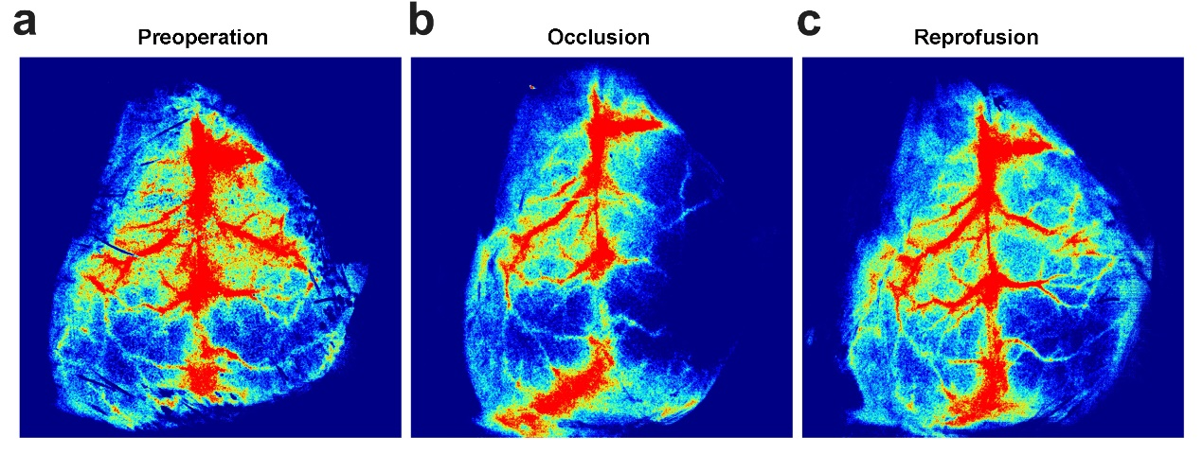
Fig. S1 Representative laser speckle imaging before and after I/R.
a. Representative laser speckle imaging before ischemia. b. Representative laser speckle imaging during ischemia. c. Representative laser speckle imaging after reperfusion.

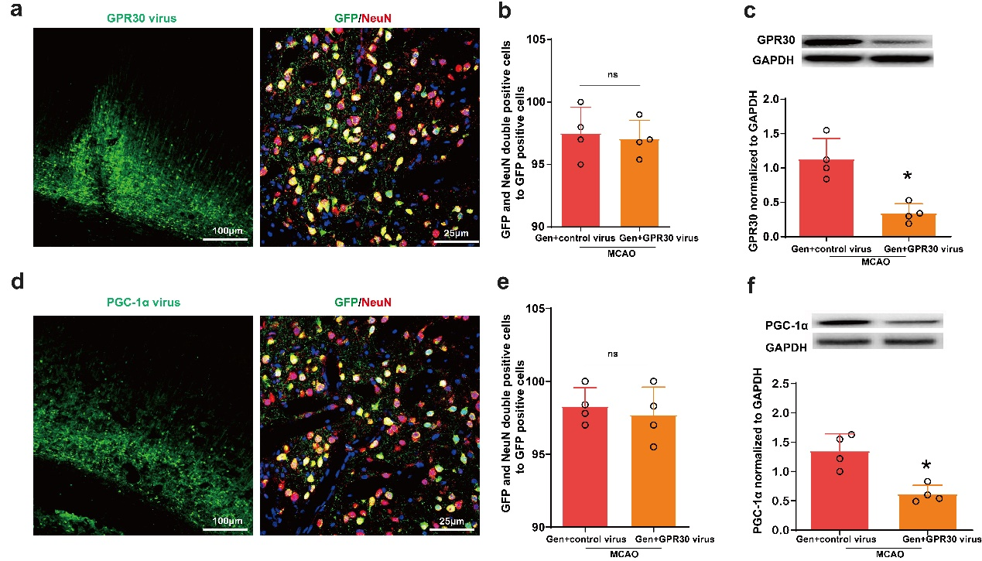
Fig. S2 Verification of the successful establishment of neuron-specific GPR30- and PGC-1α-knockdown models in vivo.
a. Left: low-magnification images showing the expression of GFP (green) in the penumbra region after microinjection of hSyn-GPR30-shRNA. Right: representative confocal images of GPR30 virus transduced penumbra region expressing GFP (green) and immunostained for the neuronal marker NeuN (red); nuclei are counterstained with DPAI (blue). GFP expression was almost restricted to NeuN⁺ neurons. b. Quantification of the percentage of GFP and NeuN double-positive (GFP⁺NeuN⁺) cells over the total GFP⁺ cells in the penumbra region of GPR30 virus-injected mice. c. GPR30 protein levels were measured in the GPR30-knockdown model using immunoblotting. d. Left: low-magnification images showing the expression of GFP (green) in the penumbra region after microinjection of hSyn-PGC-1α-shRNA. Right: representative confocal images of PGC-1α virus transduced penumbra region expressing GFP (green) and immunostained for the neuronal marker NeuN (red); nuclei are counterstained with DPAI (blue). GFP expression was almost restricted to NeuN⁺ neurons. e. Quantification of the percentage of GFP and NeuN double-positive (GFP⁺NeuN⁺) cells over the total GFP⁺ cells in the penumbra region of PGC-1α virus-injected mice. f. PGC-1α protein levels in the penumbra were measured in the PGC-1α-knockdown model using immunoblotting. The data are presented as the mean ± SD, n=4. *P < 0.05 vs. the Gen + control virus group.

