Supplementary material

Supplementary Tables

Table S1. Variables and values considered for the environmental analysis.
Variable | Values
Vegetation | Scarce: few plants no higher than 2m and without trees  Medium: some plants like bushes 2m high and lower plants with trees  Dense: abundant plants with dense foliage at all levels including tree cover
Distance to oviposition sites | Close: less than 20m from a suitable oviposition site  Intermediate: between 20 and 50m from a suitable oviposition site  Remote: more than 50m apart from a suitable oviposition site
Resting areas (not considering vegetation) | Rare: few unsuitable resting structures, like fences  Medium: some resting places available, like walls or containers  Abundant: diverse resting places available including sheds and accessible buildings
Distance to zoo animal exhibits | Close: less than 20m from an open animal exhibit  Intermediate: between 20 and 50m from an open animal exhibit  Remote: more than 50m apart from an open animal exhibit
Regional temperature | Obtained from the closest meteorological station
Precipitation | Obtained from the closest meteorological station
Local temperature | Recorded with loggers next to the traps
Humidity | Recorded with loggers next to the traps

Table S2. Values of the categorical variables for each trap.
Zoo | Trap | Vegetation | Oviposition sites | Resting Areas | Animals Exhibits
Chester Zoo | M1 | Medium | Close | Abundant | Close
Chester Zoo | M2 | Scarce | Remote | Medium | Close
Chester Zoo | M3 | Dense | Intermediate | Rare | Close
Chester Zoo | M4 | Scarce | Close | Medium | Intermediate
Chester Zoo | M5 | Dense | Remote | Medium | Remote
Chester Zoo | M6 | Medium | Intermediate | Medium | Remote
Chester Zoo | M7 | Scarce | Remote | Medium | Close
Chester Zoo | M10 | Medium | Intermediate | Medium | Close
Chester Zoo | M11 | Medium | Intermediate | Rare | Remote
Chester Zoo | M12 | Scarce | Remote | Abundant | Close
Chester Zoo | M13 | Scarce | Close | Rare | Close
Chester Zoo | G1 | Dense | Remote | Medium | Remote
Chester Zoo | G2 | Dense | Remote | Medium | Intermediate
Chester Zoo | G3 | Medium | Close | Rare | Intermediate
Chester Zoo | G4 | Medium | Close | Medium | Intermediate
Chester Zoo | G5 | Dense | Remote | Rare | Remote
Chester Zoo | G6 | Medium | Intermediate | Medium | Remote
Chester Zoo | G7 | Scarce | Remote | Medium | Intermediate
Chester Zoo | G10 | Medium | Intermediate | Medium | Close
Chester Zoo | G11 | Dense | Intermediate | Rare | Remote
Chester Zoo | G12 | Dense | Remote | Medium | Intermediate
Chester Zoo | G13 | Scarce | Close | Rare | Close
Flamingo Land | M1 | Scarce | Remote | Abundant | Close
Flamingo Land | M2 | Medium | Remote | Rare | Close
Flamingo Land | M3 | Scarce | Remote | Medium | Intermediate
Flamingo Land | M4 | Scarce | Remote | Medium | Intermediate
Flamingo Land | G1 | Scarce | Remote | Abundant | Close
Flamingo Land | G2 | Medium | Remote | Medium | Close
Flamingo Land | G3 | Scarce | Close | Medium | Intermediate
Flamingo Land | G4 | Medium | Remote | Medium | Remote
M: BG-Mosquitaire trap, G: CDC-Gravid trap. The trap numbers correspond to the sampling areas.

Table S3. Values of the generalised linear models for the significant variables in relation to the capture of blood-fed mosquitoes.
Variable | Chester Zoo 2017 |  | Chester Zoo 2018 |  | Chester Zoo 2019 |  | Flamingo Land 2017 |  | Overall
Variable | E | P | E | P | E | P | E | P | E | P
Temperature | -0.080 | <0.000 | 0.280 | <0.000 | 0.161 | 0.073* | 0.643 | <0.000 | 0.200 | <0.000
Humidity | -0.080 | 0.001 | 0.045 | 0.002 | - | - | -0.042 | <0.000 | -0.017 | <0.000
Precipitation | 0.387 | <0.000 | - | - | - | - | 0.296 | 0.001 | 0.207 | <0.000
Wind speed | - | - | - | - | -0.183 | 0.004 | 0.268 | <0.000 | - | -
Scarce vegetation | - | - | - | - | 0.794 | 0.003 | - | - | - | -
Close zoo animal exhibits | 0.519 | 0.005 | - | - | - | - | - | - | - | -
E: estimate; P: p value; *: close to significance.

Supplementary Figures
Fig. S1. Host preferences of blood-fed mosquitoes. Birds in shades of blue, non-human mammals in shades of red.

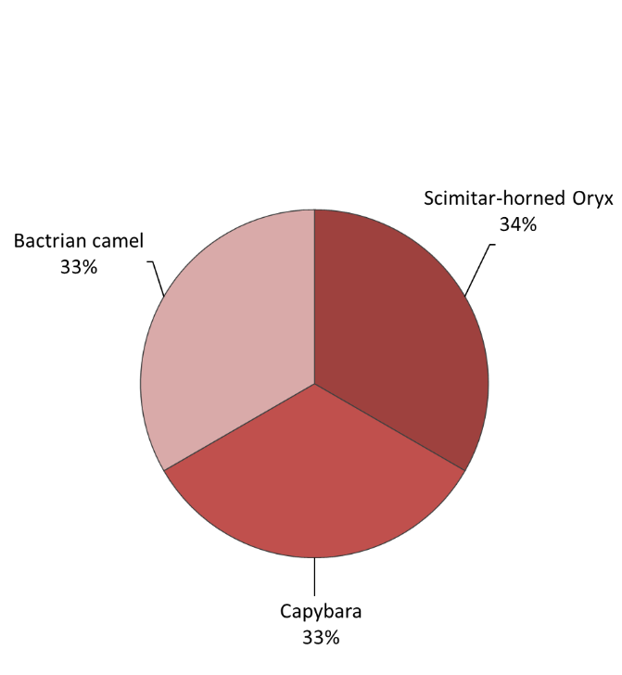
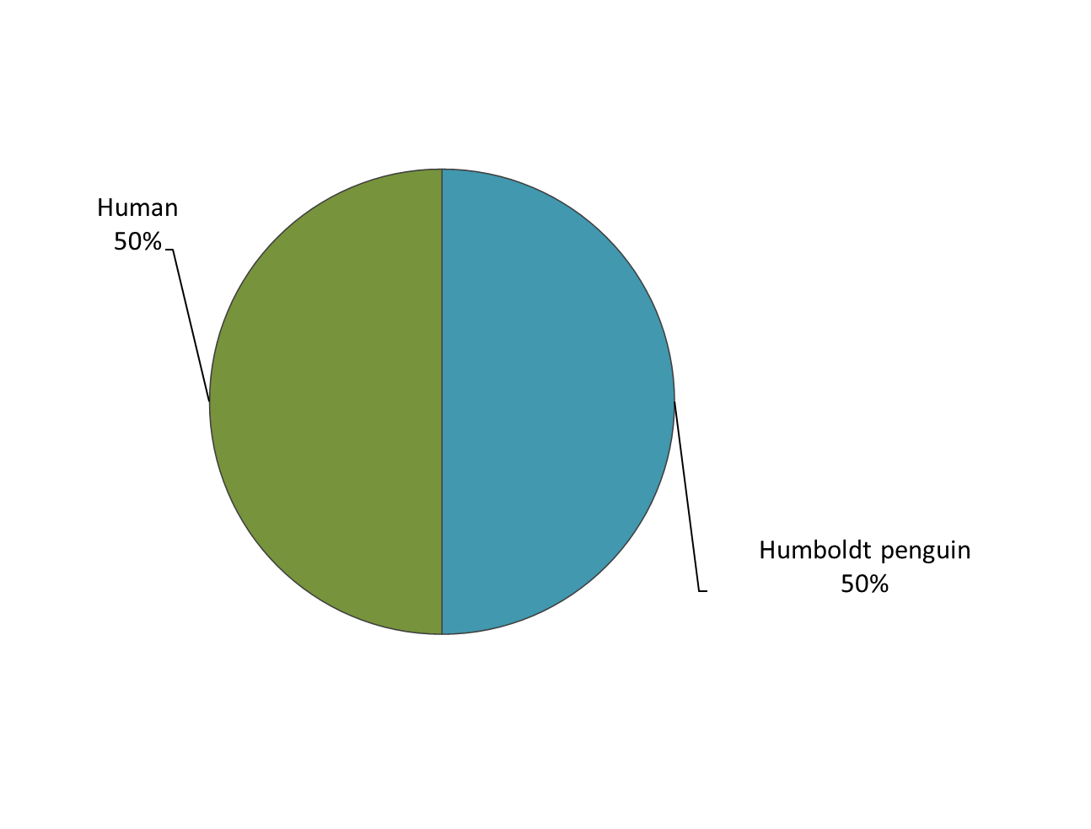
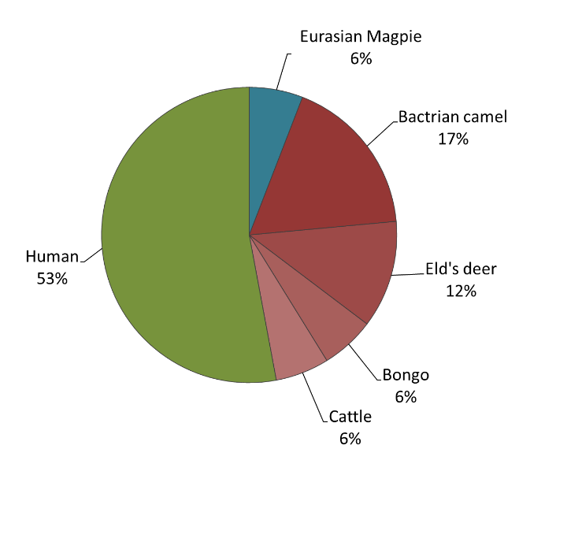
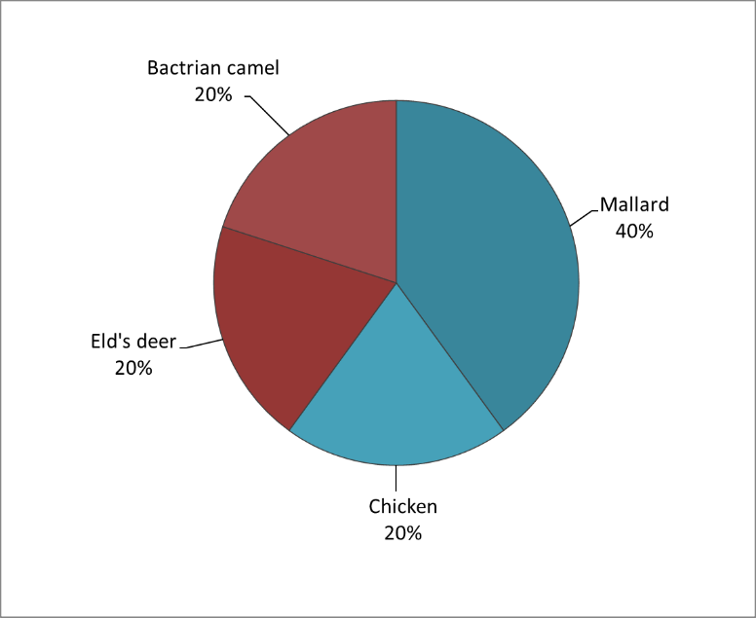
Flamingo Land, 2017, Cs. annulata (n 3)
Chester Zoo, 2017, Cs. annulata (n = 17)
Chester Zoo, 2019, An. maculipennis s.l. (n = 2)
Chester Zoo, 2018, Cs. annulata (n = 5)

