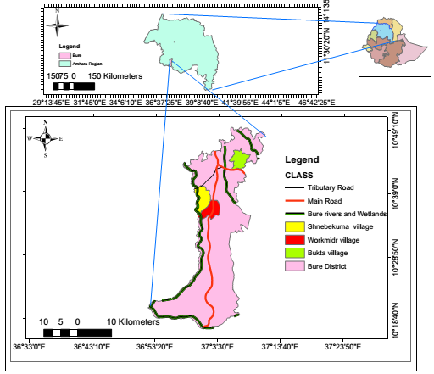
Figure 1: Map of the study area. a) Ethiopia, b) Amhara region, and c) Bure district

