Supplementary materials

Relationships between soil microbial communities and plant communities on different slope aspects in a subalpine coniferous forest

Luoshu He, Jiangling Zhu, Suhui Ma, Xinyu Xiong, Yangang Li, Biao Zhu, Chengjun Ji*

Institute of Ecology, College of Urban and Environmental Sciences, and Key Laboratory for Earth Surface Processes of the Ministry of Education, Peking University, Beijing 100871, China

*Corresponding author: Dr. Chengjun Ji
Email: jicjg@urban.pku.edu.cn
Tel: +86-130 2009 9831

This file includes:
Tables S1-S2
Figs. S1-S3
Table S1 Attributes of plant community in each slope aspect
Plant Community Attribute | North Slope | Flat | South Slope
Abundance of Trees and Shrubs | 213.07±10.24a | 200.41±8.42ab | 176.17±8.61b
Abundance of Herbs | 1809.38±63.52a | 1909.88±104.93a | 3283.72±137.91b
Total Plant Abundance | 2022.45±65.96a | 2110.28±104.08a | 3459.89±141.20b
Total Basal Aera(m² ha⁻¹) | 144.22±8.34a | 174.30±6.42b | 169.48±10.95ab
Richness of Trees and Shrubs | 16.29±0.37a | 16.14±0.32a | 14.96±0.40b
Richness of Herbs | 30.67±1.10a | 36.20±1.90b | 56.32±2.16c
Total Plant Richness | 47.14±1.21a | 51.84±1.90a | 71.28±2.31b
Litter Standing Crop（g） | 39.27±2.61a | 27.94±0.83b | 32.26±1.30c
Total stand density of trees(ha⁻¹) | 102.45±26.11a | 109.46±40.22a | 86.21±26.93b

Table S2 Pearson’s rank correlation coefficients (R) between soil microbial (bacterial and fungal) composition and the environmental variables
Aspect |  | SOM | PH | SWC | TP | TN | AP | AN | BC | BR | FC
North  slope | PH | -0.11
North  slope | SWC | 0.56*** | -0.34*
North  slope | TP | 0.17 | -0.43** | 0.58***
North  slope | TN | 0.61*** | -0.23 | 0.82*** | 0.43
North  slope | AP | 0.49** | -0.45** | 0.67*** | 0.45** | 0.55***
North  slope | AN | 0.19 | -0.05 | 0.53*** | 0.29 | 0.51*** | 0.06
North  slope | BC | -0.01 | 0.51*** | -0.25 | -0.46** | -0.1 | -0.23 | 0.07
North  slope | BR | -0.25 | 0.16 | -0.09 | -0.14 | -0.11 | -0.44** | 0.26 | 0.18
North  slope | FC | 0.1 | 0.12 | 0.03 | -0.09 | 0.11 | -0.05 | 0.05 | 0.15 | 0.37*
North  slope | FR | -0.09 | 0.26 | 0.06 | -0.11 | 0.10 | -0.15 | 0.26 | 0.31 | 0.47** | 0.34*
Flat | PH | -0.30**
Flat | SWC | 0.28* | -0.43***
Flat | TP | 0.49*** | -0.29** | 0.18
Flat | TN | 0.86*** | -0.31** | 0.29** | 0.59***
Flat | AP | 0.77*** | -0.27* | 0.19 | 0.53*** | 0.89***
Flat | AN | 0.70*** | -0.38*** | 0.36*** | 0.45*** | 0.71*** | 0.57***
Flat | BC | -0.51*** | 0.25* | -0.24* | -0.35*** | -0.57*** | -0.62*** | -0.40***
Flat | BR | -0.01 | -0.04 | 0.23* | -0.06 | -0.15 | -0.21 | 0.16 | -0.04
Flat | FC | -0.23* | 0.30** | -0.13 | -0.19 | -0.28* | -0.24* | -0.25* | 0.22* | 0.01
Flat | FR | 0.08 | -0.12 | 0.31** | 0.08 | 0.05 | 0 | 0.21 | -0.30** | 0.48*** | -0.11
South Slope | PH | -0.26
South Slope | SWC | 0.58*** | -0.43**
South Slope | TP | 0.24 | -0.04 | -0.17
South Slope | TN | 0.77*** | -0.19 | 0.36* | 0.48***
South Slope | AP | 0.72*** | -0.59*** | 0.46** | 0.21 | 0.56***
South Slope | AN | 0.64*** | -0.06 | 0.40** | 0.43** | 0.72*** | 0.40**
South Slope | BC | -0.40** | 0.58*** | -0.26 | -0.09 | -0.19 | -0.52*** | -0.1
South Slope | BR | -0.03 | 0.16 | 0.11 | 0.06 | 0.11 | -0.38** | 0.32* | 0.2
South Slope | FC | 0.05 | 0.26 | 0.09 | 0.27 | 0.19 | -0.09 | 0.19 | 0.31* | 0.41**
South Slope | FR | 0.05 | 0.18 | 0.09 | -0.19 | 0.23 | -0.25 | 0.23 | -0.05 | 0.52*** | 0.06
Soil organic matieral (SOM), soil moisture content (SMC), total phosphorus (TP), total nitrogen (TN), available phosphorus(AP), available nitrogen(AT), bacteria community(BC),bacteria richness(BR),fungal community(FC),fungal richness(FR). ***. Correlation is significant at the 0.001 level **. Correlation is significant at the 0.01 level *.Correlation is significant at the 0.05 level

Fig. S1 Principal component analysis (PCA) of environmental factors in different slope directions. MANOVA was used for statistical analysis (P < 2.2E-16), and P <0.05 showed a significant difference. The total variance of the first two axes of PCA was 66.5%, among which PC1 52.6% and PC2 13.9%
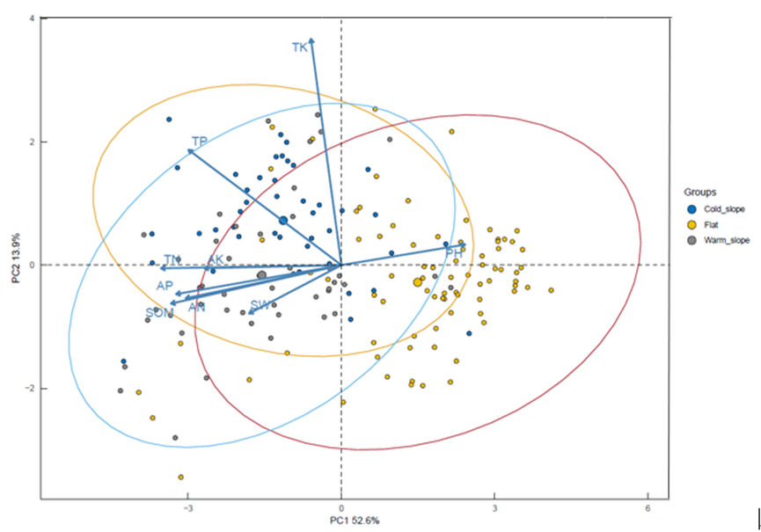

Fig. S2 Relative abundances (average values and standard error) of bacterial dominant A) phylum B) genus in different slope aspects. Different letters indicate significant differences (ANOVA, P < 0.05, Tukey’s HSD post-hoc analysis) among different slope aspects.
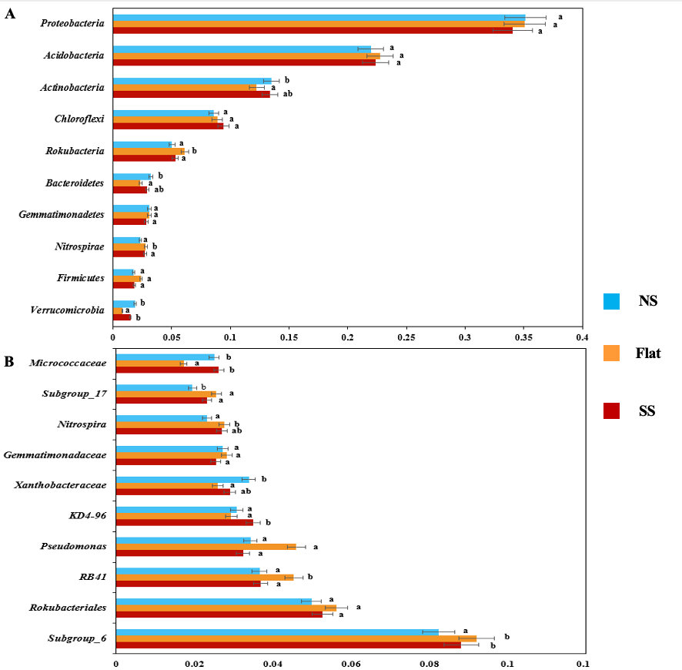

Fig. S2. Relative abundances (average values and standard error) of fungal dominant A) phylum B) genus in different slope aspects. Different letters indicate significant differences (ANOVA, P < 0.05, Tukey’s HSD post-hoc analysis) among different slope aspects.
