Supporting Information: Promoted disappearance of CO₂ hydrate self-preservation effect by surfactant SDS
Xueping Chen^{1,2}, Peng Zhang^{1,}*, Shuaijun Li^{1,2}, Wenting Chen^{1,2}, Qingbai Wu¹, Jing Zhan¹,
Yingmei Wang³
¹State Key Laboratory of Frozen Soil Engineering, Northwest Institute of Eco-Environment and Resources, Chinese Academy of Sciences, 73000, China.
²University of Chinese Academy of Sciences, Beijing 100049, China.
³Western China Energy & Environment Research Center, Lanzhou University of Technology, Lanzhou 730050, China.
*Correspondence should be addressed to P. Zhang. (Email: zhangpeng@lzb.ac.cn)

Supplementary information: The picture of the silica gel powder mixed with pure water and the specific experimental conditions set in the experiments.

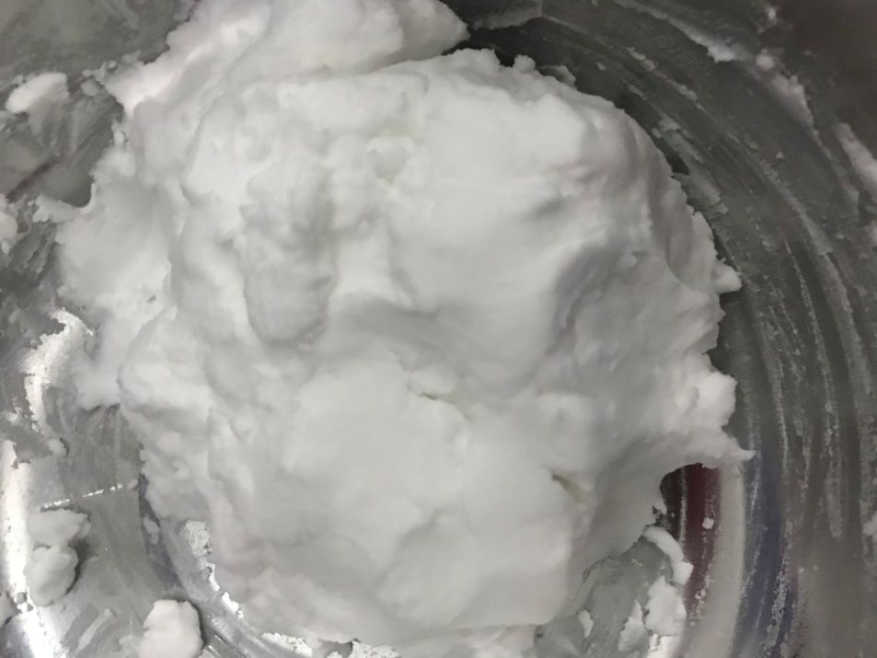
Fig. S1. Picture of the silica gel powder mixed with pure water utilized in the experiments.

Table S1 Specific experimental conditions and measurement results.
Run | Medium | Performance | Designed temperature (°C) | Equilibrium pressure (MPa) | Freezing temperature (°C) | Heating rate (°C/h) | Conversion ratio of water (%) | Dissociation time (min)
1 | Pure water | Formation 1st | 8.5 | 3.67 | -6 | 3 | 40.43 | 110.50
2 | Pure water | Repeat 2nd |  |  |  |  | 39.14 | 106.58
3 | Pure water | Repeat 3rd |  |  |  |  | 44.54 | 125.92
4 | Pure water | Formation 1st | 6.5 | 2.77 | -6 | 3 | 34.22 | 128.08
5 | Pure water | Repeat 2nd |  |  |  |  | 34.16 | 120.42
6 | Pure water | Repeat 3rd |  |  |  |  | 28.99 | 107.42
7 | Pure water | Formation 1st | 3.5 | 1.68 | -6 | 3 | 27.16 | 109.67
8 | Pure water | Repeat 2nd |  |  |  |  | 21.80 | 76.67
9 | Pure water | Repeat 3rd |  |  |  |  | 20.92 | 90.33
10 | Pure water | Formation 1st | 0.5 | 1.32 | -6 | 3 | 16.50 | 80.25
11 | Pure water | Repeat 2nd |  |  |  |  | 16.46 | 82.92
12 | Pure water | Repeat 3rd |  |  |  |  | 16.37 | 81.17
13 | SDS solution | Formation 1st | 8.5 | 3.67 | -6 | 3 | 68.88 | 156.33
14 | SDS solution | Repeat 2nd |  |  |  |  | 49.05 | 205.50
15 | SDS solution | Repeat 3rd |  |  |  |  | 61.50 | 143.92
16 | SDS solution | Formation 1st | 6.5 | 2.77 | -6 | 3 | 91.63 | 179.08
17 | SDS solution | Repeat 2nd |  |  |  |  | 95.81 | 193.17
18 | SDS solution | Repeat 3rd |  |  |  |  | 95.25 | 204.20
19 | SDS solution | Formation 1st | 3.5 | 1.68 | -6 | 3 | 96.17 | 180.08
20 | SDS solution | Repeat 2nd |  |  |  |  | 94.53 | 183.42
21 | SDS solution | Repeat 3rd |  |  |  |  | 94.48 | 194.58
22 | SDS solution | Formation 1st | 0.5 | 1.32 | -6 | 3 | 28.61 | 78.42
23 | SDS solution | Repeat 2nd |  |  |  |  | 23.48 | 80.83
24 | SDS solution | Repeat 3rd |  |  |  |  | 25.82 | 88.08
25 | Silica gel powder / pure water | Formation 1st | 8.5 | 3.67 | -6 | 3 | 66.97 | 39.08
26 | Silica gel powder / pure water | Repeat 2nd | 8.5 | 3.67 | -8 | 3 | 52.43 | 192.67
27 | Silica gel powder / pure water | Repeat 3rd | 8.5 | 3.67 | -10 | 3 | 63.36 | 208.92
28 | Silica gel powder / pure water | Formation 1st | 6.5 | 2.77 | -6 | 3 | 49.76 | 128.08
29 | Silica gel powder / pure water | Repeat 2nd | 6.5 | 2.77 | -8 | 3 | 37.02 | 93.17
30 | Silica gel powder / pure water | Repeat 3rd | 6.5 | 2.77 | -10 | 3 | 64.08 | 68.08
31 | Silica gel powder / pure water | Formation 1st | 3.5 | 1.68 | -6 | 3 | 36.54 | 41.67
32 | Silica gel powder / pure water | Repeat 2nd | 3.5 | 1.68 | -8 | 3 | 57.07 | 67.42
33 | Silica gel powder / pure water | Repeat 3rd | 3.5 | 1.68 | -10 | 3 | 51.40 | 115.83
34 | Silica gel powder / pure water | Formation 1st | 0.5 | 1.32 | -6 | 3 | 38.29 | 49.17
35 | Silica gel powder / pure water | Repeat 2nd | 0.5 | 1.32 | -8 | 3 | 19.10 | 59.08
36 | Silica gel powder / pure water | Repeat 3rd | 0.5 | 1.32 | -10 | 3 | 50.71 | 229
37 | Silica gel powder / SDS solution | Formation 1st | 8.5 | 3.67 | -6 | 3 | 43.72 | 119.67
38 | Silica gel powder / SDS solution | Repeat 2nd | 8.5 | 3.67 | -8 | 3 | 40.90 | 197.92
39 | Silica gel powder / SDS solution | Repeat 3rd | 8.5 | 3.67 | -10 | 3 | 45.24 | 265.75
40 | Silica gel powder / SDS solution | Formation 1st | 6.5 | 2.77 | -6 | 3 | 45.99 | 147.75
41 | Silica gel powder / SDS solution | Repeat 2nd | 6.5 | 2.77 | -8 | 3 | 52.15 | 202.33
42 | Silica gel powder / SDS solution | Repeat 3rd | 6.5 | 2.77 | -10 | 3 | 52.61 | 232.67
43 | Silica gel powder / SDS solution | Formation 1st | 3.5 | 1.68 | -6 | 3 | 33.23 | 125.67
44 | Silica gel powder / SDS solution | Repeat 2nd | 3.5 | 1.68 | -8 | 3 | 38.40 | 128.17
45 | Silica gel powder / SDS solution | Repeat 3rd | 3.5 | 1.68 | -10 | 3 | 37.31 | 249.50
46 | Silica gel powder / SDS solution | Formation 1st | 0.5 | 1.32 | -6 | 3 | 17.60 | 48.25
47 | Silica gel powder / SDS solution | Repeat 2nd | 0.5 | 1.32 | -8 | 3 | 16.12 | 188.25
48 | Silica gel powder / SDS solution | Repeat 3rd | 0.5 | 1.32 | -10 | 3 | 16.84 | 12.17
At standard temperature and pressure conditions, per unit volume of hydrate releases 164 volumes of gas after dissociation. Accordingly, the conversion ratio of water was calculated with the cumulative volumes of released gas measured through the digital gas flow meter (DGM) in Fig. 1.

