Supplementary Information

Piezoelectric voltage constant and sensitivity enhancements through phase boundary structure control of lead-free (K,Na)NbO₃-based ceramics

Min-Ku Lee,¹ Byung-Hoon Kim,¹ Gyoung-Ja Lee*

Smart Sensing and Diagnosis Research Division, Korea Atomic Energy Research Institute, 111 Daedeok-daero, 989 Beon-gil, Yuseong-gu, Daejeon, 34057, Republic of Korea

¹ M.-K. Lee and B.-H. Kim equally contributed to this work.
* Correspondence: leegj@kaeri.re.kr (G.-J. Lee); Tel: +82-42-868-4838

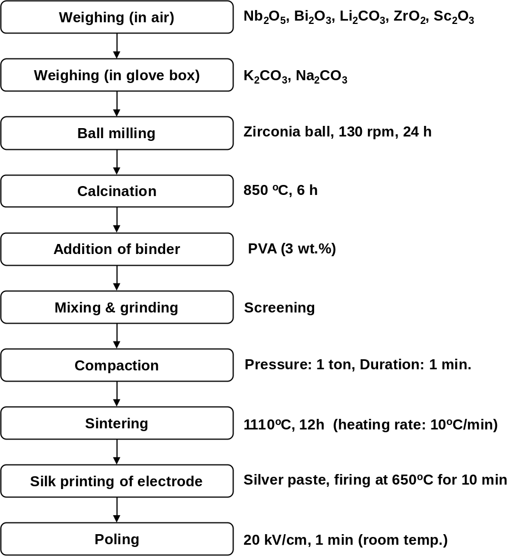

Fig. S1. Preparation conditions of KNN-BNKLZ-BS ceramic rings by conventional solid-state powder process.
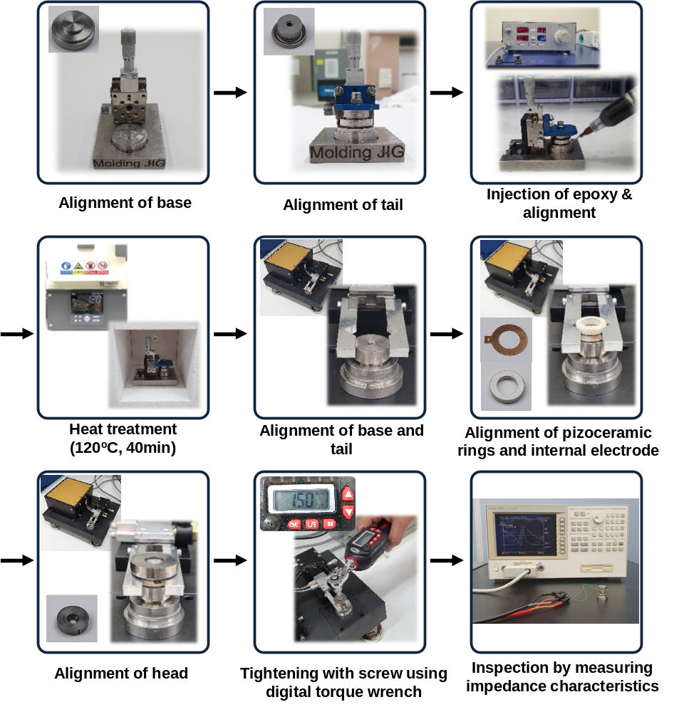
Fig. S2. Fabrication procedures of a compressive-type piezoelectric accelerometer module using modified-KNN ceramic rings and sensor components. Specially designed zig was used for accurate and reliable assembling of each sensor component and an injection mold of our own design was also used to precisely control the amount of epoxy to be injected. Components (head, tail and base) were manufactured using a CNC (computer numerically controlled) milling machine tool. A gap between tail and base was filled with epoxy (ECCOBOND A 359 LV; Emerson & Curming, Germantown, WI, USA) for insulation. In tightening with a screw, a torque value was optimized using a digital torque wrench.

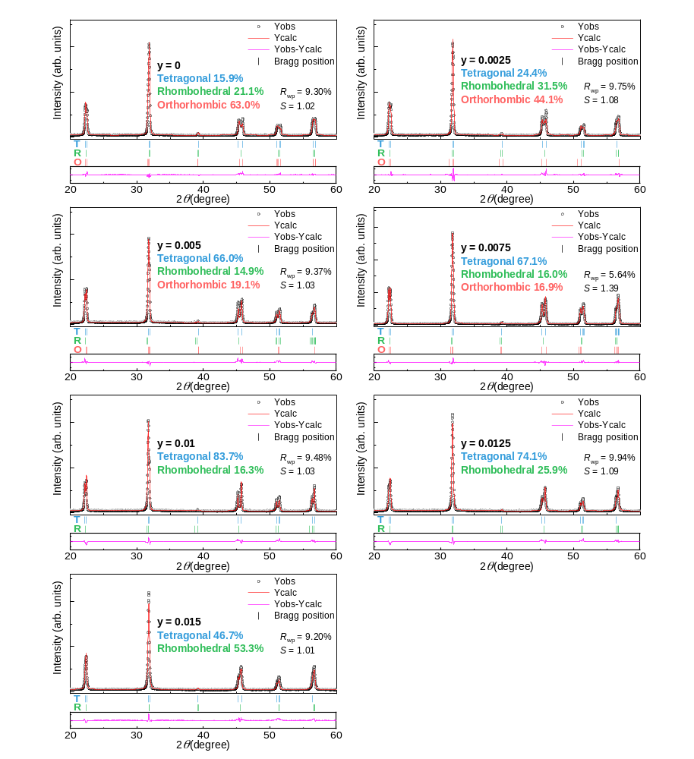

Fig. S3. Rietveld refinement analysis for θ-2θ XRD patterns obtained from KNN-0.03BNKLZ-yBS ceramic samples (y = 0 – 0.015).

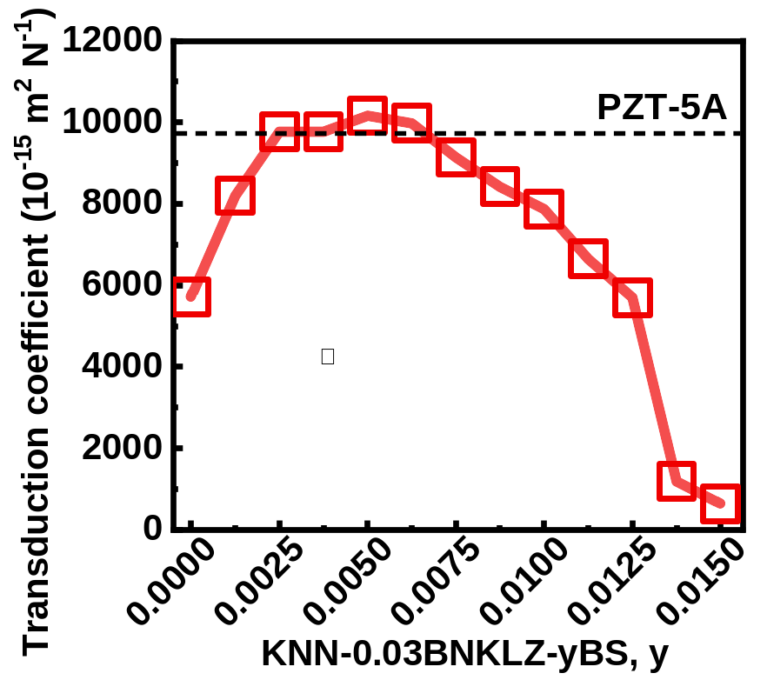

Fig. S4. Transduction coefficient (d₃₃ × g₃₃) data obtained from ring-shaped KNN-0.03BNKLZ-yBS ceramics (y = 0 – 0.015).

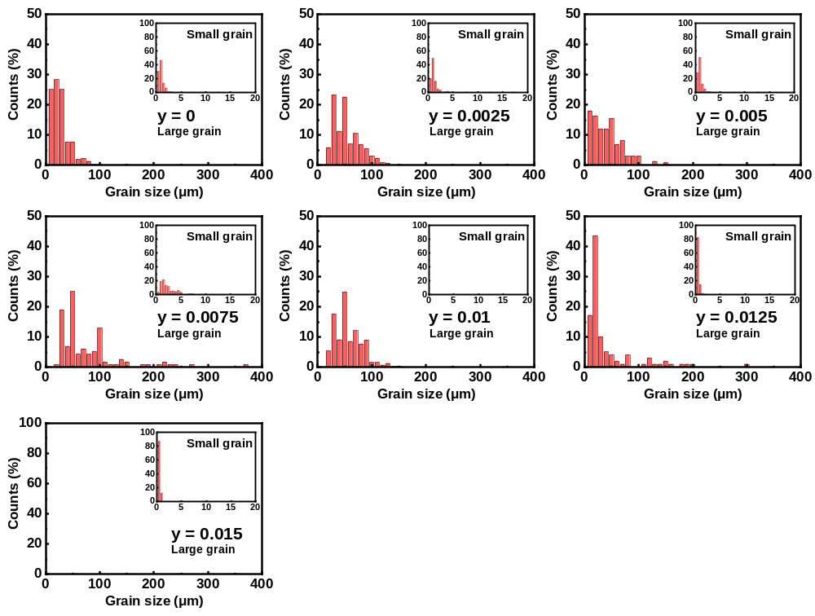

Fig. S5. Grain size distributions obtained from SEM images for ring-shaped KNN-0.03BNKLZ-yBS ceramics (y = 0 – 0.015). Because of bimodal grain size distribution characteristic, quantitative measurements were carried out for small and large grains using automatic image analysis software (Matrox imaging library 10) for SEM images taken from each sample (number of analyzed images ~28 per sample, measurement area per image ~74655 μm², total number of grains ~1100 to several thousand). Here, the large grains are defined as more than 20 μm, while the smaller grains are defined as less than 2 μm according to Ref. [30] in the main manuscript.

Table S1. Dielectric and electromechanical properties of modified(m)-KNN and PZT-5A ceramic rings.
Material property | m-KNN  (y = 0.0025) | m-KNN  (y = 0.01) | PZT-5A
Remanent polarization P_{r} (μC/cm²) | 12.8 | 18.1 | 35.2
Coercive Field E_{C} (kV/cm) | 12.4 | 13.2 | 13.1
Positive strain S_{pos} (%) | 0.062 | 0.095 | 0.168
Negative strain S_{neg} (%) | 0.063 | 0.100 | 0.246
Dielectric permittivity ε_{r} [Unpoled, 100kHz] | 488±1 | 1245±5 | 1155±1
Dielectric permittivity ε_{r} [Poled, 1kHz] | 502±3.7 | 1571±2.5 | 1607±7
Loss factor tanδ [Unpoled, 100kHz] | 0.0349±0.0002 | 0.0352±0.0019 | 0.0223±0.0008
Loss factor tanδ [Poled, 1kHz] | 0.0722±0.0041 | 0.0365±0.0022 | 0.0146±0.0001
Electromechanical coupling factor k_{p} | 0.0230±0.007 | 0.291±0.006 | 0.357±0.003
Mechanical quality factor Q_{m} | 61.8±2.9 | 64.8±8 | 83.3±3.2
AC conductivity σ_{ac} (Ω⁻¹cm⁻¹) | 8.53 x 10⁻⁸ | 1.24 x 10⁻⁷ | 5.13 x 10⁻⁸
Large-signal piezoelectric constant d₃₃* (pm/V) | 311.1 | 510.5 | 797.5
Piezoelectric charge constant d₃₃ (pC/N) | 208.2±1.2 | 330.7±2.3 | 371.6±0.4
Transduction coefficient d₃₃ × g₃₃ (×10⁻¹⁵ m²/N) | 9765 | 7871 | 9699
Curie temperature T_{C} (ºC) | 357.3 | 335.8 | 377.7

