Supplementary Figure 1. Construction and identification of hepatocyte-specific GOLM1 gene-overexpressing mice. A, Schematic diagram of mouse construction. B, Identification of GOLM1 genotypes. C, Real-time quantitative PCR analysis of GOLM1 mRNA. D, Immunohistochemical staining for GOLM1 in mouse liver tissue sections.

Supplementary Figure 2. Intrahepatic levels of immune checkpoint molecules in patients with hepatic fibrosis were higher than healthy individuals. The data were obtained by analyzing the data contained in the HBV fibrosis gene chip GSE38941 and HCV fibrosis gene chip GSE6764.

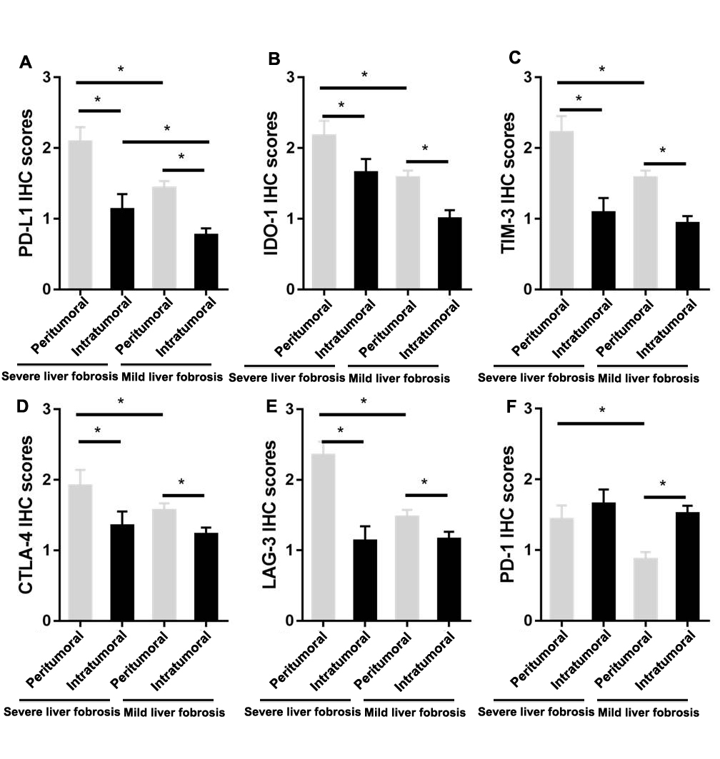Supplementary Figure 3. Analysis of immunohistochemical scores of immune checkpoint molecular staining on HCC tissue microarray. A, PD-L1; B, IDO-1; C, TIM-3; D, CTLA-4; E, LAG-3; F, PD-1. N=99, *P<0.05.

Supplementary Figure 4: Immunohistochemical images of α-SMA and collagen I stainging in liver tissues from mice with CCl₄-induced hepatic fibrosis.

Supplementary Figure 5. GOLM1 expression is significantly upregulated during liver fibrosis progression. Expression data analysis of GSE89147 was conducted by R. A, Volcano map presented the results comparing the mRNA expression between CCl₄ induced fibrosis group and control group (A,B). GOLM1 (1415698_at) was shown in the map. B, GOLM1 expression was significantly in the CCl₄ administrated group compared with control group. C, Representative IHC images of GOLM1 in the CCl₄-induced mice liver fibrosis group and the control group. (n=6/group). D, GOLM1 expressed in human liver disease (including HBV, HCV, NASH, alcohol) compared with normal liver tissues was obtained by analyzing the data contained in the gene chip GSE38941, GSE38226, GSE48452, GSE28619). E, Left: IHC staining of Sirius red, α-SMA and GOLM1 was conducted on the human liver tissue microarray and the representative images were shown. Right: GOLM1 immunohistochemical score was compared between sever liver fibrosis and mild liver fibrosis/normal liver tissues. N=99, Data are means ± SD; *P<0.05 vs mild liver fibrosis tissues.

Supplementary Figure 6. GOLM1 drives fibrosis progression. A, Liver sections stained with HE, Sirius red and collagen Ⅰ show more severe liver injury and collagen Ⅰ deposition in GOLM1 TG mice compared with WT control mice. B, Serum ALT and AST activities are increased in GOLM1 TG mice compared to WT mice. Results are expressed as mean ± SD; n=6/group, *p <0.05 for GOLM1 TG group vs. corresponding WT mice.

Supplementary Figure 7. The effects of gefitinib and/or anti-PD-L1 on kidney and liver function in mice with subcutaneous GOLM1-overexpressing H22 tumors after treatment at endpoint.

