Supplementary information
S1- Materials and Methods
Daily pH, temperature, and dissolved oxygen
On daily basis, the pH, temperature and dissolved oxygen (DO) were monitored shown in (Figure S1). The pH of water was checked by pH meter. The temperature was checked by thermometer. The (DO) on daily basis was measured by the colorimetric method.
S2- Results
S2.1 pH, temperature, and DO
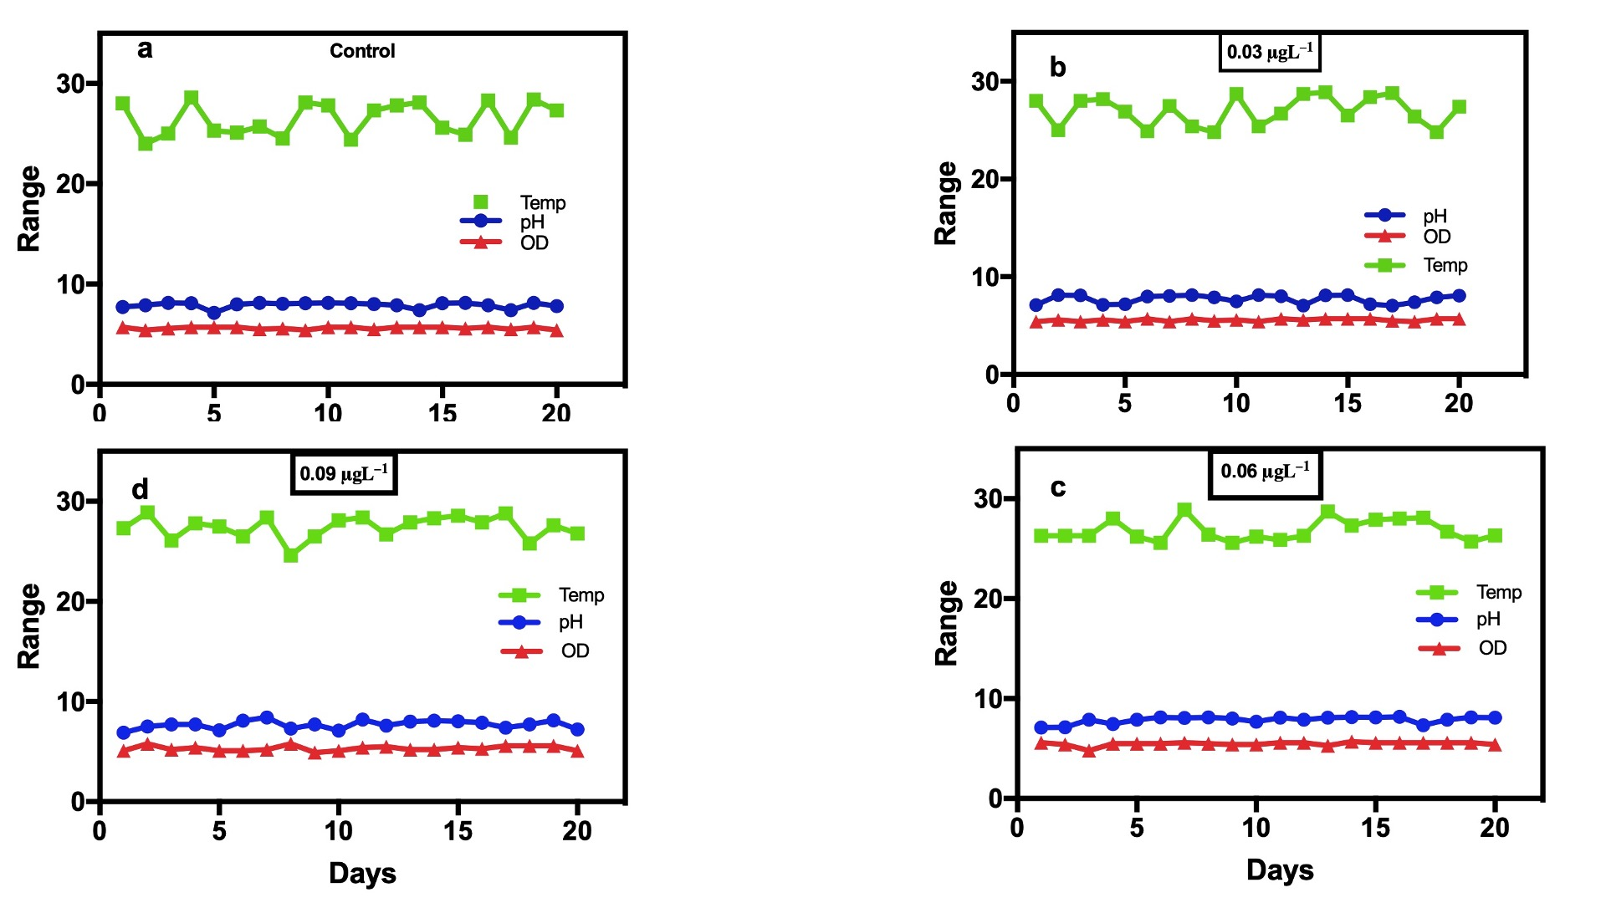
Figure S1. Daily monitored physicochemical parameters of the experimental setup, including dissolved oxygen (DO; mg/L), temperature (T; ℃), and pH: (a) Control (b) 0.03 mg/L; (c) 0.6 mg/L; (d), and 0.9 mg/L of B-AgNPs.

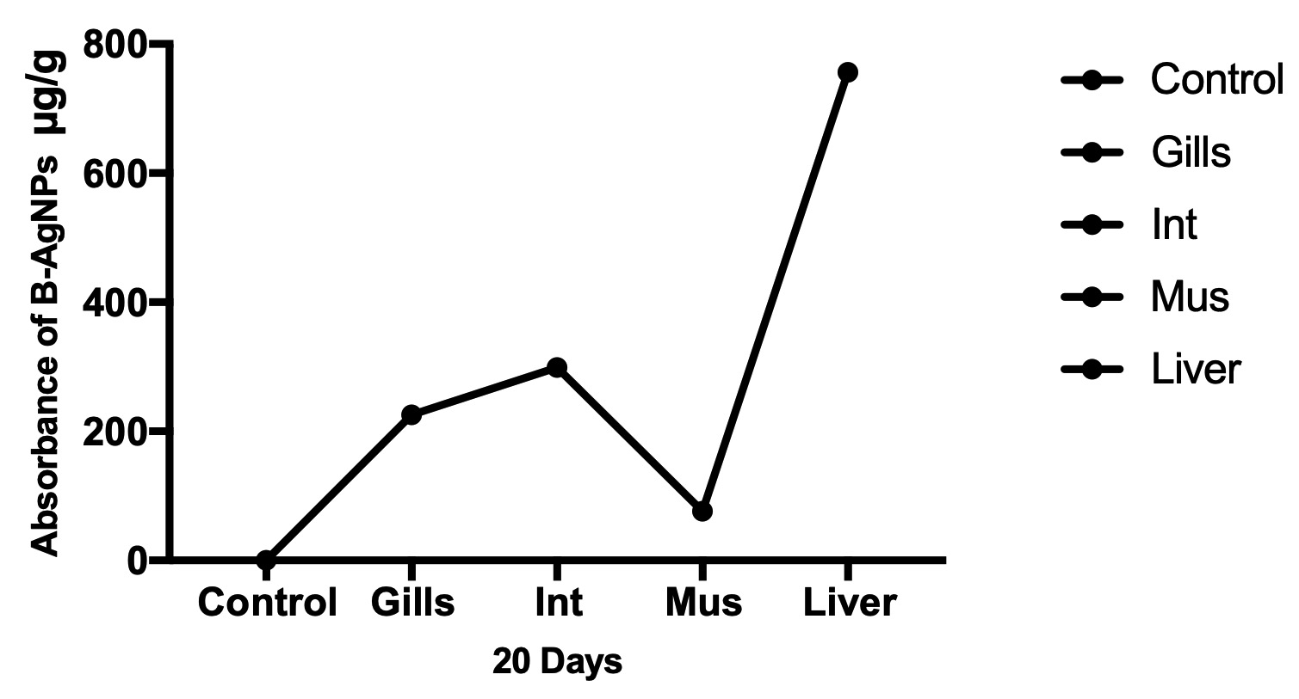
Figure S2. The combine absorption of B-AgNPs (0.3 mg/L, 0.6 mg/L, and 0.9 mg/L) in Gills, Intestine, Muscles, and Liver of fish
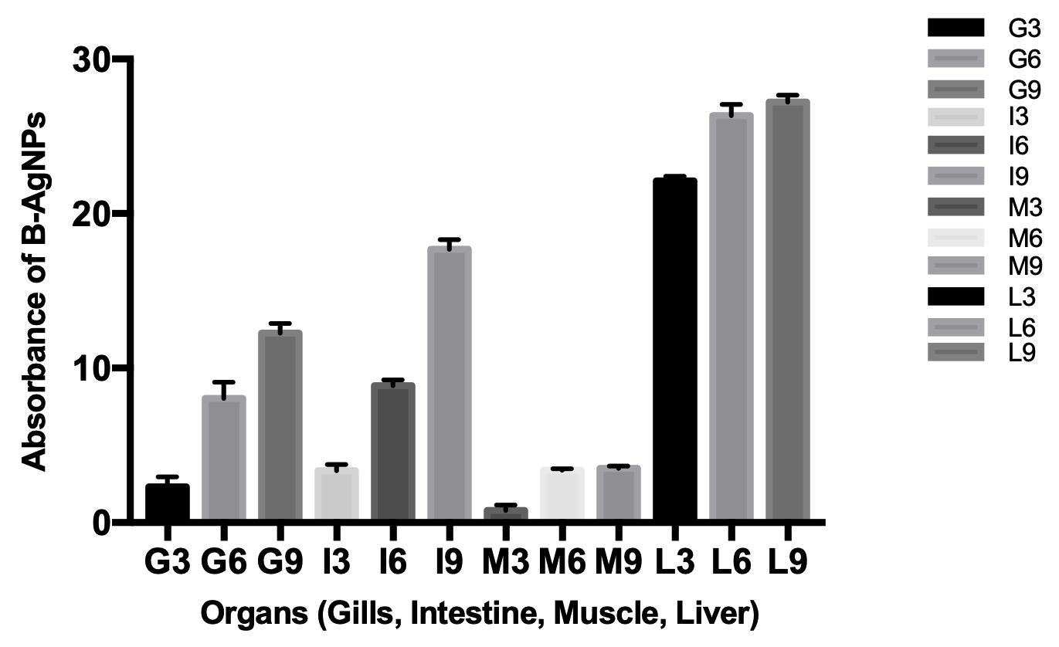
Figure S3. The concentration group wise absorption of B-AgNPs in fish

Table S1. Summary of histopathological alterations in the gill of (Cyprinus carpio) after 20 days exposure to B-AgNPs.
 | Lesions
 | Shortening of secondary lamellae | Damage of lamella | Necrosis of lamella | Epithelial lifting | Aneurism | Epithelial necrosis
AgNPs
Control | - | - | - | - | - | -
0.03 mg L⁻¹ | + | + | + | + | - | +
0.06 mg L⁻¹ | ++ | ++ | ++ | + | - | +
0.09 mg L⁻¹ |  | ++ | ++ | + | - | ++
Score value: None (−), mild (+), moderate (++) and severe (+++).

Table S2. Summary of histopathological alterations in intestine of (Cyprinus carpio) after 20 days exposure to B-AgNPs.
 | Lesions
 | Swollen villi | Missing epithelial cells | Degeneration of lamina propria | Cell lysis | Destructed villi
AgNPs
Control | - | - | - | - | -
0.03 mg L⁻¹ | + | + | + | - | +
0.06 mg L⁻¹ | ++ | + | ++ | + | ++
0.09 mg L⁻¹ | ++ | ++ | ++ | ++ | ++
Score value: None (−), mild (+), moderate (++) and severe (+++).

Days | 0.03 mg/L | 0.06 mg/L | 0.09 mg/L | Control
2 | 0.95 | 5.3 | 10.85 | 0
4 | 1.79 | 7.41 | 11.78 | 0
6 | 1.91 | 7.97 | 11.93 | 0
8 | 1.97 | 8.13 | 12.32 | 0
10 | 2.37 | 8.36 | 12.39 | 0
12 | 2.41 | 8.43 | 12.48 | 0
14 | 2.73 | 8.51 | 12.56 | 0
16 | 2.89 | 8.59 | 12.65 | 0
18 | 2.94 | 8.73 | 12.79 | 0
20 | 3.06 | 8.87 | 12.92 | 0

Days | 0.03 mg/L | 0.06 mg/L | 0.09 mg/L | Control
2 | 2.85 | 8.34 | 16.92 | 0
4 | 2.91 | 8.41 | 17.01 | 0
6 | 2.98 | 8.54 | 17.18 | 0
8 | 3.11 | 8.71 | 17.31 | 0
10 | 3.22 | 8.79 | 17.33 | 0
12 | 3.35 | 8.98 | 17.91 | 0
14 | 3.52 | 9.1 | 18.09 | 0
16 | 3.79 | 9.17 | 18.22 | 0
18 | 3.81 | 9.24 | 18.47 | 0
20 | 3.97 | 9.39 | 18.53 | 0

Days | 0.03 mg/L | 0.06 mg/L | 0.09 mg/L | Control
2 | 0.26 | 3.18 | 3.27 | 0
4 | 0.32 | 3.21 | 3.3 | 0
6 | 0.49 | 3.34 | 3.39 | 0
8 | 0.67 | 3.37 | 3.44 | 0
10 | 0.69 | 3.41 | 3.57 | 0
12 | 0.91 | 3.46 | 3.62 | 0
14 | 1.03 | 3.48 | 3.66 | 0
16 | 1.09 | 3.51 | 3.67 | 0
18 | 1.12 | 3.43 | 3.54 | 0
20 | 1.16 | 3.46 | 3.59 | 0

Days | 0.03 mg/L | 0.06 mg/L | 0.09 mg/L | Control
2 | 21.73 | 25.23 | 26.67 | 0
4 | 21.79 | 25.28 | 26.71 | 0
6 | 21.88 | 26.1 | 26.89 | 0
8 | 21.92 | 26.13 | 26.94 | 0
10 | 21.99 | 26.41 | 27.11 | 0
12 | 22.03 | 26.45 | 27.17 | 0
14 | 22.24 | 26.49 | 27.25 | 0
16 | 22.43 | 26.91 | 27.54 | 0
18 | 22.47 | 27.16 | 27.88 | 0
20 | 22.56 | 27.33 | 27.93 | 0
Table S3, S4, S5, and S6. The daily basis bioaccumulation of B-AgNPs in different organs of (Cyprinus carpio). (S3 = Gills, S4= Intestine, S5 = Muscle, and S6 = Liver)

