Table 1. 3D modeling and output of 3D-printed auxetic lattice 4 type structures.

Sample | Auxetic lattice repeat unit | Modeling images | g-code | Weight (g) | Optical images
TR | 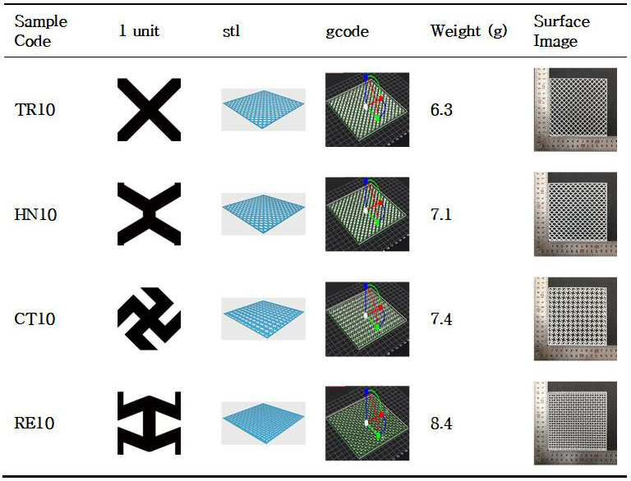 |  |  | 6.3
HN |  |  |  | 7.1
CT |  |  |  | 7.4
RE |  |  |  | 8.4

Table 2. Optical images for up to 5th cycle coatings of auxetic lattice 4 type structures.
Sample | Cycle times
Sample | Non coating | First | Second | Third | Fourth | Fifth
TR | 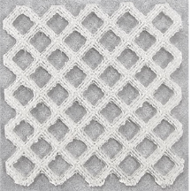 | 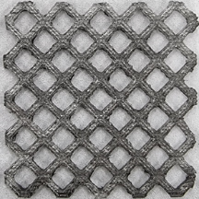 | 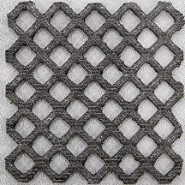 | 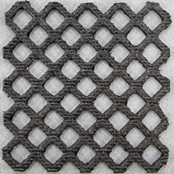 | 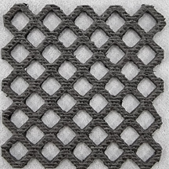 | 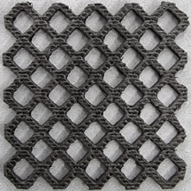
HN | 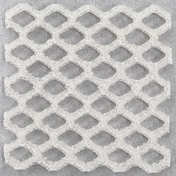 | 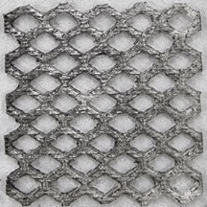 | 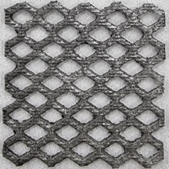 | 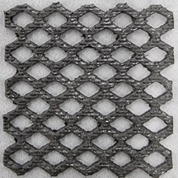 | 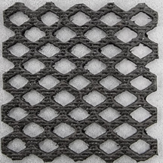 | 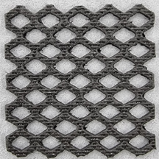
CT | 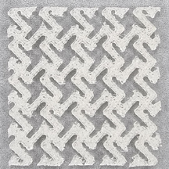 | 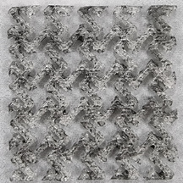 | 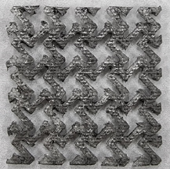 | 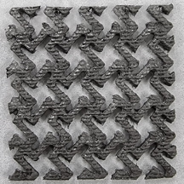 | 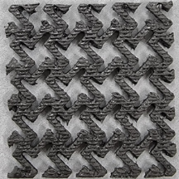 | 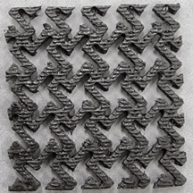
RE | 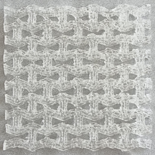 | 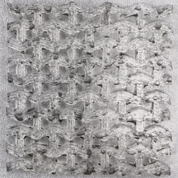 | 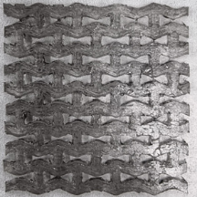 | 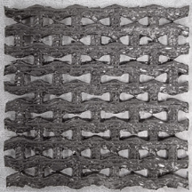 | 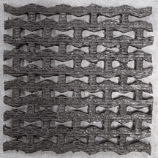 | 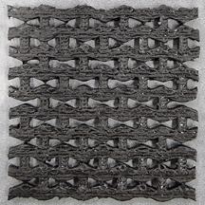

Table 4. Strain images and Poisson’s ratio of auxetic lattice TR patterns up to 60% elongation.
Description | Strain (%)
Description | 0 | 1 | 3 | 5 | 10 | 15
Images | 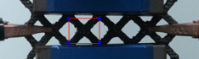 | 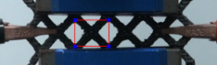 | 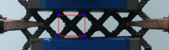 | 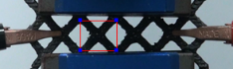 | 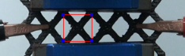 | 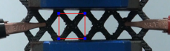
Poisson’s ratio | - | 0 | 0 | 0 | 0 | 0.067
- | 20 | 25 | 30 | 40 | 50 | 60
Images | 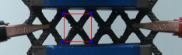 | 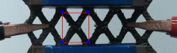 | 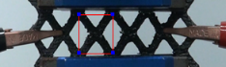 | 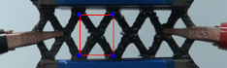 | 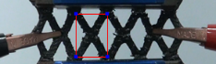 | 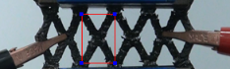
Poisson’s ratio | 0.107 | 0.105 | 0.100 | 0.119 | 0.105 | 0.091

Table 5. Strain images and Poisson’s ratio of auxetic lattice HN patterns up to 60% elongation.
Description | Strain (%)
Description | 0 | 1 | 3 | 5 | 10 | 15
Images | 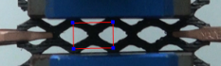 | 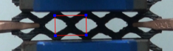 | 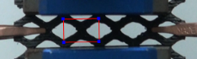 | 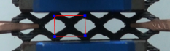 | 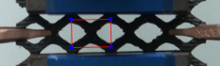 | 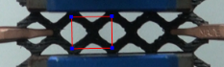
Poisson’s ratio | - | 0 | 0 | 0 | 0 | 0.059
- | 20 | 25 | 30 | 40 | 50 | 60
Images | 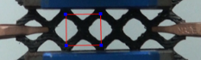 | 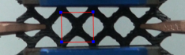 | 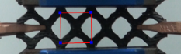 | 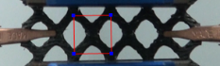 | 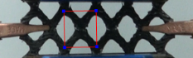 | 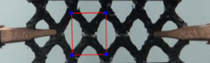
Poisson’s ratio | 0.102 | 0.143 | 0.126 | 0.100 | 0.097 | 0.112

Table 6. Strain images and Poisson’s ratio of auxetic lattice CT patterns up to 60% elongation.
Description | Strain (%)
Description | 0 | 1 | 3 | 5 | 10 | 15
Images | 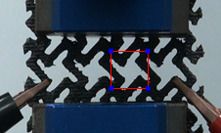 | 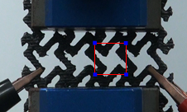 | 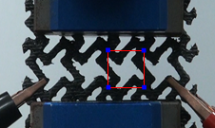 | 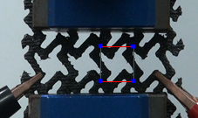 | 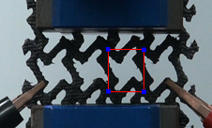 | 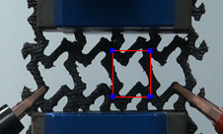
Poisson’s ratio | - | 0 | 0 | 0 | -0.102 | -0.073
- | 20 | 25 | 30 | 40 | 50 | 60
Images | 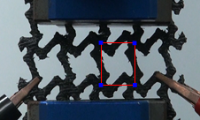 | 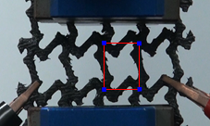 | 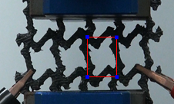 | 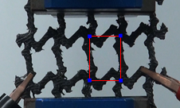 | 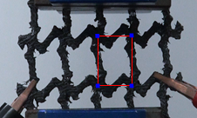 | 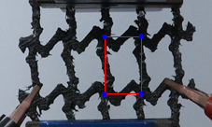
Poisson’s ratio | -0.064 | -0.054 | -0.044 | -0.070 | -0.062 | -0.051

Table 7. Strain images and Poisson’s ratio of auxetic lattice RE patterns up to 60% elongation.

Description | Strain (%)
Description | 0 | 1 | 3 | 5 | 10 | 15
Images | 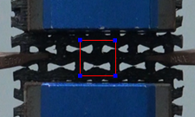 | 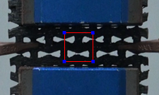 | 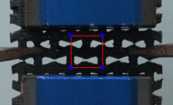 | 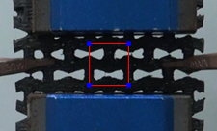 | 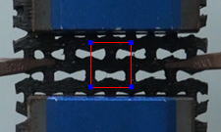 | 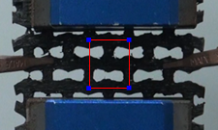
Poisson’s ratio | - | 0 | 0 | 0 | -0.145 | -0.068
- | 20 | 25 | 30 | 40 | 50 | 60
Images | 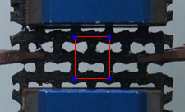 | 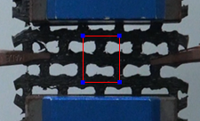 | 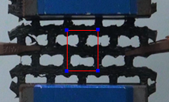 | 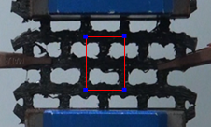 | 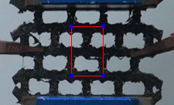 | 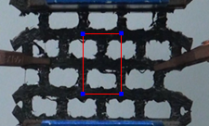
Poisson’s ratio | -0.063 | -0.056 | -0.046 | -0.038- | -0.027 | -0.026

