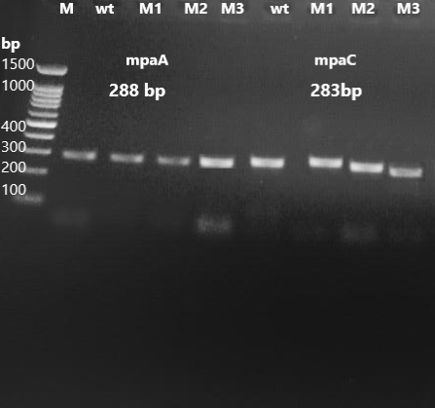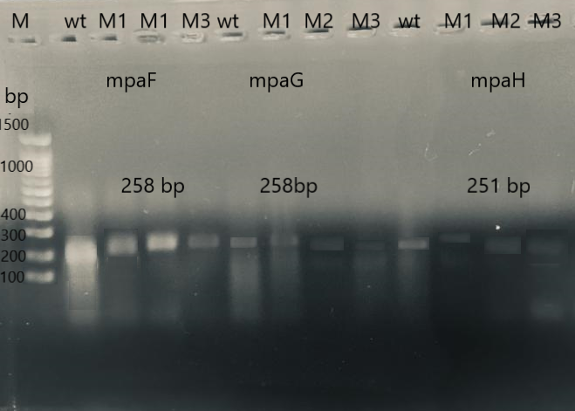
Fig. S.1 Agarose gel electrophoresis of MPA gene cluster orthologues to mpaA, mpaC, mpaF, mpaG and mpaH and amplified from genomic DNA by conventional PCR from wild type strain HE-MTwt (wt), and MPA overproducer mutant strains HE-MPM1 (M1), MPM2 (M2), MPM3 (M3) of P. arizonense genome. M is 100 molecular weight ladder DNA strand.

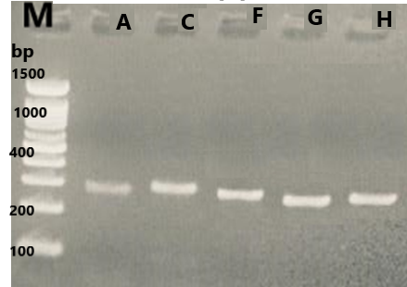
Fig S. 2: Gel electrophoresis of rtPCR products of MPA gen cluster, mpaA (lane A), mpaC (lane C), mpaF (lane F), mpaG (lane G), and mpaH (lane H), extracted from MPA overproducer mutant strains P. arezonense HE-MPM2.

